03 March, 2026

PRESS RELEASE

FISCAL ACCOUNTS OF GENERAL GOVERNMENT: JAN-DEC 2025

Surplus €939,2 mn

The preliminary General Government fiscal results, which are prepared by the Statistical Service of Cyprus (CYSTAT) indicate a surplus of €939,2 mn (2,6% of GDP) for the period of January-December 2025, as compared to a surplus of €1.439,3 mn (4,1% of GDP) that was recorded during the period of January- December 2024.

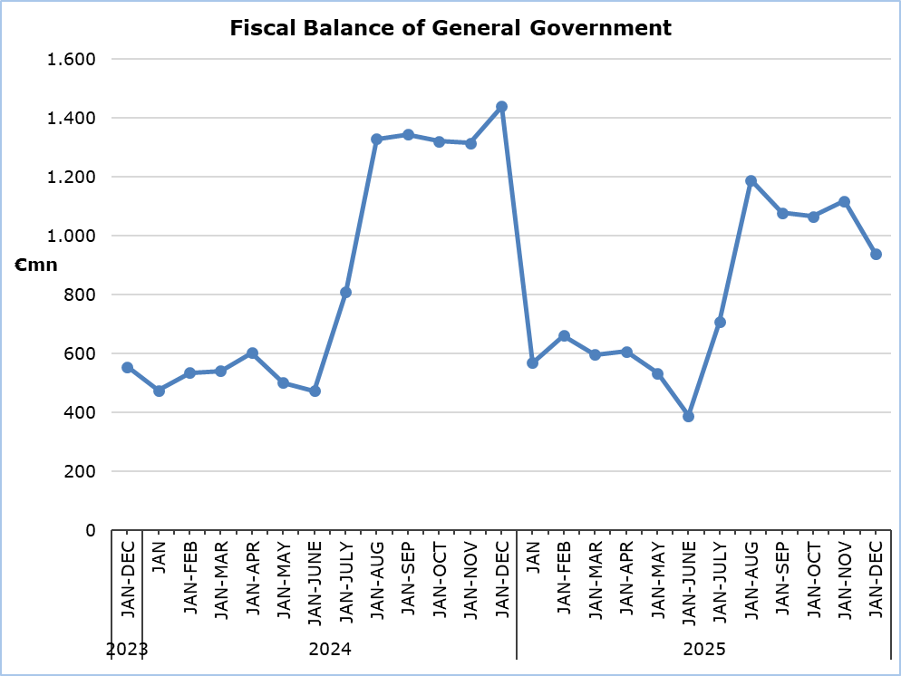

Revenue

During the period of January-December 2025, total revenue increased by €864,8 mn (+5,9%) and amounted to €15.615,2 mn, compared to €14.750,3 mn in the corresponding period of 2024.

In detail, revenue from taxes on income and wealth increased by €341,3 mn (+9,0%) and amounted to €4.146,0 mn, compared to €3.804,7 mn in 2024. Social contributions increased by €358,7 mn (+7,9%) and amounted to €4.878,7 mn, compared to €4.520,0 mn in 2024. Property income increased by €37,4 mn (+30,4%) and amounted to €160,3 mn, compared to €122,9 mn in 2024. Taxes on production and imports increased by €14,0 mn (+0,3%) and amounted to €4.696,8 mn, compared to €4.682,8 mn in 2024, of which net VAT revenue decreased by €52,8 mn (-1,7%), to €3.116,8 mn, from €3.169,6 mn in 2024. Revenue from the sale of goods and services increased by €159,6 mn (+17,9%) and amounted to €1.049,4 mn, compared to €889,8 mn in 2024. Current transfers increased by €27,9 mn (+7,1%) and amounted to €421,1 mn, compared to €393,2 mn in 2024.

On the contrary, capital transfers decreased by €74,1 mn (-22,0%) to €262,9 mn, from €337,0 mn in 2024.

Expenditure

During the period of January-December 2025, total expenditure increased by €1.364,9 mn (+10,3%) and amounted to €14.675,9 mn, compared to €13.311,0 mn in the corresponding period of 2024.

In detail, compensation of employees (including imputed social contributions and pensions of civil servants) increased by €253,3 mn (+6,5%) and amounted to €4.131,2 mn, compared to €3.877,9 mn in 2024. Social benefits increased by €382,3 mn (+7,2%) and amounted to €5.686,0 mn, compared to €5.303,7 mn in 2024. Intermediate consumption increased by €136,0 mn (+9,3%) and amounted to €1.600,8 mn, compared to €1.464,8 mn in 2024. Current transfers increased by €77,8 mn (+9,2%) and amounted to €920,2 mn, compared to €842,4 mn in 2024.

The capital account increased by €562,1 mn (+46,6%) and amounted to €1.767,2 mn, compared to €1.205,1 mn in 2024, of which gross capital formation increased by €242,6 mn (+25,1%) and amounted to €1.207,3 mn, compared to €964,7 mn in 2024 and other capital expenditure increased by €319,5 mn and amounted to €559,9 mn, compared to €240,4 mn in 2024.

On the contrary, interest payable decreased by €27,0 mn (-6,1%) to €418,7 mn, from €445,7 mn in 2024.
Subsidies decreased by €19,6 mn (-11,4%) to €151,8 mn, from €171,4 mn in 2024.

Important Notice

It is emphasized that for a number of entities of the General Government and specifically for the Local Government Subsector, estimates have been produced by the Statistical Service, due to non-submission of sufficient data by the competent authorities.

Table 1
Macroeconomic Aggregates of General Government |  | Euro (million) |  |  |  |  |  |  |  |  | Change
 |  | Fiscal Results |  |  |  | Difference |  |  |  |  |  | (%)
 |  | Jan-Dec  2024 |  | Jan-Dec 2025 |  | Jan-Dec 2025/24 |  |  |  |  | Jan-Dec 2025/24
Total Revenue | 14.750,3 |  |  | 15.615,2 |  |  | 864,8 |  |  |  |  |  | 5,9
Taxes on Production and Imports | 4.682,8 |  |  | 4.696,8 |  |  | 14,0 |  |  |  |  |  | 0,3
of which VAT (net of refunds) | 3.169,6 |  |  | 3.116,8 |  |  | -52,8 |  |  |  |  |  | -1,7
Current Taxes on Income and Wealth, etc | 3.804,7 |  |  | 4.146,0 |  |  | 341,3 |  |  |  |  |  | 9,0
Social Contributions | 4.520,0 |  |  | 4.878,7 |  |  | 358,7 |  |  |  |  |  | 7,9
Other Current Resources | 1.405,9 |  |  | 1.630,8 |  |  | 224,9 |  |  |  |  |  | 16,0
Property income | 122,9 |  |  | 160,3 |  |  | 37,4 |  |  |  |  |  | 30,4
Current transfers | 393,2 |  |  | 421,1 |  |  | 27,9 |  |  |  |  |  | 7,1
Sales | 889,8 |  |  | 1.049,4 |  |  | 159,6 |  |  |  |  |  | 17,9
Capital Transfers Received | 337,0 |  |  | 262,9 |  |  | -74,1 |  |  |  |  |  | -22,0
Total Expenditure | 13.311,0 |  |  | 14.675,9 |  |  | 1.364,9 |  |  |  |  |  | 10,3
Total Current Expenditure | 12.105,9 |  |  | 12.908,7 |  |  | 802,8 |  |  |  |  |  | 6,6
Intermediate consumption | 1.464,8 |  |  | 1.600,8 |  |  | 136,0 |  |  |  |  |  | 9,3
Compensation of employees | 3.877,9 |  |  | 4.131,2 |  |  | 253,3 |  |  |  |  |  | 6,5
Social transfers | 5.303,7 |  |  | 5.686,0 |  |  | 382,3 |  |  |  |  |  | 7,2
Interest | 445,7 |  |  | 418,7 |  |  | -27,0 |  |  |  |  |  | -6,1
Subsidies | 171,4 |  |  | 151,8 |  |  | -19,6 |  |  |  |  |  | -11,4
Other current expenditure | 842,4 |  |  | 920,2 |  |  | 77,8 |  |  |  |  |  | 9,2
Total Capital Expenditure | 1.205,1 |  |  | 1.767,2 |  |  | 562,1 |  |  |  |  |  | 46,6
Gross capital formation | 964,7 |  |  | 1.207,3 |  |  | 242,6 |  |  |  |  |  | 25,1
Gross capital formation excluding land annexations | 926,4 |  |  | 1.177,9 |  |  | 251,5 |  |  |  |  |  | 27,1
Other capital expenditure | 240,4 |  |  | 559,9 |  |  | 319,5 |  |  |  |  |  | 132,9
Net Lending (+)/ Borrowing (-) |  |  | 1.439,3 | 939,2 |  |  | -500,1
% of GDP |  |  | 4,1% | 2,6%

The Net Lending/Borrowing of the General Government for the period of January-December 2025 and 2024, respectively, which is presented above, is analysed as follows:

Table 2
Net Lending (+)/ Borrowing (-) by Subsector of the General Government | Jan-Dec 2024  (€ mn) | Jan-Dec 2025  (€ mn)
Central Government | 27,9 | -282,5
Local Government | -9,3 | 20,4
Social Security Funds | 1.420,7 | 1.201,3
General Government | 1.439,3 | 939,2

METHODOLOGICAL INFORMATION

Data Coverage and Methodology

Information is provided for the whole sequence of accounts for the General Government sector. The revenue and expenditure are analyzed by category and these are classified between current and capital, respectively.

The categories of revenue and expenditure for General Government cover all the subsectors of the General Government based on the European System of Accounts 2010 (ESA 2010).

Source of Data

The data is collected from:
- Financial Information Management Automation System (FIMAS) for Central Government, Extra Budgetary Funds and Social Security Funds,
- Budget execution of Municipalities and Communities,
- Budget execution of Semi-Government Organizations.

For the completion of the estimates, any methodological adjustments or corrections based on the European System of Accounts 2010 (ESA 2010) are taken into account.

For more information:
CYSTAT Portal, subtheme Public Finance
Predefined Tables (Excel)

Contact
Michael Panayiota: Τel.: +357-22602186, Email: pmichael@cystat.mof.gov.cy

