31 October, 2023

**PRESS RELEASE**

FISCAL ACCOUNTS OF GENERAL GOVERNMENT: **JAN-SEP 2023**

**Surplus €931,6 mn**

The preliminary General Government fiscal results, which are prepared by the Statistical Service of Cyprus (CYSTAT) indicate a surplus of €931,6 mn (3,1% of GDP) for the period of January-September 2023, as compared to a surplus of €727,1 mn (2,6% of GDP) that was recorded during the period of January- September 2022.

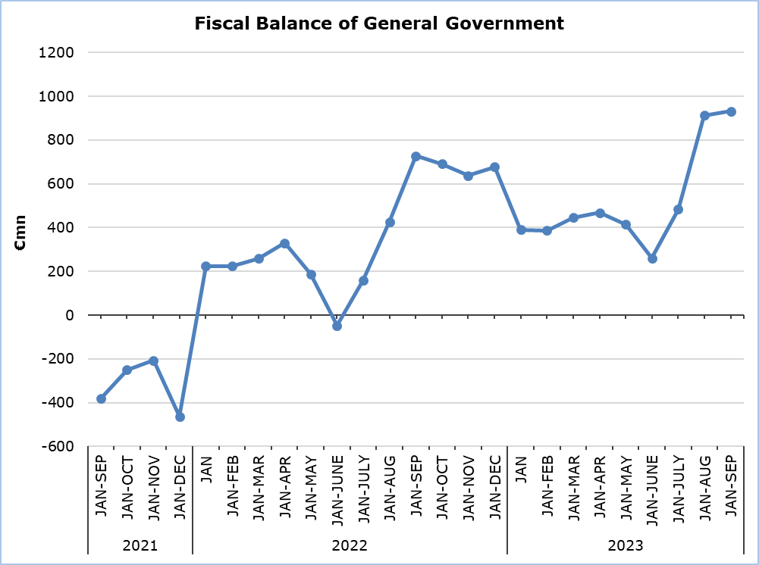

**Revenue**

During the period of January-September 2023, total revenue increased by €899,1 mn (+11,0%) and amounted to €9.050,2 mn, compared to €8.151,1 mn in the corresponding period of 2022.

In detail, taxes on production and imports increased by €286,1 mn (+9,6%) and amounted to €3.262,1 mn, compared to €2.976,0 mn in 2022, of which net VAT revenue increased by €174,7 mn (+8,8%) and amounted to €2.160,3 mn, compared to €1.985,6 mn in 2022. Revenue from taxes on income and wealth increased by €290,5 mn (+14,5%) and amounted to €2.295,8 mn, compared to €2.005,3 mn in 2022. Social contributions increased by €344,8 mn (+15,4%) and amounted to €2.580,5 mn, compared to €2.235,7 mn in 2022. Current transfers increased by €53,7 mn (+35,5%) and amounted to €204,8 mn, compared to €151,1 mn in 2022. Revenue from the sale of goods and services increased by €14,2 mn (+2,7%) and amounted to €548,4 mn, compared to €534,2 mn in 2022.

On the contrary, property income decreased by €22,2 mn (-22,7%) to €75,6 mn, from €97,8 mn in 2022. Capital transfers decreased by €68,0 mn (-45,0%) to €83,0 mn, from €151,0 mn in 2022.

**Expenditure**

During the period of January-September 2023, total expenditure increased by €694,6 mn (+9,4%) and amounted to €8.118,6 mn, compared to €7.424,0 mn in the corresponding period of 2022.

In detail, social benefits increased by €258,9 mn (+8,6%) and amounted to €3.267,8 mn, compared to €3.008,9 mn in 2022. Compensation of employees (including imputed social contributions and pensions of civil servants) increased by €263,2 mn (+12,0%) and amounted to €2.462,1 mn, compared to €2.198,9 mn in 2022. Subsidies increased by €63,3 mn and amounted to €124,1 mn, compared to €60,8 mn in 2022. Current transfers increased by €85,8 mn (+21,2%) and amounted to €490,3 mn, compared to €404,5 mn in 2022.

The capital account increased by €65,1 mn (+11,0%) and amounted to €656,7 mn, compared to €591,6 mn in 2022. In detail, gross capital formation increased by €111,8 mn (+25,2%) and amounted to €556,0 mn, compared to €444,3 mn in 2022 and other capital expenditure decreased by €46,7 mn (-31,7%) to €100,7 mn, from €147,4 mn in 2022.

On the contrary, intermediate consumption decreased by €26,1 mn (-3,1%) to €810,6 mn, from €836,7 mn in 2022. Interest payable decreased by €15,6 mn (-4,8%) to €307,0 mn, from €322,6 mn in 2022.

|  |  |  |  |  |  |  |
| --- | --- | --- | --- | --- | --- | --- |
| **Table** |  |  |  |  |  |  |
| **Macroeconomic Aggregates of General Government** | **Euro (million)** | | | |  | **Change** |
| **Fiscal Results** | |  | **Difference** |  | **(%)** |
| **Jan-Sep 2022** | **Jan-** **Sep 2023** |  | **Jan-** **Sep 2023/22** |  | **Jan-** **Sep 2023/22** |
| **Total Revenue** | **8.151,1** | **9.050,2** |  | **899,1** |  | **11,0%** |
| Taxes on Production and Imports | 2.976,0 | 3.262,1 |  | 286,1 |  | 9,6% |
| *of which VAT* | 1.985,6 | 2.160,3 |  | 174,7 |  | 8,8% |
| Current Taxes on Income and Wealth, etc | 2.005,3 | 2.295,8 |  | 290,5 |  | 14,5% |
| Social Contributions | 2.235,7 | 2.580,5 |  | 344,8 |  | 15,4% |
| Other Current Resources | 783,1 | 828,8 |  | 45,7 |  | 5,8% |
| Interest receivable | 97,8 | 75,6 |  | -22,2 |  | -22,7% |
| Current transfers | 151,1 | 204,8 |  | 53,7 |  | 35,5% |
| Sales | 534,2 | 548,4 |  | 14,2 |  | 2,7% |
| Capital Transfers Received | 151,0 | 83,0 |  | -68,0 |  | -45,0% |
| **Total Expenditure** | **7.424,0** | **8.118,6** |  | **694,6** |  | **9,4%** |
| Total Current Expenditure | 6.832,4 | 7.461,9 |  | 629,5 |  | 9,2% |
| Intermediate consumption | 836,7 | 810,6 |  | -26,1 |  | -3,1% |
| Compensation of employees | 2.198,9 | 2.462,1 |  | 263,2 |  | 12,0% |
| Social transfers | 3.008,9 | 3.267,8 |  | 258,9 |  | 8,6% |
| Interest | 322,6 | 307,0 |  | -15,6 |  | -4,8% |
| Subsidies | 60,8 | 124,1 |  | 63,3 |  | 104,1% |
| Other current expenditure | 404,5 | 490,3 |  | 85,8 |  | 21,2% |
| Total Capital Expenditure | 591,6 | 656,7 |  | 65,1 |  | 11,0% |
| Gross capital formation | 444,3 | 556,0 |  | 111,8 |  | 25,2% |
| *Gross capital formation* *excluding land annexations* | 428,2 | 543,5 |  | 115,4 |  | 26,9% |
| Other capital expenditure | 147,4 | 100,7 |  | -46,7 |  | -31,7% |
| **Net Lending (+)/ Borrowing (-)** | **727,1** | **931,6** |  | **204,5** |  |  |
| % of GDP | 2,6% | 3,1% |  |  |  |  |

**METHODOLOGICAL INFORMATION**

**Data Coverage and Methodology**

Information is provided for the whole sequence of accounts for the General Government sector. The revenue and expenditure are analyzed by category and these are classified between current and capital, respectively.

The categories of revenue and expenditure for General Government cover all the subsectors of the General Government based on the European System of Accounts 2010 (ESA 2010).

**Source of Data**

The data is collected from:

- Financial Information Management Automation System (FIMAS) for Central Government, Extra Budgetary Funds and Social Security Funds,

- Budget execution of Municipalities and Communities,

- Budget execution of Semi-Government Organizations.

For the completion of the estimates, any methodological adjustments or corrections based on the European System of Accounts 2010 (ESA 2010) are taken into account.

***For more information:***

CYSTAT Portal, subtheme [Public Finance](https://www.cystat.gov.cy/en/SubthemeStatistics?id=48)

[Predefined Tables](https://www.cystat.gov.cy/en/KeyFiguresList?s=48) (Excel)

*Contact*

Michael Panayiota: Τel: +35722602186, Email: [pmichael@cystat.mof.gov.cy](mailto:pmichael@cystat.mof.gov.cy)