3 November, 2026

PRESS RELEASE

FISCAL ACCOUNTS OF GENERAL GOVERNMENT: JAN-SEP 2026

Surplus €1.609,7 mn

The preliminary General Government fiscal results, which are prepared by the Statistical Service of Cyprus (CYSTAT) indicate a surplus of €1.609,7 mn (4,0% of GDP) for the period of January-September 2026, as compared to a surplus of €1.167,6 mn (3,0% of GDP) that was recorded during the period of January- September 2025.

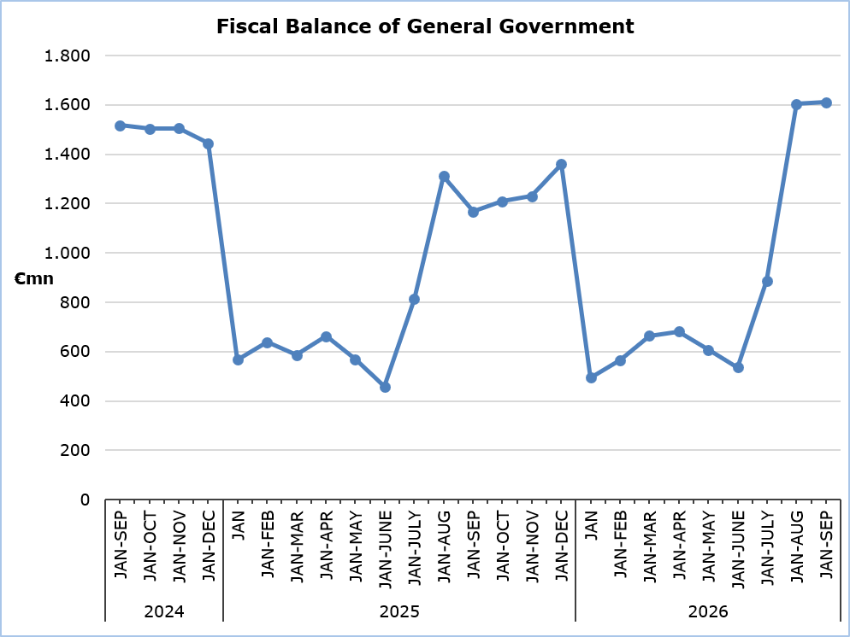

Revenue

Total General Government revenue for the period January- September 2026, amounted to €12.091,8 mn, recording an increase of €737,9 mn or 6,5%, compared to €11.353,9 mn during the corresponding period of 2025.

The increase in total revenue was mainly driven by higher taxes on income and wealth, which reached €3.337,0 mn, increased by €442,2 mn (+15,3 %), compared to €2.894,8 mn in 2025. At the same time, social contributions increased by €235,0 mn (+6,6%) and amounted to €3.778,0 compared to €3.543,0 mn in 2025. A significant increase was also recorded in taxes on production and imports, which amounted to €3.766,0 mn, increased by €251,5 mn (+7,2%) compared to €3.514,5 mn in 2025. In particular, net Value added Tax (VAT) revenue, after the deduction of refunds, reached €2.638,6 mn, representing an increase of €293,1 mn (+12,5%) compared with €2.345,5 mn in 2025.

On the contrary, capital transfers decreased by €74,6 mn to €96,7 mn, from €171,3 mn in 2025. Revenue from the sale of goods and services decreased by €7,6 mn (-1,0%) to €743,5 mn, compared with €751,1 mn in 2025. Furthermore, property income decreased by €37,0 mn (-28,6%) to €92,4 mn, from €129,4 mn in 2025. Current transfers also decreased by €71,6mn (-20,5%) to €278,2 mn, from €349,8 mn during the corresponding period of the previous year.

Expenditure

Total General Government expenditure for the period January-September 2026 amounted to €10.482,1 million, recording an increase of €295,9 million, or 2,9%, compared with €10.186,2 million during the corresponding period of 2025.

More specifically, intermediate consumption increased by €114,3 mn (+11,0%) and amounted to €1.158,0 mn, compared to €1.043,7 mn in the corresponding period of 2025. Compensation of employees, including imputed social contributions and pensions of civil servants, increased by €108,3 mn (+3,8%) to €2.987,8 mn, from €2.879,5 mn in 2025. At the same time, social benefits recorded an increase of €199,6 mn (+4,9%) reaching €4.268,9 mn, compared with €4.069,3 mn during the same period of the previous year. Interest payable also increased by €8,7 mn (+2,6%) and amounted to €340,7 mn, compared to €332,0 mn in 2025, while current transfers increased by €68,7 mn (+10,6%) €714,7 mn, compared with €646,0 mn in 2025.

In contrast, expenditure under the capital account declined significantly, falling to €936,2 mn, from €1.126,1 mn in the corresponding period of 2025, representing a decrease of €189,9 mn (-16,9%). In particular, gross fixed capital formation decreased by €94,1 mn (-12,1%) to €686,4 mn, from €780,5 mn in 2025 and other capital expenditure decreased by €95,8 mn (-27,7%) to €249,8 mn, from €345,6 mn in the previous year. Furthermore, subsidies declined by €13,9 mn (-15,5%) amounting to €75,8 mn, from €89,7 mn during the corresponding period of 2025.

Important Notice

It is emphasized that for a number of entities of the General Government and specifically for the Local Government Subsector, estimates have been produced by the Statistical Service, due to non-submission of sufficient data by the competent authorities.

Table 1
Macroeconomic Aggregates of General Government |  | Euro (million) |  |  |  |  |  |  |  | Change
 |  | Fiscal Results |  |  |  | Difference |  |  |  | (%)
 |  | Jan-Sep  2025 |  | Jan-Sep 2026 |  | Jan-Sep 2026/25 |  |  |  | Jan-Sep 2026/25
Total Revenue | 11.353,9 |  |  | 12.091,8 |  |  | 737,9 |  |  |  | 6,5
Taxes on Production and Imports | 3.514,5 |  |  | 3.766,0 |  |  | 251,5 |  |  |  | 7,2
of which VAT (net of refunds) | 2.345,5 |  |  | 2.638,6 |  |  | 293,1 |  |  |  | 12,5
Current Taxes on Income and Wealth, etc | 2.894,8 |  |  | 3.337,0 |  |  | 442,2 |  |  |  | 15,3
Social Contributions | 3.543,0 |  |  | 3.778,0 |  |  | 235,0 |  |  |  | 6,6
Other Current Resources | 1.230,2 |  |  | 1.114,1 |  |  | -116,1 |  |  |  | -9,4
Property income | 129,4 |  |  | 92,4 |  |  | -37,0 |  |  |  | -28,6
Current transfers | 349,8 |  |  | 278,2 |  |  | -71,6 |  |  |  | -20,5
Sales | 751,1 |  |  | 743,5 |  |  | -7,6 |  |  |  | -1,0
Capital Transfers Received | 171,3 |  |  | 96,7 |  |  | -74,6 |  |  |  | -43,6
Total Expenditure | 10.186,2 |  |  | 10.482,1 |  |  | 295,9 |  |  |  | 2,9
Total Current Expenditure | 9.060,1 |  |  | 9.545,9 |  |  | 485,8 |  |  |  | 5,4
Intermediate consumption | 1.043,7 |  |  | 1.158,0 |  |  | 114,3 |  |  |  | 11,0
Compensation of employees | 2.879,5 |  |  | 2.987,8 |  |  | 108,3 |  |  |  | 3,8
Social transfers | 4.069,3 |  |  | 4.268,9 |  |  | 199,6 |  |  |  | 4,9
Interest | 332,0 |  |  | 340,7 |  |  | 8,7 |  |  |  | 2,6
Subsidies | 89,7 |  |  | 75,8 |  |  | -13,9 |  |  |  | -15,5
Other current expenditure | 646,0 |  |  | 714,7 |  |  | 68,7 |  |  |  | 10,6
Total Capital Expenditure | 1.126,1 |  |  | 936,2 |  |  | -189,9 |  |  |  | -16,9
Gross capital formation | 780,5 |  |  | 686,4 |  |  | -94,1 |  |  |  | -12,1
Gross capital formation excluding land annexations | 759,5 |  |  | 673,3 |  |  | -86,2 |  |  |  | -11,4
Other capital expenditure | 345,6 |  |  | 249,8 |  |  | -95,8 |  |  |  | -27,7
Net Lending (+)/Net Borrowing (-) |  |  | 1.167,6 | 1.609,7 |  |  | 442,1
% of GDP |  |  | 3,0% | 4,0%

The Net Lending/Net Borrowing of the General Government for the period of January-September 2026 and 2025, respectively, which is presented above, is analysed as follows:

Table 2
Net Lending (+)/Net Borrowing (-)  by Subsector of the General Government | Jan-Sep 2025  (€ mn) | Jan-Sep 2026  (€ mn)
Central Government | 306,8 | 656,3
Local Government | -30,7 | -3,8
Social Security Funds | 891,5 | 957,2
General Government | 1.167,6 | 1.609,7

METHODOLOGICAL INFORMATION

Data Coverage and Methodology

Information is provided for the whole sequence of accounts for the General Government sector. The revenue and expenditure are analyzed by category and these are classified between current and capital, respectively.

The categories of revenue and expenditure for General Government cover all the subsectors of the General Government based on the European System of Accounts 2010 (ESA 2010).

Source of Data

The data is collected from:
- Financial Information Management Automation System (FIMAS) for Central Government, Extra Budgetary Funds and Social Security Funds,
- Budget execution of Municipalities and Communities,
- Budget execution of Semi-Government Organizations.

For the completion of the estimates, any methodological adjustments or corrections based on the European System of Accounts 2010 (ESA 2010) are taken into account.

For more information:
CYSTAT Portal, subtheme Public Finance
Predefined Tables (Excel)

Contact
Christodoulou Antigoni: Tel: +35722602179, Email: achristodoulou@cystat.mof.gov.cy

