21 July, 2025

**PRESS RELEASE**

QUARTERLY ACCOUNTS OF GENERAL GOVERNMENT: **1st QUARTER 2025**

**Surplus €619,1 mn**

The preliminary General Government fiscal results, which are prepared by the Statistical Service of Cyprus (CYSTAT) indicate a surplus of €619,1 mn for the period of January-March 2025, as compared to a surplus of €575,7 mn that was recorded during the period of January-March 2024.

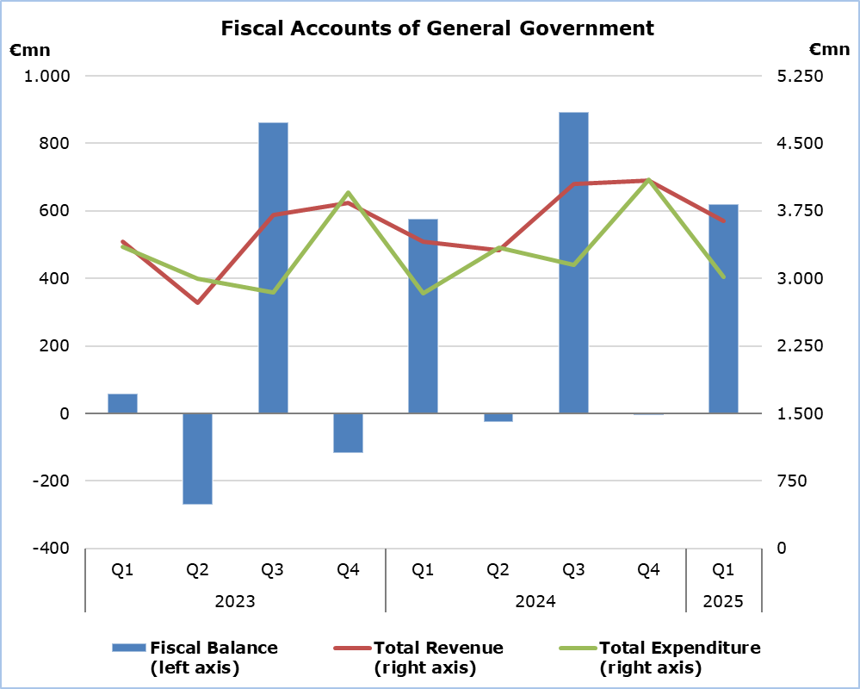

**Revenue**

During the period of January-March 2025, total revenue increased by €231,2 mn (+6,8%) and amounted to €3.639,7 mn, compared to €3.408,5 mn in the corresponding period of 2024.

In detail, social contributions increased by €139,3 mn (+13,2%) and amounted to €1.191,4 mn, compared to €1.052,1 mn in the first quarter of 2024. Revenue from taxes on income and wealth increased by €70,7 mn (+7,7%) and amounted to €985,9 mn, compared to €915,2 mn in the corresponding quarter of 2024. Revenue from the sale of goods and services increased by €57,3 mn (+26,4%) and amounted to €274,6 mn, compared to €217,3 mn in the first quarter of 2024. Taxes on production and imports increased by €28,0 mn (+2,6%) and amounted to €1.100,7 mn, compared to €1.072,7 mn in the corresponding quarter of 2024, of which net VAT revenue increased by €4,8 mn (+0,7%) to €733,2 mn, from €728,4 mn in the first quarter of 2024.

On the contrary, other current transfers decreased by €52,3 mn (-44,2%) to €66,0 mn, from €118,3 mn in the corresponding quarter of 2024. Property income receivable decreased by €2,4 mn (-11,5%) to €18,7 mn, from €21,1 mn in the first quarter of 2024. Capital transfers decreased by €9,4 mn (-79,7%) to €2,4 mn, from €11,8 mn in the corresponding quarter of 2024.

**Expenditure**

During the period of January-March 2025, total expenditure increased by €187,7 mn (+6,6%) and amounted to €3.020,6 mn, from €2.832,9 mn in the corresponding period of 2024.

Specifically, social transfers increased by €103,0 mn (+8,7%) and amounted to €1.280,9 mn, compared to €1.177,9 mn in the first quarter of 2024. Compensation of employees (including imputed social contributions and pensions of civil servants) increased by €58,0 mn (+6,5%) and amounted to €955,5 mn, compared to €897,5 mn in the corresponding quarter of 2024. Subsidies increased by €1,1 mn (+3,1%) and amounted to €36,2 mn, compared to €35,1 mn in the first quarter of 2024. Property income payable increased by €0,4 mn (+0,6%) and amounted to €72,1 mn, compared to €71,7 mn in the corresponding quarter of 2024.

The capital account increased by €53,0 mn (+33,3%) and amounted to €212,0 mn (€176,8 mn capital formation and €35,2 mn capital transfers), compared to €159,0 mn (€131,4 mn capital formation and €27,6 mn capital transfers) in the first quarter of 2024.

On the contrary, intermediate consumption decreased by €24,0 mn (-8,1%) to €271,1 mn, from €295,1 mn in the corresponding quarter of 2024. Other current expenditure decreased by €3,8 mn (-1,9%) to €192,8 mn, from €196,6 mn in the first quarter of 2024.

|  |  |  |  |  |  |
| --- | --- | --- | --- | --- | --- |
| **Table 1** |  |  |  |  |  |
| **Macroeconomic Aggregates of General Government** | **Euro (million)** | | |  | **Change** |
| **Fiscal Results** | | **Difference** |  | **(%)** |
| **Q1**  **2024** | **Q1**  **2025** | **Q1 2025/24** |  | **Q1 2025/24** |
| **Total Revenue** | 3.408,5 | 3.639,7 | 231,2 |  | 6,8 |
| Taxes on Production and Imports | 1.072,7 | 1.100,7 | 28,0 |  | 2,6 |
| *of which VAT* | 728,4 | 733,2 | 4,8 |  | 0,7 |
| Current Taxes on Income and Wealth, etc | 915,2 | 985,9 | 70,7 |  | 7,7 |
| Social Contributions | 1.052,1 | 1.191,4 | 139,3 |  | 13,2 |
| Other Current Resources | 356,7 | 359,3 | 2,6 |  | 0,7 |
| Property income receivable | 21,1 | 18,7 | -2,4 |  | -11,5 |
| Current transfers | 118,3 | 66,0 | -52,3 |  | -44,2 |
| Sales | 217,3 | 274,6 | 57,3 |  | 26,4 |
| Capital Transfers Received | 11,8 | 2,4 | -9,4 |  | -79,7 |
| **Total Expenditure** | 2.832,9 | 3.020,6 | 187,7 |  | 6,6 |
| Total Current Expenditure | 2.673,9 | 2.808,6 | 134,7 |  | 5,0 |
| Intermediate consumption | 295,1 | 271,1 | -24,0 |  | -8,1 |
| Compensation of employees | 897,5 | 955,5 | 58,0 |  | 6,5 |
| Social transfers | 1.177,9 | 1.280,9 | 103,0 |  | 8,7 |
| Property income payable | 71,7 | 72,1 | 0,4 |  | 0,6 |
| Subsidies | 35,1 | 36,2 | 1,1 |  | 3,1 |
| Other current expenditure | 196,6 | 192,8 | -3,8 |  | -1,9 |
| Total Capital Expenditure | 159,0 | 212,0 | 53,0 |  | 33,3 |
| Gross capital formation | 131,4 | 176,8 | 45,4 |  | 34,6 |
| Other capital expenditure | 27,6 | 35,2 | 7,6 |  | 27,5 |
| **Net Lending (+)/ Borrowing (-)** | **575,7** | **619,1** | **43,4** |  |  |
| % of GDP | 1,7% | 1,8% |  |  |  |

The Net Lending/Borrowing of the General Government for the first quarter of 2025 presented above is analysed as follows:

|  |  |
| --- | --- |
| **Table 2** |  |
| **Net Lending (+)/ Borrowing (-) by Subsector of the General Government** | **Q1 2025**  **(€ mn)** |
| Central Government | 307,4 |
| Local Government | -9,0 |
| Social Security Funds | 320,7 |
| **General Government** | **619,1** |

**METHODOLOGICAL INFORMATION**

**Data Coverage and Methodology**

Information is provided for the whole sequence of accounts for the General Government sector. The revenue and expenditure are analyzed by category and these are classified between current and capital, respectively.

The categories of revenue and expenditure for General Government cover all the subsectors of the General Government based on the European System of Accounts 2010 (ESA 2010).

**Source of Data**

The data is collected from:

- Financial Information Management Automation System (FIMAS) for Central Government, Extra Budgetary Funds and Social Security Funds,

- Budget execution of Municipalities and Communities,

- Budget execution of Semi-Government Organizations.

For the completion of the estimates, any methodological adjustments or corrections based on the European System of Accounts 2010 (ESA 2010) are taken into account.

***For more information:***

CYSTAT Portal, subtheme [Public Finance](https://www.cystat.gov.cy/en/SubthemeStatistics?id=48)

[CYSTAT-DB](https://cystatdb.cystat.gov.cy/pxweb/en/8.CYSTAT-DB/8.CYSTAT-DB__Public%20Finance__) (Online Database)

[Predefined Tables](https://www.cystat.gov.cy/en/KeyFiguresList?s=48) (Excel)

[Methodological Information](https://www.cystat.gov.cy/en/MethodologicalDetails?m=2216)

*Contact*

Michael Panayiota: Τel: +35722602186, Email: [pmichael@cystat.mof.gov.cy](mailto:pmichael@cystat.mof.gov.cy)