6 November, 2024

**PRESS RELEASE**

QUARTERLY ACCOUNTS OF GENERAL GOVERNMENT: **2nd QUARTER 2024**

**Deficit €39,0 mn**

The preliminary General Government fiscal results, which are prepared by the Statistical Service of Cyprus (CYSTAT) indicate a deficit of €39,0 mn for the period of April-June 2024, as compared to a deficit of €260,8 mn that was recorded during the period of April-June 2023.

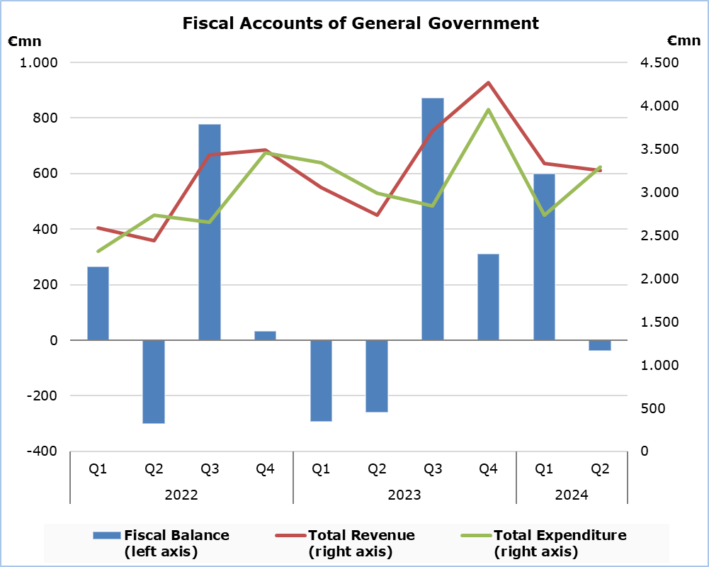

**Revenue**

During the period of April-June 2024, total revenue increased by €523,2 mn (+19,2%) and amounted to €3.252,6 mn, compared to €2.729,4 mn in the corresponding period 2023.

In detail, taxes on production and imports increased by €173,6 mn (+17,4%) and amounted to €1.172,5 mn, compared to €998,9 mn in the second quarter of 2023, of which net VAT revenue increased by €131,3 mn (+20,0%) and amounted to €789,0 mn, compared to €657,7 mn in the corresponding quarter of 2023. Social contributions increased by €131,2 mn (+13,5%) and amounted to €1.101,9 mn, compared to €970,7 mn in the second quarter of 2023. Revenue from taxes on income and wealth increased by €89,2 mn (+21,3%) and amounted to €507,1 mn, compared to €417,9 mn in the corresponding quarter of 2023. Revenue from the sale of goods and services increased by €47,9 mn (+26,7%) and amounted to €227,0 mn, compared to €179,2 mn in the second quarter of 2023. Capital transfers increased by €2,4 mn (+4,5%) and amounted to €56,1 mn, compared to €53,7 mn in the corresponding quarter of 2023. Property income receivable increased by €17,1 mn (+62,2%) and amounted to €44,6 mn, compared to €27,5 mn in the second quarter of 2023. Other current transfers increased by €61,8 mn (+75,8%) and amounted to €143,4 mn, compared to €81,6 mn in the corresponding quarter of 2023.

**Expenditure**

During the period of April-June 2024, total expenditure increased by €301,4 mn (+10,1%) and amounted to €3.291,6 mn, from €2.990,2 mn in the corresponding period of 2023.

Specifically, social transfers increased by €108,5 mn (+8,4%) and amounted to €1.402,4 mn, compared to €1.293,9 mn in the second quarter of 2023. Compensation of employees (including imputed social contributions and pensions of civil servants) increased by €58,0 mn (+6,9%) and amounted to €899,7mn, compared to €841,7 mn in the corresponding quarter of 2023. Other current expenditure increased by €68,3 mn (+48,0%) and amounted to €225,1 mn, compared to €142,3 mn in the second quarter of 2023. Intermediate consumption increased by €11,2 mn (+3,8%) and amounted to €310,2 mn, compared to €299,0 mn in the corresponding quarter of 2023. Property income payable increased by €48,4 mn (+38,8%) and amounted to €172,9 mn, compared to €124,5 mn in the second quarter of 2023.

The capital account increased by €22,0 mn (+9,6%) and amounted to €250,6 mn (€201,5 mn capital formation and €49,1 mn capital transfers), compared to €228,6 mn (€184,0 mn capital formation and €44,6 mn capital transfers) in the corresponding quarter of 2023.

On the contrary, subsidies decreased by €29,5 mn (-49,0%) to €30,7 mn, from €60,2 mn in the second quarter of 2023.

|  |  |  |  |  |  |
| --- | --- | --- | --- | --- | --- |
| **Table** |  |  |  |  |  |
| **Macroeconomic Aggregates of General Government** | **Euro (million)** | | |  | **Change** |
| **Fiscal Results** | | **Difference** |  | **(%)** |
| **Q2**  **2023** | **Q2**  **2024** | **Q2 2024/23** |  | **Q2 2024/23** |
| **Total Revenue** | **2.729,4** | **3.252,6** | **523,2** |  | **19,2** |
| Taxes on Production and Imports | 998,9 | 1.172,5 | 173,6 |  | 17,4 |
| *of which VAT* | 657,7 | 789,0 | 131,3 |  | 20,0 |
| Current Taxes on Income and Wealth, etc | 417,9 | 507,1 | 89,2 |  | 21,3 |
| Social Contributions | 970,7 | 1.101,9 | 131,2 |  | 13,5 |
| Other Current Resources | 288,2 | 415,0 | 126,8 |  | 44,0 |
| Property income receivable | 27,5 | 44,6 | 17,1 |  | 62,2 |
| Current transfers | 81,6 | 143,4 | 61,8 |  | 75,8 |
| Sales | 179,2 | 227,0 | 47,9 |  | 26,7 |
| Capital Transfers Received | 53,7 | 56,1 | 2,4 |  | 4,5 |
| **Total Expenditure** | **2.990,2** | **3.291,6** | **301,4** |  | **10,1** |
| Total Current Expenditure | 2.761,5 | 3.041,0 | 265,0 |  | 9,6 |
| Intermediate consumption | 299,0 | 310,2 | 11,2 |  | 3,8 |
| Compensation of employees | 841,7 | 899,7 | 58,0 |  | 6,9 |
| Social transfers | 1.293,9 | 1.402,4 | 108,5 |  | 8,4 |
| Property income payable | 124,5 | 172,9 | 48,4 |  | 38,8 |
| Subsidies | 60,2 | 30,7 | -29,5 |  | -49,0 |
| Other current expenditure | 142,3 | 225,1 | 68,3 |  | 48,0 |
| Total Capital Expenditure | 228,6 | 250,6 | 22,0 |  | 9,6 |
| Gross capital formation | 184,0 | 201,5 | 17,5 |  | 9,5 |
| Other capital expenditure | 44,6 | 49,1 | 4,5 |  | 10,1 |
| **Net Lending (+)/ Borrowing (-)** | **-260,8** | **-39,0** | **221,8** |  |  |
| % of GDP | -0,8% | -0,1% |  |  |  |

**METHODOLOGICAL INFORMATION**

**Data Coverage and Methodology**

Information is provided for the whole sequence of accounts for the General Government sector. The revenue and expenditure are analyzed by category and these are classified between current and capital, respectively.

The categories of revenue and expenditure for General Government cover all the subsectors of the General Government based on the European System of Accounts 2010 (ESA 2010).

**Source of Data**

The data is collected from:

- Financial Information Management Automation System (FIMAS) for Central Government, Extra Budgetary Funds and Social Security Funds,

- Budget execution of Municipalities and Communities,

- Budget execution of Semi-Government Organizations.

For the completion of the estimates, any methodological adjustments or corrections based on the European System of Accounts 2010 (ESA 2010) are taken into account.

***For more information:***

CYSTAT Portal, subtheme [Public Finance](https://www.cystat.gov.cy/en/SubthemeStatistics?id=48)

[CYSTAT-DB](https://cystatdb.cystat.gov.cy/pxweb/en/8.CYSTAT-DB/8.CYSTAT-DB__Public%20Finance__) (Online Database)

[Predefined Tables](https://www.cystat.gov.cy/en/KeyFiguresList?s=48) (Excel)

[Methodological Information](https://www.cystat.gov.cy/en/MethodologicalDetails?m=2216)

**The Predefined Tables, available in Excel format, include data up to the first quarter of 2023. Data from the second quarter of 2023 onwards will be available only in the CYSTAT-DB Online**

**Database.**

*Contact*

Michael Panayiota: Τel: +35722602186, Email: [pmichael@cystat.mof.gov.cy](mailto:pmichael@cystat.mof.gov.cy)