9 June, 2026

PRESS RELEASE

FOREIGN TRADE STATISTICS:
MARCH 2026 (FINAL DATA) AND APRIL 2026
(PROVISIONAL DATA)

April 2026, Provisional Data

Total imports of goods in April 2026 were €1.370,7 mn as compared to €1.190,7 mn in April 2025, recording an increase of 15,1% (Table). Imports from other EU Member States were €645,3 mn and from third countries €725,4 mn, compared to €740,8 mn and €449,9 mn respectively in April 2025 (Figure 1). Imports in April 2026 include the transfer of economic ownership of vessels, with a total value of €240,4 mn, compared with €100,4 mn in April 2025.

Total exports of goods in April 2026 were €363,6 mn as compared to €393,6 mn in April 2025, recording a decrease of 7,6% (Table). Exports to other EU Member States were €119,6 mn and to third countries €244,0 mn, compared to €109,2 mn and €284,4 mn respectively in April 2025 (Figure 1). Exports in April 2026 include the transfer of economic ownership of vessels, with a total value of €33,8 mn, compared with €32,8 mn in April 2025.

Total imports of goods in January-April 2026 amounted to €4.697,0 mn as compared to €4.483,1 mn in January–April 2025, recording an increase of 4,8%. Total exports of goods in January-April 2026 were €1.639,9 mn compared to €1.808,5 mn in January-April 2025, registering a decrease of 9,3%. The trade deficit was €3.057,1 mn in January–April 2026 compared to €2.674,6 mn in the corresponding period of 2025.

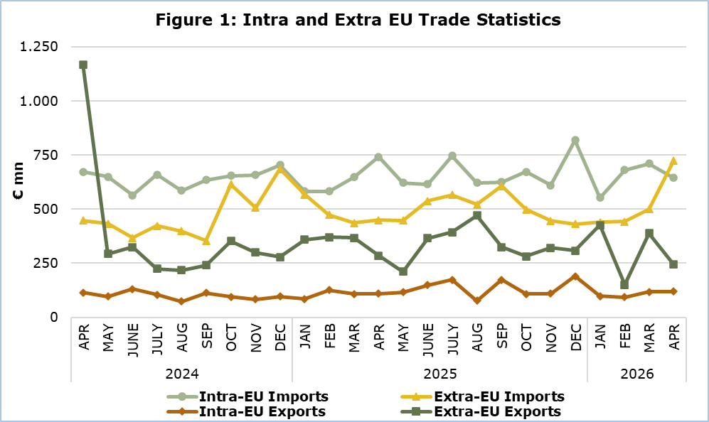

March 2026, Final Data

Total imports of goods amounted to €1.211,1 mn in March 2026, compared with €1.084,8 mn in March 2025, recording an increase of 11,6%. (Table)

Exports of domestically produced products, including stores and provisions for ships and aircraft, were €368,2 mn in March 2026 as compared to €284,8 mn in March 2025, recording an increase of 29,3%.

Domestic exports of industrial products, excluding stores and provisions for ships and aircraft, were €352,4 mn in March 2026 compared to €273,0 mn in March 2025. Domestic exports of agricultural products, excluding stores and provisions for ships and aircraft, were €14,7 mn in March 2026 compared to €11,0 mn in March 2025.

Exports of foreign products, including stores and provisions for ships and aircraft, were €137,8 mn in March 2026 as compared to €190,2 mn in March 2025, recording a decrease of 27,5%.

Main categories of exports of domestically produced goods for the period January-March 2026 (excl. stores and provisions for ships and aircraft) were mineral fuels and oils with value €424,7 mn, pharmaceutical products with €94,8 mn and halloumi cheese with €91,7 mn. (Figure 2)

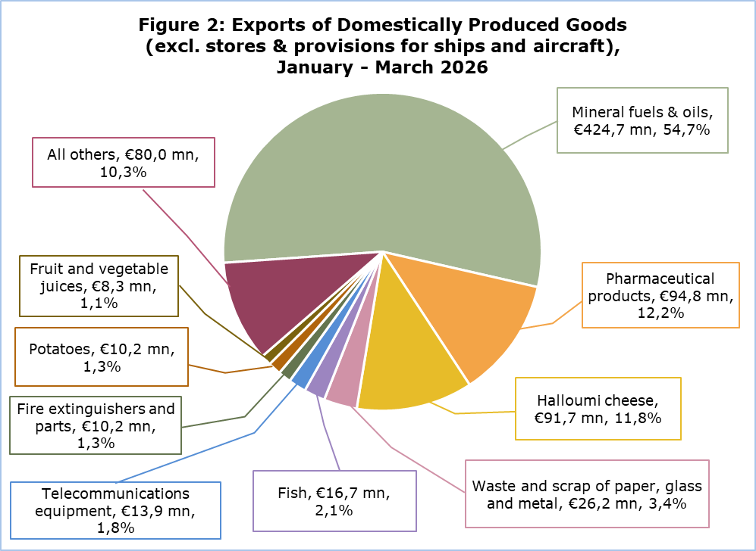
Note: Category ‘Mineral fuels & Oils’ refers to products that were initially imported, processed and then re-exported.

Table
Year and Month | Total Imports | Total Exports
Year and Month | €000’s | €000’s
2026
April | 1.370.679 | 363.647
March | 1.211.089 | 506.052
February | 1.122.652 | 244.829
January | 992.580 | 525.333
2025 | 13.866.998 | 5.580.995
December | 1.249.292 | 498.431
November | 1.055.145 | 430.761
October | 1.170.809 | 390.538
September | 1.231.616 | 497.383
August | 1.143.895 | 546.556
July | 1.310.875 | 567.063
June | 1.152.240 | 514.112
May | 1.070.065 | 327.648
April | 1.190.717 | 393.553
March | 1.084.757 | 475.020
February | 1.056.396 | 496.220
January | 1.151.189 | 443.712
Note: Imports and exports data for the months February and March 2026 have been revised. Data for April 2026 are provisional.

METHODOLOGICAL INFORMATION

Statistical Value

The statistical value is the value of the goods at the time and place they cross the border of Cyprus.

Domestic and Foreign Goods

Domestically produced goods are goods wholly obtained in Cyprus or goods produced in another country but their last economically substantial processing or processing that led to the manufacture of a new product or representing an important stage of manufacture, took place in Cyprus. Goods that were originally imported and have undergone repair or other minor operations which leave them essentially unchanged are not defined as domestic.

Foreign goods are goods which were not produced in the economic territory of Cyprus and compensating goods obtained under the outward processing procedure when such processing confers foreign origin.

Partner Country

Intra-EU exports and extra-EU exports are classified by the Member State of the EU and country of final destination of the goods, respectively. The last country to which the goods are known to be specifically directed on their outward movement from the reporting country is regarded as their final destination.

For extra-EU imports, the trading partner is the country of origin. In general, goods obtained entirely from a given country originate in that country. A product in the production of which two or more countries are involved, is considered as originating in the country in which the last substantial, economically justified transformation or processing took place, resulting in the manufacture of a new product or representing an important stage of manufacture.

For intra-EU imports, the trading partner is the Member State of consignment of the goods.

The United Kingdom is considered as an extra-EU partner country for the EU. Imports from the United Kingdom are recorded by country of consignment until 31 December 2020. As of January 2021 onwards, for trade with Northern Ireland imports are recorded by country of consignment while for trade with the United Kingdom (excluding Northern Ireland) imports are recorded by country of origin. For these reasons data on trade with the United Kingdom are not fully comparable with data on trade with other extra-EU trade partners for reference periods before and after the end of 2020.

For more information:
CYSTAT Portal, subtheme External Trade
CYSTAT-DB (Online Database)
Publications
Methodological Information

Contact
Sofronis Vikis: Tel: +357 22 602206, Email: svikis@cystat.mof.gov.cy
Ioanna Leontiou: Tel: +357 22 605122, Email: ileontiou@cystat.mof.gov.cy

