10 October, 2024

PRESS RELEASE

FOREIGN TRADE STATISTICS:
JULY 2024 (FINAL DATA) AND AUGUST 2024 (PROVISIONAL DATA)

August 2024, Provisional Data

Total imports of goods in August 2024 were €948,6 mn as compared to €1.243,1 mn in August 2023, recording a decrease of 23,7%. Imports from other EU Member States were €564,8 mn and from third countries €383,8 mn, compared to €692,4 mn and €550,7 mn respectively in August 2023. Imports in August 2024 include the transfer of economic ownership of vessels and aircraft, with total value of €38,8 mn as compared to €246,7 mn in August 2023.

Total exports of goods in August 2024 were €276,4 mn as compared to €422,8 mn in August 2023, recording a decrease of 34,6%. Exports to other EU Member States were €70,0 mn and to third countries €206,4 mn, compared to €79,1 mn and €343,7 mn respectively in August 2023.

Total imports of goods in January–August 2024 amounted to €7.577,7 mn as compared to €8.968,7 mn in January–August 2023, recording a decrease of 15,5%. Total exports of goods in January-August 2024 were €2.589,8 mn compared to €2.845,2 mn in January-August 2023, registering a decrease of 9,0%. The trade deficit was €4.987,9 mn in January–August 2024 compared to €6.123,5 mn in the corresponding period of 2023.

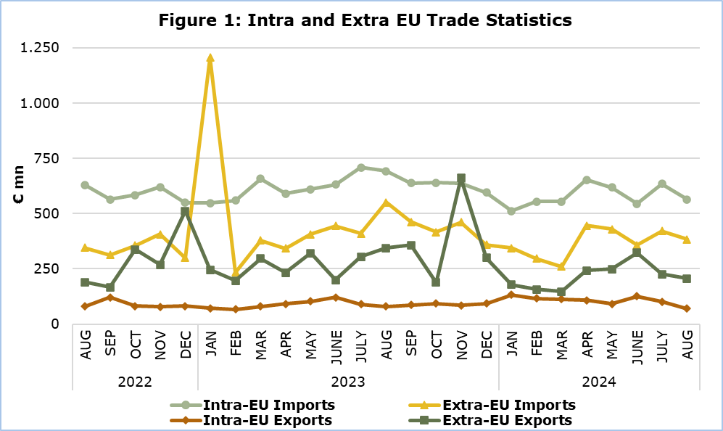

July 2024, Final Data

Total imports of goods amounted to €1.056,0 mn in July 2024 as compared to €1.117,5 mn in July 2023, recording a decrease of 5,5%.

Exports of domestically produced products, including stores and provisions, in July 2024 were €216,0 mn as compared to €227,4 mn in July 2023, recording a decrease of 5,0%. Domestic exports of industrial products in July 2024 were €207,4 mn compared to €222,6 mn in July 2023, whilst domestic exports of agricultural products in July 2024 were €7,5 mn compared to €3,6 mn in July 2023.

Exports of foreign products, including stores and provisions, in July 2024 were €111,1 mn as compared to €168,2 mn in July 2023, recording a decrease of 33,9%.

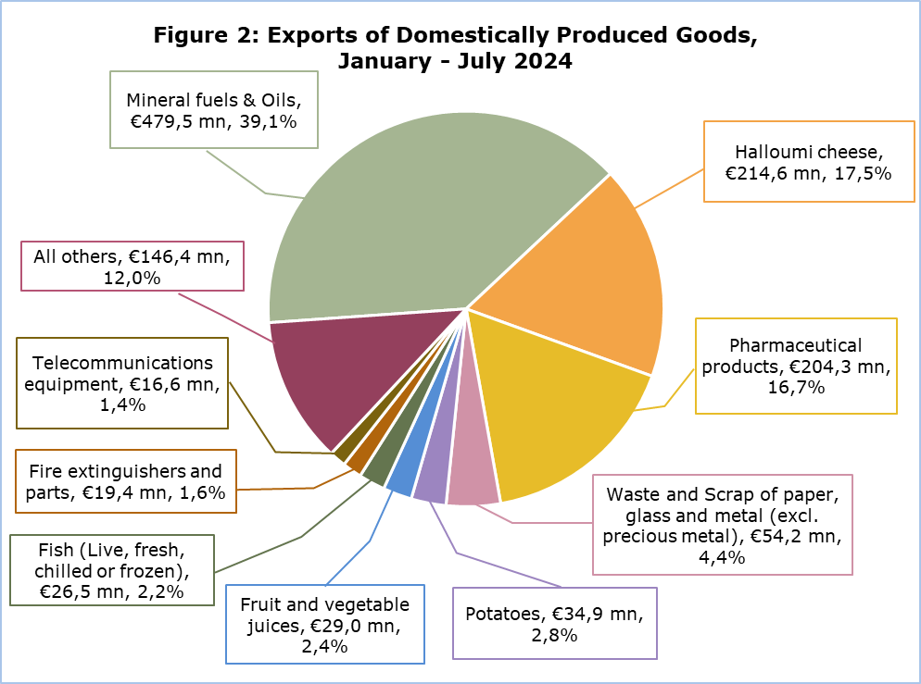

More data are published in the monthly publication ‘Intra – Extra EU Trade Statistics (Summarised Data) – July 2024’ and in the online database CYSTAT-DB, under the subtheme External Trade.

Table
Year and Month | Total Imports | Total Exports
Year and Month | €000’s | €000’s
2024
August | 948.583 | 276.398
July | 1.055.965 | 327.116
June | 901.868 | 449.378
May | 1.047.982 | 340.793
April | 1.098.529 | 350.750
March | 816.066 | 261.009
February | 852.143 | 273.236
January | 856.554 | 311.088
2023
January – December | 13.179.758 | 4.709.389
December | 954.146 | 392.429
November | 1.098.573 | 745.785
October | 1.056.959 | 281.770
September | 1.101.388 | 444.197
August | 1.243.104 | 422.799
July | 1.117.523 | 395.606
June | 1.076.567 | 321.856
May | 1.015.991 | 423.444
April | 932.823 | 324.630
March | 1.035.073 | 376.672
February | 794.000 | 262.520
January | 1.753.611 | 317.682
Note: Imports and exports data for the year 2023 have been revised. Imports data for May, June and July 2024 and exports data for June and July 2024 have been revised. Data for August 2024 are provisional.

METHODOLOGICAL INFORMATION

Statistical Value

The statistical value is the value of the goods at the time and place they cross the border of Cyprus.

Domestic and Foreign Goods

Domestically produced goods are goods wholly obtained in Cyprus or goods produced in another country but their last economically substantial processing or processing that led to the manufacture of a new product or representing an important stage of manufacture, took place in Cyprus. Goods that were originally imported and have undergone repair or other minor operations which leave them essentially unchanged are not defined as domestic.

Foreign goods are goods which were not produced in the economic territory of Cyprus and compensating goods obtained under the outward processing procedure when such processing confers foreign origin.

Partner Country

Intra-EU exports and extra-EU exports are classified by the Member State of the EU and country of final destination of the goods, respectively. The last country to which the goods are known to be specifically directed on their outward movement from the reporting country is regarded as their final destination.

For extra-EU imports, the trading partner is the country of origin. In general, goods obtained entirely from a given country originate in that country. A product in the production of which two or more countries are involved, is considered as originating in the country in which the last substantial, economically justified transformation or processing took place, resulting in the manufacture of a new product or representing an important stage of manufacture.

For intra-EU imports, the trading partner is the Member State of consignment of the goods.

The United Kingdom is considered as an extra-EU partner country for the EU. Imports from the United Kingdom are recorded by country of consignment until 31 December 2020. As of January 2021 onwards, for trade with Northern Ireland imports are recorded by country of consignment while for trade with the United Kingdom (excluding Northern Ireland) imports are recorded by country of origin. For these reasons data on trade with the United Kingdom are not fully comparable with data on trade with other extra-EU trade partners for reference periods before and after the end of 2020.

For more information:
CYSTAT Portal, subtheme External Trade
CYSTAT-DB (Online Database)
Predefined Tables (Excel)
Publications
Methodological Information

The Predefined Tables, available in Excel format, include data up to December 2022. Data from January 2023 onwards are available only in the CYSTAT-DB Online Database.

Contact
Sofronis Vikis: Tel: +357 22 602206, Email: svikis@cystat.mof.gov.cy
Ioanna Leontiou: Tel: +357 22 605122, Email: ileontiou@cystat.mof.gov.cy

