12 October, 2026

PRESS RELEASE

FOREIGN TRADE STATISTICS:
PROVISIONAL DATA FOR AUGUST 2026 AND
FINAL DATA FOR JULY 2026

August 2026, Provisional Data

Total imports of goods in August 2026 amounted to €1.324,1 mn, compared with €1.152,1 mn in August 2025, recording an increase of 14,9% (Table). Imports from other EU Member States amounted to €569,2 mn and imports from third countries to €754,9 mn, compared with €630,6 mn and €521,5 mn respectively in August 2025 (Figure 1). Imports in August 2026 include the transfer of economic ownership of vessels with a total value of €1,1 mn, compared with €55,0 mn in August 2025.

Total exports of goods in August 2026 amounted to €643,5 mn, compared with €545,9 mn in August 2025, recording an increase of 17,9% (Table). Exports to other EU Member States amounted to €106,8 mn and exports to third countries €536,7 mn, compared with €76,0 mn and €469,9 mn respectively in August 2025 (Figure 1). Exports in August 2026 include the transfer of economic ownership of vessels and aircraft with a total value of €20,8 mn, compared with €54,3 mn in August 2025.

Total imports of goods for the period January-August 2026 amounted to €10.257,0 mn, compared with €9.247,7 mn for the period January–August 2025, recording an increase of 10,9%. Total exports of goods for the period January-August 2026 amounted to €3.953,7 mn, compared with €3.764,2 mn for the period January-August 2025, recording an increase of 5,0%. The trade deficit amounted to €6.303,3 mn for the period January–August 2026, compared with €5.483,5 mn in the corresponding period of 2025.

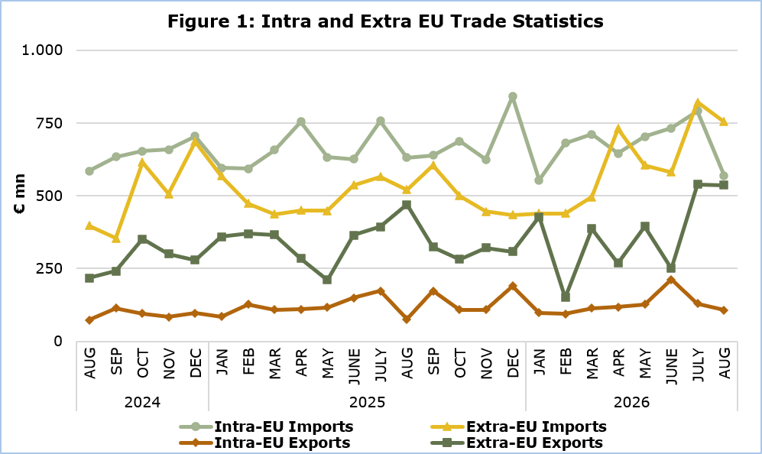

July 2026, Final Data

Total imports of goods in July 2026 amounted to €1.613,1 mn, compared with €1.322,3 mn in July 2025, recording an increase of 22,0%. (Table)

Exports of domestically produced products, including stores and provisions for ships and aircraft, amounted to €510,4 mn in July 2026 compared with €382,7 mn in July 2025, recording an increase of 33,4%.

Domestic exports of industrial products, excluding stores and provisions for ships and aircraft, amounted to €501,3 mn in July 2026 compared with €372,2 mn in July 2025. Domestic exports of agricultural products, excluding stores and provisions for ships and aircraft, amounted to €7,8 mn in July 2026 compared with €8,7 mn in July 2025.

Exports of foreign products, including stores and provisions for ships and aircraft, amounted to €159,0 mn in July 2026 compared with €184,2 mn in July 2025, recording a decrease of 13,7%.

Main categories of exports of domestically produced goods for the period January-July 2026 (excluding stores and provisions for ships and aircraft) were mineral fuels and oils with a value of €1.250,5 mn, halloumi cheese with €233,4 mn and pharmaceutical products valued at €208,4 mn. (Figure 2)

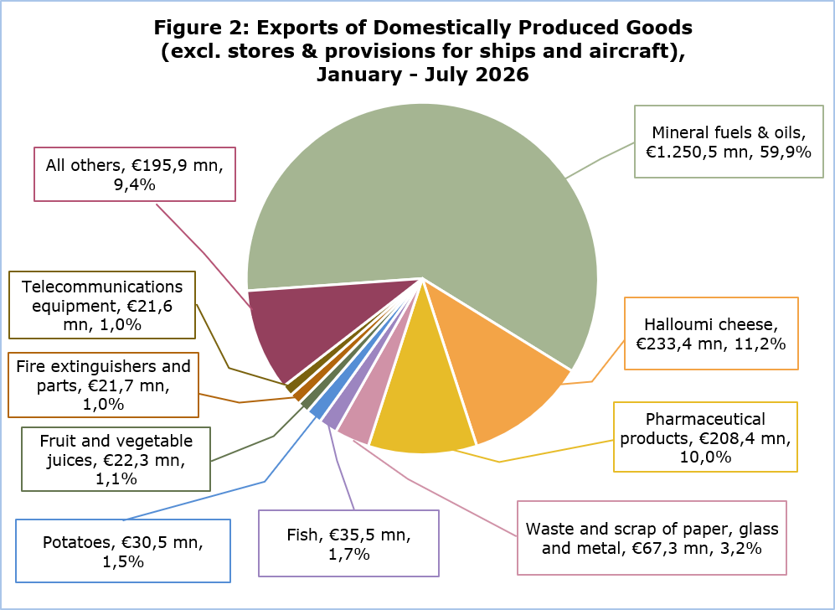
Note: Category ‘Mineral fuels & Oils’ refers to products that were initially imported, processed and then re-exported.

Table
Year and Month | Total Imports | Total Exports
Year and Month | €000’s | €000’s
2026
August | 1.324.056 | 643.507
July | 1.613.100 | 669.457
June | 1.312.651 | 463.264
May | 1.309.352 | 521.996
April | 1.376.686 | 385.661
March | 1.207.683 | 500.550
February | 1.120.333 | 243.866
January | 993.148 | 525.386
2025 | 14.025.144 | 5.580.253
December | 1.276.064 | 498.418
November | 1.069.790 | 430.498
October | 1.187.374 | 390.514
September | 1.244.242 | 496.649
August | 1.152.147 | 545.895
July | 1.322.313 | 566.895
June | 1.163.029 | 513.845
May | 1.081.317 | 327.405
April | 1.203.995 | 393.772
March | 1.094.944 | 475.120
February | 1.066.481 | 496.501
January | 1.163.447 | 444.741
Note: Imports data for the year 2025 and for January, June and July 2026 and exports data for the year 2025 and for January, February, June and July 2026 have been revised. Data for August 2026 are provisional.

METHODOLOGICAL INFORMATION

Statistical Value

The statistical value is the value of the goods at the time and place they cross the border of Cyprus.

Domestic and Foreign Goods

Domestically produced goods are goods wholly obtained in Cyprus or goods produced in another country but their last economically substantial processing or processing that led to the manufacture of a new product or representing an important stage of manufacture, took place in Cyprus. Goods that were originally imported and have undergone repair or other minor operations which leave them essentially unchanged are not defined as domestic.

Foreign goods are goods which were not produced in the economic territory of Cyprus and compensating goods obtained under the outward processing procedure when such processing confers foreign origin.

Partner Country

Intra-EU exports and extra-EU exports are classified by the Member State of the EU and country of final destination of the goods, respectively. The last country to which the goods are known to be specifically directed on their outward movement from the reporting country is regarded as their final destination.

For extra-EU imports, the trading partner is the country of origin. In general, goods obtained entirely from a given country originate in that country. A product whose production involves two or more countries, is considered as originating in the country in which the last substantial, economically justified transformation or processing took place, resulting in the manufacture of a new product or representing an important stage of manufacture.

For intra-EU imports, the trading partner is the Member State of consignment of the goods.

The United Kingdom is considered as an extra-EU partner country for the EU. Imports from the United Kingdom are recorded by country of consignment until 31 December 2020. From January 2021onwards, for trade with Northern Ireland imports are recorded by country of consignment while for trade with the United Kingdom (excluding Northern Ireland) imports are recorded by country of origin. For these reasons, data on trade with the United Kingdom are not fully comparable with data on trade with other extra-EU trade partners for reference periods before and after the end of 2020.

For more information:
CYSTAT Portal, subtheme External Trade
CYSTAT-DB (Online Database)
Publications
Methodological Information

Contact
Sofronis Vikis: Tel: +357 22 602206, Email: svikis@cystat.mof.gov.cy
Ioanna Leontiou: Tel: +357 22 605122, Email: ileontiou@cystat.mof.gov.cy

