10 December, 2024

**PRESS RELEASE**

**FOREIGN TRADE STATISTICS:**

**SEPTEMBER 2024 (FINAL DATA) AND OCTOBER 2024**

**(PROVISIONAL DATA)**

**October 2024, Provisional Data**

**Total imports of goods in October 2024 were €1.209,9 mn** as compared to €1.057,0 mn in October 2023, recording an increase of 14,5%. Imports from other EU Member States were €615,7 mn and from third countries €594,1 mn, compared to €640,2 mn and €416,7 mn respectively in October 2023. Imports in October 2024 include the transfer of economic ownership of vessels, with total value of €63,3 mn as compared to €21,6 mn in October 2023.

**Total exports of goods in October 2024 were €442,3 mn** as compared to €281,8 mn in October 2023, recording an increase of 57,0%. Exports to other EU Member States were €90,7 mn and to third countries €351,6 mn, compared to €93,8 mn and €187,9 mn respectively in October 2023. Exports in October 2024 include the transfer of economic ownership of vessels, with total value of €53,0 mn as compared to €4,8 mn in October 2023.

**Total imports of goods in January–October 2024 amounted to €9.758,1 mn** as compared to €11.127,0 mn in January–October 2023, recording a decrease of 12,3%. **Total exports of goods in January-October 2024 were €3.383,7 mn** compared to €3.571,2 mn in January-October 2023, registering a decrease of 5,3%. **The trade deficit was €6.374,4 mn in January–October 2024** compared to €7.555,9 mn in the corresponding period of 2023.

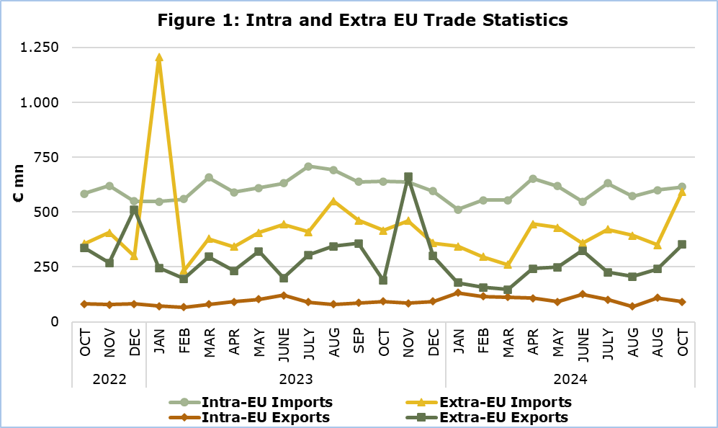

**September 2024, Final Data**

**Total imports of goods amounted to €951,9 mn in September 2024** as compared to €1.101,4 mn in September 2023, recording a decrease of 13,6%.

**Exports of domestically produced products, including stores and provisions, in September 2024 were €205,9 mn** as compared to €355,3 mn in September 2023, recording a decrease of 42,0%. Domestic exports of industrial products in September 2024 were €198,0 mn compared to €349,2 mn in September 2023, whilst domestic exports of agricultural products in September 2024 were €6,8 mn compared to €4,8 mn in September 2023.

**Exports of foreign products, including stores and provisions, in September 2024 were €144,3 mn** as compared to €88,9 mn in September 2023, recording an increase of 62,3%.

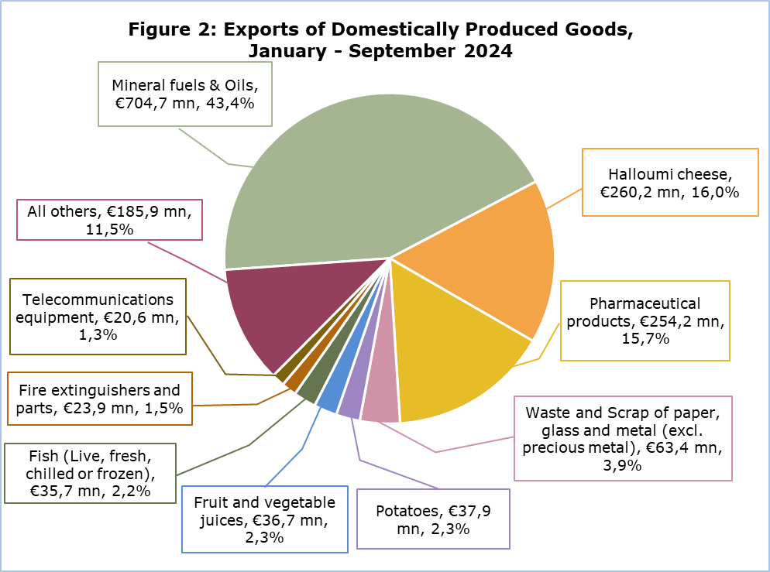

More data are published in the monthly publication ‘Intra – Extra EU Trade Statistics (Summarised Data) – September 2024’ and in the online database CYSTAT-DB, under the subtheme External Trade.

|  |  |  |
| --- | --- | --- |
| **Table** | | |
| **Year and Month** | **Total Imports** | **Total Exports** |
| **€000’s** | **€000’s** |
| **2024** |  |  |
| October | 1.209.853 | 442.343 |
| September | 951.916 | 350.178 |
| August | 966.550 | 276.716 |
| July | 1.052.834 | 327.116 |
| June | 905.628 | 450.447 |
| May | 1.047.982 | 340.793 |
| April | 1.098.529 | 350.750 |
| March | 816.066 | 261.009 |
| February | 852.143 | 273.236 |
| January | 856.554 | 311.088 |
| **2023** |  |  |
| **January – December** | **13.179.758** | **4.709.389** |
| December | 954.146 | 392.429 |
| November | 1.098.573 | 745.785 |
| October | 1.056.959 | 281.770 |
| September | 1.101.388 | 444.197 |
| August | 1.243.104 | 422.799 |
| July | 1.117.523 | 395.606 |
| June | 1.076.567 | 321.856 |
| May | 1.015.991 | 423.444 |
| April | 932.823 | 324.630 |
| March | 1.035.073 | 376.672 |
| February | 794.000 | 262.520 |
| January | 1.753.611 | 317.682 |
| Note: Imports data for June, August and September 2024 have been revised. Data for October 2024 are provisional. | | |

**METHODOLOGICAL INFORMATION**

**Statistical Value**

The statistical value is the value of the goods at the time and place they cross the border of Cyprus.

**Domestic and Foreign Goods**

**Domestically produced goods** are goods wholly obtained in Cyprus or goods produced in another country but their last economically substantial processing or processing that led to the manufacture of a new product or representing an important stage of manufacture, took place in Cyprus. Goods that were originally imported and have undergone repair or other minor operations which leave them essentially unchanged are not defined as domestic.

**Foreign goods** are goods which were not produced in the economic territory of Cyprus and compensating goods obtained under the outward processing procedure when such processing confers foreign origin.

**Partner Country**

**Intra-EU exports** and **extra-EU exports** are classified by the Member State of the EU and country of final destination of the goods, respectively. The last country to which the goods are known to be specifically directed on their outward movement from the reporting country is regarded as their final destination.

For **extra-EU imports**, the trading partner is the country of origin. In general, goods obtained entirely from a given country originate in that country. A product in the production of which two or more countries are involved, is considered as originating in the country in which the last substantial, economically justified transformation or processing took place, resulting in the manufacture of a new product or representing an important stage of manufacture.

For **intra-EU imports**, the trading partner is the Member State of consignment of the goods.

The United Kingdom is considered as an extra-EU partner country for the EU. Imports from the United Kingdom are recorded by country of consignment until 31 December 2020. As of January 2021 onwards, for trade with Northern Ireland imports are recorded by country of consignment while for trade with the United Kingdom (excluding Northern Ireland) imports are recorded by country of origin. For these reasons data on trade with the United Kingdom are not fully comparable with data on trade with other extra-EU trade partners for reference periods before and after the end of 2020.

***For more information:***

CYSTAT Portal, subtheme [External Trade](https://www.cystat.gov.cy/en/SubthemeStatistics?s=36)

[CYSTAT-DB](https://cystatdb.cystat.gov.cy/pxweb/en/8.CYSTAT-DB/8.CYSTAT-DB__External%20Trade__) (Online Database)

[Predefined Tables](https://www.cystat.gov.cy/en/KeyFiguresList?s=36) (Excel)

[Publications](https://www.cystat.gov.cy/en/PublicationList?s=36)

[Methodological Information](https://www.cystat.gov.cy/en/MethodologicalDetails?m=2190" \o "Methodological Information - External Trade" \t "_blank)

**The Predefined Tables, available in Excel format, include data up to December 2022. Data from January 2023 onwards are available only in the CYSTAT-DB Online Database.**

*Contact*  
Sofronis Vikis: Tel: +357 22 602206, Email: [svikis@cystat.mof.gov.cy](mailto:svikis@cystat.mof.gov.cy)

Ioanna Leontiou: Tel: +357 22 605122, Email: ileontiou@cystat.mof.gov.cy