10 December, 2025

PRESS RELEASE

FOREIGN TRADE STATISTICS:
SEPTEMBER 2025 (FINAL DATA) AND OCTOBER 2025
(PROVISIONAL DATA)

October 2025, Provisional Data

Total imports of goods in October 2025 were €1.153,3 mn as compared to €1.266,5 mn in October 2024, recording a decrease of 8,9%. Imports from other EU Member States were €654,8 mn and from third countries €498,5 mn, compared to €653,2 mn and €613,3 mn respectively in October 2024. Imports in October 2025 include the transfer of economic ownership of vessels, with total value of €106,5 mn as compared to €82,5 mn in October 2024. (Table)

Total exports of goods in October 2025 were €388,9 mn as compared to €446,8 mn in October 2024, recording a decrease of 13,0%. Exports to other EU Member States were €108,6 mn and to third countries €280,3 mn, compared to €95,2 mn and €351,6 mn respectively in October 2024. Exports in October 2025 include the transfer of economic ownership of vessels, with total value of €46,1 mn as compared to €52,9 mn in October 2024. (Table)

Total imports of goods in January–October 2025 amounted to €11.270,8 mn as compared to €10.034,5 mn in January–October 2024, recording an increase of 12,3%. Total exports of goods in January-October 2025 were €4.616,1 mn compared to €4.427,8 mn in January-October 2024, registering an increase of 4,3%. The trade deficit was €6.654,7 mn in January–October 2025 compared to €5.606,7 mn in the corresponding period of 2024.

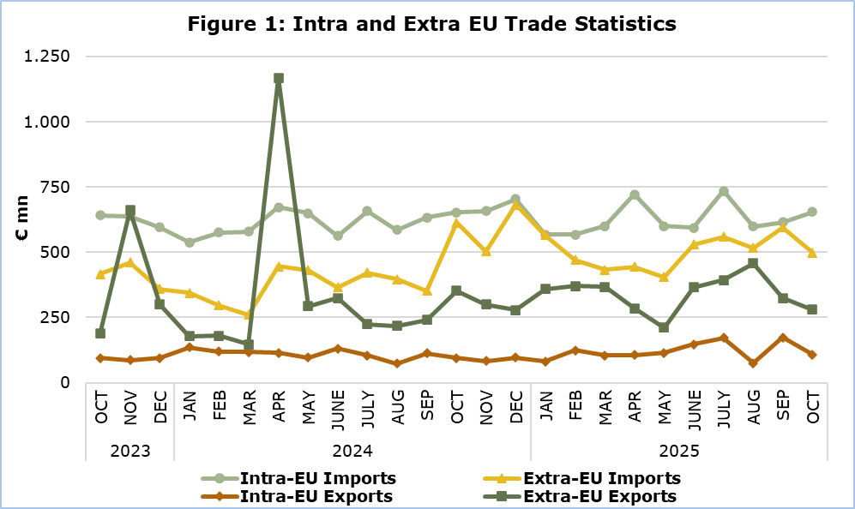

September 2025, Final Data

Total imports of goods amounted to €1.211,0 mn in September 2025 as compared to €986,3 mn in September 2024, recording an increase of 22,8%. (Table)

Exports of domestically produced products, including stores and provisions for ships and aircraft, were €300,2 mn in September 2025 as compared to €207,3 mn in September 2024, recording an increase of 44,8%.

Domestic exports of industrial products, excluding stores and provisions for ships and aircraft, were €291,9 mn in September 2025 compared to €199,3 mn in September 2024. Domestic exports of agricultural products, excluding stores and provisions for ships and aircraft, were €7,1 mn in September 2025 compared to €6,8 mn in September 2024.

Exports of foreign products, including stores and provisions for ships and aircraft, were €197,6 mn in September 2025 as compared to €146,8 mn in September 2024, recording an increase of 34,6%.

Main categories of exports of domestically produced goods for the period January-September 2025 (excl. stores and provisions for ships and aircraft), were mineral fuels and oils with value €1.859,4 mn, halloumi cheese with €288,3 mn and pharmaceutical products with €259,5 mn. (Figure 2)

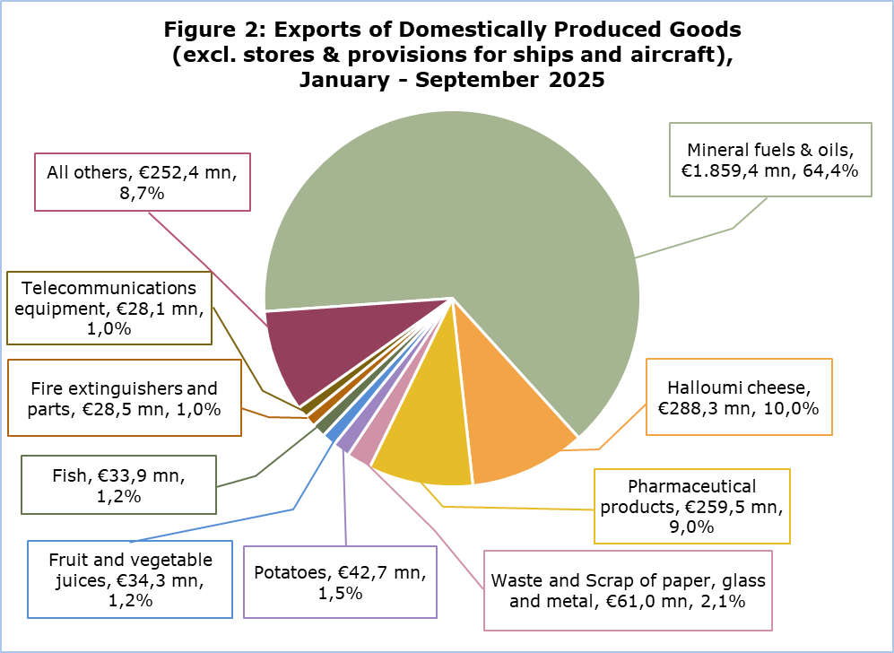
Note: Category ‘Mineral fuels & Oils’ refers to products that were initially imported, processed and then re-exported.

More data are published in the monthly publication ‘Intra – Extra EU Trade Statistics (Summarised Data) – September 2025’ and in the online database CYSTAT-DB, under the subtheme External Trade.

Table
Year and Month | Total Imports | Total Exports
Year and Month | €000’s | €000’s
2025
October | 1.153.326 | 388.897
September | 1.210.988 | 497.788
August | 1.116.094 | 531.534
July | 1.293.184 | 564.966
June | 1.122.812 | 511.548
May | 1.005.415 | 325.003
April | 1.165.181 | 390.694
March | 1.032.158 | 471.661
February | 1.037.789 | 493.486
January | 1.133.873 | 440.555
2024 | 12.582.032 | 5.186.705
December | 1.386.142 | 375.954
November | 1.161.405 | 382.918
October | 1.266.524 | 446.841
September | 986.307 | 354.099
August | 981.822 | 290.832
July | 1.079.358 | 329.215
June | 928.681 | 455.042
May | 1.079.917 | 389.891
April | 1.117.885 | 1.282.749
March | 839.685 | 264.824
February | 871.977 | 299.823
January | 882.327 | 314.518
Note: Imports data for the months July, August and September 2025 and exports data for September 2025 have been revised. Data for October 2025 are provisional.

METHODOLOGICAL INFORMATION

Statistical Value

The statistical value is the value of the goods at the time and place they cross the border of Cyprus.

Domestic and Foreign Goods

Domestically produced goods are goods wholly obtained in Cyprus or goods produced in another country but their last economically substantial processing or processing that led to the manufacture of a new product or representing an important stage of manufacture, took place in Cyprus. Goods that were originally imported and have undergone repair or other minor operations which leave them essentially unchanged are not defined as domestic.

Foreign goods are goods which were not produced in the economic territory of Cyprus and compensating goods obtained under the outward processing procedure when such processing confers foreign origin.

Partner Country

Intra-EU exports and extra-EU exports are classified by the Member State of the EU and country of final destination of the goods, respectively. The last country to which the goods are known to be specifically directed on their outward movement from the reporting country is regarded as their final destination.

For extra-EU imports, the trading partner is the country of origin. In general, goods obtained entirely from a given country originate in that country. A product in the production of which two or more countries are involved, is considered as originating in the country in which the last substantial, economically justified transformation or processing took place, resulting in the manufacture of a new product or representing an important stage of manufacture.

For intra-EU imports, the trading partner is the Member State of consignment of the goods.

The United Kingdom is considered as an extra-EU partner country for the EU. Imports from the United Kingdom are recorded by country of consignment until 31 December 2020. As of January 2021 onwards, for trade with Northern Ireland imports are recorded by country of consignment while for trade with the United Kingdom (excluding Northern Ireland) imports are recorded by country of origin. For these reasons data on trade with the United Kingdom are not fully comparable with data on trade with other extra-EU trade partners for reference periods before and after the end of 2020.

For more information:
CYSTAT Portal, subtheme External Trade
CYSTAT-DB (Online Database)
Publications
Methodological Information

Contact
Sofronis Vikis: Tel: +357 22 602206, Email: svikis@cystat.mof.gov.cy
Ioanna Leontiou: Tel: +357 22 605122, Email: ileontiou@cystat.mof.gov.cy

