15 May, 2025

**PRESS RELEASE**

GDP GROWTH RATE: **1st QUARTER 2025** (FLASH ESTIMATE)

**Growth Rate 3,0%**

The GDP growth rate in real terms during the first quarter of 2025 is positive and it is estimated at 3,0% over the corresponding quarter of 2024. Based on seasonally and working day adjusted data, GDP growth rate in real terms is estimated at 3,0%.

The positive GDP growth rate is mainly attributed to the sectors: "Wholesale and Retail Trade, Repair of Motor Vehicles", "Information and Communication", "Construction" and "Hotels and Restaurants".

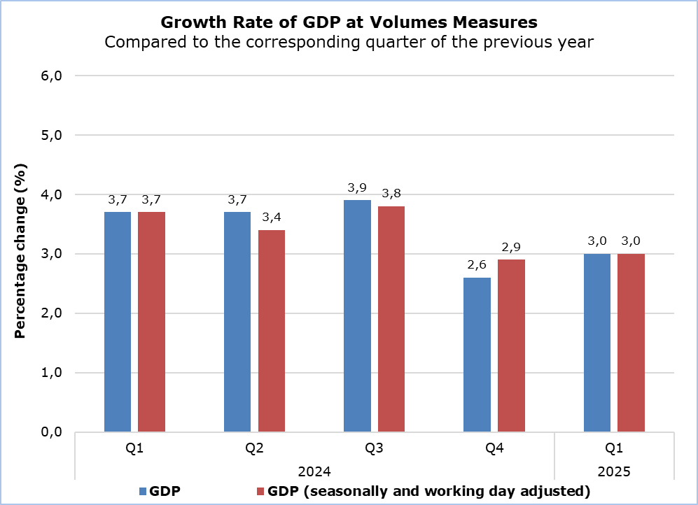

|  |  |  |  |  |  |
| --- | --- | --- | --- | --- | --- |
| **Table** |  |  |  |  | |
| **YEAR** | **QUARTER** | **Gross Domestic Product (GDP)** |  | **GDP Seasonally and Working Day Adjusted)** | |
| Compared to the Same Quarter of the Previous Year  (% change) |  | Compared to the Previous Quarter  (% change) | Compared to the Same Quarter of the Previous Year  (% change) |
| **2024** | 1st Quarter | 3,7 |  | 1,2 | 3,7 |
|  | 2nd Quarter | 3,7 |  | 0,3 | 3,4 |
|  | 3rd Quarter | 3,9 |  | 1,1 | 3,8 |
|  | 4th Quarter | 2,6 |  | 0,2 | 2,9 |
| **2025** | **1st Quarter** | **3,0** |  | **1,3** | **3,0** |
|  |  |  |  |  |  |

**METHODOLOGICAL INFORMATION**

**Scope**

The scope of GDP Flash estimate is to provide an early picture of the overall development of Cyprus economy based on preliminary data, 45 days after the end of the quarter, by using less input information available compared to the one used for the regular Quarterly National Accounts (QNA) estimation at t+2 months.

**Compilation and Methodology**

QNA are generally constructed using an indirect approach, which is based on short-term indicators providing information on the evolution of the phenomena under study. Furthermore, Chow-Lin’s approach technique is used for temporal disaggregation.

The GDP level in Cyprus is determined from the production and expenditure approaches, while the income approach is considered a residual item.

QNA are produced at current, volume and previous-year-prices, published and transmitted to Eurostat at t+2 months. The flash estimate is obtained by running the same estimation procedure as the one applied for the t+2 months calculation however, with less input information available. It is calculated in volume terms at t+45 days, published and transmitted to Eurostat as well.

QNA are compiled in accordance with the European System of Accounts (ESA 2010) as defined in Regulation (EU) No 549/2013 of the European Parliament and of the Council of 21 May 2013.

**Source of Data**

In order to produce QNA estimates, the following data are used as input to the system of calculation:

- short-term economic indicators by activity,

- administrative data,

- quarterly employment data,

- price indices.

***For more information:***

CYSTAT Portal, subtheme [National Accounts](https://www.cystat.gov.cy/en/SubthemeStatistics?s=45)

[CYSTAT-DB](https://cystatdb.cystat.gov.cy/pxweb/en/8.CYSTAT-DB/8.CYSTAT-DB__National%20Accounts__) (Online Database)

[Predefined Tables](https://www.cystat.gov.cy/en/KeyFiguresList?s=45) (Excel)

**The Predefined Tables, available in Excel format, include data up to the fourth quarter of 2022. Data from the first quarter of 2023 onwards will be available only in the CYSTAT-DB Online Database.**

*Contact*

Constantinou Maria: Τel: +35722602226, Email: [mconstantinou@cystat.mof.gov.cy](mailto:mconstantinou@cystat.mof.gov.cy)