11 August, 2025

**PRESS RELEASE**

###### GOVERNMENT EMPLOYMENT BY CATEGORY: JULY 2025

**Total Employment: 53.447**

In July 2025, total government employment reached 53.447 persons, an increase of 408 individuals (0,8%) compared to June 2024. Employment in the Civil Service and in the Security Forces declined by 0,5% and 1,3% respectively, while employment in the Educational Service rose by 4,6%.

Compared to July 2024, the main increase is observed in the number of employees with contracts of definite duration (9,8%), with the highest percentage increase for this category observed in the Educational Service (14,3%). The main decrease is observed in the number of employees with contracts of indefinite duration (-6,1%), with the largest percentage decrease for this category observed in the Educational Service (-20,5%).

For the period January –July 2025 the average total government employment increased by 0,9% compared to the corresponding period of 2024.

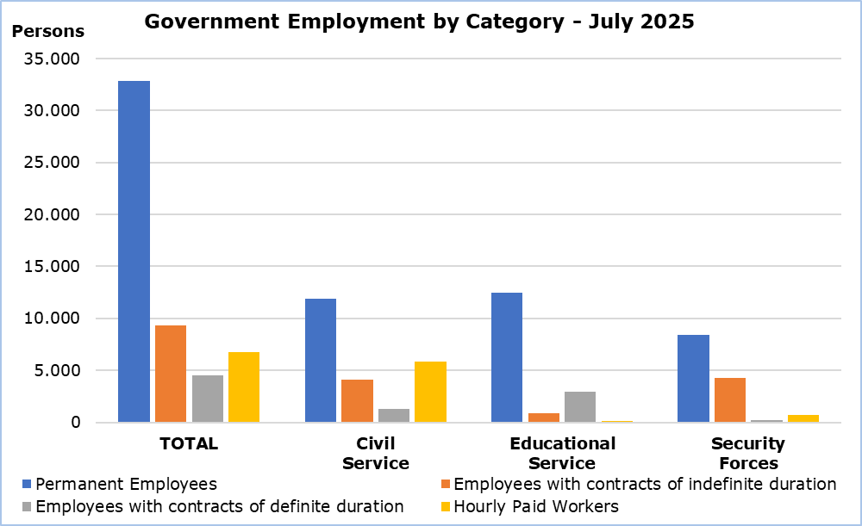

|  |  |  |  |  |  |  |
| --- | --- | --- | --- | --- | --- | --- |
| **Table** |  |  |  |  |  |  |
| **Personnel Category** | | **Number of Persons** | |  | **Change (%)** | |
| **July**  **2024** | **July**  **2025** |  | **July 25/ July 24** | **Jan–Jul 25/ Jan-Jul 24** |
| **Civil Service** | **Total** | **23.333** | **23.208** |  | **-0,5** | **-0,2** |
| Permanent Employees | 12.032 | 11.931 |  | -0,8 | -0,6 |
| Employees with contracts of indefinite duration | 4.235 | 4.117 |  | -2,8 | -2,7 |
| Employees with contracts of definite duration | 1.231 | 1.312 |  | 6,6 | 11,8 |
| Hourly Paid Workers | 5.835 | 5.848 |  | 0,2 | 0,0 |
| **Educational**  **Service** | **Total** | **15.780** | **16.501** |  | **4,6** | **3,8** |
| Permanent Employees | 11.888 | 12.470 |  | 4,9 | 4,8 |
| Employees with contracts of indefinite duration | 1.158 | 921 |  | -20,5 | -20,3 |
| Employees with contracts of definite duration | 2.593 | 2.965 |  | 14,3 | 8,4 |
| Hourly Paid Workers | 141 | 145 |  | 2,8 | -5,7 |
| **Security**  **Forces** | **Total** | **13.926** | **13.738** |  | **-1,3** | **-1,0** |
| Permanent Employees | 8.327 | 8.436 |  | 1,3 | 2,6 |
| Employees with contracts of indefinite duration | 4.559 | 4.310 |  | -5,5 | -7,1 |
| Employees with contracts of definite duration | 298 | 250 |  | -16,1 | -6,5 |
| Hourly Paid Workers | 742 | 742 |  | 0,0 | 0,7 |
| **Total** | **Total** | **53.039** | **53.447** |  | **0,8** | **0,9** |
|  | Permanent Employees | 32.247 | 32.837 |  | 1,8 | 2,2 |
|  | Employees with contracts of indefinite duration | 9.952 | 9.348 |  | -6,1 | -6,8 |
|  | Employees with contracts of definite duration | 4.122 | 4.527 |  | 9,8 | 8,4 |
|  | Hourly Paid Workers | 6.718 | 6.735 |  | 0,3 | 0,0 |

**METHODOLOGICAL INFORMATION**

**Coverage**

Government employment includes the Civil Service, Educational Service and Security Forces staff. Civil Service includes employees of the Ministries, Departments and Services. Educational Service includes the employees of school units and the staff of the Cyprus Productivity Center and the Higher Hotel Institute of Cyprus. Security Forces include the Police Service, Fire Service and the National Guard staff. In all three categories the employees are classified in permanent employees, employees with contracts of indefinite and definite duration and hourly paid workers (regular, casual and seasonal staff).

The members of the House of Representatives are not included in the data.

**Collection of Data**

Data concerning Government employment is provided by the Treasury of the Republic and refers to the number of persons that were paid in the current month, irrespective of the period and duration of employment.

**Break in the Series**

As from January 2024 the classification for permanent and casual staff was discontinued. CYSTAT has adjusted the structure of government personnel to permanent, employees with contracts of indefinite duration, employees with contracts of definite duration and hourly paid workers. Therefore, there is a break in the series and data from previous months are not comparable.

***For more information:***

CYSTAT Portal, subtheme [Labour Market](https://www.cystat.gov.cy/en/SubthemeStatistics?s=43)

[CYSTAT-DB](https://cystatdb.cystat.gov.cy/pxweb/en/8.CYSTAT-DB/8.CYSTAT-DB__Labour%20Market__) (Online Database)

[Methodological Information](https://www.cystat.gov.cy/en/MethodologicalDetails?m=2256)

*Contact*

Maria Kkoushi: Tel: +357-22602235, Email: [mkkoushi@cystat.mof.gov.cy](mailto:mkkoushi@cystat.mof.gov.cy)