11 April, 2025

**PRESS RELEASE**

###### GOVERNMENT EMPLOYMENT BY CATEGORY: MARCH 2025

**Total Employment: 55.325**

In March 2025 total government employment increased by 574 persons (1,0%) in comparison to the corresponding month of 2024 and reached 55.325 persons. Employment in the Civil Service remained at the same levels as in March 2024, it increased in the Educational Service by 3,8%, and it decreased in the Security Forces by 0,7%. For the period January – March 2025 the average total government employment increased by 1,0% compared to the corresponding period of 2024.

In March 2025 in the Civil Service there were 11.951 permanent employees, 4.158 employees with contracts of indefinite duration, 1.430 employees with contracts of definite duration and 5.659 hourly paid workers. Permanent employees represented the highest percentage of total employees in the Civil Service (51,5%) and employees with contracts of definite duration represented the lowest percentage (6,2%).

In the Educational Service there were 12.462 permanent employees, 948 employees with contracts of indefinite duration, 4.745 employees with contracts of definite duration and 140 hourly paid workers. Permanent employees represented the highest percentage of total employees in the Educational Service (68,1%) and hourly paid workers represented the lowest percentage (0,8%).

In Security Forces there were 8.464 permanent employees, 4.346 employees with contracts of indefinite duration, 269 employees with contracts of definite duration and 753 hourly paid workers. Permanent employees represented the highest percentage of total employees in Security Forces (61,2%) and employees with contracts of definite duration represented the lowest percentage (1,9%).

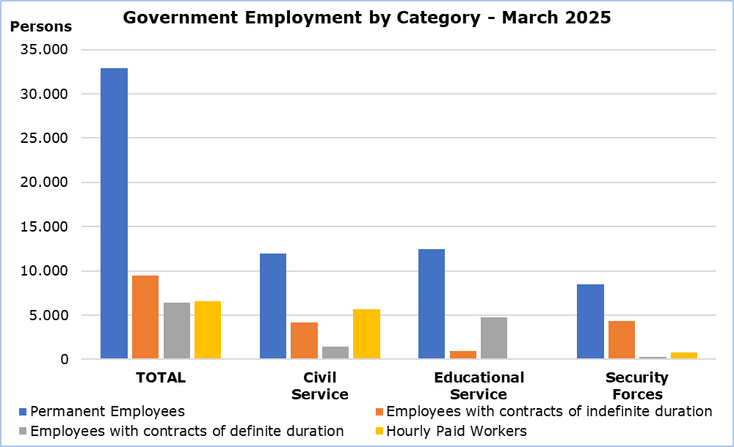

|  |  |  |  |  |  |  |
| --- | --- | --- | --- | --- | --- | --- |
| **Table** |  |  |  |  |  |  |
| **Personnel Category** | | **Number of Persons** | |  | **Change (%)** | |
| **March**  **2024** | **March**  **2025** |  | **Mar 25/ Mar 24** | **Jan–Mar 25/ Jan-Mar 24** |
| **Civil Service** | **Total** | **23.208** | **23.198** |  | **0,0** | **0,2** |
| Permanent Employees | 12.013 | 11.951 |  | -0,5 | 0,0 |
| Employees with contracts of indefinite duration | 4.269 | 4.158 |  | -2,6 | -2,5 |
| Employees with contracts of definite duration | 1.289 | 1.430 |  | 10,9 | 12,7 |
| Hourly Paid Workers | 5.637 | 5.659 |  | 0,4 | -0,2 |
| **Educational**  **Service** | **Total** | **17.617** | **18.295** |  | **3,8** | **3,7** |
| Permanent Employees | 11.880 | 12.462 |  | 4,9 | 4,8 |
| Employees with contracts of indefinite duration | 1.184 | 948 |  | -19,9 | -20,0 |
| Employees with contracts of definite duration | 4.401 | 4.745 |  | 7,8 | 7,4 |
| Hourly Paid Workers | 152 | 140 |  | -7,9 | -8,4 |
| **Security**  **Forces** | **Total** | **13.926** | **13.832** |  | **-0,7** | **-1,0** |
| Permanent Employees | 8.190 | 8.464 |  | 3,3 | 2,4 |
| Employees with contracts of indefinite duration | 4.689 | 4.346 |  | -7,3 | -7,5 |
| Employees with contracts of definite duration | 300 | 269 |  | -10,3 | 3,5 |
| Hourly Paid Workers | 747 | 753 |  | 0,8 | 0,6 |
| **Total** | **Total** | **54.751** | **55.325** |  | **1,0** | **1,0** |
|  | Permanent Employees | 32.083 | 32.877 |  | 2,5 | 2,4 |
|  | Employees with contracts of indefinite duration | 10.142 | 9.452 |  | -6,8 | -6,9 |
|  | Employees with contracts of definite duration | 5.990 | 6.444 |  | 7,6 | 8,4 |
|  | Hourly Paid Workers | 6.536 | 6.552 |  | 0,2 | -0,3 |

**METHODOLOGICAL INFORMATION**

**Coverage**

Government employment includes the Civil Service, Educational Service and Security Forces staff. Civil Service includes employees of the Ministries, Departments and Services. Educational Service includes the employees of school units and the staff of the Cyprus Productivity Center and the Higher Hotel Institute of Cyprus. Security Forces include the Police Service, Fire Service and the National Guard staff. In all three categories the employees are classified in permanent employees, employees with contracts of indefinite and definite duration and hourly paid workers (regular, casual and seasonal staff).

The members of the House of Representatives are not included in the data.

**Collection of Data**

Data concerning Government employment is provided by the Treasury of the Republic and refers to the number of persons that were paid in the current month, irrespective of the period and duration of employment.

**Break in the Series**

As from January 2024 the classification for permanent and casual staff was discontinued. CYSTAT has adjusted the structure of government personnel to permanent, employees with contracts of indefinite duration, employees with contracts of definite duration and hourly paid workers. Therefore, there is a break in the series and data from previous months are not comparable.

***For more information:***

CYSTAT Portal, subtheme [Labour Market](https://www.cystat.gov.cy/en/SubthemeStatistics?s=43)

[CYSTAT-DB](https://cystatdb.cystat.gov.cy/pxweb/en/8.CYSTAT-DB/8.CYSTAT-DB__Labour%20Market__) (Online Database)

[Predefined Tables](https://www.cystat.gov.cy/en/KeyFiguresList?s=43) (Excel)

[Methodological Information](https://www.cystat.gov.cy/en/MethodologicalDetails?m=2256)

*Contact*

Maria Kkoushi: Tel: +357-22602235, Email: [mkkoushi@cystat.mof.gov.cy](mailto:mkkoushi@cystat.mof.gov.cy)