11 November, 2025

PRESS RELEASE

GOVERNMENT EMPLOYMENT BY CATEGORY: OCTOBER 2025

Total Employment: 54.976

In October 2025, total government employment reached 54.976 persons, recording a slight increase of 92 employees (0,2%) compared to October 2024. Employment in the Civil Service and in the Security Forces declined by 1,0% and 1,2% respectively, while employment in the Educational Service increased by 2,7%.

Compared to October 2024, the largest increase in total government employment is observed in the category of employees with contracts of definite duration (2,5%) and the largest decrease is observed in the category of hourly paid workers (-1,2%). Focusing on employee categories by Service, the largest percentage increase in employment is recorded in employees with contracts of indefinite duration in the Educational Service (19,7%), while the largest percentage decrease in employment is observed for employees with contracts of definite duration in the Security Forces (-71,8%).

It is noted that the significant decrease observed in the number of employees with contracts of definite duration in the Security Forces (-71,8%) is mainly attributed to the completion and non-renewal of specific definite duration contracts in July 2025.

For the period January – October 2025 the average total government employment increased by 0,7% compared to the corresponding period of 2024.

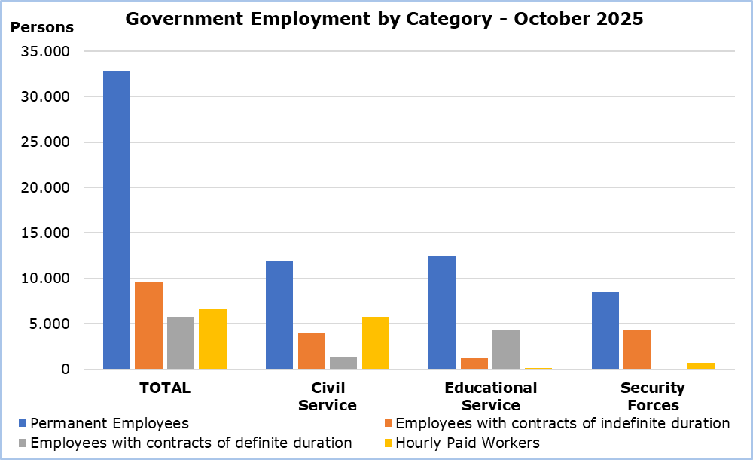

Table
Personnel Category |  | Number of Persons |  |  | Change (%)
 |  | Oct  2024 | Oct  2025 |  | Oct 25/ Oct 24 | Jan–Oct 25/ Jan-Oct 24
Civil Service | Total | 23.346 | 23.119 |  | -1,0 | -0,4
Civil Service | Permanent Employees | 12.045 | 11.893 |  | -1,3 | -0,7
Civil Service | Employees with contracts of indefinite duration | 4.199 | 4.066 |  | -3,2 | -2,8
Civil Service | Employees with contracts of definite duration | 1.219 | 1.357 |  | 11,3 | 10,9
Civil Service | Hourly Paid Workers | 5.883 | 5.803 |  | -1,4 | -0,4
Educational  Service | Total | 17.686 | 18.172 |  | 2,7 | 3,8
Educational  Service | Permanent Employees | 12.396 | 12.466 |  | 0,6 | 4,0
Educational  Service | Employees with contracts of indefinite duration | 996 | 1.192 |  | 19,7 | -13,7
Educational  Service | Employees with contracts of definite duration | 4.150 | 4.367 |  | 5,2 | 9,0
Educational  Service | Hourly Paid Workers | 144 | 147 |  | 2,1 | -4,4
Security  Forces | Total | 13.852 | 13.685 |  | -1,2 | -1,3
Security  Forces | Permanent Employees | 8.328 | 8.466 |  | 1,7 | 2,3
Security  Forces | Employees with contracts of indefinite duration | 4.479 | 4.391 |  | -2,0 | -6,3
Security  Forces | Employees with contracts of definite duration | 294 | 83 |  | -71,8 | -26,4
Security  Forces | Hourly Paid Workers | 751 | 745 |  | -0,8 | 0,3
Total | Total | 54.884 | 54.976 |  | 0,2 | 0,7
 | Permanent Employees | 32.769 | 32.825 |  | 0,2 | 1,8
 | Employees with contracts of indefinite duration | 9.674 | 9.649 |  | -0,3 | -5,7
 | Employees with contracts of definite duration | 5.663 | 5.807 |  | 2,5 | 7,5
 | Hourly Paid Workers | 6.778 | 6.695 |  | -1,2 | -0,4

METHODOLOGICAL INFORMATION

Coverage

Government employment includes the Civil Service, Educational Service and Security Forces staff. Civil Service includes employees of the Ministries, Departments and Services. Educational Service includes the employees of school units and the staff of the Cyprus Productivity Center and the Higher Hotel Institute of Cyprus. Security Forces include the Police Service, Fire Service and the National Guard staff. In all three categories the employees are classified in permanent employees, employees with contracts of indefinite and definite duration and hourly paid workers (regular, casual and seasonal staff).

The members of the House of Representatives are not included in the data.

Collection of Data

Data concerning Government employment is provided by the Treasury of the Republic and refers to the number of persons that were paid in the current month, irrespective of the period and duration of employment.

Break in the Series

As from January 2024 the classification for permanent and casual staff was discontinued. CYSTAT has adjusted the structure of government personnel to permanent, employees with contracts of indefinite duration, employees with contracts of definite duration and hourly paid workers. Therefore, there is a break in the series and data from previous months are not comparable.

For more information:
CYSTAT Portal, subtheme Labour Market
CYSTAT-DB (Online Database)
Methodological Information

Contact
Maria Kkoushi: Tel: +357-22602235, Email: mkkoushi@cystat.mof.gov.cy

