20 May, 2026

PRESS RELEASE

HARMONIZED INDEX OF CONSUMER PRICES (HICP): APRIL 2026

Annual Rate of Change 3,0%

The HICP rose by 3,0% between April 2025 and April 2026 and increased by 2,2% between March and April 2026. (Table 1)

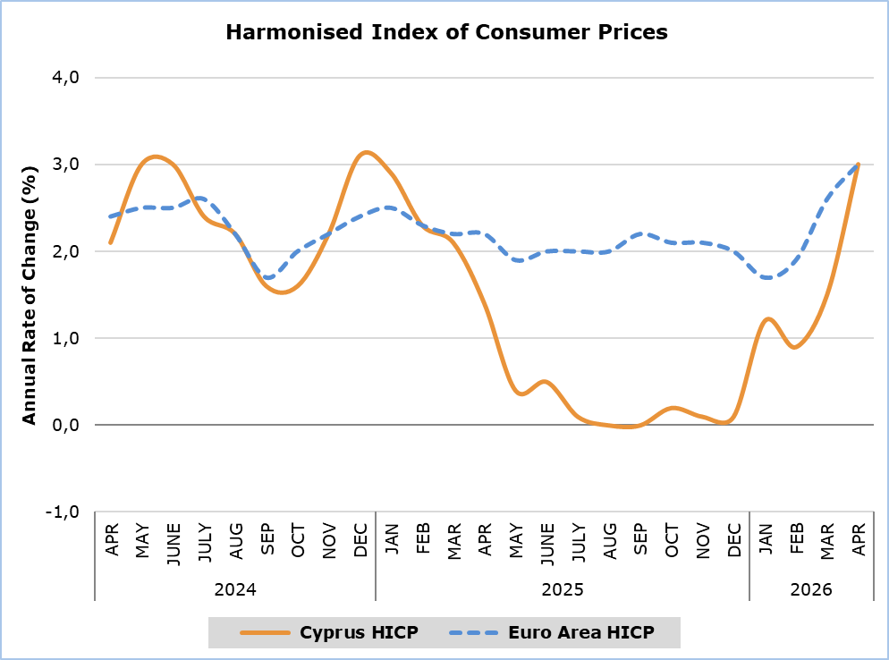
Note: The HICP in Euro area for the last month is based on EUROSTAT’s estimation (flash estimate).

Compared to April 2025, the categories Recreation, Sports and Culture (6,8%) and Transport (6,7%), showed the largest positive changes. The largest negative changes were observed in the categories Clothing and Footwear (-5,4%) and Information and Communication (-2,2%). (Table 1)

Compared with March 2026, the largest changes were recorded in the categories Transport (9,6%) and Clothing and Footwear (5,3%). (Table 1)

The largest change in the economic categories, both compared to April 2025 and March 2026, was observed in the category Energy (8,5% and 7,5% respectively). (Table 2)

Table 1
Categories of Goods  and Services | HICP (2025=100) |  |  | Change (%)
Categories of Goods  and Services | March 2026 | April  2026 |  | Apr 26/  Apr 25 | Apr 26/  Mar 26 | Jan – Apr 26/  Jan – Apr 25
Food and Non-Alcoholic  Beverages | 105,52 | 104,89 |  | 5,20 | -0,60 | 4,39
Alcoholic Beverages and Tobacco | 101,02 | 100,79 |  | 1,24 | -0,23 | 1,12
Clothing and Footwear | 94,09 | 99,05 |  | -5,43 | 5,27 | -5,83
Housing, Water, Electricity, Natural Gas and Other Fuels | 98,58 | 99,99 |  | 1,16 | 1,43 | -2,23
Furnishings and Home Decoration, Household Equipment, and Routine Home Maintenance | 100,03 | 99,91 |  | -0,28 | -0,12 | 0,18
Health | 100,69 | 100,76 |  | 0,95 | 0,07 | 0,56
Transport | 99,75 | 109,30 |  | 6,73 | 9,57 | 1,57
Information and Communication | 98,21 | 97,84 |  | -2,20 | -0,38 | -2,47
Recreation, Sports and Culture | 102,53 | 103,61 |  | 6,83 | 1,05 | 5,91
Educational Services | 102,33 | 102,33 |  | 3,41 | 0,00 | 3,41
Restaurants and Accommodation Services | 99,50 | 102,02 |  | 4,78 | 2,53 | 4,21
Insurance and Financial Services | 100,05 | 100,05 |  | 0,03 | 0,00 | 0,10
Personal Care, Social Protection, and Miscellaneous Goods and Services | 100,41 | 100,64 |  | 0,74 | 0,23 | 1,16
General Harmonised Consumer Price Index | 100,45 | 102,68 |  | 3,01 | 2,22 | 1,67

Table 2
Economic Origin | Weights | Change (%)
Economic Origin | Weights | Apr 26/  Apr 25 | Apr 26/  Mar 26
General HICP | 1000 | 3,0 | 2,2
Energy | 88,45 | 8,5 | 7,5
Food-Alcoholic Beverages-Tobacco | 205,02 | 4,3 | -0,5
Non-Energy Industrial Goods | 223,72 | -2,5 | 1,5
Services | 482,81 | 4,1 | 2,8
Note: The weights of the categories are calculated with infinite decimal figures and rounded up to two decimals when published. Figures do not add up to the total due to rounding.

METHODOLOGICAL NOTES

Definitions

The Harmonized Price Index (HICP) is an economic indicator constructed to measure the changes of prices over time of consumer goods and services acquired, used or paid by households and tourists within the economic territory of the country. The HICP is calculated according to a harmonized approach and methodology laid down by a series of regulations of EU.

The Annual change shows the change of the HICP when compared with the index of the corresponding month of the previous year.

Products/Services
From January 2026 and onwards, the products included in the HICP have been revised. The revision was based on the results of the Household Budget Survey 2023. More details are available on CYSTAT website in the Methodology section, in the statistical sub-category Economy / Price Indices / Harmonized Consumer Price Index.

Price collection

The price collection is carried out only in urban districts of Nicosia, Larnaca, Limassol and Paphos. For each city, the fluctuations in the product prices for each month are weighted according to their population. Specifically, the weights for the four districts are: Nicosia 40%, Limassol 30%, Larnaca 18% and Paphos 12%.

The prices of 850 goods and services are recorded once every month, except for some seasonal products (e.g vegetables and fruits), meat and fuels, for which prices are collected every week (every Thursday). The collected prices are those actually paid by consumers for the purchase of specific goods and services, and they include various taxes, such as the Value Added Tax and excise duties. For the calculation of the Index end-of-season sales prices are taken into account as well as special offer prices which are available for the general public and have no restrictions.

Weights

The weight of the HICP goods and services are calculated based on consumption expenditure (of both households and tourists) incurred in the economic territory of the country. Up to 2011, the main source for the consumption expenditures was the Household Budget Survey, while from 2012 and onwards, data from the National Accounts are utilized satisfying relevant EU Regulation.

Base Year

From January 2026 onwards, the base year is 2025=100. The index reference period was 2015=100 from January 2016 to December 2025.

Classification

Until December 2025, ECOICOP classification was used for the calculation and the dissemination of the HICP. From January 2026 onwards, CYSTAT adopts the ECOICOP ver.2 classification. The lowest level of detail for the classification used in HICP is COICOP 5-digits level of analysis.

Further information:
CYSTAT Portal, subtheme Price Indices
CYSTAT-DB (Online Database)

Contact
Sofronis Vikis: Tel.: +357-22602206, Email: svikis@cystat.mof.gov.cy
Kyriakos Voutouris: Tel.: +357-22605132, Email: kvoutouris@cystat.mof.gov.cy
Filippos Kakoutsis: Tel.: +357-22605149, Email: fkakoutsis@cystat.mof.gov.cy

