16 April, 2025

**PRESS RELEASE**

###### HARMONIZED INDEX OF CONSUMER PRICES (HICP): March 2025

**Annual Rate of Change 2,1%**

The HICP rose by 2,1% between March 2024 and March 2025, and increased by 0,5% in the month between February 2025 and March 2025 (Table 1).

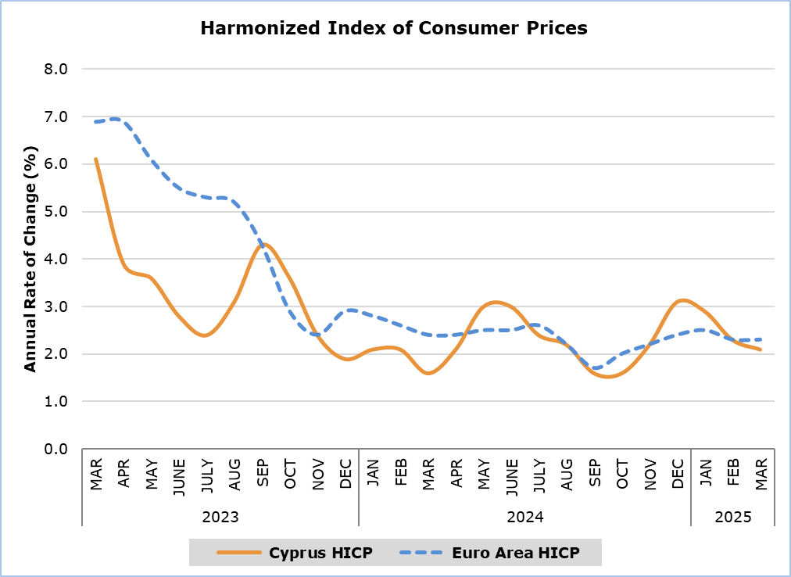

Note: The HICP in Euro area for the last month is based on Eurostat’s flash estimate.

Compared to March 2024, the categories *Recreation and Culture* (7,2%) and *Restaurants and Hotels* (6,1%) showed the highest positive changes, while *Clothing and Footwear* (-7,7%) recorded the largest negative change (Table 1).

In comparison to February 2025, the most significant changes were observed in the categories *Clothing and Footwear* (3,2%) and *Restaurants and Hotels* (2,7%) (Table 1).

For the period January – March 2025, compared to the corresponding period of the previous year, the most significant changes were recorded in the categories *Recreation and Culture* (7,3%), *Restaurants and Hotels* (5,2%), and *Clothing and Footwear* (-5,1%) (Table 1).

The most significant change in economic categories compared to March 2024 was observed in *Services* (4,6%) and *Non-Energy Industrial Goods* (-2,8%), while compared to the previous month, the largest change was recorded in the *Services* category (1,3%) (Table 2).

|  |  |  |  |  |  |  |
| --- | --- | --- | --- | --- | --- | --- |
| **Table 1** | | | | | | |
| **Categories of Goods**  **and Services** | **CPI (2015=100)** | |  | **Change (%)** | | |
| **February**  **2025** | **March**  **2025** |  | **Mar 25/**  **Mar 24** | **Mar 25/ Feb 25** | **Jan- Mar 25/**  **Jan- Mar 24** |
| Food and Non-Alcoholic  Beverages | 126,45 | 125,17 |  | 2,6 | -1,0 | 3,5 |
| Alcoholic Beverages and Tobacco | 102,05 | 101,95 |  | 0,0 | -0,1 | 0,7 |
| Clothing and Footwear | 91,64 | 94,59 |  | -7,7 | 3,2 | -5,1 |
| Housing, Water, Electricity, Gas and Other Fuels | 145,36 | 145,33 |  | 3,9 | 0,0 | 2,5 |
| Furnishings, Household Equipment and Routine Maintenance of the House | 102,42 | 102,92 |  | -1,0 | 0,5 | -0,6 |
| Health | 107,98 | 108,15 |  | 1,7 | 0,2 | 1,6 |
| Transport | 109,31 | 108,65 |  | 0,2 | -0,6 | 1,9 |
| Communication | 89,00 | 88,91 |  | -1,9 | -0,1 | -1,7 |
| Recreation and Culture | 122,67 | 122,86 |  | 7,2 | 0,2 | 7,3 |
| Education | 114,59 | 114,59 |  | 3,7 | 0,0 | 3,7 |
| Restaurants and Hotels | 124,22 | 127,56 |  | 6,1 | 2,7 | 5,2 |
| Miscellaneous Goods  and Services | 111,07 | 111,52 |  | 0,5 | 0,4 | 0,9 |
| **General Consumer Price Index** | **116,26** | **116,86** |  | **2,1** | **0,5** | **2,4** |

|  |  |  |  |
| --- | --- | --- | --- |
| **Table 2** | | | |
| **Economic Origin** | **Weights** | **Change (%)** | |
| **Mar 25/**  **Mar 24** | **Mar 25/**  **Feb 25** |
| **General HICP** | **1000** | **2,1** | **0,5** |
| Energy | 96,25 | 2,4 | -0,8 |
| Food-Alcoholic Beverages-Tobacco | 223,95 | 2,0 | -0,8 |
| Non-Energy Industrial Goods | 229,71 | -2,8 | 0,8 |
| Services | 450,09 | 4,6 | 1,3 |

Note: The weights of the categories are calculated with infinite decimal figures and rounded up to two decimals when published. Figures do not add up to the total due to rounding.

**METHODOLOGICAL NOTES**

**Definitions**

The **Harmonized Index of Consumer Prices (HICP)** is an economic indicator constructed to measure the changes of prices over time of consumer goods and services acquired, used or paid by households and tourists within the economic territory of the country. The HICP is calculated according to a harmonized approach and methodology laid down by a series of regulations of EU.

The **Annual change** shows the change of the HICP when compared with the index of the corresponding month of the previous year.

Products/Services

From January 2018 onwards, the products included in the HICP have been revised. The revision was based on the results of the Household Budget Survey 2015/2016. More details are available on CYSTAT website in the Methodology section, in the statistical sub-category Economy / Price Indices / Harmonized Consumer Price Index.

**Price collection**

The price collection is carried out only in urban districts of Nicosia, Larnaca, Limassol and Paphos. For each city, the fluctuations in the product prices for each month are weighted according to their population. Specifically, the weights for the four districts are: Nicosia 42%, Limassol 30%, Larnaca 18% and Paphos 10%.

The prices of 805 goods and services are recorded once every month, except for some seasonal products (e.g vegetables and fruits), meat and fuels, for which prices are collected every week (every Thursday). The collected prices are those actually paid by consumers for the purchase of specific goods and services, and they include various taxes, such as the Value Added Tax and excise duties. For the calculation of the Index end-of-season sales prices are taken into account as well as special offer prices which are available for the general public and have no restrictions.

**Weights**

The weights of HICP goods and services are calculated based on consumption expenditure (of both households and tourists) incurred in the economic territory of the country. Up to 2011, the main source for the consumption expenditures was the Household Budget Survey, while from 2012 onwards, data from the National Accounts are utilized satisfying relevant EU Regulation.

Base Year

The index reference period was 2005=100 for the period between January 2006 and December 2015. From January 2016 and onwards, the base year is 2015=100.

Classification

Until December 2015, COICOP 4 classification up to four digits level of analysis was used for the calculation and the dissemination of the HICP. From January 2016 onwards, CYSTAT is adopting the ECOICOP classification satisfying relevant EU Regulation. Consequently, the lowest level of detail for the classification used in HICP is ECOICOP 5-digits level of analysis.

Since February 2019, CYSTAT publishes HICP special aggregates (economic origin), compiled from more detailed input data.

***Further information:***

CYSTAT Portal, subtheme [Price Indices](https://www.cystat.gov.cy/en/SubthemeStatistics?s=47)

[CYSTAT-DB](https://cystatdb.cystat.gov.cy/pxweb/en/8.CYSTAT-DB/8.CYSTAT-DB__Price%20Indices__) (Online Database)

[Methodological Information](https://www.cystat.gov.cy/en/MethodologicalDetails?m=2092" \o "Methodological Information)

*Contact*

Sofronis Vikis: Tel:+35722602206, Email: [svikis@cystat.mof.gov.cy](mailto:svikis@cystat.mof.gov.cy)

Kyriakos Voutouris: Tel:+35722605132, Email: [kvoutouris@cystat.mof.gov.cy](mailto:kvoutouris@cystat.mof.gov.cy)

Filippos Kakoutsis: Tel:+35722605149, Email: [fkakoutsis@cystat.mof.gov.cy](mailto:fkakoutsis@cystat.mof.gov.cy)