18 June, 2024

**PRESS RELEASE**

###### HARMONIZED INDEX OF CONSUMER PRICES (HICP): MAY 2024

**Annual Rate of Change 3,0%**

The HICP rose by 3,0% between May 2023 and May 2024, and increased by 1,2% in the month between April 2024 and May 2024. For the period January – May 2024, the HICP rose by 2,2% compared to the corresponding period of the previous year. (Table 1)

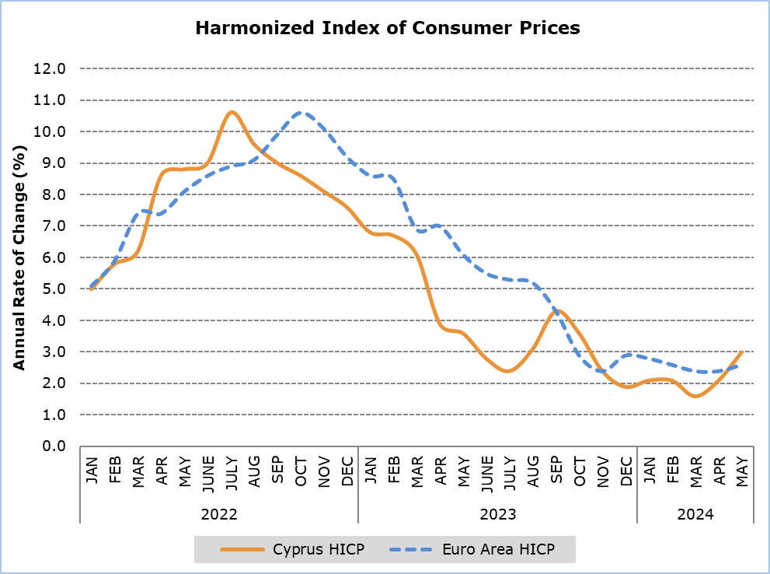

Note: The HICP in Euro area for the last month is based on EUROSTAT’s estimation (flash estimate).

Compared to May 2023, the largest positive changes were noted in *Restaurants and Hotels* (6,1%) and *Transport* (5,6%). (Table 1)

Compared to April 2024, the largest change was recorded in category *Restaurants and Hotels* (2,4%). (Table 1)

For the period January - May 2024, compared to the corresponding period of the previous year, the largest change was noted in *Restaurants and Hotels* (5,8%). (Table 1)

As regards the economic origin, the largest change when compared to the index of May 2023 was observed in category *Energy* (7,2%). When compared to the index of the previous month, the largest change was monitored in category *Services* (1,7%). (Table 2)

|  |  |  |  |  |  |  |
| --- | --- | --- | --- | --- | --- | --- |
| Table 1 | | | | | | |
| Categories of Goods  and Services | **HICP (2015=100)** | |  | **Change (%)** | | | |
| **April**  **2024** | **May**  **2024** |  | **May 24/**  **May 23** | **May 24/**  **Apr 24** | **Jan – May**  **24/23** | |
| Food and Non-Alcoholic Beverages | 122,35 | 124,58 |  | 1,4 | 1,8 | 2,0 | |
| Alcoholic Beverages  and Tobacco | 101,86 | 102,11 |  | 0,9 | 0,2 | 2,0 | |
| Clothing and Footwear | 106,96 | 107,54 |  | 0,0 | 0,5 | 0,6 | |
| Housing, Water, Electricity, Gas and Other Fuels | 143,96 | 144,50 |  | 2,8 | 0,4 | 1,0 | |
| Furnishings, Household Equipment and Routine Maintenance of the House | 103,97 | 104,40 |  | -0,1 | 0,4 | -0,5 | |
| Health | 106,37 | 106,38 |  | 1,2 | 0,0 | 1,2 | |
| Transport | 113,31 | 115,60 |  | 5,6 | 2,0 | 0,9 | |
| Communication | 90,70 | 90,85 |  | -0,1 | 0,2 | 0,0 | |
| Recreation and Culture | 114,66 | 114,65 |  | 2,5 | 0,0 | 2,6 | |
| Education | 110,54 | 110,54 |  | 2,3 | 0,0 | 2,3 | |
| Restaurants and Hotels | 121,14 | 124,07 |  | 6,1 | 2,4 | 5,8 | |
| Miscellaneous Goods and Services | 111,65 | 111,86 |  | 3,1 | 0,2 | 2,9 | |
| General Harmonised Consumer Price Index | **116,07** | **117,46** |  | **3,0** | **1,2** | **2,2** | |

|  |  |  |  |  |
| --- | --- | --- | --- | --- |
| **Table 2** | | | | |
| **Economic Origin** | **Weights** | **Change (%)** | | |
| **May 24/**  **May 23** | **May 24/**  **Apr 24** | |
| **General HICP** | **1000** | **3,0** | **1,2** | |
| Energy | 101,71 | 7,2 | 0,6 | |
| Food-Alcoholic Beverages-Tobacco | 222,41 | 1,3 | 1,4 | |
| Non energy industrial goods | 231,47 | -0,2 | 0,3 | |
| Services | 444,42 | 4,7 | 1,7 | |
| Note: The weights of the categories are calculated with infinite decimal figures and rounded up to two decimals when published. Figures do not add up to the total due to rounding. | | | |

**METHODOLOGICAL NOTES**

**Definitions**

The **Harmonized Price Index (HICP)** an economic indicator constructed to measure the changes of prices over time of consumer goods and services acquired, used or paid by households and tourists within the economic territory of the country. The HICP is calculated according to a harmonized approach and methodology laid down by a series of regulations of EU.

The **Annual change** shows the change of the HICP when compared with the index of the corresponding month of the previous year.

Products/Services

From January 2018 and onwards, the products included in the HICP have been revised. The revision was based on the results of the Household Budget Survey 2015/2016. More details are available on CYSTAT website in the Methodology section, in the statistical sub-category Economy / Price Indices / Harmonized Consumer Price Index.

**Collection**

The price collection is carried out only in urban districts of Nicosia, Larnaca, Limassol and Paphos. For each city, the fluctuations in the product prices each month are weighted according to their population. Specifically, the weights for the four districts are: Nicosia 42%, Limassol 30%, Larnaca 18% and Paphos 10%.

The prices of 805 goods and services are recorded once every month, except for some seasonal products (e.g vegetables and fruits), meat and fuels, whose prices are collected every week (every Thursday). The collected prices are those actually paid by consumers for the purchase of specific goods and services, and they include various taxes, such as the Value Added Tax and excise duties. For the calculation of the Index end-of-season sales prices are taken into account as well as special offer prices which are available for the general public and have no restrictions.

**Weights**

The weight of the HICP goods and services are calculated based on consumption expenditure (of both households and tourists) incurred in the economic territory of the country. Up to 2011, the main source for the consumption expenditures was the Household Budget Survey, while from 2012 and onwards, data from the National Accounts are utilized satisfying relevant Eurostat’s Regulation (No 1148/2020).

Base Year

The index reference period was 2005=100 for the period between January 2006 and January 2015. From January 2016 and onwards, the base year is 2015=100.

Classification

Until January 2015, COICOP 4 classification was used for the calculation and the dissemination of the HICP. From January 2016 and onwards, CYSTAT is adopting the ECOICOP classification satisfying relevant Eurostat’s Regulation. In other words, the lowest level of detail for the classification used in CPI is COICOP 5-digits.

Since February 2019 CYSTAT publishes HICP special aggregates (economic origin) compiled from more detailed input data.

***Further information:***

CYSTAT Portal, subtheme [Price Indices](https://www.cystat.gov.cy/en/SubthemeStatistics?s=47)

[CYSTAT-DB](https://cystatdb.cystat.gov.cy/pxweb/en/8.CYSTAT-DB/8.CYSTAT-DB__Price%20Indices__) (Online Database)

[Predefined Tables](https://www.cystat.gov.cy/en/KeyFiguresList?s=47) (Excel)

[Methodological Information](https://www.cystat.gov.cy/en/MethodologicalDetails?m=2092" \o "Methodological Information)

**The data included in the Predefined Tables in Excel format are available up to January 2021. Data from January 2022 onwards are available only in the CYSTAT-DB Online Database.**

*Contact*

Constandia Papageorgiou: Tel: +35722602116, Email: [cpapageorgiou@cystat.mof.gov.cy](mailto:cpapageorgiou@cystat.mof.gov.cy)