8 September, 2023

PRESS RELEASE

HEALTH AND HOSPITAL STATISTICS 2021

In-patient Discharges from Hospitals contracted with the General Healthcare System (GHS)

During 2021, 89.357 discharges were issued to in-patients, i.e., to patients who stayed at the hospital for at least one night. Of the total number of in-patient discharges, a percentage of 46,0% referred to the hospitals of the State Health Service Organisation (SHSO), whereas the remaining 54,0% referred to the private hospitals contracted with the GHS.

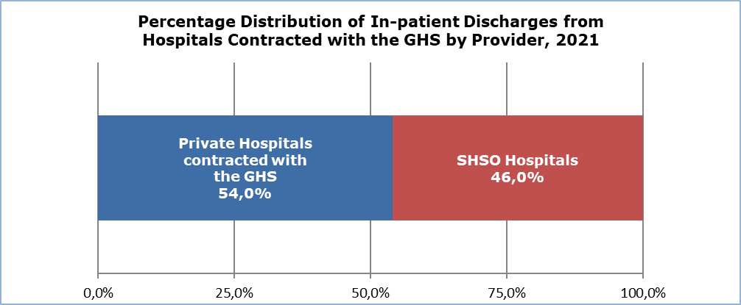

The highest share of discharges among in-patients was issued from the speciality of Obstetrics and Gynaecology with 15,7%, followed by the specialities of General Surgery with 14,9%, Pathology with 12,1%, Cardiology with 11,4% and Orthopaedics with 9,1%. The term speciality refers to the speciality of the physician who submitted the claim for the incident. It should be stated that for each discharge it is possible to submit only one claim exclusively from the physician to whom the incident has been assigned, regardless of whether during the hospitalization the patient also received health care services from physicians of other specialities.

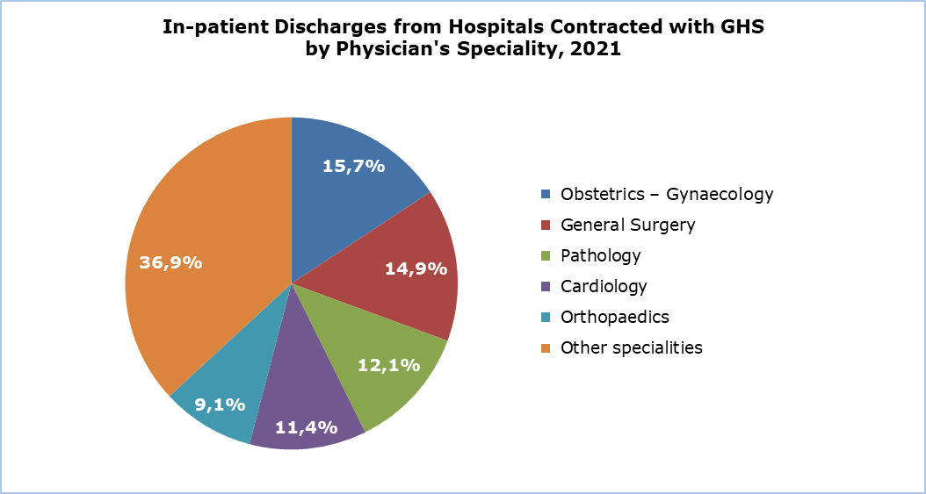

According to the diagnosis at discharge, the diseases of the respiratory system and diseases of the circulatory system recorded the same percentage of 12,7%, followed by neoplasms with 11,7%, the diseases of the digestive system with 11,1%, pregnancy, childbirth and the puerperium with 10,5%, the diseases of the genitourinary system with 9,4% and injury, poisoning and certain other consequences of external causes with 9,2%.

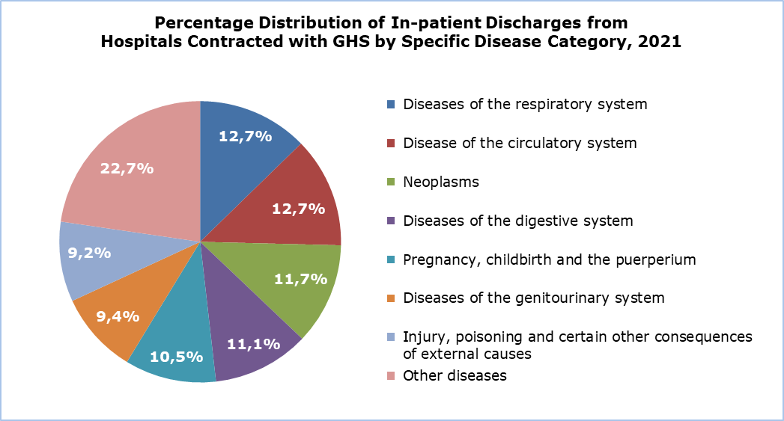

Day-care patient discharges from Hospitals contracted with the General Healthcare System (GHS)

During 2021, 231.109 discharges were issued to day-care patients, namely to patients admitted in a hospital, received a planned medical care and were discharged at the same day. Of the discharges issued to day-care patients, a percentage of 62,7% referred to SHSO hospitals, whereas the remaining percentage of 37,3% referred to private hospitals contracted with the GHS.

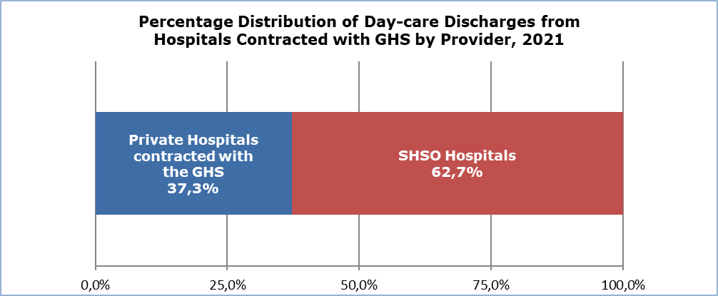

As regards the discharges by the physician’s speciality, the speciality of Nephrology recorded the highest percentage of 50,1%, followed by Pathological Oncology with 14,5% and Haematology with 7,5%.

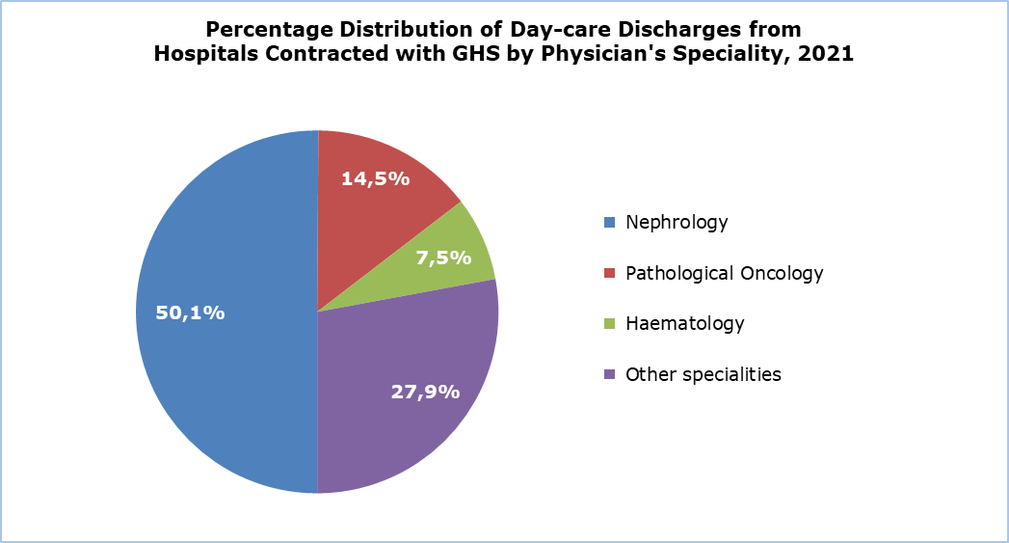

Out-patient Attendances

During 2021 a total of 7.202.579 out-patient attendances were recorded compared to 6.016.478 in 2020, recording an increase of 19,7%.

Of the total number of out-patient attendances, 951.872 (percentage of 13,2%) were performed at the out-patient departments of SHSO hospitals and health centres, whereas 6.250.707 (percentage of 86,8%) were performed to physicians of the private sector contracted with the GHS. For 2020 the respective figures were 16,3% and 83,7%.

As regards the type of health care provider, of the out-patient attendances to personal doctors, a percentage of 14,3% was performed at SHSO hospitals and health centres, whereas the remaining percentage of 85,7% was performed to physicians of the private sector contracted with the GHS. The respective figures for 2020 were 16,8% and 83,2%.

Of the out-patient attendances to special doctors, a percentage of 12,3% was performed at SHSO hospitals and health centres, whereas the remaining percentage of 87,7% was performed to physicians of the private sector contracted with the GHS. The respective figures for 2020 were 15,9% and 84,1%.

Attendances to | Total |  | SHSO Hospitals and Health Centres |  | GHS Private Doctors
Attendances to | No. | % | No. | % | No. | %
Personal doctors | 3.431.996 | 100,0% | 489.164 | 14,3% | 2.942.832 | 85,7%
Specialists | 3.770.583 | 100,0% | 462.708 | 12,3% | 3.307.875 | 87,7%
Total | 7.202.579 | 100,0% | 951.872 | 13,2% | 6.250.707 | 86,8%

Deaths by Cause of Death

In 2021, 7.326 deaths have been recorded, including all deaths of residents, as well as non-residents dying in Cyprus. A percentage of 53,1% of total deaths (3.889 deaths) referred to men, whereas 46,9% (3.437 deaths) referred to women. The main causes of death were diseases of the circulatory system (25,4%), neoplasms (22,6%), endocrine, nutritional and metabolic diseases and as well as COVID-19 (8,5% respectively) and diseases of the respiratory system (7,2%). Other causes of death follow with lower frequencies.

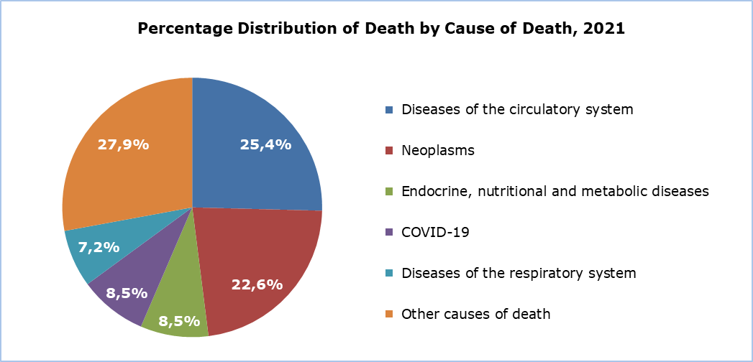

METHODOLOGICAL INFORMATION

Definitions

In-patient – Is a person who has been through the full admission procedure in a hospital, stayed at the hospital for treatment for at least one night and for whom a “Patient’s File” has been prepared.

Day-care patient – Is a person who has been through the full admission procedure in a hospital, was admitted and discharged at the same day and for whom a “Patient´s File” has been prepared.

Discharge – Is the conclusion of a period of in-patient care, irrespective of whether the patient returned home, was sent to another hospital, left the hospital without medical advice or died.

Out-patient attendance – Is the visit of the patient to an out-patient department of a hospital, clinic or the visit to a medical office.

Sources of Data and Coverage

Coverage. Up to May 2019, medical care in Cyprus was provided through the public and private sector health services. From June 2019 the gradual implementation of the GHS began, firstly at the level of the primary care (out-patient visits) and from June 2020, at the level of in-patient and day-care. The figures included at the present press release refer to the primary care and the in-patient and day-care provided from all medical institutions contracted with the GHS i.e., medical institutions of the SHSO and of the private sector, in the Government controlled areas.

In-patient and day-care patient discharges. Data on patients who are admitted for treatment and discharged from the hospitals contracted with the GHS have been obtained from the IT system of the HIO.

Out-patient attendances. The data on out-patient attendances performed at the hospitals and physicians’ offices contracted with the GHS have been obtained from the IT system of the HIO.

Causes of death. The source is the Cause of Death Register owned by the Health Monitoring Unit of the Ministry of Health. The total number of deaths recorded in the register, includes all deaths occurring in Cyprus, both of residents and non-residents, as well as deaths of Cypriot residents occurring abroad.

For more information:
CYSTAT Portal, subtheme Health
CYSTAT-DB (Online Database)
Predefined Tables (Excel)
Publications

Contact
Eleni Kyriacou: Tel: +35722605114, Email: ekyriacou@cystat.mof.gov.cy
Nicoletta Petrou: Tel: +35722602158, Email: npetrou@cystat.mof.gov.cy

