30 May, 2024

**PRESS RELEASE**

###### HEALTH AND HOSPITAL STATISTICS 2022

**In-patient Discharges from Hospitals contracted with the General Healthcare System (GHS)**

During 2022, 94.654 discharges were issued to in-patients, i.e., to patients who stayed at the hospital for at least one night, compared to 89.357 in 2021, recording an increase of 5,9%. Part of the increase is due to the gradual inclusion of new hospitals in the GHS. Of the total number of in-patient discharges issued in 2022, a percentage of 45,9% referred to the hospitals of the State Health Service Organisation (SHSO), whereas the remaining 54,1% referred to the private hospitals contracted with the GHS. The respective figures for 2021 were 46,0% and 54,0%.

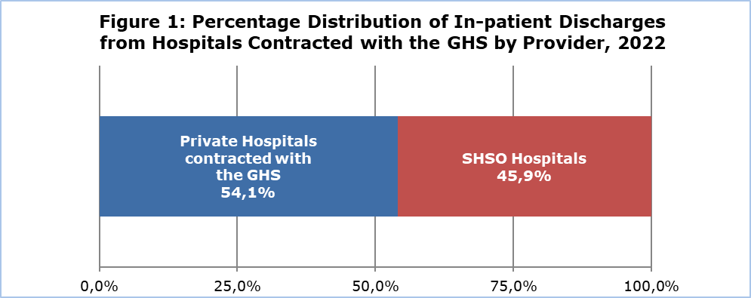

The highest share of discharges among in-patients was issued from the speciality of Obstetrics and Gynaecology with 15,0%, followed by the specialities of General Surgery with 14,7%, Pathology with 12,0%, Cardiology with 10,9% and Orthopaedics with 9,8%. The term speciality refers to the speciality of the physician who submitted the claim for the incident. It should be stated that for each discharge it is possible to submit only one claim exclusively from the physician to whom the incident has been assigned, regardless of whether during the hospitalization the patient also received health care services from physicians of other specialities.

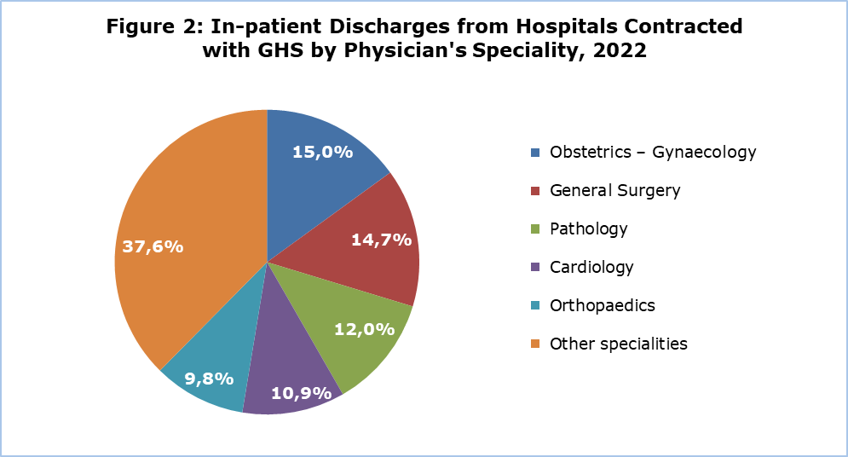

According to the diagnosis at discharge, the diseases of the circulatory system recorded a percentage of 12,4%, followed by the diseases of the digestive system with 12,3%, neoplasms with 11,4%, the diseases of the respiratory system with 10,6%, pregnancy, childbirth and the puerperium with 10,5%, injury, poisoning and certain other consequences of external causes with 9,3% and the diseases of the genitourinary system with 9,1%.

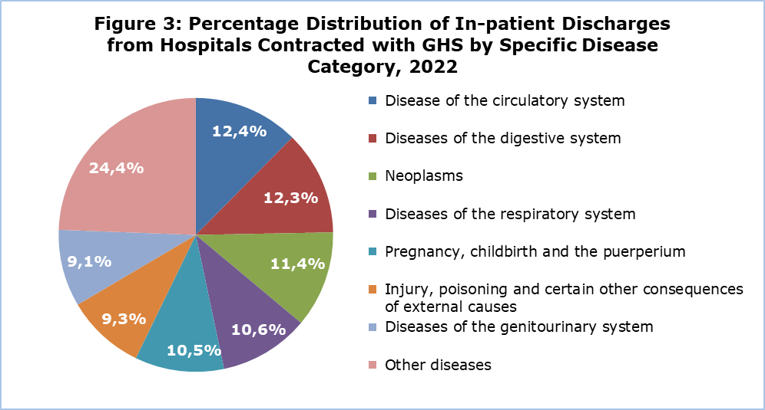

**Day-care patient discharges from Hospitals contracted with the General Healthcare System (GHS)**

During 2022, 278.059 discharges were issued to day-care patients, namely to patients admitted in a hospital, received a planned medical care and were discharged at the same day, compared to 231.109 in 2021, recording an increase of 20,3%. This increase is partly due to the inclusion of new private day-care hospitals in the GHS in 2022. Of the discharges issued to day-care patients in 2022, a percentage of 56,2% referred to SHSO hospitals, whereas the remaining percentage of 43,8% referred to private hospitals contracted with the GHS. The respective figures for 2021 were 62,7% and 37,3%.

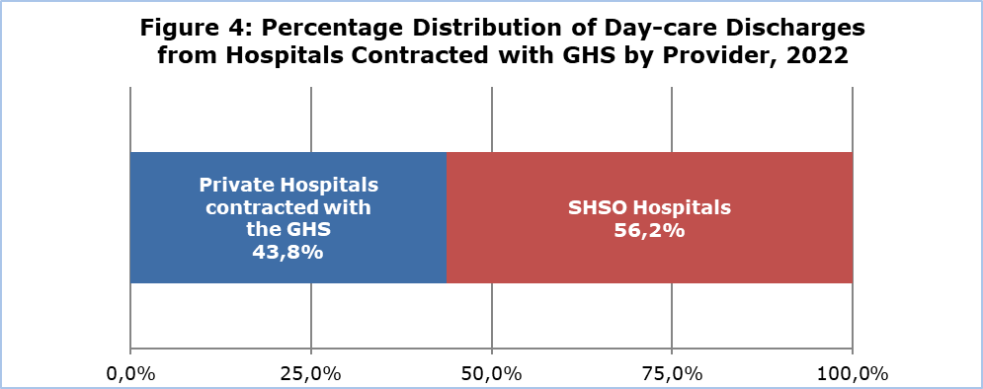

As regards the discharges by the physician’s speciality, the speciality of Nephrology recorded the highest percentage of 46,3%, followed by Pathological Oncology with 16,3% and Haematology with 8,0%.

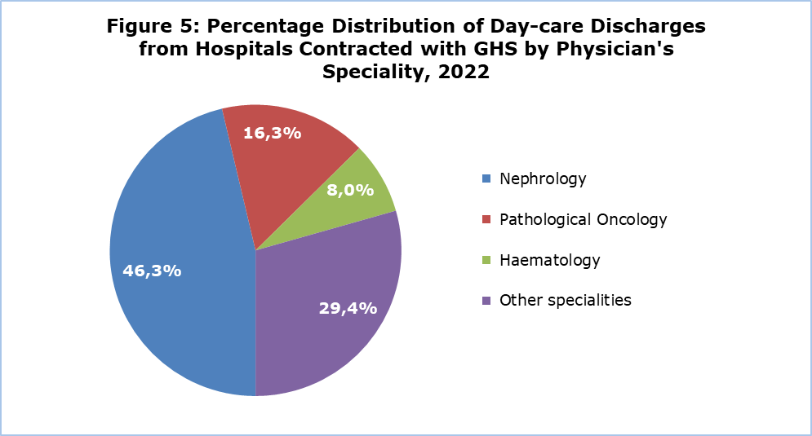

**Out-patient Attendances**

During 2022 a total of 7.669.535 out-patient attendances were recorded compared to 7.202.579 in 2021, recording an increase of 6,5%.

Of the total number of out-patient attendances in 2022, 879.584 (percentage of 11,5%) were performed at the out-patient departments of SHSO hospitals and health centres, whereas 6.789.951 (percentage of 88,5%) were performed to physicians of the private sector contracted with the GHS. For 2021 the respective figures were 13,2% and 86,8%.

As regards the type of health care provider, of the out-patient attendances to personal doctors, a percentage of 11,8% was performed at SHSO hospitals and health centres, whereas the remaining percentage of 88,2% was performed to physicians of the private sector contracted with the GHS. The respective figures for 2021 were 14,3% and 85,7%.

Of the out-patient attendances to special doctors, a percentage of 11,1% was performed at SHSO hospitals and health centres, whereas the remaining percentage of 88,9% was performed to physicians of the private sector contracted with the GHS. The respective figures for 2021 were 12,3% and 87,7%.

|  |  |  |  |  |  |  |
| --- | --- | --- | --- | --- | --- | --- |
| **Table** |  | |  | |  | |
| **Attendances to** | **Total** | | **SHSO Hospitals and Health Centres** | | **GHS Private Doctors** | |
| **No.** | **%** | **No.** | **%** | **No.** | **%** |
| Personal doctors | 4.020.730 | 100,0% | 474.667 | 11,8% | 3.546.063 | 88,2% |
| Specialists | 3.648.805 | 100,0% | 404.917 | 11,1% | 3.243.888 | 88,9% |
| **Total** | **7.669.535** | **100,0%** | **879.584** | **11,5%** | **6.879.951** | **88,5%** |

**Deaths by Cause of Death**

In 2022, 7.404 deaths have been recorded, including all deaths of residents, as well as non-residents dying in Cyprus. A percentage of 52,3% of total deaths (3.873 deaths) referred to men, whereas 47,7% (3.531 deaths) referred to women. The main causes of death were diseases of the circulatory system (24,5%), neoplasms (21,2%), COVID-19 (9,3%), endocrine, nutritional and metabolic diseases (8,6%), as well as respectively) and diseases of the respiratory system (7,9%). Other causes of death follow with lower frequencies.

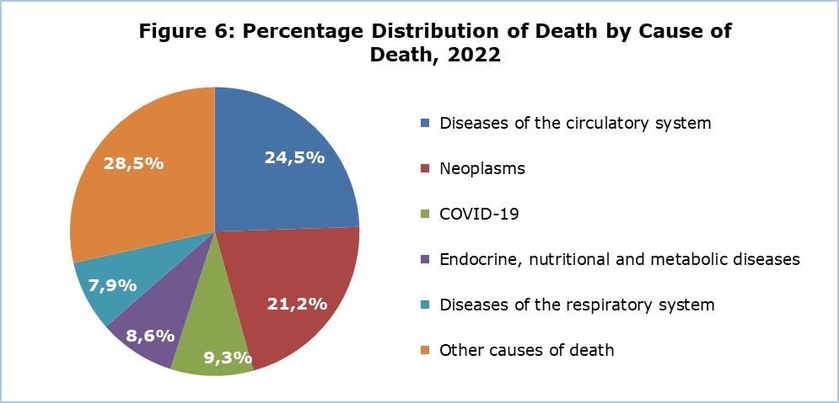

**METHODOLOGICAL INFORMATION**

**Definitions**

**In-patient** – Is a person who has been through the full admission procedure in a hospital, stayed at the hospital for treatment for at least one night and for whom a “Patient’s File” has been prepared.

**Day-care patient** – Is a person who has been through the full admission procedure in a hospital, was admitted and discharged at the same day and for whom a “Patient´s File” has been prepared.

**Discharge** – Is the conclusion of a period of in-patient care, irrespective of whether the patient returned home, was sent to another hospital, left the hospital without medical advice or died.

**Out-patient attendance** – Is the visit of the patient to an out-patient department of a hospital, clinic or the visit to a medical office.

**Sources of Data and Coverage**

**Coverage.** Up to May 2019, medical care in Cyprus was provided through the public and private sector health services. From June 2019 the gradual implementation of the GHS began, firstly at the level of the primary care (out-patient visits) and from June 2020, at the level of in-patient and day-care. The number of private hospitals contracted to GESY is gradually increasing. The figures included at the present press release refer to the primary care and the in-patient and day-care provided from all medical institutions contracted with the GHS i.e., medical institutions of the SHSO and of the private sector, in the Government controlled areas.

**In-patient and day-care patient discharges**. Data on patients who are admitted for treatment and discharged from the hospitals contracted with the GHS have been obtained from the IT system of the HIO.

**Out-patient attendances.** The data on out-patient attendances performed at the hospitals and physicians’ offices contracted with the GHS have been obtained from the IT system of the HIO.

**Causes of death.** The source is the Cause of Death Register owned by the Health Monitoring Unit of the Ministry of Health. The total number of deaths recorded in the register, includes all deaths occurring in Cyprus, both of residents and non-residents, as well as deaths of Cypriot residents occurring abroad.

***For more information:***

CYSTAT Portal, subtheme [Health](https://www.cystat.gov.cy/en/SubthemeStatistics?s=38)

[CYSTAT-DB](https://cystatdb.cystat.gov.cy/pxweb/en/8.CYSTAT-DB/8.CYSTAT-DB__Health__) (Online Database)

[Predefined Tables](https://www.cystat.gov.cy/en/KeyFiguresList?s=38) (Excel)

*Contact*

Eleni Kyriacou: Tel: +35722605114, Email: [ekyriacou@cystat.mof.gov.cy](mailto:ekyriacou@cystat.mof.gov.cy)

Nicoletta Petrou: Tel: +35722602158, Email: [npetrou@cystat.mof.gov.cy](mailto:npetrou@cystat.mof.gov.cy)