21 March, 2025

**PRESS RELEASE**

HOUSEHOLD BUDGET SURVEY: **2023**

**Mean Annual Household Consumption Expenditure €43.263**

Based on the results of the Household Budget Survey 2023, the mean annual consumption expenditure per household in 2023 amounted to €43.263, compared to €31.206 in 2015/2016 (Figure 1), recording an increase of 38,6%.

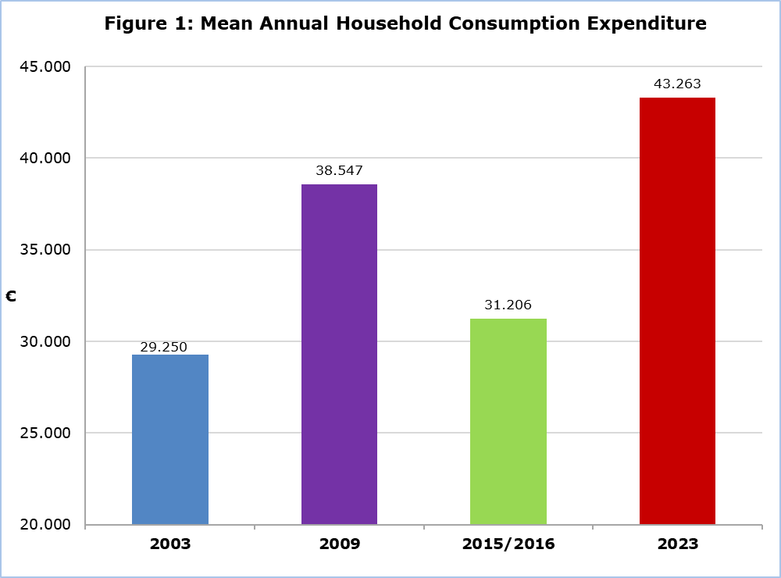

In the urban areas, the mean annual consumption expenditure per household in 2023 amounted to €44.548, compared to €31.884 in 2015/2016, recording an increase of 39,7%. Similarly, in the rural areas, the mean annual consumption expenditure per household in 2023 amounted to €40.505, compared to €29.740 in 2015/2016, recording an increase of 36,2% (Table 2).

**Analysis of Changes**

In all main categories of goods and services, there was an increase in expenditure compared to 2015/2016, with the exception of the category of “Health”, where a decrease of 26,4% was recorded (Table 1). The largest increase was recorded in the category «Insurance and financial services», where the expenditure increased by 126,5%. It is worth noting, that these two categories are linked, as the reduction in expenditure on health is attributed to the implementation of the General Healthcare System (GHS), while the significant increase in the category "Insurance and financial services" is due to the contributions of households to the GHS.

A significant increase was also recorded in the category of "Restaurants and accommodation services", where expenditure increased by 71,5%, and in the category of "Housing", where the increase amounted to 49,2%.

**Expenditure Distribution**

As it is shown in Figure 2, which presents the percentage distribution of the mean annual consumption expenditure by main category of goods and services, the largest share of the household annual expenditure corresponds to housing (27,5%), followed by food and non-alcoholic beverages (14,5%) and transport (11,6%). On the contrary, the smallest percentage is recorded in the alcoholic beverages and tobacco category (1,4%). Similar consumption patterns were observed in 2015/2016, with the corresponding percentages being 25,5%, 15,3%, 12,0% and 1,6%, respectively.

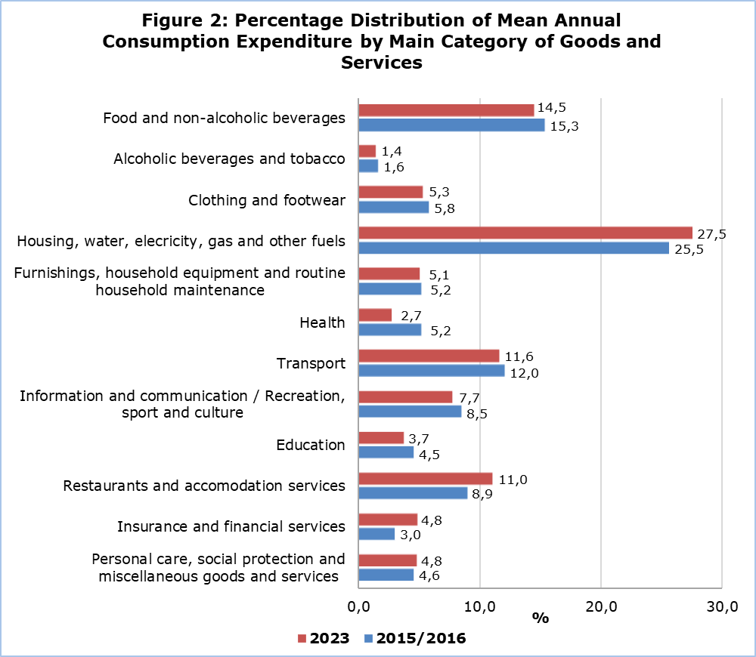

|  |  |  |  |  |
| --- | --- | --- | --- | --- |
| **Table 1** |  |  |  |  |
| **Main Categories of Goods and Services** | **Euro (€)** | | | **Change**  **2023/**  **2015-2016**  **(%)** |
| **2009** | **2015-2016** | **2023** |
| **Total** | **38.547** | **31.206** | **43.263** | **38,6** |
| **Food and non-alcoholic beverages** | 4.735 | 4.781 | 6.254 | 30,8 |
| **Alcoholic beverages and tobacco** | 507 | 502 | 598 | 19,1 |
| **Clothing and footwear** | 2.639 | 1.807 | 2.276 | 26,0 |
| **Housing, water, electricity, gas and other fuels** | 10.236 | 7.967 | 11.884 | 49,2 |
| **Furnishings, household equipment and routine household maintenance** | 2.207 | 1.615 | 2.185 | 35,3 |
| **Health** | 2.061 | 1.614 | 1.188 | -26,4 |
| **Transport** | 5.351 | 3.748 | 5.004 | 33,5 |
| **Information and communication(1)** | 3.446 | 2.638 | 1.468 | 26,5 |
| **Recreation, sport and culture(1)** | 1.870 |
| **Education** | 1.314 | 1.408 | 1.596 | 13,4 |
| **Restaurants and accommodation services** | 3.290 | 2.786 | 4.777 | 71,5 |
| **Insurance and financial services** | 721 | 921 | 2.086 | 126,5 |
| **Personal care, social protection and miscellaneous goods and services** | 2.041 | 1.420 | 2.075 | 46,1 |

Note (1): The categories "Information and communication" and "Recreation, sport and culture" are presented as two separate categories for the first time in 2023. To ensure data comparability across different years of the Household Budget Survey, in Tables 1 and 2, these two categories have been merged into a single category for the years 2009 and 2015/2016.

|  |  |  |  |  |  |  |  |  |  |
| --- | --- | --- | --- | --- | --- | --- | --- | --- | --- |
| **Table 2** |  |  |  |  |  |  |  |  |  |
| **Main Categories of Goods and Services** | **2015-2016 (€)** | | | **2023**  **(€)** | | | **Change 2023/2015-2016**  **(%)** | | |
| **Total** | **Urban** | **Rural** | **Total** | **Urban** | **Rural** | **Total** | **Urban** | **Rural** |
| **Total** | **31.206** | **31.884** | **29.740** | **43.263** | **44.548** | **40.505** | **38,6** | **39,7** | **36,2** |
| **Food and non-alcoholic beverages** | 4.781 | 4.669 | 5.022 | 6.254 | 6.153 | 6.471 | 30,8 | 31,8 | 28,9 |
| **Alcoholic beverages and tobacco** | 502 | 498 | 511 | 598 | 574 | 652 | 19,1 | 15,3 | 27,6 |
| **Clothing and footwear** | 1.807 | 1.875 | 1.660 | 2.276 | 2.307 | 2.208 | 26,0 | 23,0 | 33,0 |
| **Housing, water, electricity, gas and other fuels** | 7.967 | 8.169 | 7.530 | 11.884 | 12.734 | 10.061 | 49,2 | 55,9 | 33,6 |
| **Furnishings, household equipment and routine household maintenance** | 1.615 | 1.677 | 1.481 | 2.185 | 2.214 | 2.125 | 35,3 | 32,0 | 43,5 |
| **Health** | 1.614 | 1.634 | 1.571 | 1.188 | 1.238 | 1.079 | -26,4 | -24,2 | -31,3 |
| **Transport** | 3.748 | 3.818 | 3.597 | 5.004 | 4.914 | 5.195 | 33,5 | 28,7 | 44,4 |
| **Information and communication(1)** | 2.638 | 2.735 | 2.428 | 1.468 | 1.495 | 1.412 | 26,5 | 25,0 | 30,4 |
| **Recreation, sport and culture(1)** | 1.870 | 1.924 | 1.753 |
| **Education** | 1.408 | 1.449 | 1.320 | 1.596 | 1.745 | 1.276 | 13,4 | 20,4 | -3,3 |
| **Restaurants and accommodation services** | 2.786 | 2.885 | 2.571 | 4.777 | 5.021 | 4.255 | 71,5 | 74,0 | 65,5 |
| **Insurance and financial services** | 921 | 969 | 818 | 2.086 | 2.149 | 1.953 | 126,5 | 121,8 | 138,8 |
| **Personal care, social protection and miscellaneous goods and services** | 1.420 | 1.506 | 1.232 | 2.075 | 2.080 | 2.066 | 46,1 | 38,1 | 67,7 |

**METHODOLOGICAL INFORMATION**

**Survey Identity**

The content, methods and definitions used in the Household Budget Survey 2023 were in accordance with the recommendations and the methodology of the European Statistical Office (EUROSTAT).

**Objectives of the Survey**

The aim of the Household Budget Survey (HBS) is to collect data that reflect the households' purchasing trends and habits throughout the year. The data from the survey is utilised for the following purposes:

* revising the goods and services included in the "shopping basket," as well as the weighting factors that determine the relative importance of each good and service within the Consumer Price Index.
* updating statistical data used to estimate private consumption for national accounts purposes.
* analyzing the level and distribution of household expenditure and income, by source of income and various socioeconomic and demographic groups.
* the compilation of various socioeconomic indicators with the ultimate goal of studying the standard of living of households.

**Coverage and Response**

The initial sample of the survey included 4.800 households, in the Government controlled area, from all districts of Cyprus, in both urban and rural areas. A total of 2.985 households participated in the survey, which corresponds to approximately 0,8% of the total number of households. The response rate of the survey was 74.0%.

**Data Collection**

Data collection is conducted through personal interviews with households, using laptops (CAPI) to complete the main questionnaire.

Additionally, households are provided with a daily expenditure diary, in which all household members aged 16 and over record, with the help of the enumerator (where considered necessary), all daily household expenditure for 14 consecutive days.

**Reference Period**

The households that were selected were evenly distributed over a 12-month period, from April 2023 to March 2024, so that seasonal fluctuations in consumers’ purchasing habits could be accurately reflected.

**Definitions**

**Main categories of goods and services:** The classification of goods and services (COICOP) that was proposed by EUROSTAT was used for the survey. The thirteen (13) main categories of goods and services are:

• 01 Food and non-alcoholic beverages

• 02 Alcoholic beverages and tobacco

• 03 Clothing and footwear

• 04 Housing, water, electricity, gas and other fuels

• 05 Furnishings, household equipment and routine household maintenance

• 06 Health

• 07 Transport

• 08 Information and communication

• 09 Recreation, sport and culture

• 10 Education

• 11 Restaurants and accommodation services

• 12 Insurance and financial services

• 13 Personal care, social protection and miscellaneous goods and services

**Household:** A household consists of either a single person living alone or a group of two or more people residing together in the same dwelling, not necessarily related, who jointly make food and living arrangements, maintaining, to a greater or lesser extent, a shared budget.

**Consumption Expenditure:** The total value of all goods and services purchased by the household for consumption within one year. It includes the consumption of goods from their own production (mainly agricultural products and food), as well as the imputed rent value for homeowners and housing occupants living rent-free. Additionally, it includes expenditure on gifts purchased for other households, whereas gifts received by the household from others are excluded. Consumption expenditure does not include investments, savings and direct taxes.

**Imputed rent:** The self-assessment of the value of the rent that an owner/occupier of a dwelling would pay if they were to rent their house, based on the market rents for similar dwellings.

***For more information:***

CYSTAT Portal, subtheme [Living Conditions, Social Protection](https://www.cystat.gov.cy/en/SubthemeStatistics?id=44)

[CYSTAT-DB](https://cystatdb.cystat.gov.cy/pxweb/en/8.CYSTAT-DB/8.CYSTAT-DB__Living%20Conditions,%20Social%20Protection) (Online Database)

[Predefined Tables](https://www.cystat.gov.cy/en/KeyFiguresList?s=44&p=3) (Excel)

[Methodological Information](https://www.cystat.gov.cy/en/MethodologicalDetails?m=2282)

**The Predefined Tables, available in Excel format, are updated up to and including the HBS2015/2016. For the data concerning the HBS 2023 and onwards, data will only be published on the CYSTAT-DB Online Database.**

*Contact*

Eleni Haperi: Tel:+35722602157, Email: [ehaperi@cystat.mof.gov.cy](mailto:ehaperi@cystat.mof.gov.cy)

Anastasia Pashiardi: Tel:+35722605113, Email: [apashiardi@cystat.mof.gov.cy](mailto:apashiardi@cystat.mof.gov.cy)