**CENSUS OF POPULATION 2021**

**“Take part, everybody counts”**

[www.census2021.cystat.gov.cy](https://www.census2021.cystat.gov.cy/en)

23 December, 2021

**PRESS RELEASE**

SURVEY RESULTS ON INFORMATION AND COMMUNICATION TECHNOLOGIES USAGE IN HOUSEHOLDS AND BY INDIVIDUALS 2021

**Use of Internet**

In 2021, Internet access in households reached 93,4% compared to 92,8% in 2020. 80,0% of households have access to a personal computer (desktop, laptop/netbook or tablet) and a computer is found in almost all (95,4%) households with dependent children. In households with no dependent children that percentage drops to 74,2%. (Table 1)

Regarding the frequency of Internet use, nine out of ten individuals use the Internet at least once a week. The Internet use decreases with age. Starting from 98,9% for the 16 – 24 age group the Internet use drops to 71,0% for the 55 – 74 age group. Persons with high educational attainment level (98,7%) use the internet more frequently than persons with low educational attainment level (67,8%). (Figure 1)

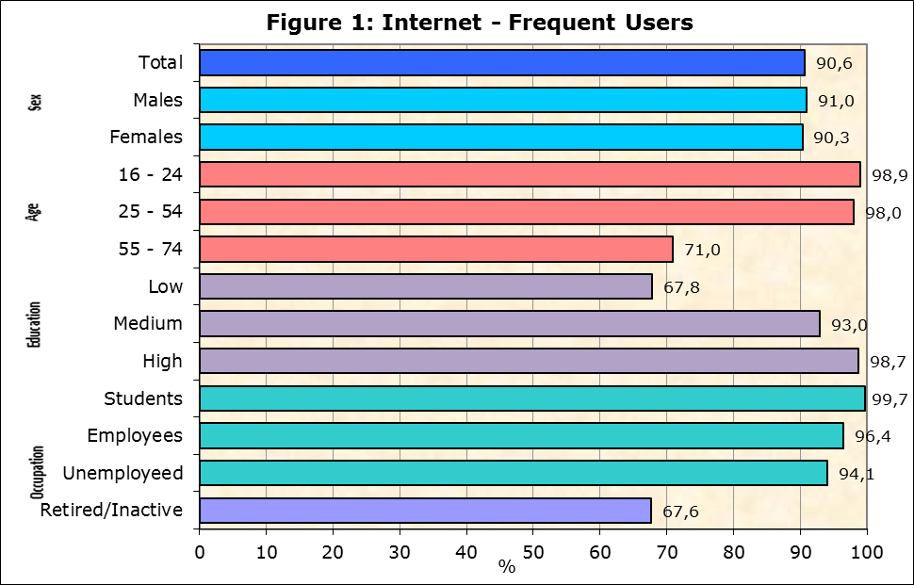

The most popular Internet activities by individuals during the first quarter of 2021 were instant messaging via Skype, Messenger, WhatsApp, Viber (94,3%), making calls over the Internet (94,2%), reading online news / newspapers / magazines (88,8%), finding information about goods or services (87,1%) and participating in social networks (Facebook, twitter) (86,6%). (Table 2)

21,7% of persons that used the Internet in the first quarter of 2021, did an online course and 19,0% used online learning material other than a complete online course. (Table 2)

**e-Government**

During the period of April 2020 - March 2021 the percentage of individuals who used the Internet for interaction with public authorities has increased to 57,3% compared to 53,3% in the corresponding period of 2019-2020. (Table 3)

55,9% of individuals aged 16-74 used the internet to obtain information from public authorities or public services websites or apps, 47,6% to download or print official forms and 45,8% to submit completed forms online. (Figure 2)

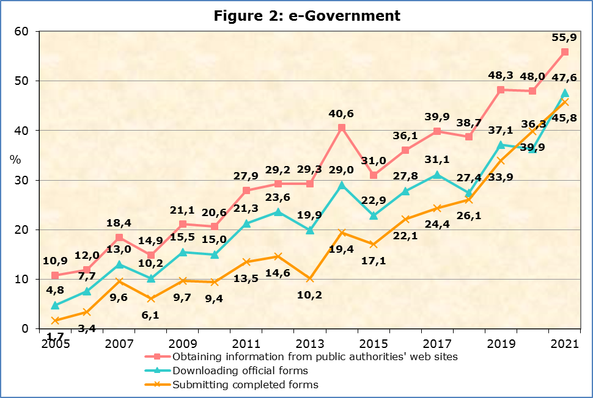

**e-Commerce**

The percentage of individuals 16-74 years old placing online orders during the first quarter of the year increased to 48,0% in 2021 compared to 34,1% in 2020. (Table 4)

The most popular categories of goods/services ordered online were the following: deliveries or pick up from restaurants, fast-food chains (68,6%), clothes (including sport clothing) shoes or accessories (62,0%), computers, tablets, mobile phones or accessories (32,6%) and cosmetics, beauty or wellness products (20,3%). (Figure 3)

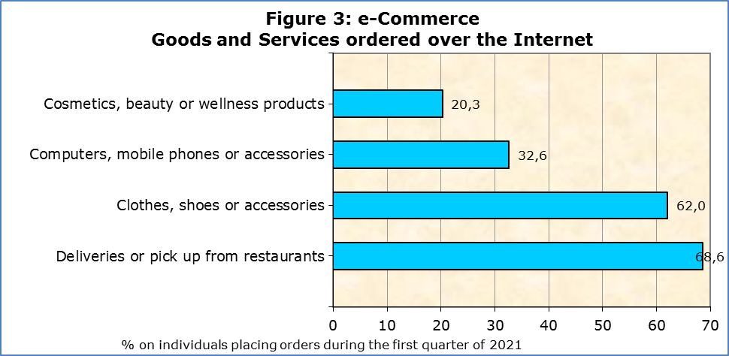

Three out of four individuals, or 75,5% who bought or ordered goods or services for private use in the first quarter of 2021, preferred sellers from Cyprus, 61,8% bought from sellers from other EU countries and 56,8% from sellers from the rest of the world. (Table 4)

|  |  |  |  |  |
| --- | --- | --- | --- | --- |
| **Table 1** |  |  |  |  |
| **Computer / Internet in Households**  (% of Households) | **2018** | **2019** | **2020** | **2021** |
| **Personal Computer** | **78,7** | **74,8** | **78,1** | **80,0** |
| **By household type:** |  |  |  |  |
| With dependent children | 93,3 | 90,7 | 94,5 | 95,4 |
| Without dependent children | 72,0 | 68,2 | 71,0 | 74,2 |
| **Households with Internet Access** | **86,2** | **89,6** | **92,8** | **93,4** |

|  |  |  |  |  |
| --- | --- | --- | --- | --- |
| **Table 2** |  |  |  |  |
| **Internet Use** | **2018** | **2019** | **2020** | **2021** |
| **Individuals that Used the Internet**  (during the 1st quarter of the year)  (% on total individuals aged 16-74) | **84,4** | **86,1** | **90,8** | **90,8** |
| **Most popular Internet Activities**  (% on total individuals aged 16-74 that used the Internet during the 1st quarter of the year) | | | | |
| Telephoning over the internet/video calls (via webcam) over the internet | 74,4 | 84,0 | 94,0 | 94,2 |
| Using instant messaging | … | 88,6 | 92,4 | 94,3 |
| Finding information about goods and services | 85,1 | 83,2 | 86,2 | 87,1 |
| Participation in Social Networks | 81,7 | 83,3 | 86,1 | 86,6 |
| Reading online news | … | 81,9 | 78,8 | 88,8 |

**Learning Activities over the Internet**

|  |  |  |  |  |
| --- | --- | --- | --- | --- |
| Online course | … | 6,6 | 20,6 | 21,7 |
| Online material | … | 13,1 | 18,4 | 19,0 |
|  |  |  |  |  |

… Data not available

|  |  |  |  |  |  |
| --- | --- | --- | --- | --- | --- |
| **Table 3** |  | |  |  |  |
| **e-Government**  (% on total individuals aged 16 - 74) | **2018** | | **2019** | **2020** | **2021** |
| **Individuals Interacted with Public Authorities**  (during the period of 04/20 – 03/21) | | **41,7** | **50,3** | **53,3** | **57,3** |
| Obtaining information from public authorities’ web sites | 38,7 | | 48,3 | 48,0 | 55,9 |
| Downloading official forms | 27,4 | | 37,1 | 36,3 | 47,6 |
| Submitting completed forms | 26,1 | | 33,9 | 39,9 | 45,8 |

|  |  |  |  |  |
| --- | --- | --- | --- | --- |
| **Table 4** |  |  |  |  |
| **e-Commerce** | | | **2020** | **2021** |
| **Purchases / Orders of goods and services over the Internet**  (during the 1st quarter of the year)  (% on total individuals aged 16-74 that used the Internet) | | | **34,1** | **48,0** |
|  | | | | |

**Country of Origin of Sellers**

(% on total individuals aged 16-74 that ordered goods or services over the Internet during the 1st quarter of the year)

|  |  |  |  |  |
| --- | --- | --- | --- | --- |
| Sellers from Cyprus |  |  | 65,8 | 75,5 |
| Sellers from other EU countries |  |  | 60,3 | 61,8 |
| Sellers from the rest of the world |  |  | 49,9 | 56,8 |

**METHODOLOGICAL NOTES**

**Aim**

The aim of the survey is to collect data on the access of households to selected Information and Communication Technologies (ICT), the use of Internet, use of e-Government, e-Commerce, e-Skills and Privacy and Protection of Personal Data.

**Coverage**

The survey was conducted during the period April – June 2021 and covered 1.782 households with at least one member aged 16 – 74 (inclusive) and 3.635 individuals aged 16 – 74 (inclusive). The survey covers all the government controlled areas of the Republic of Cyprus.

Sampling

The sampling frame used for the selection of the sample was the 2011 Population Census Frame, with reference date the 1st of October 2011. The sampling units are households. Auxiliary information for each household (district, municipality, quarter, address, number of persons, telephone numbers) is also included in the frame. The 2011 Census frame was updated at different time periods with data obtained from the Electricity Authority of Cyprus.

The selection of the sample in urban areas is done by simple random sampling (one-stage sampling). In rural areas, two-stage sampling is used. Villages are the primary sampling units, while households are the secondary sampling units. Neighbouring Villages with a small number of households are merged in order to create complexes with a minimum number of households. The sample of villages is selected with probability proportional to the size of the village (PPS). Some villages are large and therefore their probability of selection is equal to 1. A simple random sample of households is selected from each village.

All individuals, aged 16-74 (inclusive), within each sampled household were selected.

Data Collection

The data collection was conducted through telephone interviews with all individuals of household aged 16 -74 (inclusive). In case of absence of an individual, some other member that knew answered the questionnaire.

Reference Period

The data refers to first quarter of 2021, unless otherwise stated.

Definitions

e- Commerce: Use of e-commerce refers to the purchase of goods and services over the Internet for private use via any device. Purchases refer to ordering goods or services for which payment is required but the payment does not have to be online. Orders via manually typed e-mails, SMS or MMS should be excluded.

e- Government: Use of e-government refers to electronic contacts via the Internet with public authorities and some public services. Contacts through manually typed e-mails should be excluded.

**Use of Internet:** Internet use via any device: desktop, laptop, netbook, tablet, as well as smart phones, games consoles, e-book readers.

***For more information:***

CYSTAT Portal, subtheme [Information Society](https://www.cystat.gov.cy/en/SubthemeStatistics?s=40)

[CYSTAT-DB](https://cystatdb.cystat.gov.cy/pxweb/en/8.CYSTAT-DB/8.CYSTAT-DB__Information%20Society__) (Online Database)

View the related [**Infographic**](https://www.cystat.gov.cy/en/Infographics/) (Infographic)

**Data up to 2020 are available in excel format under** [Predefined Tables](https://www.cystat.gov.cy/en/KeyFiguresList?s=40)

*Contact*

Antreas Charalambous: Tel:+35726804436, Email.: [ancharalambous@cystat.mof.gov.cy](mailto:ancharalambous@cystat.mof.gov.cy)

Constantinos Minas: Tel.: +35722602112, Email: [cmina@cystat.mof.gov.cy](mailto:cmina@cystat.mof.gov.cy)

Eleni Christodoulidou: Tel.: +35722602142, Email: [echristodoulidou@cystat.mof.gov.cy](mailto:echristodoulidou@cystat.mof.gov.cy)