3 December, 2024

**PRESS RELEASE**

Results of the survey on the usage of information and communication technologies (ict) and e-commerce in enterprises 2024

**Remote Working-Use of Portable Devices, Remote Access and Meetings Over the Internet**

During 2024, 84,1% of enterprises with 10 or more persons employed, provided their employees portable devices that allow a mobile connection to the internet using mobile telephone networks. The subscription and usage costs of these devices are being paid either in full or at least up to a limit by the enterprise. (Figure 1)

88,1% of all enterprises provide remote access to their e-mail system, 71,7% to the enterprise’s documents, including spreadsheets, presentations or any other files and 66,3% provide remote access to the enterprise’s business applications or to software used by the enterprise, such as applications or software related to accounting, sales, CRM or other business software. (Figure 1)

Remote access refers to the enterprises’ readiness, capacity and willingness to make it possible for the persons they employ to work remotely, by giving them remote access to the enterprises’ resources (e.g. e-mail, documents and ICT systems of the enterprise).

In 2024, 59,1% of all enterprises have conducted remote meetings via the internet (e.g., Skype, Zoom, MS Teams, WebEx etc.). (Figure 1)

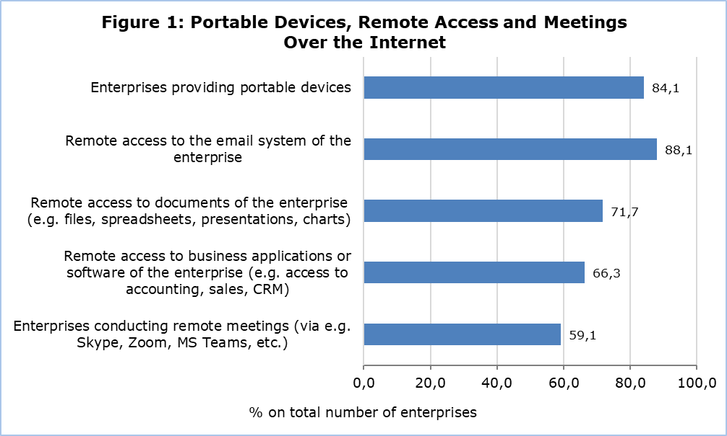

**E-Commerce Sales**

During 2023, almost one out of four enterprises (23,5%) received orders for goods and services via computer networks, 22,7% via websites or “apps” and 2,5% via EDI–type messages. 17,1% of all enterprises received orders for goods and services via the enterprises’ own websites or “apps”, while 14,2% received orders via e-commerce marketplace websites or “apps” used by several enterprises for trading products. 21,2% of enterprises received orders via websites or “apps” from private customers compared to 11,4% of enterprises which received orders from other businesses and/or from the government or public authorities. (Figure 2)

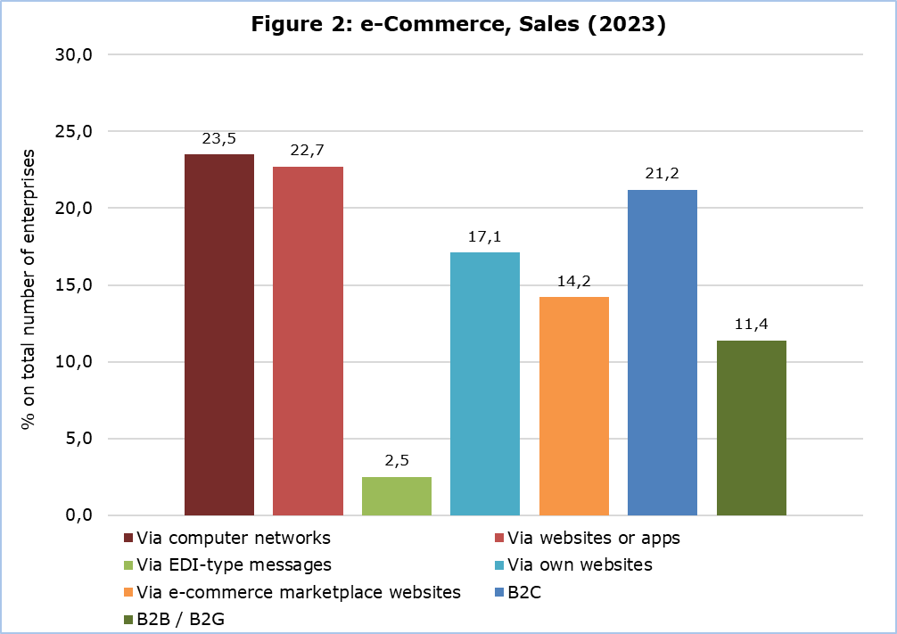

**Advertising Over the Internet**

Advertising over the internet refers to paid advertisements by the enterprises in order to promote their goods and services. In 2024, almost one out of two (49,4%) enterprises declared that they paid to advertise on the internet. Compared to 2016 that figure almost doubled. 43,5% paid for targeted advertisements based on the geolocation of the internet users, 38,4% of enterprises paid for targeted advertisements based on content or keywords searched by the internet users and 28,7% based on tracking of past activities and profile of the internet users. (Table 1)

Ict specialists and skills

The information and communications technologies (ICT) specialist develops, designs, maintains, operates and services systems and applications that are used to store, retrieve and send data.

In 2024, 27,5% of enterprises employ ICT specialists. In large enterprises, this percentage reaches 85,8%, in medium 49,6% and in small enterprises 22,8%. (Table 2)

The proportion of enterprises, that provided any type of training during 2023 to develop ICT related skills to either ICT specialists or other persons employed, remains low at 15,3% and 27,0% respectively. In large enterprises the corresponding percentages are 59,4% (ICT specialists) and 78,3% (other persons employed). (Table 2)

12,2% of enterprises with 10 or more persons employed recruited or tried to recruit ICT specialists in 2023. More than half of those enterprises (6,4%) faced difficulties to fill the ICT specialists’ vacancies during 2023. (Table 2)

**ICT Security**

ICT security refers to the measures, controls and procedures applied on an enterprise’s ICT systems to ensure integrity, authenticity, availability and confidentiality of the enterprise’s data and systems.

The most common ICT security measures applied by enterprises are: authentication via strong password (95,0%), data backup to a separate location (including backup to the cloud) (90,0%), network access control (management of user rights in enterprise’s network) (73,9%), VPN (Virtual Private Network) (67,3%) and ICT security monitoring system used to detect suspicious activity (e.g. intrusion detection or prevention systems) (56,0%). (Figure 3)

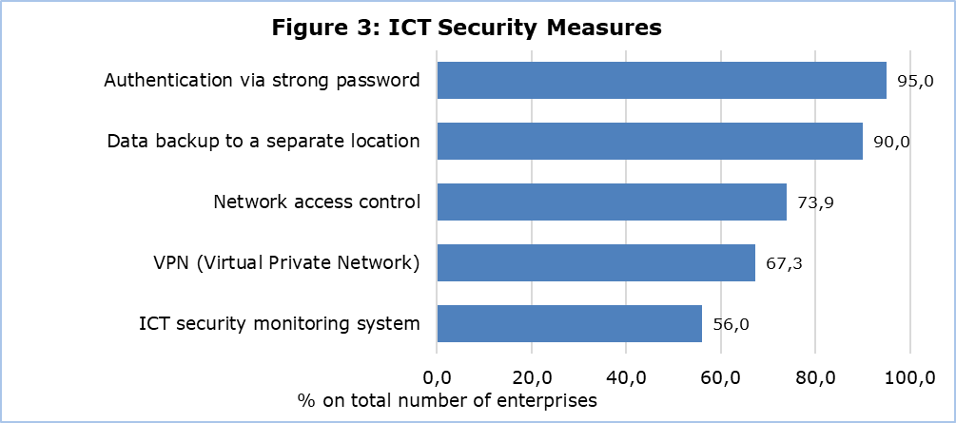

**Artificial Intelligence**

In 2024, 7,9% of all enterprises in Cyprus used Artificial Intelligence (AI) technologies compared to 4,7% in 2023. 34,9% of large size enterprises use AI, 14,3% of medium enterprises and 6,3% of small enterprises. (Figure 4)

AI refers to systems that use technologies such as text mining, computer vision, speech recognition, natural language generation, machine learning, deep learning to gather and/or use data to predict, recommend or decide, with varying levels of autonomy, the best action to achieve specific goals.

The adoption of AI technologies is growing steadily across enterprises of all sizes, with large enterprises leading the way. Large enterprises have the highest rate of AI adoption. In 2021, 13% of large enterprises used AI technologies, increasing to 15,5% in 2023 and to 34,9% in 2024. (Figure 4)

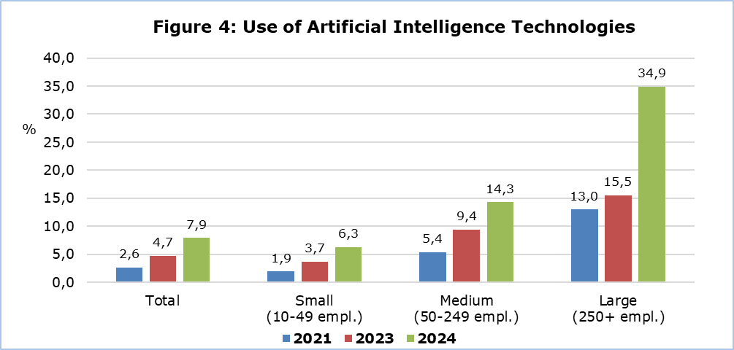

|  |  |  |  |  |  |  |  |
| --- | --- | --- | --- | --- | --- | --- | --- |
| **Table 1** |  |  | |  |  |  |  |
| **Advertising over the internet**  (% on total number of enterprises) |  |  | | **2016** | **2018** | **2023** | **2024** |
| Enterprises paying to advertise over the internet | | | | 25,0 | 32,9 | 43,5 | 49,4 |
| Enterprises paying to advertise over the internet based on content or keywords searched by users | | | 17,5 | | 27,2 | 33,0 | 38,4 |
| Enterprises paying to advertise on the internet based on the tracking of internet users' past activities or profile | | | 12,1 | | 15,7 | 21,8 | 28,7 |
| Enterprises paying to advertise on the internet based on the geolocation of internet users | | | 13,3 | | 18,2 | 28,5 | 43,5 |

|  |  |  |  |  |  |  |  |
| --- | --- | --- | --- | --- | --- | --- | --- |
| **Table 2** | | | | | | | |
| **ICT specialists**  (% on total number of enterprises) |  |  |  | **Total** | **Small**  **(10-49 empl.)** | **Medium (50-249 empl.)** | **Large (250+ empl.)** |
| **Enterprises employing ICT specialists** | | | | 27,5 | 22,8 | 49,6 | 85,8 |
| Enterprises that provided any type of training to develop ICT related skills of ICT specialists employed, during the previous year | | | | 15,3 | 11,9 | 31,3 | 59,4 |
| Enterprises that provided any type of training to develop ICT related skills of other persons employed, during the previous year | | | | 27,0 | 22,7 | 47,9 | 78,3 |
| Enterprises that recruited or tried to recruit ICT specialists, during the previous year | | | | 12,2 | 9,7 | 23,0 | 49,1 |
| Enterprises that had vacancies for ICT specialists that were difficult to fill, during the previous year | | | | 6,4 | 4,9 | 13,4 | 26,4 |
| Enterprises that faced difficulties to recruit ICT specialists during the previous year, due to: | | | |  |  |  |  |
| * lack of applications | | | | 4,6 | 3,5 | 9,8 | 17,9 |
| * applicants' lack of relevant ICT related qualifications from education and/or training | | | | 4,7 | 3,5 | 10,3 | 17,9 |
| * applicants' lack of relevant work experience | | | | 4,4 | 3,2 | 10,2 | 18,9 |
| * applicants' salary expectations being too high | | | | 4,7 | 3,6 | 8,8 | 24,5 |
| ICT functions of the enterprise during the previous year performed by own employees (incl. those employed in parent or affiliate enterprises) | | | | 40,9 | 36,9 | 59,8 | 93,4 |
| ICT functions of the enterprise during the previous year performed by external suppliers | | | | 84,5 | 84,8 | 84,2 | 77,4 |
|  | | | |  |  |  |  |

**METHODOLOGICAL NOTES**

**Aim**

The aim of the survey is to collect data about the use of information and communication technologies by enterprises, the access and use of the internet, e-commerce, ICT specialists and skills, ICT security and the use of artificial intelligence. These data are necessary for the implementation of policy programmes, both for the government and the private sector. The survey is co-funded by the European Union and is carried out simultaneously in all EU Member States.

**Coverage**

The survey was carried out during February-June 2024 and covered around 4.950 enterprises with 10 or more persons employed in the following economic activities:

|  |  |
| --- | --- |
| **NACE Rev.2** | **Description** |
| C | Manufacturing |
| D | Electricity, Gas, Steam and Air Conditioning Supply |
| E | Water Supply, Sewerage, Waste Management and Remediation Activities |
| F | Construction |
| G | Wholesale and Retail Trade. Repair of motor vehicles, motorcycles |
| Η | Transport and Storage |
| I | Accommodation and Food Service Activities |
| J | Information and Communication |
| L | Real Estate Activities |
| M | Professional, Scientific and Technical Activities |
| N | Administrative and Support Service Activities |
| S | Other Service Activities |

**Sampling**

For the year 2024 all small, medium and large enterprises with 10 or more employed persons and self-employed persons were covered on a census basis. In the population there were 32 economic activity groupings and 3 enterprise size groups based on the number of persons employed: small (10-49 persons employed), medium (50-249 persons employed) and large (250+ persons employed).

**Data Collection**

The data collection was conducted with the use of a web-based questionnaire.

**Reference Period**

The data refer to 2024, unless otherwise stated.

**Definitions**

**Application (App):** A mobile app, short for mobile application or just app, is application software designed for a specific purpose (e.g. entertainment, shopping, etc.), downloaded and used on computers depending on their operating system (e.g. portable devices such as tablets, smartphones, etc.)

**Autentication:** Authentication is a way to ascertain that a user is who they claim to be. This is usually performed by presenting one or more challenges to the user.

**Electronic commerce (e-commerce):** An e-commerce transaction is the sale or purchase of goods or services, conducted over computer networks by methods specifically designed for the purpose of receiving or placing orders.

ICT specialists: Employees for whom ICT is their main job. For example, they are responsible for the development, operation or maintenance of ICT systems or applications.

Internet: the internet is a global system of interconnected computer networks that use the standard internet Protocol Suite (TCP/IP) to serve billions of users worldwide.

**Marketplace (e-commerce marketplace):** the term "e-commerce marketplace" refers to websites or apps used by several enterprises for trading products e.g. Booking, eBay, Amazon, Amazon Business, Alibaba, Rakuten, etc.

**Machine learning (incl. deep learning):** Machine learning involves ‘training’ a computer model to better perform an automated task, e.g. pattern recognition.

**Natural language generation (NLG):** Natural language generation is the ability for a computer program to convert data into natural language representation.

**Natural language processing (NLP):** Natural language processing is the ability for a computer program to understand human language as it is spoken.

**Sales via website (web sales):** web sales are sales made via an online store (web shop), via web forms on a website or extranet, or apps.

**Speech recognition:** Speech recognition is the ability of a machine or program to identify words and phrases in spoken language and convert them to a machine-readable format.

***For more information:***

CYSTAT Portal, subtheme [Information Society](https://www.cystat.gov.cy/en/SubthemeStatistics?s=40)

[CYSTAT-DB](https://cystatdb.cystat.gov.cy/pxweb/en/8.CYSTAT-DB/8.CYSTAT-DB__Information%20Society__) (Online Database)

[Infographic](https://www.cystat.gov.cy/en/Infographics/)

[Methodological Information](https://www.cystat.gov.cy/en/MethodologicalDetails?m=2028)

[Summary Results](https://www.cystat.gov.cy/en/PublicationList?s=40)

**Data up to 2020 are available in Excel format under** [Predefined Tables](https://www.cystat.gov.cy/en/KeyFiguresList?s=40)

*Contact*

Constantinos Minas: Tel.: +35722602112, Email: [cmina@cystat.mof.gov.cy](mailto:cmina@cystat.mof.gov.cy)