4 December, 2025

PRESS RELEASE

Results of the survey on the usage of information and communication technologies (ict) and e-commerce in enterprises 2025

Internet Connection Speed

98,2% of enterprises have fixed internet connection. The demand for high-speed internet connections (100 Mbit/s or more) has increased significantly over the years. In 2025, 87,3% of enterprises have internet connection speeds higher than 100 Mbit/s compared to 44,8% in 2021. (Table 1)

In 2025, the most popular contracted download speed among enterprises in Cyprus was at least 100 Mbit/s but less than 500 Mbit/s (36,5% of all enterprises). The second most popular download speed was at least 1 Gbit/s (26,2%), followed by the enterprises with download speeds of at least 500 Mbit/s but less than 1 Gbit/s with 24,6% and of at least 30 Mbit/s but less than 100 Mbit/s with 8,9%. The least favourite download speed was the less than 30 Mbit/s with 2,0%. (Figure 1)

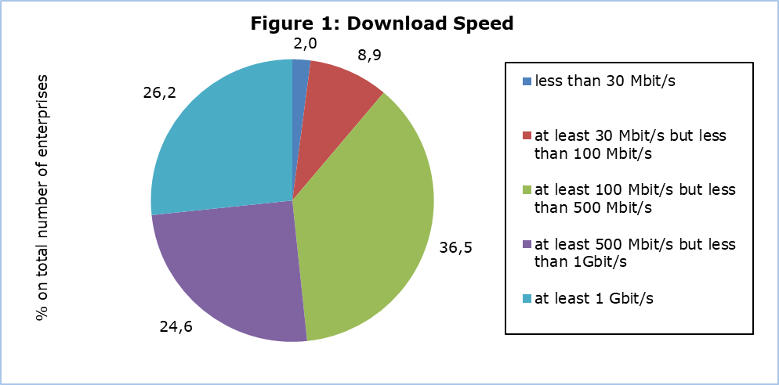

E-Commerce Sales

During 2024, almost one out of four enterprises (23,9%) received orders for goods and services via computer networks, 23,0% via websites or “apps” and 1,9% via EDI–type messages. 17,1% of all enterprises received orders for goods and services via the enterprises’ own websites or “apps”, while 14,1% received orders via e-commerce marketplace websites or “apps” used by several enterprises for trading products. 21,9% of enterprises received orders via websites or “apps” from private customers compared to 10,0% of enterprises which received orders from other businesses and/or from the government or public authorities. (Figure 2)

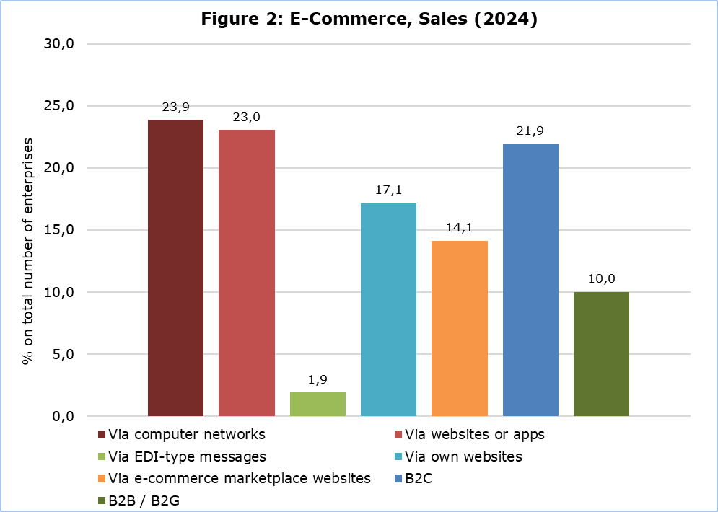

Artificial Intelligence

In 2025, 9,3% of all enterprises in Cyprus used artificial intelligence (AI) technologies compared to 2,6% in 2021. 35,1% of large size enterprises use AI, 15,3% of medium and 7,7% of small. (Figure 3)

AI refers to systems that use technologies such as text mining, computer vision, speech recognition, natural language generation, machine learning, deep learning to gather and/or use data to predict, recommend or decide, with varying levels of autonomy, the best action to achieve specific goals.

The adoption of AI technologies is growing steadily across enterprises of all sizes. Compared to 2021, when the use of AI technologies was first measured, the use of AI by large enterprises has risen from 13,0% to 35,1% in 2025. The use of AI technologies by medium-sized enterprises has increased from 5,4% in 2021 to 15,3% in 2025. In small enterprises that percentage rose from 1,9% to 7,7%. (Figure 3)
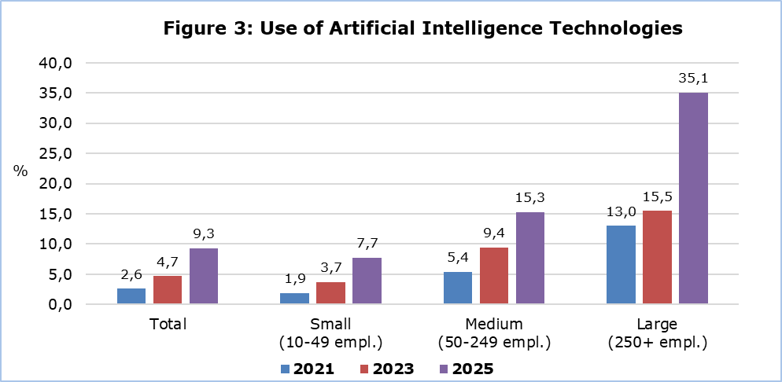

Use of a Business Software and Data Analytics

Enterprise Resource Planning (ERP) is the most popular business software used by enterprises in Cyprus. ERP consists of one or more sets of software applications that integrate information and processes across the several business functions within an enterprise (e.g. accounting, planning, production, marketing). In 2025, 41,0% of enterprises use an ERP software. (Figure 4)

The second most popular business software is the Customer Relationship Management (CRM) software. It refers to any software application used for managing customer information. CRM collects customer information derived from different channels, integrates it in one database, processes and analyses information related to the customers. The customer is at the center of the business activity. 33,1% of all enterprises in Cyprus use a CRM software. (Figure 4)

The third most popular software is the Business Intelligence (BI) software. It accesses and analyses data (e.g. from data warehouses, data lakes) from internal IT systems and external sources and presents analytical findings in reports (summaries, graphs, charts, etc.) to provide users with detailed insights for decision-making and strategic planning. 22,1% of all enterprises use BI software. (Figure 4)

There seems to be a connection between the size of an enterprise and its likelihood of using business software such as ERP, CRM, or BI. Smaller enterprises tend to adopt these tools less frequently, while the use of such software by large enterprises more common. In general, the larger an enterprise is, the more likely it is to utilize business software to support its operations. (Figure 4)

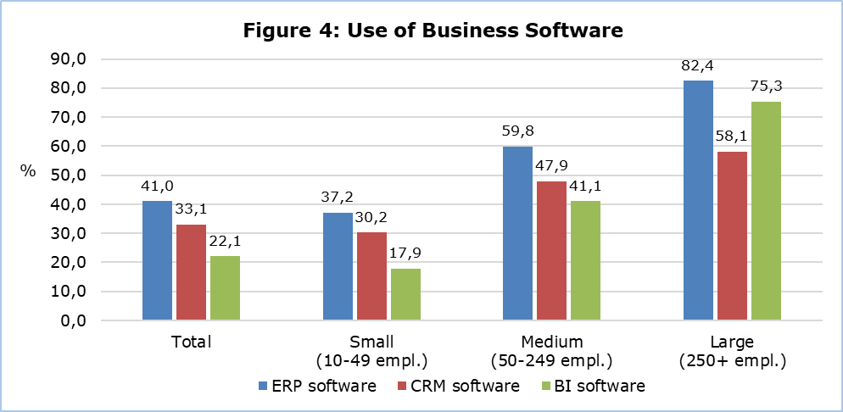

33,7% of all enterprises declared that the enterprise’s own employees perform data analytics on any data source, internal (from enterprises’ own information systems, sensors, smart meters, own websites or social media) or external data (from other enterprises, public authorities or publicly available data from websites or social media). 16,0% of enterprises choose to hire a service provider (external enterprise or organization) to perform data analytics on their behalf rather than doing so themselves. (Table 2)

Enterprises Using Environmentally Friendly Procedures (ICT and the Environment)

25,4% of all enterprises use ICT systems or solutions to reduce energy consumption and 22,3% use ICT systems or sollutions to reduce the materials used or enhance the use of recycled materials - including consumables. (Table 3)

ICT equipment (e.g. computers, monitors) that is no longer used, is disposed in an electronic waste collection/recycling facility by 68,6% of enterprises, is kept in the enterprise (for spare parts) by 53,2% and is sold, donated or returned to the leasing enterprise by 32,6%. (Table 3)

Table 1
Download Speed  (% on total number of enterprises) |  | 2021 | 2022 | 2023 | 2024 | 2025
Enterprises with fixed broadband connection to the internet |  | 96,6 | 91,9 | 96,4 | 98,1 | 98,2
Less than 30 Mbit/s |  | 15,5 | 8,0 | 4,9 | 2,3 | 2,0
At least 30 Mbit/s but less than 100 Mbit/s |  | 36,2 | 22,7 | 19,3 | 12,3 | 8,9
100 Mbit/s or more |  | 44,8 | 61,2 | 72,1 | 83,5 | 87,3

Table 2
Use of Business Software and Data Analytics  (% on total number of enterprises) |  | Total | Small  (10-49 empl.) | Medium (50-249 empl.) | Large (250+ empl.)
Enterprises using an Enterprise Resource Planning (ERP) software |  | 41,0 | 37,2 | 59,8 | 82,4
Enterprises using Customer Relationship Management (CRM) software |  | 33,1 | 30,2 | 47,9 | 58,1
Enterprises using Business Intelligence (BI) software |  | 22,1 | 17,9 | 41,1 | 75,3
Enterprises (own employees) performing data analytics |  | 33,7 | 29,9 | 51,7 | 77,8
Enterprises using an external enterprise or organization to perform data analytics |  | 16,0 | 14,9 | 22,4 | 22,0

Table 3
ICT and the Environment  (% on total number of enterprises) |  |  |  |  |  |  | 2025
Use of ICT systems or solutions to reduce the energy consumption |  |  |  |  |  |  | 25,4
Use of ICT systems or solutions to reduce the materials used |  |  |  |  |  |  | 22,3
Disposal of ICT equipment (recycle) |  |  |  |  |  |  | 68,6
Keep the ICT equipment that is no longer used (spare parts) |  |  |  |  |  |  | 53,2
Sale, donate or return to the leasing company of the ICT equipment that is no longer used |  |  |  |  |  |  | 32,6

METHODOLOGICAL NOTES

Aim

The aim of the survey is to collect data about the use of information and communication technologies by enterprises, the access and use of the internet, e-commerce, data utilisation and analytics, the use of cloud computing services, artificial intelligence and the environmental impact of ICT usage. These data are necessary for the implementation of policy programmes, both for the government and the private sector. The survey is co-funded by the European Union and is carried out simultaneously in all EU Member States.

Coverage

The survey was carried out during February-June 2025 and covered 5.232 enterprises with 10 or more persons employed in the following economic activities:
NACE Rev.2 | Description
C | Manufacturing
D | Electricity, Gas, Steam and Air Conditioning Supply
E | Water Supply, Sewerage, Waste Management and Remediation Activities
F | Construction
G | Wholesale and Retail Trade. Repair of motor vehicles, motorcycles
Η | Transport and Storage
I | Accommodation and Food Service Activities
J | Information and Communication
L | Real Estate Activities
M | Professional, Scientific and Technical Activities
N | Administrative and Support Service Activities
S | Other Service Activities

Sampling
For the year 2025 all small, medium and large enterprises with 10 or more employed persons and self-employed persons were covered on a census basis. In the population there were 32 economic activity groupings and 3 enterprise size groups based on the number of persons employed: small (10-49 persons employed), medium (50-249 persons employed) and large (250+ persons employed).

Data Collection
The data collection was conducted with the use of a web-based questionnaire.

Reference Period
The data refer to 2025, unless otherwise stated.

Definitions

Application (App): A mobile app, short for mobile application or just app, is application software designed for a specific purpose (e.g. entertainment, shopping, etc.), downloaded and used on computers depending on their operating system (e.g. portable devices such as tablets, smartphones, etc.)

Electronic commerce (e-commerce): An e-commerce transaction is the sale or purchase of goods or services, conducted over computer networks by methods specifically designed for the purpose of receiving or placing orders.

EDI e-commerce: EDI (electronic data interchange) is an e-business tool for exchanging different kinds of business messages (without the individual message being manually typed). “EDI e-commerce” is limited to EDI messages placing an order.

Marketplace (e-commerce marketplace): the term "e-commerce marketplace" refers to websites or apps used by several enterprises for trading products e.g. Booking, eBay, Amazon, Amazon Business, Alibaba, Rakuten, etc.

Sales via website (web sales): web sales are sales made via an online store (web shop), via web forms on a website or extranet, or apps.

Internet: the internet is a global system of interconnected computer networks that use the standard internet Protocol Suite (TCP/IP) to serve billions of users worldwide.

Internet connection speed: the term internet connection speed refers to the maximum contracted download speed of the fastest fixed internet connection of the enterprise.

Text mining: Text mining refers to the use of advanced techniques for automated detection of patterns in (large) texts.

Computer Vision: Computer vision tasks include methods for acquiring, processing, analysing and understanding digital images, and extraction of high-dimensional data.

Machine learning (incl. deep learning): Machine learning involves ‘training’ a computer model to better perform an automated task, e.g. pattern recognition.

Natural language generation (NLG): Natural language generation is the ability for a computer program to convert data into natural language representation.

Natural language processing (NLP): Natural language processing is the ability for a computer program to understand human language as it is spoken.

Speech recognition: Speech recognition is the ability of a machine or program to identify words and phrases in spoken language and convert them to a machine-readable format.

For more information:
CYSTAT Portal, subtheme Information Society
CYSTAT-DB (Online Database)
Infographic
Methodological Information
Summary Results

Data up to 2020 are also available in Excel format under Predefined Tables

Contact
Constantinos Minas: Tel.: +357 22602112, Email: cmina@cystat.mof.gov.cy

