15 December, 2022

**PRESS RELEASE**

SURVEY RESULTS ON INFORMATION AND COMMUNICATION TECHNOLOGIES USAGE IN HOUSEHOLDS AND BY INDIVIDUALS 2022

**Use of Internet**

Nine out of ten individuals use the Internet at least once a week. The Internet use decreases with age. Starting from 98,8% for the 16–24 age group the Internet use drops to 71,1% for the 55 – 74 age group. Persons with high educational attainment level (97,9%) use the internet more frequently than persons with low educational attainment level (64,4%). (Figure 1)

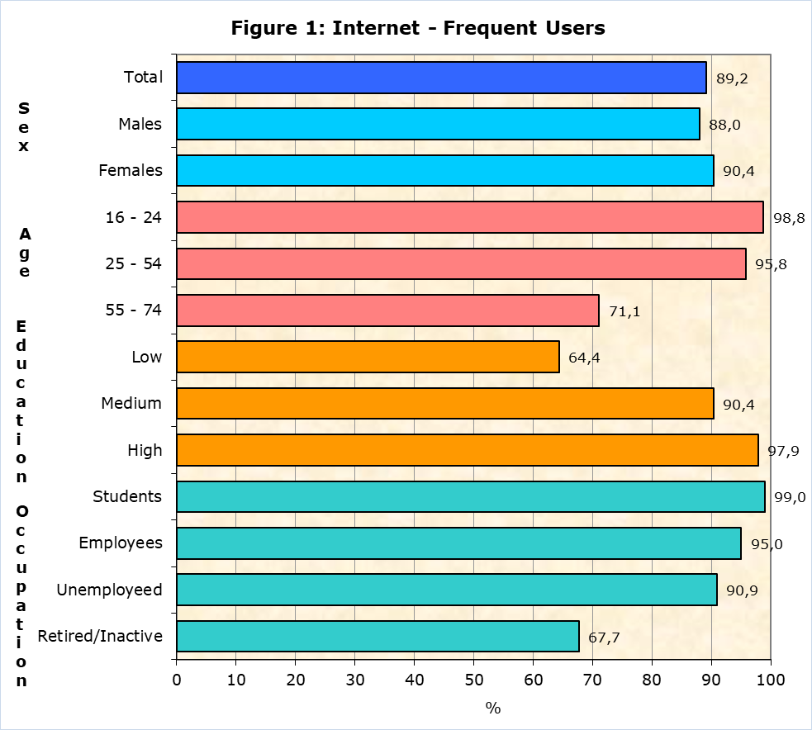

The most popular Internet activities by individuals during the first quarter of 2022 were instant messaging via Skype, Messenger, WhatsApp and Viber (91,9%), making calls over the Internet (91,4%), watching video content from sharing services like YouTube (88,6%), participating in social networks like Facebook and Twitter (87,0%) and finding information about goods or services (81,6%). (Table 1)

17,8% of persons that used the Internet in the first quarter of 2022, used online learning material other than a complete online course, 17,7% had an online course and 17,0% communicated with educators or learners using audio or video online tools. (Table 1)

**e-Government**

During the period of April 2021 - March 2022, 50,7% of individuals aged 16-74 accessed information stored about them by public authorities or public services, 41,2% obtained information and 15,3% accessed information from public databases or registers.

**e-Commerce**

The percentage of individuals 16-74 years old placing online orders during the first quarter of the year decreased to 37,0% in 2022 compared to 48,0% in 2021. (Table 2)

The most popular categories of goods/services ordered online were the following: clothes (including sport clothing) shoes or accessories (75,8%), deliveries or pick up from restaurants, fast-food chains (71,8%), sports goods (excluding sport clothing) (34,5%) and computers, mobile phones or accessories (30,6%). (Figure 2)

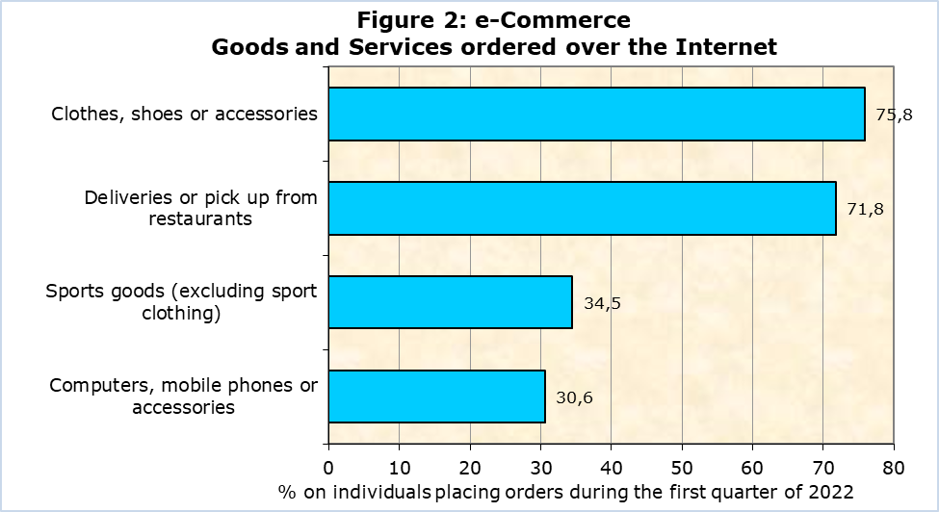

Among the people who bought or ordered goods or services for private use in the first quarter of 2022, 84,8% prefer sellers from Cyprus, 77,7% bought from sellers from other EU countries and 59,7% from sellers from the rest of the world. (Table 2)

|  |  |  |  |  |  |  |  |  |
| --- | --- | --- | --- | --- | --- | --- | --- | --- |
| **Table 1** | |  | |  | |  | |  |
| **Internet Use** | | **2019** | | **2020** | | **2021** | | **2022** |
| **Households with Internet Access** | **89,6** | | **92,8** | | **93,4** | | **94,0** | |
| **Individuals that Used the Internet**  (during the 1st quarter of the year)  (% on total individuals aged 16-74) | | **86,1** | | **90,8** | | **90,8** | | **89,6** |
| **Most popular Internet Activities**  (% on total individuals aged 16-74 that used the Internet during the 1st quarter of the year) | | | | | | | | |
| Using instant messaging | | 88,6 | | 92,4 | | 94,3 | | 91,9 |
| Telephoning over the internet/video calls (via webcam) over the internet | | 84,0 | | 94,0 | | 94,2 | | 91,4 |
| Watching video content from sharing services | | 81,7 | | 83,3 | | … | | 88,6 |
| Participation in Social Networks | | 83,3 | | 86,1 | | 86,6 | | 87,0 |
| Finding information about goods and services | | 83,2 | | 86,2 | | 87,1 | | 81,6 |
| **Learning Activities over the Internet** | |  | |  | |  | |  |
| Online material | | 13,1 | | 18,4 | | 19,0 | | 17,8 |
| Online course | | 6,6 | | 20,6 | | 21,7 | | 17,7 |
| Communication with instructors or students | | 7,9 | | 10,1 | | … | | 17,0 |

… Data not available

|  |  |  |  |  |
| --- | --- | --- | --- | --- |
| **Table 2** |  |  |  |  |
| **e-Commerce** |  | **2020** | **2021** | **2022** |
| **Purchases / Orders of goods and services over the Internet**  (during the 1st quarter of the year)  (% on total individuals aged 16-74 that used the Internet) | | **34,1** | **48,0** | **37,0** |
| **Country of Origin of Sellers**  (% on total individuals aged 16-74 that ordered goods or services over the Internet during the 1st quarter of the year) | | | | |
| Sellers from Cyprus |  | 65,8 | 75,5 | 84,8 |
| Sellers from other EU countries |  | 60,3 | 61,8 | 77,7 |
| Sellers from the rest of the world |  | 49,9 | 56,8 | 59,7 |

**METHODOLOGICAL NOTE**

**Aim**

The aim of the survey is to collect data on the access of households to selected Information and Communication Technologies (ICT), the use of Internet, use of e-Government, e-Commerce, Internet of Things and Green ICT.

**Coverage**

The survey was conducted during the period April – June 2022 and covered 1.664 households with at least one member aged 16 – 74 (inclusive) and 3.268 individuals aged 16 – 74 (inclusive). The survey covers all the government controlled areas of the Republic of Cyprus.

Sampling

The sampling frame used for the selection of the sample was the 2011 Population Census Frame, with reference date the 1st of October 2011. The sampling units are households. Auxiliary information for each household (district, municipality, quarter, address, number of persons, telephone numbers) is also included in the frame. The 2011 Census frame was updated at different time periods with data obtained from the Electricity Authority of Cyprus.

The selection of the sample in urban areas is done by simple random sampling (one-stage sampling). In rural areas, two-stage sampling is used. Villages are the primary sampling units, while households are the secondary sampling units. Neighbouring Villages with a small number of households are merged in order to create complexes with a minimum number of households. The sample of villages is selected with probability proportional to the size of the village (PPS). Some villages are large and therefore their probability of selection is equal to 1. A simple random sample of households is selected from each village.

All individuals, aged 16-74 (inclusive), within each sampled household were selected.

Data Collection

The data collection was conducted through telephone interviews with all individuals of household aged 16 -74 (inclusive). In case of absence of an individual, another member of the household who knew, answered the questionnaire.

Reference Period

The data refers to first quarter of 2022, unless otherwise stated.

Definitions

e- Commerce: Use of e-commerce refers to the purchase of goods and services over the Internet for private use via any device. Purchases refer to ordering goods or services for which payment is required but the payment does not have to be online. Orders via manually typed e-mails, SMS or MMS should be excluded.

e- Government: Use of e-government refers to electronic contacts via the Internet with public authorities and some public services. Contacts through manually typed e-mails should be excluded.

**Use of Internet:** Internet use via any device: desktop, laptop, netbook, tablet, as well as smart phones, games consoles, e-book readers.

***For more information:***

CYSTAT Portal, subtheme [Information Society](https://www.cystat.gov.cy/en/SubthemeStatistics?s=40)

[CYSTAT-DB](https://cystatdb.cystat.gov.cy/pxweb/en/8.CYSTAT-DB/8.CYSTAT-DB__Information%20Society__) (Online Database)

**Data up to 2020 are available in excel format under** [Predefined Tables](https://www.cystat.gov.cy/en/KeyFiguresList?s=40)

*Contact*

Antreas Charalambous: Tel:+35726804436, Email.: [ancharalambous@cystat.mof.gov.cy](mailto:ancharalambous@cystat.mof.gov.cy)

Thomas Gregoriou: Tel.: +35722602126, Email: [tgregoriou@cystat.mof.gov.cy](mailto:tgregoriou@cystat.mof.gov.cy)