12 December, 2024

**PRESS RELEASE**

**SURVEY RESULTS ON INFORMATION AND COMMUNICATION TECHNOLOGIES (ICT) USAGE IN HOUSEHOLDS AND BY INDIVIDUALS 2024**

**Use of the Internet**

On the basis of the results of the ad hoc survey carried out by the Statistical Service of Cyprus, more than nine out of ten individuals use the internet at least once a week (94,4%). Internet use decreases with age: starting from 99,9% for the 16–24 age group, internet use drops to 83,3% for the 55–74 age group. Persons with high educational attainment level use the internet more frequently (99,6%) than persons with low educational attainment level (76,8%). (Figure 1)

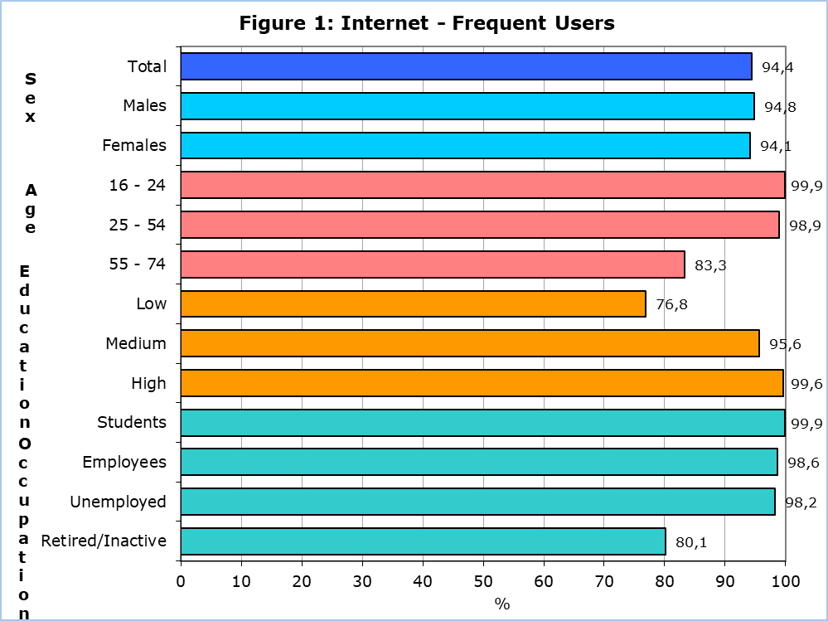

The most popular internet activities by individuals during the first quarter of 2024 were instant messaging via Skype, Messenger, WhatsApp and Viber (97,3%), making calls over the internet (97,2%), finding information about goods or services (94,3%), participating in social networks like Facebook and Twitter (91,8%) and watching video content from sharing services (91,3%). (Table 1)

Of the persons that used the internet in the first quarter of 2024, 10,3% used online learning material other than a complete online course, 10,0% had an online course and 9,7% communicated with educators or learners using audio or video online tools. (Table 1)

**e-Government**

During the period April 2023 - March 2024, 70,6% of individuals aged 16-74 years, obtained information from public authorities online, 54,0% accessed information stored about them by public authorities or public services and 22,8% accessed information from public databases or registers.

**e-Commerce**

The proportion of individuals aged 16-74 years old placing online orders during the first quarter of 2024 increased significantly to 63,6% compared to 55,3% in the corresponding period of 2023. (Figure 2)

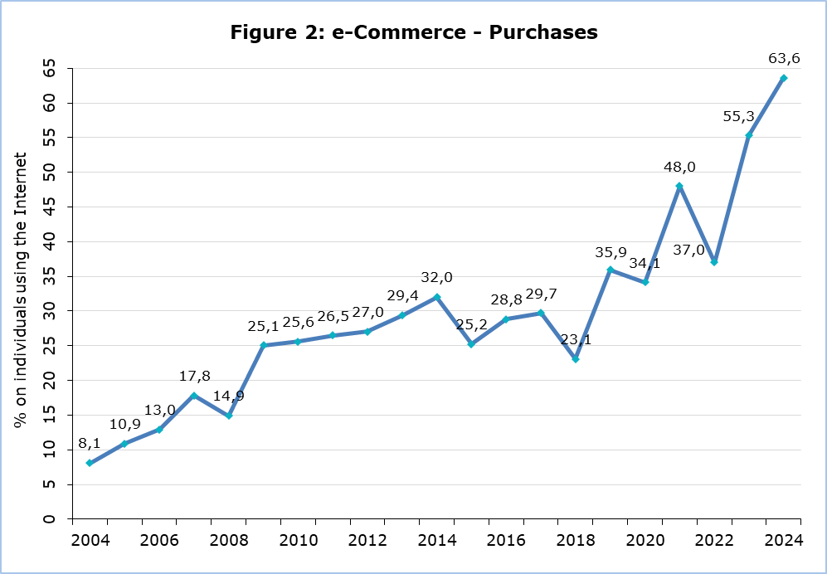

The most popular categories of goods/services ordered online were the following: clothes (including sport clothing), shoes or accessories (85,3%), deliveries or pick up from restaurants, fast-food chains (78,8%), computers, mobile phones or accessories (53,4%) and cosmetics, beauty or wellness products (33,4%).

Among the people who bought or ordered goods or services for private use in the first quarter of 2024, 46,5% bought accommodation services, 45,5% bought transport services and 33,2% bought tickets to events. (Table 2)

|  |  |  |  |  |  |  |
| --- | --- | --- | --- | --- | --- | --- |
| **Table 1** | |  | |  |  |  |
| **Internet Use** | | **2021** | | **2022** | **2023** | **2024** |
| **Households with Internet Access (%)** | **93,4** | | **94,0** | | **92,3** | **94,9** |
| **Individuals that Used the Internet**  (during the 1st quarter of the year)  (% on total individuals aged 16-74) | | **90,8** | | **89,6** | **91,2** | **94,4** |
| **Most Popular Internet Activities**  (% on total individuals aged 16-74 that used the internet  during the 1st quarter of the year) | | | | | | |
| Using instant messaging | | 94,3 | | 91,9 | 95,9 | 97,3 |
| Telephoning over the internet/video calls (via webcam) over the internet | | 94,2 | | 91,4 | 95,4 | 97,2 |
| Finding information about goods and services | | 88,8 | | 78,4 | 89,1 | 94,3 |
| Participation in social networks | | 86,6 | | 87,0 | 90,5 | 91,8 |
| Watching video content from sharing services | | 83,3 | | 88,6 | … | 91,3 |
| **Learning Activities over the Internet**  (% on total individuals aged 16-74 that used the internet  during the 1st quarter of the year) | |  | |  |  |  |
| Online material | | 19,0 | | 17,8 | 14,8 | 10,3 |
| Online course | | 21,7 | | 17,7 | 13,3 | 10,0 |
| Communication with instructors or students | | … | | 17,0 | 10,9 | 9,7 |

… Data not available

|  |  |  |  |  |
| --- | --- | --- | --- | --- |
| **Table 2** |  |  |  |  |
| **e-Commerce** |  | **2022** | **2023** | **2024** |
| **Purchases / Orders of Goods and Services over the Internet**  (during the 1st quarter of the year)  (% on total individuals aged 16-74 that used the internet) | | **37,0** | **55,3** | **63,6** |
| **Services Bought over the Internet**  (% on total individuals aged 16-74 that ordered goods or services  over the internet during the 1st quarter of the year) | | | | |
| Accommodation services |  | … | … | 46,5 |
| Transport services from enterprises |  | … | … | 45,5 |
| Tickets to events |  | … | … | 33,2 |

… Data not available

**METHODOLOGICAL NOTE**

**Aim**

The aim of the survey is to collect data on the access to selected Information and Communication Technologies (ICT), the use of the internet, use of e-government, e-commerce, internet of things and green ICT.

**Coverage**

The survey was conducted during the period April – June 2024 and covered 1.838 households with at least one member aged 16 – 74 and 3.763 individuals aged 16 – 74 years.

Sampling

The sampling frame used for the selection of the sample was the 2021 Population Census, with reference date the 1st of October 2021. The sampling units are the households.

The selection of the sample in urban areas was done by simple random sampling (one-stage sampling). In rural areas, two-stage sampling was used. Communities constituted the primary sampling units, while households were the secondary sampling units. Neighbouring communities with a small number of households were merged in order to create agglomerations with a minimum number of households. The sample of communities was selected with probability proportional to the size of the community (PPS). Some communities are large and therefore their probability of selection was equal to 1. A simple random sample of households was then selected within each community sampled.

All individuals aged 16-74 years within each sampled household were selected for an interview.

Data Collection

The data collection was conducted through personal interviews with all individuals of households aged 16-74 years. In case of absence of an individual, another family member helped with the answers.

Reference Period

The data refer to the first quarter of 2024, unless otherwise stated.

Definitions

Use of e-Commerce: refers to the purchase of goods and services over the internet for private use via any device. Purchases refer to ordering goods or services for which payment is required but the payment does not have to be online. Orders via manually typed e-mails, SMS or MMS are excluded.

Use of e-Government: refers to electronic contacts via the internet with public authorities and some public services. Contacts through manually typed e-mails are excluded.

**Use of the Internet:** Internet use via any device: desktop, laptop, netbook, tablet, as well as smart phones, games consoles, e-book readers.

***For more information:***

CYSTAT Portal, subtheme [Information Society](https://www.cystat.gov.cy/en/SubthemeStatistics?s=40)

[CYSTAT-DB](https://cystatdb.cystat.gov.cy/pxweb/en/8.CYSTAT-DB/8.CYSTAT-DB__Information%20Society__) (Online Database)

[Methodological Information](https://www.cystat.gov.cy/en/MethodologicalDetails?m=2022)

[Summary Results](https://www.cystat.gov.cy/en/PublicationList?s=40&pcID=1)

**Data up to 2020 are available in excel format under** [Predefined Tables](https://www.cystat.gov.cy/en/KeyFiguresList?s=40).

*Contact*

Antreas Charalambous: Tel: +35726804436, Email.: [ancharalambous@cystat.mof.gov.cy](mailto:ancharalambous@cystat.mof.gov.cy)