11 December, 2025

PRESS RELEASE

SURVEY RESULTS ON INFORMATION AND COMMUNICATION TECHNOLOGIES (ICT) USAGE IN HOUSEHOLDS AND BY INDIVIDUALS 2025

Use of the Internet

On the basis of the results of the ad hoc survey carried out by the Statistical Service of Cyprus, more than nine out of ten individuals use the internet at least once a week (93,6%). Internet use decreases with age: starting from 98,5% for the 16–24 age group, internet use drops to 81,5% for the 55–74 age group. Persons with high educational attainment level use the internet more frequently (98,9%) than persons with low educational attainment level (75,9%). (Figure 1)

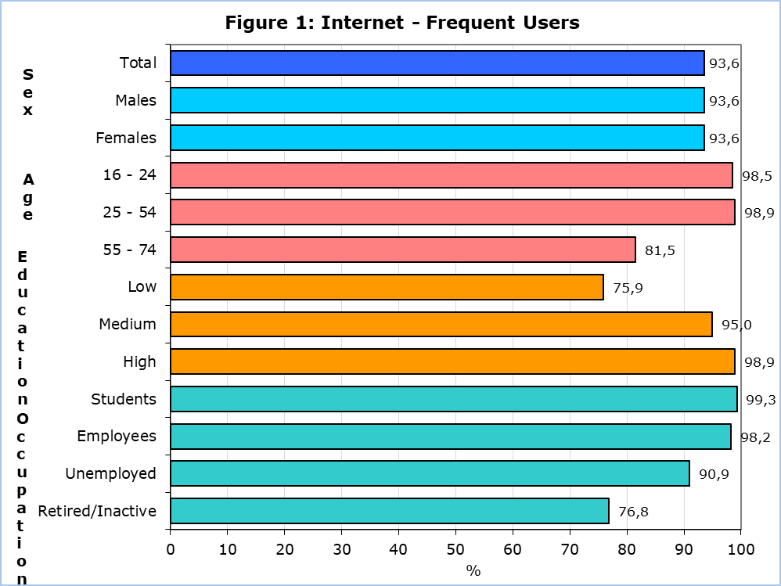

The most popular internet activities by individuals during the first quarter of 2025 were making calls over the internet (96,4%), instant messaging via Skype, Messenger, WhatsApp and Viber (96,2%), participating in social networks like Facebook and X (formerly Twitter) (92,3%), reading online news (91,1%) and finding information about goods or services (88,2%) (Table 1)

Of the persons that used the internet in the first quarter of 2025, 20,5% used online learning material other than a complete online course, 17,8% had an online course and another 17,8% communicated with educators or learners using audio or video online tools. (Table 1)

e-Government

During the period April 2024 - March 2025, 62,7% of individuals aged 16-74 years, obtained information from public authorities online, 52,0% accessed information stored about them by public authorities or public services and 31,9% accessed information from public databases or registers.

e-Commerce

The proportion of individuals aged 16-74 years old placing online orders during the first quarter of 2025 slightly decreased to 62,0% compared to 63,6% in the corresponding period of 2024. (Figure 2)

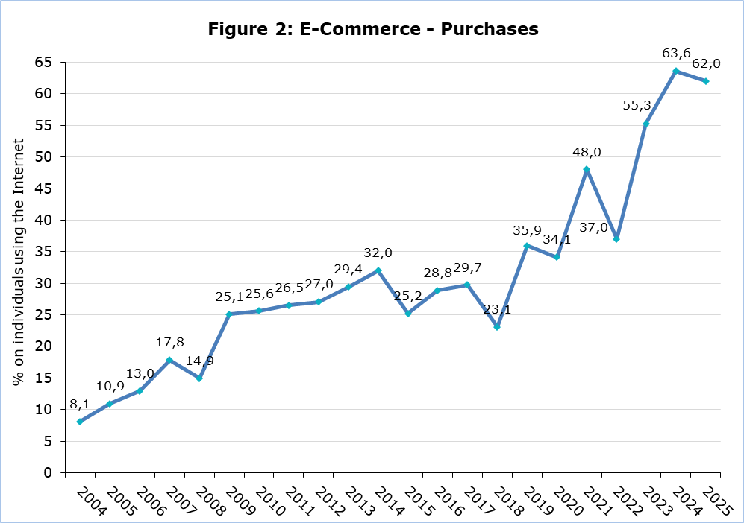

The most popular categories of goods/services subscribed online were the following: film, series, or sports streaming services (43,5%), music streaming services (18,3%), gaming streaming services (9,5%) and apps related to health or fitness (7,5%).

Among the people who bought or ordered goods or services for private use in the first quarter of 2025, 58,6% bought tickets to events, 53,2% bought accommodation services and 50,3% bought transport services. (Table 2)

Table 1
Internet Use |  | 2022 |  | 2023 | 2024 | 2025
Households with Internet Access (%) | 94,0 |  | 92,3 |  | 94,9 | 95,6
Individuals that Used the Internet  (during the 1st quarter of the year)  (% on total individuals aged 16-74) |  | 89,6 |  | 91,2 | 94,4 | 93,6
Most Popular Internet Activities
(% on total individuals aged 16-74 that used the internet
during the 1st quarter of the year)
Telephoning over the internet/video calls (via webcam) over the internet |  | 91,4 |  | 95,4 | 97,2 | 96,4
Using instant messaging |  | 91,9 |  | 95,9 | 97,3 | 96,2
Participation in social networks |  | 87,0 |  | 90,5 | 91,8 | 92,3
Reading online news |  | 78,5 |  | 89,1 | 89,3 | 91,1
Finding information about goods and services |  | 78,4 |  | 89,1 | 94,3 | 88,2
Learning Activities over the Internet
(% on total individuals aged 16-74 that used the internet
during the 1st quarter of the year)
Online material |  | 17,8 |  | 14,8 | 10,3 | 20,5
Online course |  | 17,7 |  | 13,3 | 10,0 | 17,8
Communication with instructors or students |  | 17,0 |  | 10,9 | 9,7 | 17,8
… Data not available

Table 2
e-Commerce |  | 2023 | 2024 | 2025
Purchases / Orders of Goods and Services over the Internet  (during the 1st quarter of the year)  (% on total individuals aged 16-74 that used the internet) |  | 55,3 | 63,6 | 62,0
Services Bought over the Internet
(% on total individuals aged 16-74 that ordered goods or services
over the internet during the 1st quarter of the year)
Accommodation services |  | … | 46,5 | 53,2
Transport services from enterprises |  | … | 45,5 | 50,3
Tickets to events |  | … | 33,2 | 58,6
… Data not available

METHODOLOGICAL NOTE

Aim
The aim of the survey is to collect data on the access to selected Information and Communication Technologies, the use of the internet, use of e-government, use of electronic identification (eID), e-commerce, e-skills and privacy and protection of personal data.

Coverage
The survey was conducted during the period April – June 2025 and covered 1.718 households with at least one member aged 16 – 74 and 3.275 individuals aged 16 – 74 years.

Sampling
The sampling frame used for the selection of the sample was the 2021 Population Census, with reference date the 1st of October 2021. The sampling units are the households.

The selection of the sample in urban areas was done by simple random sampling (one-stage sampling). In rural areas, two-stage sampling was used. Communities constituted the primary sampling units, while households were the secondary sampling units. Neighbouring communities with a small number of households were merged in order to create agglomerations with a minimum number of households. The sample of communities was selected with probability proportional to the size of the community (PPS). Some communities are large and therefore their probability of selection was equal to 1. A simple random sample of households was then selected within each community sampled.

All individuals aged 16-74 years within each sampled household were selected for an interview.

Data Collection
The data collection was conducted through personal interviews with all individuals of households aged 16-74 years. In case of absence of an individual, another family member helped with the answers.

Reference Period
The data refer to the first quarter of 2025, unless otherwise stated.

Definitions

Use of e-Commerce: refers to the purchase of goods and services over the internet for private use via any device. Purchases refer to ordering goods or services for which payment is required but the payment does not have to be online. Orders via manually typed e-mails, SMS or MMS are excluded.

Use of e-Government: refers to electronic contacts via the internet with public authorities and some public services. Contacts through manually typed e-mails are excluded.

Use of the Internet: Internet use via any device: desktop, laptop, netbook, tablet, as well as smart phones, games consoles, e-book readers.

For more information:
CYSTAT Portal, subtheme Information Society
CYSTAT-DB (Online Database)
Methodological Information
Publications

Data up to 2020 are available in excel format under Predefined Tables.

Contact
Antreas Charalambous: Tel.: +357 26804436, Email: ancharalambous@cystat.mof.gov.cy

