7 December, 2023

**PRESS RELEASE**

Results of the survey on the usage of information and communication technologies (ict) and e-commerce in enterprises 2023

**Use of social media and mobile applications**

In 2023, almost 8 out of 10 enterprises (79,9%) in Cyprus use any kind of social media. Enterprises using social media are considered those that have a user profile, an account for business purposes or a user license depending on the requirements and the type of the social media.

In particular, 79,7% of all enterprises with 10 or more employed persons use social networks (e.g. Facebook, LinkedIn, etc.), 38,5% use multimedia content sharing websites or apps (e.g. YouTube, Instagram, etc.) and 22,7% use blogs or microblogs (e.g. Twitter, etc.). 8,5% of enterprises have a mobile application for clients (e.g. loyalty program, customer support, etc.). (Figure 1)

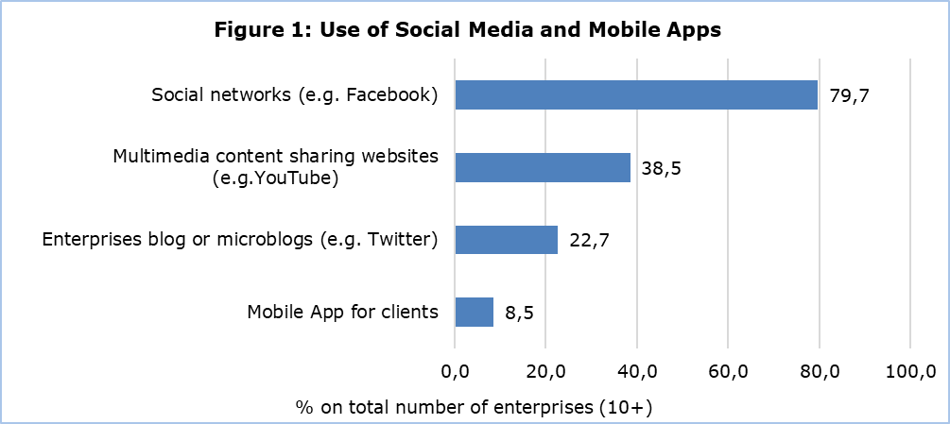

**Internet connection Speed**

96,4% of enterprises have internet connection. The demand for high-speed internet connections (100 Mbit/s or more) has increased significantly over the years. In 2023, 72,1% of enterprises have internet connection speeds higher than 100 Mbit/s compared to 17,1% in 2019. (Table 1)

In 2023, the most popular contracted download speed among enterprises in Cyprus was at least 100 Mbit/s but less than 500 Mbit/s (41,6% of all enterprises). The second most popular download speed was at least 30 Mbit/s but less than 100 Mbit/s (19,3%), followed by the enterprises with download speeds of more than 1 Gbit/s with 16,1% and of at least 500 Mbit/s but less than 1 Gbit/s with 14,5%. The least favourite download speed was less than 30 Mbit/s (4,9%). (Figure 2)

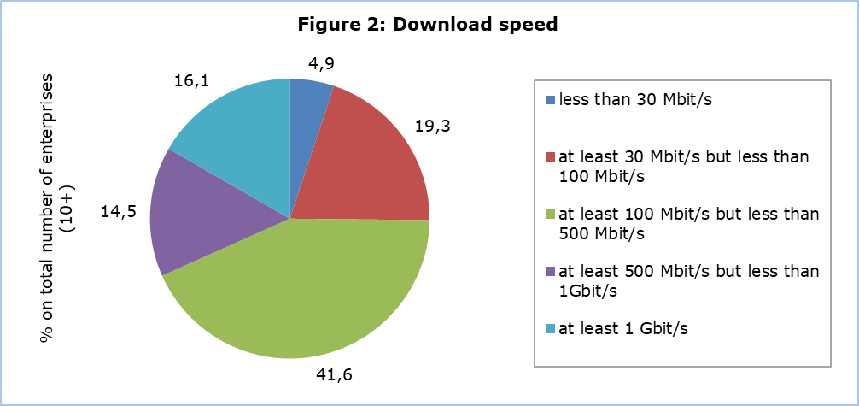

**E-Commerce Sales**

During 2022, almost one out of four enterprises (23,5%) received orders for goods and services via computer networks. 22,4% via websites or “apps” and 3,6% via EDI–type messages. 18,2% of all enterprises received orders for goods and services via the enterprises’ o wn websites or “apps”, while 11,9% received orders via e-commerce marketplace websites or “apps” used by several enterprises for trading products. 20,8% of enterprises received orders via websites or “apps” from private customers compared to 13,2% of enterprises which received orders from other businesses and/or from the government or public authorities. (Figure 3)

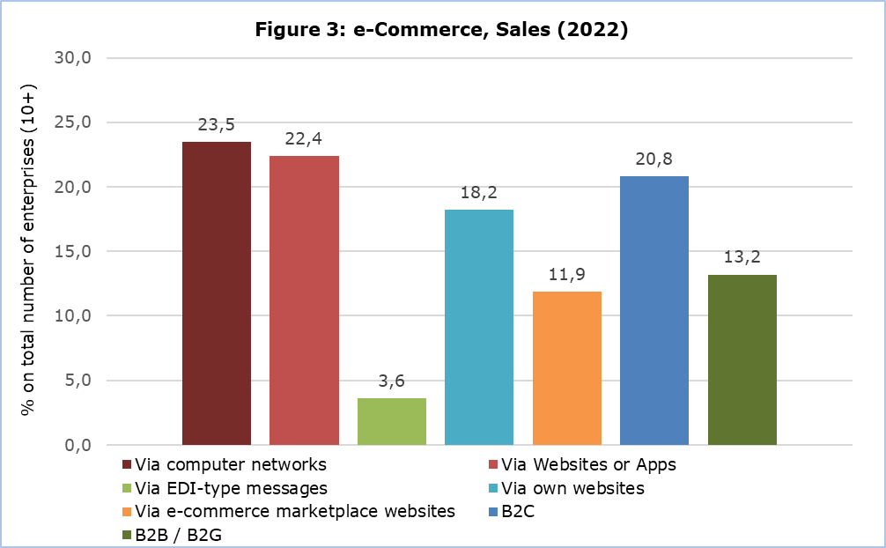

**Use of a business software and data analytics**

Enterprise Resource Planning (ERP) is the most popular business software used by enterprises in Cyprus. ERP consists of one or more sets of software applications that integrate information and processes across the several business functions within an enterprise (e.g. accounting, planning, production, marketing). In 2023, 41,6% of enterprises use an ERP software. (Figure 4)

The second most popular business software is the Customer Relationship Management (CRM) software. It refers to any software application used for managing customer information. CRM collects customer information derived from different channels, integrates it in one database, processes and analyses information related to the customers. The customer is at the centre of the business activity. 29,5% of all enterprises in Cyprus use a CRM software. (Figure 4)

The third most popular software is the Business Intelligence (BI) software. It accesses and analyses data (e.g. from data warehouses, data lakes) from internal IT systems and external sources and presents analytical findings in reports (summaries, graphs, charts, etc.) to provide users with detailed insights for decision-making and strategic planning. 20,8% of all enterprises use BI software. (Figure 4)

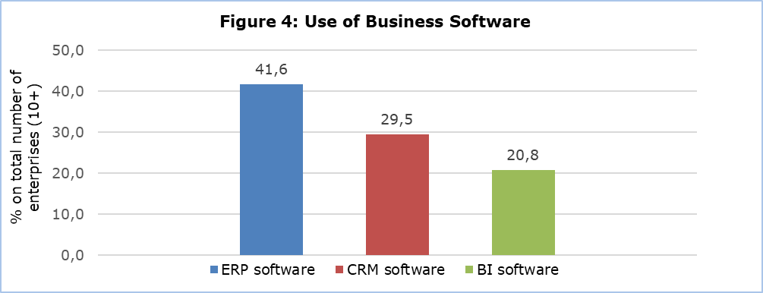

26,6% of all enterprises declared that the enterprises’ own employees perform data analytics on any data source, internal (from enterprises’ own information systems, sensors, smart meters, own websites or social media) or external data (from other enterprises, government authorities or publicly available data from websites or social media). 13,6% of enterprises choose to to hire a service provider (external enterprise or organisation) to perform data analytics on their behalf rather than doing so themselves. (Table 2)

Nowadays, enterprises have to deal with immense data flows of complex structured or unstructured data which are often updated in real time. The use of any kind of business software enables the enterprises to take advantage of all available information (data) and create value from the data in order to gain a competitive advantage.

**Use of cloud computing services**

Cloud computing refers to ICT services that are used over the internet to access software, computing power, storage capacity, etc. These services can be delivered from servers of service providers, can be easily scaled up or down (e.g. number of users or change of storage capacity), can be used on-demand by the user, at least after the initial set up (without human interaction with the service provider) and are paid for, either per user, by capacity used, or they are pre-paid.

52,9% of enterprises have bought cloud computing services during 2023. The main use of cloud computing services in enterprises is e-mail (e.g. Email Enterprise, Microsoft Exchange Online / Office 365, etc.) (47,4%). Office software (e.g. word processors, spreadsheets (e.g. Microsoft Office Cloud), etc.) is the second most popular service (40,3%) and is followed by security software applications (e.g. antivirus program, network access control) with 39,7% of all enterprises and storage of files with 26,2%. (Table 3)

|  |  |  |  |  |  |  |
| --- | --- | --- | --- | --- | --- | --- |
| **Table 1** |  |  |  |  |  |  |
| **Download Speed**  (% on total number of enterprises (10+)) |  | **2019** | **2020** | **2021** | **2022** | **2023** |
| Less than 30 Mbit/s |  | 44,0 | 26,6 | 15,5 | 8,0 | 4,9 |
| At least 30 Mbit/s but less than 100 Mbit/s |  | 32,2 | 37,2 | 36,2 | 22,7 | 19,3 |
| At least 100 Mbit/s |  | 17,1 | 31,8 | 44,8 | 61,2 | 72,1 |

|  |  |  |  |  |  |  |  |
| --- | --- | --- | --- | --- | --- | --- | --- |
| **Table 2** | | | | | | | |
| **Use of Business Software and Data Analytics**  (% on total number of enterprises (10+)) |  |  |  | **Total** | **Small** | **Medium** | **Large** |
| Enterprises using an ERP (Enterprise Resource Planning) software package | | | | 41,6 | 37,6 | 63,7 | 81,5 |
| Enterprises using Customer Relationship Management (CRM) software | | | | 29,5 | 27,2 | 41,5 | 54,4 |
| Enterprises using Business Intelligence (BI) software | | | | 20,8 | 17,3 | 40,0 | 54,3 |
| Enterprises (own employees) performing data analytics | | | | 26,6 | 23,2 | 44,8 | 66,3 |
| Enterprises using an external enterprise or organisation to perform data analytics | | | | 13,6 | 12,1 | 22,4 | 26,8 |

|  |  |  |  |  |  |  |  |  |
| --- | --- | --- | --- | --- | --- | --- | --- | --- |
| **Table 3** | | | | | | | | |
| **Cloud Computing Services**  (% on total number of enterprises (10+)) |  | |  |  |  | **2020** | **2021** | **2023** |
| Any Cloud Computing Service | |  |  |  |  | 34,6 | 50,3 | 52,9 |
| E-mail | |  |  |  |  | 29,8 | 41,9 | 47,4 |
| Office software |  | |  |  |  | 24,9 | 34,4 | 40,3 |
| Security software applications |  | |  |  |  | … | 35,8 | 39,7 |
| Storage of files |  | |  |  |  | 23,9 | 30,3 | 36,2 |
| Finance or accounting software “Apps” |  | |  |  |  | 13,9 | 21,8 | 23,0 |

**METHODOLOGICAL NOTES**

**Aim**

The aim of the survey is to collect data about the use of information and communication technologies by enterprises, the access and use of the internet, e-commerce, data utilisation, sharing, analytics and trading, the use of cloud computing, the use of artificial intelligence and invoicing. These data are necessary for the implementation of policy programs, both for the Government and the private sector. The survey is co-funded by the European Union.

**Coverage**

The survey took place during February-June 2023 and covered approximately 4.500 enterprises with 10 or more employed persons in the following economic activities:

|  |  |
| --- | --- |
| **NACE Rev.2** | **Description** |
| C | Manufacturing |
| D | Electricity, Gas, Steam and Air Conditioning Supply |
| E | Water Supply, Sewerage, Waste Management and Remediation Activities |
| F | Construction |
| G | Wholesale and Retail Trade. Repair of motor vehicles, motorcycles |
| Η | Transport and Storage |
| I | Accommodation and Food Service Activities |
| J | Information and Communication |
| L | Real Estate Activities |
| M | Professional, Scientific and Technical Activities |
| N | Administrative and Support Service Activities |
| S | Other Service Activities |

**Sampling**

For the year 2023 all small, medium and large enterprises with 10 or more employed persons and self-employed persons were covered on a census basis. In the population there were 32 NACE groupings and 3 size groups: small enterprises (10-49 persons employed), medium enterprises (50-249 persons employed) and large enterprises (250+ persons employed).

**Data Collection**

The data collection was conducted with the use of a web-based questionnaire.

**Reference Period**

The data refer to 2023, unless otherwise stated.

**Definitions**

**Application (App):** A mobile app, short for mobile application or just app, is application software designed for a specific purpose (e.g. entertainment, shopping, etc.), downloaded and used on computers depending on their operating system (e.g. portable devices such as tablets, smartphones, etc.)

**Internet connection speed:** the maximum download speed according to the contract with the internet service provider.

**Electronic commerce (e-commerce):** An e-commerce transaction is the sale or purchase of goods or services, conducted over computer networks by methods specifically designed for the purpose of receiving or placing orders.

**Cloud computing:** refers to ICT services that are used over the internet to access software, computing power, storage capacity etc. These services are delivered from servers of service providers, can be easily scaled up or down, can be used on-demand by the user and are paid for.

***For more information:***

CYSTAT Portal, subtheme [Information Society](https://www.cystat.gov.cy/en/SubthemeStatistics?s=40)

[CYSTAT-DB](https://cystatdb.cystat.gov.cy/pxweb/en/8.CYSTAT-DB/8.CYSTAT-DB__Information%20Society__) (Online Database)

[Infographic](https://www.cystat.gov.cy/el/Infographics/)

[Methodological Information](https://www.cystat.gov.cy/en/MethodologicalDetails?m=2028)

**Data up to 2020 are available in Excel format under** [Predefined Tables](https://www.cystat.gov.cy/en/KeyFiguresList?s=40)

*Contact*

Constantinos Minas: Tel.: +35722602112, Email: [cmina@cystat.mof.gov.cy](mailto:cmina@cystat.mof.gov.cy)