10 September, 2025

PRESS RELEASE

SALES OF INDUSTRIAL COMMODITIES OF LOCAL PRODUCTION BY TYPE: 2023

Annual Increase 7,3%

In The Statistical Service announces the publication of detailed data on the sales of commodities produced by industrial units in Cyprus in 2023, both in quantity (wherever this is possible) and in value terms.

During 2023 the total sales of industrial commodities of local production reached €4.601,6 million compared to €4.289,6 million in 2022, registering an increase of 7,3%.

The sales from local industrial units of some indicative products were in 2023: halloumi cheese 41,9 thousand tonnes with value €338,1 million, pasteurized milk and fresh cream 60,7 million litres with value €85,9 million, fresh fruit juice 71,1 thousand tonnes with value €49,0 million, prepared meat products €50,4 million, fresh bakery and pastry products €351,4 million, beer 42,3 million litres with value €53,8 million, wines 11,9 million litres with value €39,5 million, soft drinks 13,5 million litres with value €20,5 million, bottled mineral water 190,7 million litres with value €39,9 million, chemical products €84,0 million, pharmaceutical products and preparations €351,4 million, cement and clinker €158,2 million and ready-mixed concrete 3,2 million cubic metres with value €247,7 million.

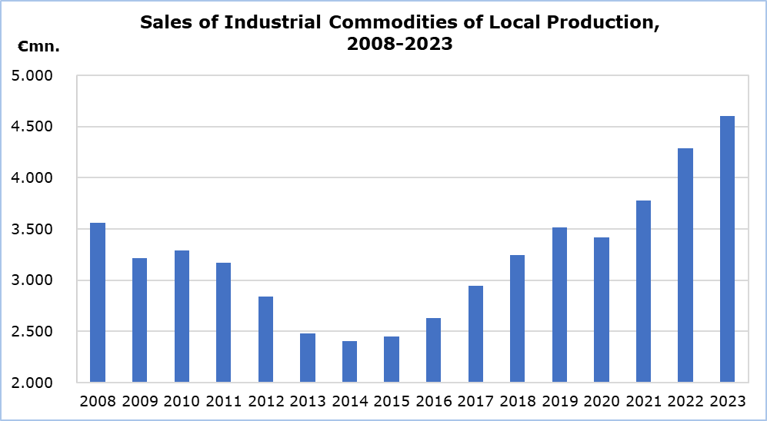

For more information:
CYSTAT Portal, subtheme Industry
Predefined Tables (Excel)

Contact
Charalambos Alkiviadous: Tel.: +357 22602189, Email: calkiviadous@cystat.mof.gov.cy

