27 January, 2025

**PRESS RELEASE**

IMPORTS, SALES AND STOCKS OF PETROLEUM PRODUCTS: **DECEMBER 2024**

**Annual Change in Sales -2,0%**

In December 2024, the total sales of petroleum products amounted to 117.510 tonnes, recording a decrease of 2,0% compared to December 2023. A decline was observed in the provisions of marine gasoil (-7,0%) and aviation kerosene (-1,2%), as well as in the sales of light fuel oil (-30,8%) and asphalt (-17,5%). On the contrary, an increase was recorded in the sales of kerosene (26,4%), liquefied petroleum gases (23,9%), heating gasoil (11,2%), motor gasoline (2,8%) and road diesel (0,4%). As far as the sales from filling stations are specifically concerned, these have increased by 3,2% to 60.834 tonnes.

The total sales of petroleum products in December 2024 compared to November 2024 recorded a rise of 3,4%. Indicatively, an increase was recorded in the sales of motor gasoline (2,6%), while the provisions of aviation kerosene dropped by 15,8% and the sales of road diesel by 2,0%. The total stocks of petroleum products at the end of December 2024 increased by 7,1% compared to the end of the previous month.

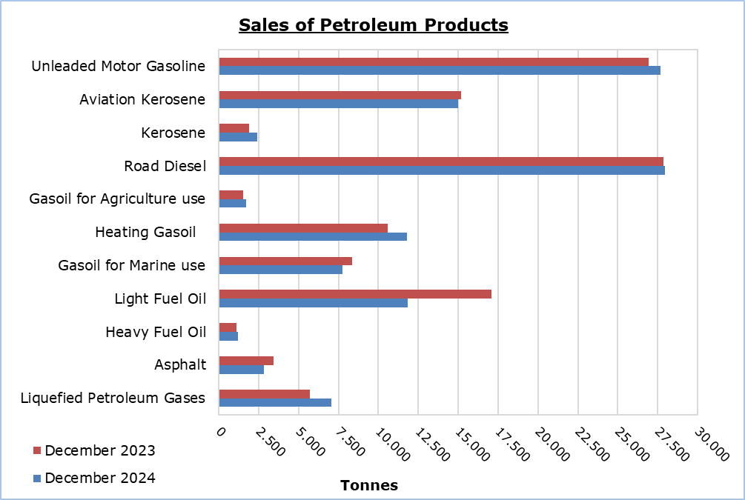

The total sales of petroleum products in 2024 marginally increased by 0,6% compared to 2023. The provisions of aviation kerosene rose by 3,6% and an increase was also recorded in the sales of heavy fuel oil (3,3%), motor gasoline (3,1%), asphalt (1,2%) and road diesel (1,1%). On the other hand, a decrease was observed in the provisions of marine gasoil (-4,4%) and in the sales of kerosene (-7,1%), light fuel oil (-6,9%) and heating gasoil (-3,4%). In 2024, the sales from filling stations reached 682.790 tonnes, recording a rise of 2,4% compared to 2023.

|  |  |  |  |  |  |  |  |
| --- | --- | --- | --- | --- | --- | --- | --- |
| **Table 1** |  |  |  |  |  |  |  |
| **Products** | **Total Sales (tonnes)** | | | |  | **Percentage Change**  **(%)** | |
| **Dec 2024** | **Dec 2023** | **Jan - Dec 2024** | **Jan - Dec 2023** |  | **Dec 2024/2023** | **Jan - Dec 2024/2023** |
| Unleaded Motor Gasoline | 27.682 | 26.918 | 334.770 | 324.591 | 2,8 | 3,1 |
| Aviation Gasoline | 2 | 1 | 16 | 20 |  | 100,0 | -20,0 |
| Aviation Kerosene | 15.021 | 15.205 | 305.158 | 294.569 |  | -1,2 | 3,6 |
| Kerosene | 2.391 | 1.891 | 9.339 | 10.057 |  | 26,4 | -7,1 |
| Road Diesel | 27.965 | 27.858 | 349.513 | 345.657 |  | 0,4 | 1,1 |
| Gasoil for Agriculture Use | 1.717 | 1.543 | 22.164 | 20.242 |  | 11,3 | 9,5 |
| Heating Gasoil | 11.788 | 10.600 | 78.814 | 81.564 |  | 11,2 | -3,4 |
| Gasoil for Marine use | 7.762 | 8.349 | 86.720 | 90.715 |  | -7,0 | -4,4 |
| Light Fuel Oil | 11.824 | 17.078 | 156.421 | 168.093 |  | -30,8 | -6,9 |
| Heavy Fuel Oil | 1.209 | 1.120 | 14.773 | 14.307 |  | 7,9 | 3,3 |
| Lubricants | 256 | 227 | 3.061 | 2.934 |  | 12,8 | 4,3 |
| Asphalt | 2.821 | 3.421 | 37.743 | 37.284 |  | -17,5 | 1,2 |
| Liquefied Petroleum Gases | 7.072 | 5.706 | 55.212 | 55.134 |  | 23,9 | 0,1 |
| **Total** | **117.510** | **119.917** | **1.453.704** | **1.445.167** | **-2,0** | **0,6** |

|  |  |  |  |  |  |  |  |
| --- | --- | --- | --- | --- | --- | --- | --- |
| **Table 2** |  |  |  |  |  |  |  |
| **Products** | **Sales from Filling Stations (tonnes)** | | | |  | **Percentage Change**  **(%)** | |
| **Dec 2024** | **Dec 2023** | **Jan - Dec 2024** | **Jan - Dec 2023** |  | **Dec 2024/2023** | **Jan - Dec 2024/2023** |
| Unleaded Motor Gasoline | 27.484 | 26.670 | 331.739 | 321.282 | 3,1 | 3,3 |
| Kerosene | 1.809 | 1.448 | 7.084 | 7.582 |  | 24,9 | -6,6 |
| Road Diesel | 22.687 | 22.492 | 280.212 | 273.229 |  | 0,9 | 2,6 |
| Gasoil for Agriculture Use | 1.196 | 1.197 | 15.087 | 14.077 |  | -0,1 | 7,2 |
| Heating Gasoil | 7.545 | 7.034 | 46.997 | 48.977 |  | 7,3 | -4,0 |
| Light Fuel Oil | - | 38 | 405 | 443 |  | -100,0 | -8,6 |
| Lubricants | 113 | 88 | 1.266 | 1.203 |  | 28,4 | 5,2 |
| **Total** | **60.834** | **58.967** | **682.790** | **666.793** | **3,2** | **2,4** |

**METHODOLOGICAL INFORMATION**

**Scope and Coverage**

The collection of data on Imports, Sales and Stocks of Petroleum Products is carried out on a monthly basis.

It concerns the sales of petroleum products from filling stations and the sales to government departments, to the British Bases and the United Nations, to ships and to other customers, as well as the stocks held at the end of each month. Only the petroleum companies are being covered. Additionally, the imports of petroleum products imported directly from the Electricity Authority of Cyprus (EAC) and the manufacturing industry are also included.

**Data Collection**

The collection of data is conducted by the Statistical Service on a monthly basis by electronically receiving a purpose-designed questionnaire from each of these companies.

***For more information*:**

CYSTAT Portal, subtheme [Energy](https://www.cystat.gov.cy/en/SubthemeStatistics?s=34)

[CYSTAT-DB](https://cystatdb.cystat.gov.cy/pxweb/en/8.CYSTAT-DB/8.CYSTAT-DB__Energy__) (Online Database)

[Predefined Tables](https://www.cystat.gov.cy/en/KeyFiguresList?s=34) (Excel)

[Methodological Information](https://www.cystat.gov.cy/en/MethodologicalDetails?m=2196)

**The Predefined Tables, available in Excel format, include data up to December 2022. Data from January 2023 onwards are available only in the CYSTAT-DB Online Database.**

*Contact*

Nafsika Apostolou: Tel.: +35722602199, E-mail: napostolou@cystat.mof.gov.cy