27 January, 2026

PRESS RELEASE

IMPORTS, SALES AND STOCKS OF PETROLEUM PRODUCTS: DECEMBER 2025

Annual Change in Sales +4,9%

In December 2025, the total sales of petroleum products amounted to 123.274 tonnes, recording an increase of 4,9% compared to December 2024. A rise was observed in the provisions of marine gasoil (76,3%) and aviation kerosene (23,6%), as well as in the sales of asphalt (51,4%), heating gasoil (10,9%), motor gasoline (7,5%) and road diesel (6,1%). On the contrary, a drop was observed ιn the sales of light and heavy fuel oil (-82,8% and -34,9% respectively) and liquefied petroleum gases (-0,6%). As far as the sales from filling stations are specifically concerned, these have registered a rise of 5,7% to 64.311 tonnes.

The total sales of petroleum products in December 2025 compared to November 2025 recorded an increase of 2,8%. Indicatively, a rise was recorded in the sales of motor gasoline (9,7%) and road diesel (2,1%), yet the provisions of aviation kerosene dropped by -18,3% and those of marine gasoil by 9,6%. The total stocks of petroleum products at the end of December 2025 fell by 7,6% compared to the end of the previous month.

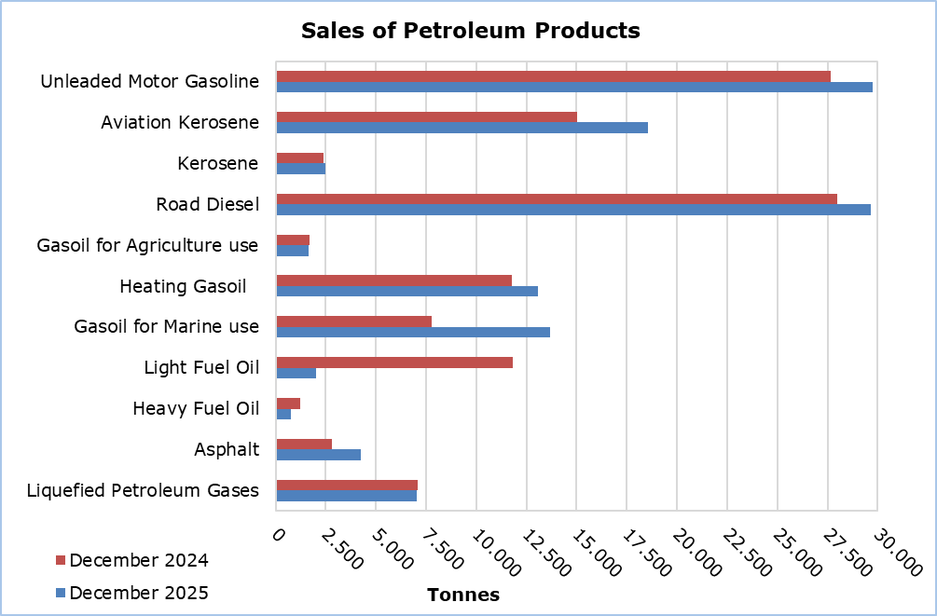

The total sales of petroleum products in 2025 increased by 4,8% compared to 2024. The provisions of marine gasoil and aviation kerosene rose by 90,3% and 13,0% respectively, as well as the sales of asphalt (15,6%), kerosene (6,1%), heating gasoil (5,8%), liquefied petroleum gases (3,7%), motor gasoline (3,5%), and road diesel (2,7%). On the other hand, a decrease was observed in the sales of light (-52,9%) and heavy (-12,0%) fuel oil. The sales from filling stations in 2025 rose by 3,0% compared to 2024.

Table 1
Products | Total Sales (tonnes) |  |  |  |  | Percentage Change  (%)
Products | Dec  2025 | Dec  2024 | Jan - Dec 2025 | Jan - Dec 2024 |  | Dec 2025/2024 | Jan - Dec 2025/2024
Unleaded Motor Gasoline | 29.745 | 27.682 | 346.494 | 334.770 |  | 7,5 | 3,5
Aviation Gasoline | 1 | 2 | 19 | 16 |  | -50,0 | 18,8
Aviation Kerosene | 18.565 | 15.021 | 344.885 | 305.158 |  | 23,6 | 13,0
Kerosene | 2.495 | 2.391 | 9.910 | 9.339 |  | 4,3 | 6,1
Road Diesel | 29.663 | 27.965 | 359.043 | 349.513 |  | 6,1 | 2,7
Gasoil for Agriculture Use | 1.645 | 1.717 | 23.369 | 22.164 |  | -4,2 | 5,4
Heating Gasoil | 13.075 | 11.788 | 83.352 | 78.814 |  | 10,9 | 5,8
Gasoil for Marine Use | 13.688 | 7.762 | 164.990 | 86.720 |  | 76,3 | 90,3
Light Fuel Oil | 2.032 | 11.824 | 73.613 | 156.421 |  | -82,8 | -52,9
Heavy Fuel Oil | 787 | 1.209 | 12.994 | 14.773 |  | -34,9 | -12,0
Lubricants | 279 | 256 | 3.481 | 3.061 |  | 9,0 | 13,7
Asphalt | 4.270 | 2.821 | 43.646 | 37.743 |  | 51,4 | 15,6
Liquefied Petroleum Gases | 7.029 | 7.072 | 57.239 | 55.212 |  | -0,6 | 3,7
Total | 123.274 | 117.510 | 1.523.035 | 1.453.704 |  | 4,9 | 4,8

Table 2
Products | Sales from Filling Stations (tonnes) |  |  |  |  | Percentage Change  (%)
Products | Dec  2025 | Dec  2024 | Jan - Dec 2025 | Jan - Dec 2024 |  | Dec 2025/2024 | Jan - Dec 2025/2024
Unleaded Motor Gasoline | 29.463 | 27.484 | 343.099 | 331.739 |  | 7,2 | 3,4
Kerosene | 1.802 | 1.809 | 7.230 | 7.084 |  | -0,4 | 2,1
Road Diesel | 23.318 | 22.687 | 286.171 | 280.212 |  | 2,8 | 2,1
Gasoil for Agriculture Use | 1.180 | 1.196 | 16.007 | 15.087 |  | -1,3 | 6,1
Heating Gasoil | 8.391 | 7.545 | 48.734 | 46.997 |  | 11,2 | 3,7
Light Fuel Oil | 48 | - | 530 | 405 |  | - | 30,9
Lubricants | 109 | 113 | 1.421 | 1.266 |  | -3,5 | 12,2
Total | 64.311 | 60.834 | 703.192 | 682.790 |  | 5,7 | 3,0

METHODOLOGICAL INFORMATION

Scope and Coverage

The collection of data on Imports, Sales and Stocks of Petroleum Products is carried out on a monthly basis.

It concerns the sales of petroleum products from filling stations and the sales to government departments, to the British Bases and the United Nations, to ships and to other customers, as well as the stocks held at the end of each month. Only the petroleum companies are being covered. Additionally, the imports of petroleum products imported directly from the Electricity Authority of Cyprus (EAC) and the manufacturing industry are also included.

Data Collection

The collection of data is conducted by the Statistical Service on a monthly basis by electronically receiving a purpose-designed questionnaire from each of these companies.

For more information:
CYSTAT Portal, subtheme Energy
CYSTAT-DB (Online Database)
Predefined Tables (Excel)
Methodological Information

The Predefined Tables, available in Excel format, include data up to December 2022. Data from January 2023 onwards are available only in the CYSTAT-DB Online Database.

Contact
Nafsika Apostolou: Tel.: +35722602199, E-mail: napostolou@cystat.mof.gov.cy

