27 February, 2025

**PRESS RELEASE**

IMPORTS, SALES AND STOCKS OF PETROLEUM PRODUCTS: **JANUARY 2025**

**Annual Change in Sales -2,9 %**

In January 2025, the total sales of petroleum products amounted to 106.552 tonnes, recording a decrease of 2,9% compared to January 2024. A decrease was observed in the provisions of marine gasoil (-7,0%) and aviation kerosene (-5,8%), as well as in the sales of light fuel oil (-36,8%) and kerosene (-1,9%). On the contrary, a rise was recorded in the sales of asphalt (52,4%), liquefied petroleum gases (6,9%), motor gasoline (4,0%), heating gasoil (2,3%) and road diesel (1,9%). As far as the sales from filling stations are specifically concerned, these have registered a rise of 3,4% to 56.518 tonnes.

The total sales of petroleum products in January 2025 compared to December 2024 recorded a drop of 9,3%. Indicatively, a fall was recorded in the provisions of marine gasoil and aviation kerosene (-25,9% and -9,7%, respectively) as well as in the sales of motor gasoline (-6,9%) and road diesel (-5,0%).

The total stocks of petroleum products at the end of January 2025 rose by 12,8% compared to the end of the previous month.

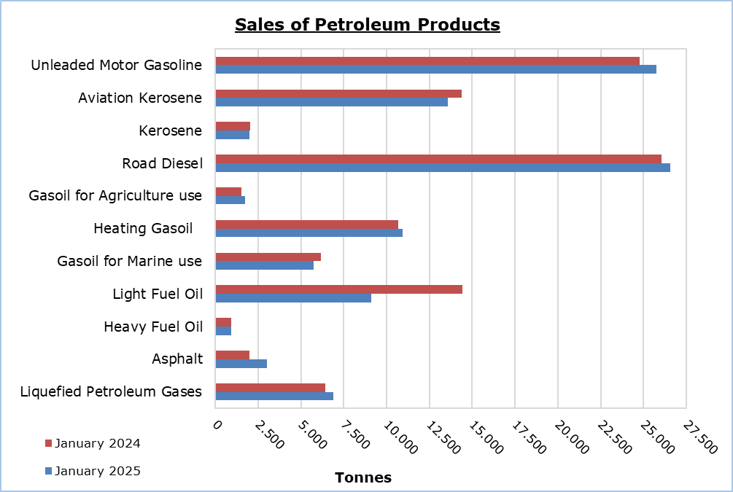

|  |  |  |  |  |  |  |  |
| --- | --- | --- | --- | --- | --- | --- | --- |
| **Table 1** |  |  |  |  |  |  |  |
| **Products** | **Total Sales (tonnes)** | | | |  | **Percentage Change**  **(%)** | |
| **Jan 2025** | **Jan 2024** | **Jan – Dec 2024** | **Jan – Dec 2023** |  | **Jan 2025/2024** | **Jan - Dec**  **2024/2023** |
| Unleaded Motor Gasoline | 25.775 | 24.780 | 334.770 | 324.591 | 4,0 | 3,1 |
| Aviation Gasoline | 1 | 1 | 16 | 20 |  | 0,0 | -20,0 |
| Aviation Kerosene | 13.569 | 14.399 | 305.158 | 294.569 |  | -5,8 | 3,6 |
| Kerosene | 2.008 | 2.047 | 9.339 | 10.057 |  | -1,9 | -7,1 |
| Road Diesel | 26.555 | 26.063 | 349.513 | 345.657 |  | 1,9 | 1,1 |
| Gasoil for Agriculture Use | 1.723 | 1.527 | 22.164 | 20.242 |  | 12,8 | 9,5 |
| Heating Gasoil | 10.926 | 10.683 | 78.814 | 81.564 |  | 2,3 | -3,4 |
| Gasoil for Marine use | 5.748 | 6.179 | 86.720 | 90.715 |  | -7,0 | -4,4 |
| Light Fuel Oil | 9.121 | 14.428 | 156.421 | 168.093 |  | -36,8 | -6,9 |
| Heavy Fuel Oil | 926 | 927 | 14.773 | 14.307 |  | -0,1 | 3,3 |
| Lubricants | 277 | 241 | 3.061 | 2.934 |  | 14,9 | 4,3 |
| Asphalt | 3.032 | 1.990 | 37.743 | 37.284 |  | 52,4 | 1,2 |
| Liquefied Petroleum Gases | 6.891 | 6.445 | 55.212 | 55.134 |  | 6,9 | 0,1 |
| **Total** | **106.552** | **109.710** | **1.453.704** | **1.445.167** | **-2,9** | **0,6** |

|  |  |  |  |  |  |  |  |
| --- | --- | --- | --- | --- | --- | --- | --- |
| **Table 2** |  |  |  |  |  |  |  |
| **Products** | **Sales from Filling Stations (tonnes)** | | | |  | **Percentage Change**  **(%)** | |
| **Jan 2025** | **Jan 2024** | **Jan – Dec 2024** | **Jan – Dec 2023** |  | **Jan 2025/2024** | **Jan - Dec**  **2024/2023** |
| Unleaded Motor Gasoline | 25.624 | 24.546 | 331.739 | 321.282 | 4,4 | 3,3 |
| Kerosene | 1.493 | 1.579 | 7.084 | 7.582 |  | -5,4 | -6,6 |
| Road Diesel | 21.372 | 20.525 | 280.212 | 273.229 |  | 4,1 | 2,6 |
| Gasoil for Agriculture Use | 1.098 | 1.064 | 15.087 | 14.077 |  | 3,2 | 7,2 |
| Heating Gasoil | 6.786 | 6.772 | 46.997 | 48.977 |  | 0,2 | -4,0 |
| Light Fuel Oil | 45 | 43 | 405 | 443 |  | 4,7 | -8,6 |
| Lubricants | 100 | 106 | 1.266 | 1.203 |  | -5,7 | 5,2 |
| **Total** | **56.518** | **54.635** | **682.790** | **666.793** | **3,4** | **2,4** |

**METHODOLOGICAL INFORMATION**

**Scope and Coverage**

The collection of data on Imports, Sales and Stocks of Petroleum Products is carried out on a monthly basis.

It concerns the sales of petroleum products from filling stations and the sales to government departments, to the British Bases and the United Nations, to ships and to other customers, as well as the stocks held at the end of each month. Only the petroleum companies are being covered. Additionally, the imports of petroleum products imported directly from the Electricity Authority of Cyprus (EAC) and the manufacturing industry are also included.

**Data Collection**

The collection of data is conducted by the Statistical Service on a monthly basis by electronically receiving a purpose-designed questionnaire from each of these companies.

***For more information*:**

CYSTAT Portal, subtheme [Energy](https://www.cystat.gov.cy/en/SubthemeStatistics?s=34)

[CYSTAT-DB](https://cystatdb.cystat.gov.cy/pxweb/en/8.CYSTAT-DB/8.CYSTAT-DB__Energy__) (Online Database)

[Predefined Tables](https://www.cystat.gov.cy/en/KeyFiguresList?s=34) (Excel)

[Methodological Information](https://www.cystat.gov.cy/en/MethodologicalDetails?m=2196)

**The Predefined Tables, available in Excel format, include data up to December 2022. Data from January 2023 onwards are available only in the CYSTAT-DB Online Database.**

*Contact*

Nafsika Apostolou: Tel.: +35722602199, E-mail: napostolou@cystat.mof.gov.cy