27 August, 2025

**PRESS RELEASE**

IMPORTS, SALES AND STOCKS OF PETROLEUM PRODUCTS: **JULY 2025**

**Annual Change in Sales +7,7%**

In July 2025, the total sales of petroleum products amounted to 144.790 tonnes, recording an increase of 7,7% compared to July 2024. A rise was observed in the provisions of marine gasoil (270,3%) and aviation kerosene (13,0%), as well as in the sales of asphalt (9,3%), road diesel (3,8%), heating gasoil (3,3%), motor gasoline (3,0%), kerosene (2,2%) and liquefied petroleum gases (0,8%). On the contrary, a drop was observed in the sales of light and heavy fuel oil (-67,0% and -59,7% respectively). As far as the sales from filling stations are specifically concerned, these have increased by 3,0% to 62.497 tonnes.

The total sales of petroleum products in July 2025 compared to June 2025 recorded an increase of 2,9%. Indicatively, a rise was recorded in the provisions of aviation kerosene (4,5%) and in the sales of asphalt (27,9%), motor gasoline (5,9%) and road diesel (4,8%), whereas there was a drop in the sales of kerosene (-68,0%) and heavy fuel oil (-32,3%). The total stocks of petroleum products at the end of July 2025 rose by 30,8% compared to the end of the previous month.

During the period January – July 2025, the total sales of petroleum products increased by 4,5% compared to the corresponding period of the previous year.

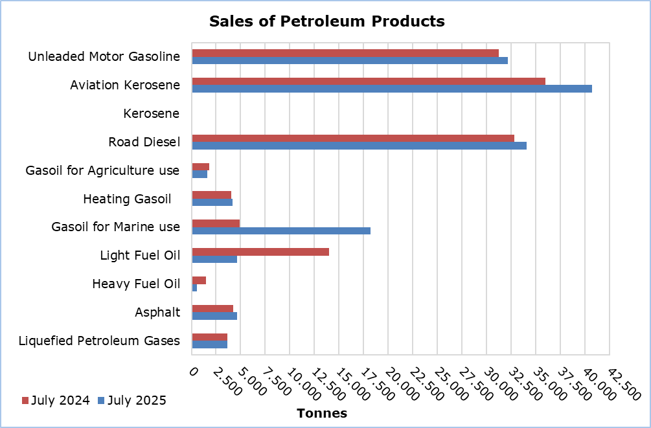

|  |  |  |  |  |  |  |  |
| --- | --- | --- | --- | --- | --- | --- | --- |
| **Table 1** |  |  |  |  |  |  |  |
| **Products** | **Total Sales (tonnes)** | | | |  | **Percentage Change**  **(%)** | |
| **July 2025** | **July 2024** | **Jan - Jul 2025** | **Jan - Jul 2024** |  | **July 2025/2024** | **Jan - Jul 2025/2024** |
| Unleaded Motor Gasoline | 32.141 | 31.198 | 197.066 | 191.409 | 3,0 | 3,0 |
| Aviation Gasoline | 2 | 1 | 12 | 9 |  | 100,0 | 33,3 |
| Aviation Kerosene | 40.675 | 35.994 | 185.447 | 166.530 |  | 13,0 | 11,4 |
| Kerosene | 47 | 46 | 6.115 | 5.082 |  | 2,2 | 20,3 |
| Road Diesel | 34.072 | 32.814 | 207.855 | 202.703 |  | 3,8 | 2,5 |
| Gasoil for Agriculture Use | 1.585 | 1.797 | 13.800 | 12.423 |  | -11,8 | 11,1 |
| Heating Gasoil | 4.195 | 4.061 | 50.532 | 44.960 |  | 3,3 | 12,4 |
| Gasoil for Marine use | 18.220 | 4.920 | 90.461 | 46.618 |  | 270,3 | 94,0 |
| Light Fuel Oil | 4.621 | 14.013 | 50.162 | 97.774 |  | -67,0 | -48,7 |
| Heavy Fuel Oil | 589 | 1.460 | 9.287 | 9.040 |  | -59,7 | 2,7 |
| Lubricants | 347 | 306 | 1.986 | 1.786 |  | 13,4 | 11,2 |
| Asphalt | 4.634 | 4.240 | 22.725 | 22.199 |  | 9,3 | 2,4 |
| Liquefied Petroleum Gases | 3.662 | 3.634 | 34.722 | 32.064 |  | 0,8 | 8,3 |
| **Total** | **144.790** | **134.484** | **870.170** | **832.597** | **7,7** | **4,5** |

|  |  |  |  |  |  |  |  |
| --- | --- | --- | --- | --- | --- | --- | --- |
| **Table 2** |  |  |  |  |  |  |  |
| **Products** | **Sales from Filling Stations (tonnes)** | | | |  | **Percentage Change**  **(%)** | |
| **July 2025** | **July 2024** | **Jan - Jul 2025** | **Jan - Jul 2024** |  | **July 2025/2024** | **Jan - Jul 2025/2024** |
| Unleaded Motor Gasoline | 31.765 | 30.922 | 195.325 | 189.597 | 2,7 | 3,0 |
| Kerosene | 31 | 35 | 4.484 | 3.880 |  | -11,4 | 15,6 |
| Road Diesel | 27.160 | 26.157 | 165.591 | 160.882 |  | 3,8 | 2,9 |
| Gasoil for Agriculture Use | 1.149 | 1.255 | 9.361 | 8.271 |  | -8,4 | 13,2 |
| Heating Gasoil | 2.202 | 2.154 | 29.278 | 26.499 |  | 2,2 | 10,5 |
| Light Fuel Oil | 48 | 29 | 318 | 260 |  | 65,5 | 22,3 |
| Lubricants | 142 | 126 | 808 | 754 |  | 12,7 | 7,2 |
| **Total** | **62.497** | **60.678** | **405.165** | **390.143** | **3,0** | **3,9** |

**METHODOLOGICAL INFORMATION**

**Scope and Coverage**

The collection of data on Imports, Sales and Stocks of Petroleum Products is carried out on a monthly basis.

It concerns the sales of petroleum products from filling stations and the sales to government departments, to the British Bases and the United Nations, to ships and to other customers, as well as the stocks held at the end of each month. Only the petroleum companies are being covered. Additionally, the imports of petroleum products imported directly from the Electricity Authority of Cyprus (EAC) and the manufacturing industry are also included.

**Data Collection**

The collection of data is conducted by the Statistical Service on a monthly basis by electronically receiving a purpose-designed questionnaire from each of these companies.

***For more information*:**

CYSTAT Portal, subtheme [Energy](https://www.cystat.gov.cy/en/SubthemeStatistics?s=34)

[CYSTAT-DB](https://cystatdb.cystat.gov.cy/pxweb/en/8.CYSTAT-DB/8.CYSTAT-DB__Energy__) (Online Database)

[Predefined Tables](https://www.cystat.gov.cy/en/KeyFiguresList?s=34) (Excel)

[Methodological Information](https://www.cystat.gov.cy/en/MethodologicalDetails?m=2196)

**The Predefined Tables, available in Excel format, include data up to December 2022. Data from January 2023 onwards are available only in the CYSTAT-DB Online Database.**

*Contact*

Nafsika Apostolou: Tel.: +35722602199, E-mail: [napostolou@cystat.mof.gov.cy](mailto:napostolou@cystat.mof.gov.cy)

Dimitrios Pilavakis: Tel.: +35722602153, E-mail: [dpilavakis@cystat.mof.gov.cy](mailto:dpilavakis@cystat.mof.gov.cy)