28 April, 2025

**PRESS RELEASE**

IMPORTS, SALES AND STOCKS OF PETROLEUM PRODUCTS: **MARCH 2025**

**Annual Change in Sales -0,8 %**

In March 2025, the total sales of petroleum products amounted to 107.291 tonnes, recording a decrease of 0,8% compared to March 2024. A drop was observed in the sales of kerosene (-31,4%), asphalt (-28,9%), heating gasoil (-22,5%), liquefied petroleum gases (-5,1%) and road diesel (-4,4%). On the contrary, an increase was recorded in the provisions of marine gasoil (14,6%) and aviation kerosene (4,7%), as well as in the sales of light and heavy fuel oil (14,0% and 28,7% respectively) and motor gasoline (0,8%). As far as the sales from filling stations are specifically concerned, these have registered a drop of 1,5% to 55.584 tonnes.

The total sales of petroleum products in March 2025 compared to February 2025 recorded a decrease of 4,0%. Indicatively, a drop was recorded in the sales of kerosene (-76,4%) and heating gasoil (-53,4%), yet there was a rise in the provisions of aviation kerosene (34,4%) and in the sales of motor gasoline (11,5%) and road diesel (7,9%). The total stocks of petroleum products at the end of March 2025 fell by 2,1% compared to the end of the previous month.

During the period January – March 2025, the total sales of petroleum products decreased by 2,3% compared to the corresponding period of the previous year.

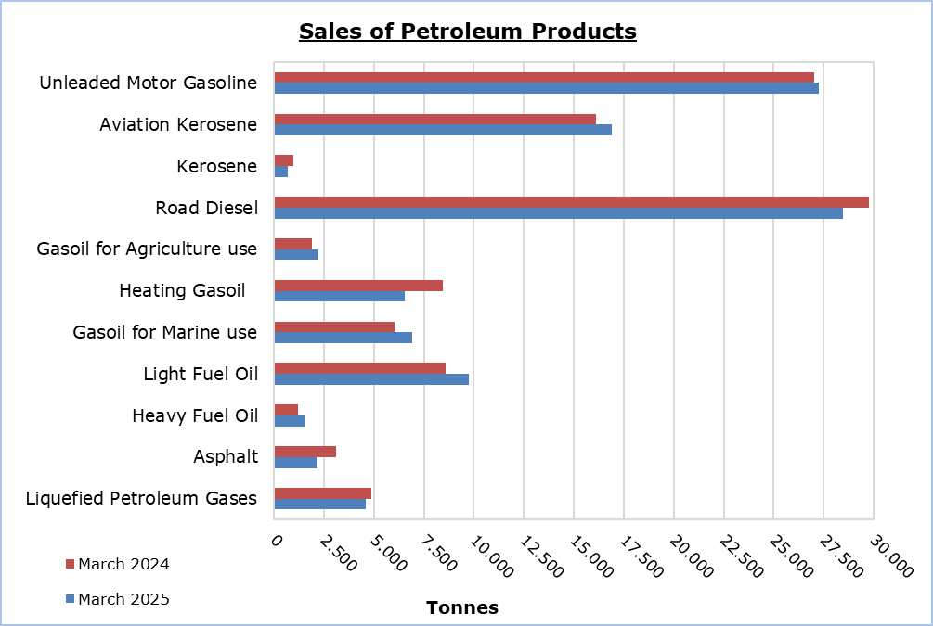

|  |  |  |  |  |  |  |  |
| --- | --- | --- | --- | --- | --- | --- | --- |
| **Table 1** |  |  |  |  |  |  |  |
| **Products** | **Total Sales (tonnes)** | | | |  | **Percentage Change**  **(%)** | |
| **Mar 2025** | **Mar 2024** | **Jan - Mar 2025** | **Jan - Mar 2024** |  | **Mar 2025/2024** | **Jan - Mar 2025/2024** |
| Unleaded Motor Gasoline | 27.254 | 27.046 | 77.464 | 76.993 | 0,8 | 0,6 |
| Aviation Gasoline | 2 | 1 | 5 | 4 |  | 100,0 | 25,0 |
| Aviation Kerosene | 16.896 | 16.132 | 43.033 | 44.226 |  | 4,7 | -2,7 |
| Kerosene | 673 | 981 | 5.538 | 4.808 |  | -31,4 | 15,2 |
| Road Diesel | 28.448 | 29.769 | 81.379 | 82.880 |  | -4,4 | -1,8 |
| Gasoil for Agriculture Use | 2.235 | 1.914 | 5.777 | 4.841 |  | 16,8 | 19,3 |
| Heating Gasoil | 6.526 | 8.426 | 31.449 | 29.354 |  | -22,5 | 7,1 |
| Gasoil for Marine use | 6.906 | 6.027 | 19.595 | 21.883 |  | 14,6 | -10,5 |
| Light Fuel Oil | 9.761 | 8.566 | 29.866 | 38.017 |  | 14,0 | -21,4 |
| Heavy Fuel Oil | 1.546 | 1.201 | 3.762 | 3.704 |  | 28,7 | 1,6 |
| Lubricants | 248 | 200 | 768 | 690 |  | 24,0 | 11,3 |
| Asphalt | 2.194 | 3.087 | 7.836 | 8.320 |  | -28,9 | -5,8 |
| Liquefied Petroleum Gases | 4.602 | 4.850 | 19.131 | 17.611 |  | -5,1 | 8,6 |
| **Total** | **107.291** | **108.200** | **325.603** | **333.331** | **-0,8** | **-2,3** |

|  |  |  |  |  |  |  |  |
| --- | --- | --- | --- | --- | --- | --- | --- |
| **Table 2** |  |  |  |  |  |  |  |
| **Products** | **Sales from Filling Stations (tonnes)** | | | |  | **Percentage Change**  **(%)** | |
| **Mar 2025** | **Mar 2024** | **Jan - Mar 2025** | **Jan - Mar 2024** |  | **Mar 2025/2024** | **Jan - Mar 2025/2024** |
| Unleaded Motor Gasoline | 27.016 | 26.794 | 76.885 | 76.314 | 0,8 | 0,7 |
| Kerosene | 502 | 740 | 4.102 | 3.674 |  | -32,2 | 11,6 |
| Road Diesel | 22.606 | 22.785 | 64.743 | 65.128 |  | -0,8 | -0,6 |
| Gasoil for Agriculture Use | 1.464 | 1.162 | 3.826 | 3.177 |  | 26,0 | 20,4 |
| Heating Gasoil | 3.836 | 4.824 | 19.429 | 18.276 |  | -20,5 | 6,3 |
| Light Fuel Oil | 52 | 56 | 139 | 133 |  | -7,1 | 4,5 |
| Lubricants | 108 | 89 | 304 | 292 |  | 21,3 | 4,1 |
| **Total** | **55.584** | **56.450** | **169.428** | **166.994** | **-1,5** | **1,5** |

**METHODOLOGICAL INFORMATION**

**Scope and Coverage**

The collection of data on Imports, Sales and Stocks of Petroleum Products is carried out on a monthly basis.

It concerns the sales of petroleum products from filling stations and the sales to government departments, to the British Bases and the United Nations, to ships and to other customers, as well as the stocks held at the end of each month. Only the petroleum companies are being covered. Additionally, the imports of petroleum products imported directly from the Electricity Authority of Cyprus (EAC) and the manufacturing industry are also included.

**Data Collection**

The collection of data is conducted by the Statistical Service on a monthly basis by electronically receiving a purpose-designed questionnaire from each of these companies.

***For more information*:**

CYSTAT Portal, subtheme [Energy](https://www.cystat.gov.cy/en/SubthemeStatistics?s=34)

[CYSTAT-DB](https://cystatdb.cystat.gov.cy/pxweb/en/8.CYSTAT-DB/8.CYSTAT-DB__Energy__) (Online Database)

[Predefined Tables](https://www.cystat.gov.cy/en/KeyFiguresList?s=34) (Excel)

[Methodological Information](https://www.cystat.gov.cy/en/MethodologicalDetails?m=2196)

**The Predefined Tables, available in Excel format, include data up to December 2022. Data from January 2023 onwards are available only in the CYSTAT-DB Online Database.**

*Contact*

Nafsika Apostolou: Tel.: +35722602199, E-mail: napostolou@cystat.mof.gov.cy