27 December, 2024

**PRESS RELEASE**

IMPORTS, SALES AND STOCKS OF PETROLEUM PRODUCTS: **NOVEMBER 2024**

**Annual Change in Sales -4,7 %**

In November 2024, the total sales of petroleum products amounted to 113.640 tonnes, recording a decrease of 4,7% compared to November 2023. A decrease was observed in the provisions of marine gasoil (-13,9%) and aviation kerosene (-8,1%), as well as in the sales of light and heavy fuel oil (-23,9% and -6,3%, respectively), asphalt (-7,0%) and road diesel (-5,7%). On the contrary, an increase was recorded in the sales of kerosene (35,1%), heating gasoil (18,6%), liquefied petroleum gases (13,7%) and motor gasoline (0,1%). As far as the sales from filling stations are specifically concerned, these have increased by 4,1% to 58.587 tonnes.

The total sales of petroleum products in November 2024 compared to October 2024 recorded a drop of 16,0%. Indicatively, a drop was recorded in the provisions of aviation kerosene (-50,1%) and in the sales of road diesel (-10,2%) and motor gasoline (-8,8%). The total stocks of petroleum products at the end of November 2024 decreased by 3,7% compared to the end of the previous month.

During the period January – November 2024, the total sales of petroleum products increased by 0,8% compared to the corresponding period of the previous year.

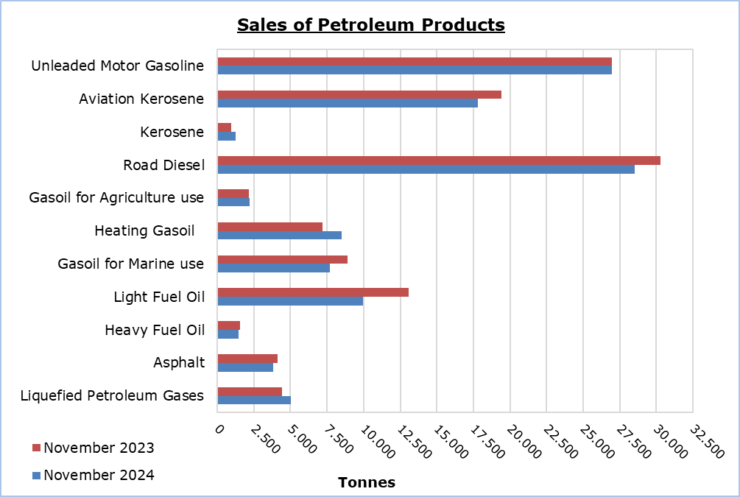

|  |  |  |  |  |  |  |  |
| --- | --- | --- | --- | --- | --- | --- | --- |
| **Table 1** |  |  |  |  |  |  |  |
| **Products** | **Total Sales (tonnes)** | | | |  | **Percentage Change**  **(%)** | |
| **Nov 2024** | **Nov 2023** | **Jan - Nov 2024** | **Jan - Nov 2023** |  | **Nov 2024/2023** | **Jan - Nov 2024/2023** |
| Unleaded Motor Gasoline | 26.986 | 26.954 | 307.088 | 297.673 | 0,1 | 3,2 |
| Aviation Gasoline | 1 | 1 | 14 | 19 |  | 0,0 | -26,3 |
| Aviation Kerosene | 17.832 | 19.412 | 290.137 | 279.364 |  | -8,1 | 3,9 |
| Kerosene | 1.251 | 926 | 6.948 | 8.166 |  | 35,1 | -14,9 |
| Road Diesel | 28.534 | 30.269 | 321.548 | 317.799 |  | -5,7 | 1,2 |
| Gasoil for Agriculture Use | 2.230 | 2.137 | 20.447 | 18.699 |  | 4,4 | 9,3 |
| Heating Gasoil | 8.512 | 7.175 | 67.026 | 70.964 |  | 18,6 | -5,5 |
| Gasoil for Marine use | 7.675 | 8.911 | 78.958 | 82.366 |  | -13,9 | -4,1 |
| Light Fuel Oil | 9.940 | 13.059 | 144.597 | 151.015 |  | -23,9 | -4,2 |
| Heavy Fuel Oil | 1.478 | 1.577 | 13.564 | 13.187 |  | -6,3 | 2,9 |
| Lubricants | 313 | 264 | 2.805 | 2.707 |  | 18,6 | 3,6 |
| Asphalt | 3.842 | 4.129 | 34.922 | 33.863 |  | -7,0 | 3,1 |
| Liquefied Petroleum Gases | 5.046 | 4.439 | 48.140 | 49.428 |  | 13,7 | -2,6 |
| **Total** | **113.640** | **119.253** | **1.336.194** | **1.325.250** | **-4,7** | **0,8** |

|  |  |  |  |  |  |  |  |
| --- | --- | --- | --- | --- | --- | --- | --- |
| **Table 2** |  |  |  |  |  |  |  |
| **Products** | **Sales from Filling Stations (tonnes)** | | | |  | **Percentage Change**  **(%)** | |
| **Nov 2024** | **Nov 2023** | **Jan - Nov 2024** | **Jan - Nov 2023** |  | **Nov 2024/2023** | **Jan - Nov 2024/2023** |
| Unleaded Motor Gasoline | 26.789 | 26.672 | 304.255 | 294.612 | 0,4 | 3,3 |
| Kerosene | 915 | 640 | 5.275 | 6.134 |  | 43,0 | -14,0 |
| Road Diesel | 23.673 | 23.174 | 257.525 | 250.737 |  | 2,2 | 2,7 |
| Gasoil for Agriculture Use | 1.572 | 1.366 | 13.891 | 12.880 |  | 15,1 | 7,8 |
| Heating Gasoil | 5.449 | 4.289 | 39.452 | 41.943 |  | 27,0 | -5,9 |
| Light Fuel Oil | 80 | 33 | 405 | 405 |  | 142,4 | 0,0 |
| Lubricants | 109 | 108 | 1.153 | 1.115 |  | 0,9 | 3,4 |
| **Total** | **58.587** | **56.282** | **621.956** | **607.826** | **4,1** | **2,3** |

**METHODOLOGICAL INFORMATION**

**Scope and Coverage**

The collection of data on Imports, Sales and Stocks of Petroleum Products is carried out on a monthly basis.

It concerns the sales of petroleum products from filling stations and the sales to government departments, to the British Bases and the United Nations, to ships and to other customers, as well as the stocks held at the end of each month. Only the petroleum companies are being covered. Additionally, the imports of petroleum products imported directly from the Electricity Authority of Cyprus (EAC) and the manufacturing industry are also included.

**Data Collection**

The collection of data is conducted by the Statistical Service on a monthly basis by electronically receiving a purpose-designed questionnaire from each of these companies.

***For more information*:**

CYSTAT Portal, subtheme [Energy](https://www.cystat.gov.cy/en/SubthemeStatistics?s=34)

[CYSTAT-DB](https://cystatdb.cystat.gov.cy/pxweb/en/8.CYSTAT-DB/8.CYSTAT-DB__Energy__) (Online Database)

[Predefined Tables](https://www.cystat.gov.cy/en/KeyFiguresList?s=34) (Excel)

[Methodological Information](https://www.cystat.gov.cy/en/MethodologicalDetails?m=2196)

**The Predefined Tables, available in Excel format, include data up to December 2022. Data from January 2023 onwards are available only in the CYSTAT-DB Online Database.**

*Contact*

Nafsika Apostolou: Tel.: +35722602199, E-mail: napostolou@cystat.mof.gov.cy