27 November, 2025

PRESS RELEASE

IMPORTS, SALES AND STOCKS OF PETROLEUM PRODUCTS: OCTOBER 2025

Annual Change in Sales +4,7%

In October 2025, the total sales of petroleum products amounted to 141.540 tonnes, recording an increase of 4,7% compared to October 2024. A rise was observed in the provisions of marine gasoil (101,9%) and aviation kerosene (5,9%), as well as in the sales of asphalt (44,9%), heavy fuel oil (26,8%), motor gasoline (4,6%), liquefied petroleum gases (3,6%) and road diesel (1,7%). On the contrary, a drop was observed ιn the sales of light fuel oil (-53,5%) and heating gasoil (-11,4%). As far as the sales from filling stations are specifically concerned, these have registered a rise of 3,0% to 61.904 tonnes.

The total sales of petroleum products in October 2025 compared to September 2025 recorded a drop of 2,2%. Indicatively, a fall was recorded in the provisions of marine gasoil (-22,5%) and aviation kerosene (-2,9%), as well as in the sales of motor gasoline (-4,1%) and road diesel (-2,0%). The total stocks of petroleum products at the end of October 2025 decreased by 17,6% compared to the end of the previous month.

During the period January – October 2025, the total sales of petroleum products increased by 4,7% compared to the corresponding period of the previous year.

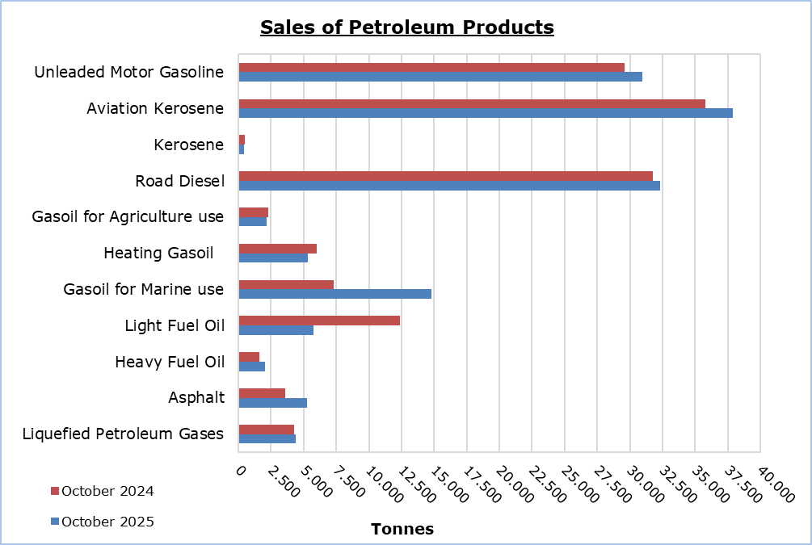

Table 1
Products | Total Sales (tonnes) |  |  |  |  | Percentage Change  (%)
Products | Oct  2025 | Oct  2024 | Jan - Oct 2025 | Jan - Oct 2024 |  | Oct 2025/2024 | Jan - Oct 2025/2024
Unleaded Motor Gasoline | 30.951 | 29.587 | 289.646 | 280.102 |  | 4,6 | 3,4
Aviation Gasoline | 1 | 1 | 16 | 13 |  | 0,0 | 23,1
Aviation Kerosene | 37.871 | 35.770 | 303.589 | 272.305 |  | 5,9 | 11,5
Kerosene | 399 | 463 | 6.662 | 5.697 |  | -13,8 | 16,9
Road Diesel | 32.300 | 31.768 | 300.313 | 293.014 |  | 1,7 | 2,5
Gasoil for Agriculture Use | 2.148 | 2.299 | 19.535 | 18.217 |  | -6,6 | 7,2
Heating Gasoil | 5.334 | 6.017 | 63.655 | 58.514 |  | -11,4 | 8,8
Gasoil for Marine Use | 14.795 | 7.327 | 136.153 | 71.283 |  | 101,9 | 91,0
Light Fuel Oil | 5.758 | 12.372 | 66.072 | 134.657 |  | -53,5 | -50,9
Heavy Fuel Oil | 2.025 | 1.597 | 11.312 | 12.086 |  | 26,8 | -6,4
Lubricants | 323 | 192 | 2.879 | 2.492 |  | 68,2 | 15,5
Asphalt | 5.237 | 3.613 | 33.888 | 31.080 |  | 44,9 | 9,0
Liquefied Petroleum Gases | 4.398 | 4.244 | 46.088 | 43.094 |  | 3,6 | 6,9
Total | 141.540 | 135.250 | 1.279.808 | 1.222.554 |  | 4,7 | 4,7

Table 2
Products | Sales from Filling Stations (tonnes) |  |  |  |  | Percentage Change  (%)
Products | Oct  2025 | Oct  2024 | Jan - Oct 2025 | Jan - Oct 2024 |  | Oct 2025/2024 | Jan - Oct 2025/2024
Unleaded Motor Gasoline | 30.633 | 29.289 | 286.844 | 277.466 |  | 4,6 | 3,4
Kerosene | 315 | 364 | 4.910 | 4.360 |  | -13,5 | 12,6
Road Diesel | 26.078 | 25.277 | 239.921 | 233.852 |  | 3,2 | 2,6
Gasoil for Agriculture Use | 1.568 | 1.586 | 13.416 | 12.319 |  | -1,1 | 8,9
Heating Gasoil | 3.138 | 3.505 | 36.490 | 34.003 |  | -10,5 | 7,3
Light Fuel Oil | 40 | 30 | 439 | 325 |  | 33,3 | 35,1
Lubricants | 132 | 62 | 1.191 | 1.044 |  | 112,9 | 14,1
Total | 61.904 | 60.113 | 583.211 | 563.369 |  | 3,0 | 3,5

METHODOLOGICAL INFORMATION

Scope and Coverage

The collection of data on Imports, Sales and Stocks of Petroleum Products is carried out on a monthly basis.

It concerns the sales of petroleum products from filling stations and the sales to government departments, to the British Bases and the United Nations, to ships and to other customers, as well as the stocks held at the end of each month. Only the petroleum companies are being covered. Additionally, the imports of petroleum products imported directly from the Electricity Authority of Cyprus (EAC) and the manufacturing industry are also included.

Data Collection

The collection of data is conducted by the Statistical Service on a monthly basis by electronically receiving a purpose-designed questionnaire from each of these companies.

For more information:
CYSTAT Portal, subtheme Energy
CYSTAT-DB (Online Database)
Predefined Tables (Excel)
Methodological Information

The Predefined Tables, available in Excel format, include data up to December 2022. Data from January 2023 onwards are available only in the CYSTAT-DB Online Database.

Contact
Nafsika Apostolou: Tel.: +35722602199, E-mail: napostolou@cystat.mof.gov.cy
Dimitrios Pilavakis: Tel.: +35722602153, E-mail: dpilavakis@cystat.mof.gov.cy

