27 October, 2025

PRESS RELEASE

IMPORTS, SALES AND STOCKS OF PETROLEUM PRODUCTS: SEPTEMBER 2025

Annual Change in Sales +11,2%

In September 2025, the total sales of petroleum products amounted to 144.720 tonnes, recording an increase of 11,2% compared to September 2024. A rise was observed in the provisions of marine gasoil (112,3%) and aviation kerosene (16,8%), as well as in the sales of asphalt (29,7%), liquefied petroleum gases (9,1%), motor gasoline (8,6%), heating gasoil (7,4%) and road diesel (6,9%). On the contrary, a drop was observed ιn the sales of light fuel oil (-47,8%). As far as the sales from filling stations are specifically concerned, these have registered a rise of 6,3% to 61.537 tonnes.

The total sales of petroleum products in September 2025 compared to August 2025 recorded an increase of 17,3%. Indicatively, a rise was recorded in the provisions of marine gasoil (61,7%) and in the sales of road diesel (21,1%) and motor gasoline (10,0%), whereas there was a drop in the provisions of aviation kerosene (-5,6%). The total stocks of petroleum products at the end of September 2025 rose by 38,9% compared to the end of the previous month.

During the period January – September 2025, the total sales of petroleum products increased by 4,7% compared to the corresponding period of the previous year.

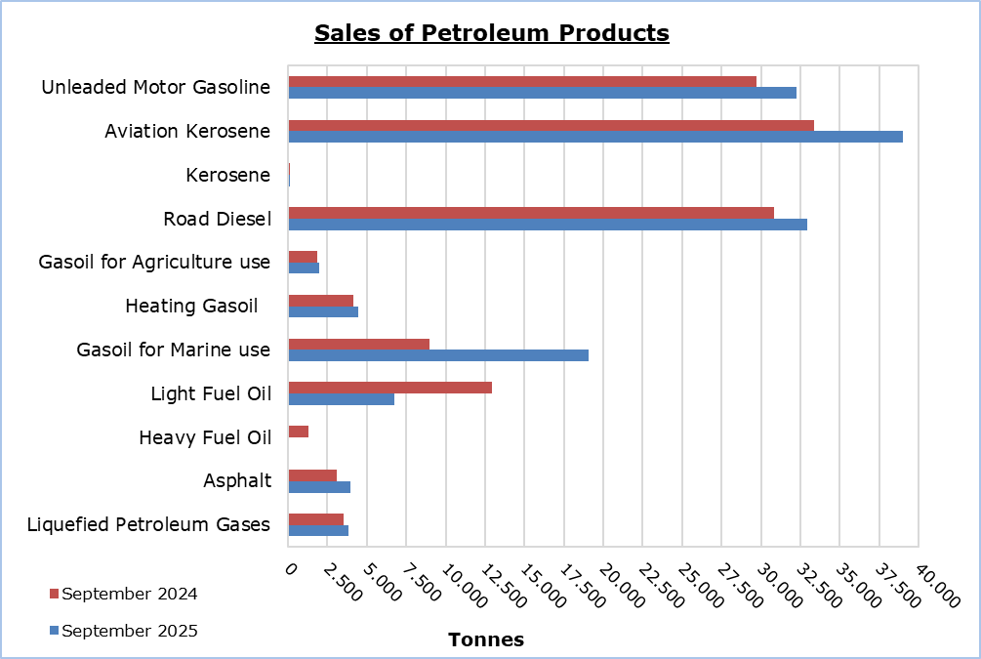

Table 1
Products | Total Sales (tonnes) |  |  |  |  | Percentage Change  (%)
Products | Sept  2025 | Sept  2024 | Jan - Sept 2025 | Jan - Sept 2024 |  | Sept 2025/2024 | Jan - Sept 2025/2024
Unleaded Motor Gasoline | 32.285 | 29.725 | 258.695 | 250.515 |  | 8,6 | 3,3
Aviation Gasoline | 1 | 2 | 15 | 12 |  | -50,0 | 25,0
Aviation Kerosene | 38.987 | 33.391 | 265.718 | 236.535 |  | 16,8 | 12,3
Kerosene | 116 | 106 | 6.263 | 5.234 |  | 9,4 | 19,7
Road Diesel | 32.954 | 30.839 | 268.013 | 261.246 |  | 6,9 | 2,6
Gasoil for Agriculture Use | 1.950 | 1.822 | 17.387 | 15.918 |  | 7,0 | 9,2
Heating Gasoil | 4.462 | 4.153 | 58.321 | 52.497 |  | 7,4 | 11,1
Gasoil for Marine Use | 19.090 | 8.990 | 121.358 | 63.956 |  | 112,3 | 89,8
Light Fuel Oil | 6.743 | 12.916 | 60.314 | 122.285 |  | -47,8 | -50,7
Heavy Fuel Oil | 0 | 1.323 | 9.287 | 10.489 |  | -100,0 | -11,5
Lubricants | 319 | 275 | 2.556 | 2.300 |  | 16,0 | 11,1
Asphalt | 3.977 | 3.066 | 28.651 | 27.467 |  | 29,7 | 4,3
Liquefied Petroleum Gases | 3.836 | 3.516 | 41.690 | 38.850 |  | 9,1 | 7,3
Total | 144.720 | 130.124 | 1.138.268 | 1.087.304 |  | 11,2 | 4,7

Table 2
Products | Sales from Filling Stations (tonnes) |  |  |  |  | Percentage Change  (%)
Products | Sept  2025 | Sept  2024 | Jan - Sept 2025 | Jan - Sept 2024 |  | Sept 2025/2024 | Jan - Sept 2025/2024
Unleaded Motor Gasoline | 31.933 | 29.472 | 256.211 | 248.177 |  | 8,4 | 3,2
Kerosene | 86 | 80 | 4.595 | 3.996 |  | 7,5 | 15,0
Road Diesel | 25.629 | 24.784 | 213.843 | 208.575 |  | 3,4 | 2,5
Gasoil for Agriculture Use | 1.348 | 1.262 | 11.848 | 10.733 |  | 6,8 | 10,4
Heating Gasoil | 2.361 | 2.189 | 33.352 | 30.498 |  | 7,9 | 9,4
Light Fuel Oil | 47 | 15 | 399 | 295 |  | 213,3 | 35,3
Lubricants | 133 | 112 | 1.059 | 982 |  | 18,8 | 7,8
Total | 61.537 | 57.914 | 521.307 | 503.256 |  | 6,3 | 3,6

METHODOLOGICAL INFORMATION

Scope and Coverage

The collection of data on Imports, Sales and Stocks of Petroleum Products is carried out on a monthly basis.

It concerns the sales of petroleum products from filling stations and the sales to government departments, to the British Bases and the United Nations, to ships and to other customers, as well as the stocks held at the end of each month. Only the petroleum companies are being covered. Additionally, the imports of petroleum products imported directly from the Electricity Authority of Cyprus (EAC) and the manufacturing industry are also included.

Data Collection

The collection of data is conducted by the Statistical Service on a monthly basis by electronically receiving a purpose-designed questionnaire from each of these companies.

For more information:
CYSTAT Portal, subtheme Energy
CYSTAT-DB (Online Database)
Predefined Tables (Excel)
Methodological Information

The Predefined Tables, available in Excel format, include data up to December 2022. Data from January 2023 onwards are available only in the CYSTAT-DB Online Database.

Contact
Nafsika Apostolou: Tel.: +35722602199, E-mail: napostolou@cystat.mof.gov.cy
Dimitrios Pilavakis: Tel.: +35722602153, E-mail: dpilavakis@cystat.mof.gov.cy

