31 July, 2025

**PRESS RELEASE**

INDEX OF INDUSTRIAL OUTPUT PRICES: **JUNE 2025**

**Annual Change 0,0%**

The Index of Industrial Output Prices for June 2025 reached 123,1 units (base 2021=100), recording an increase of 0,3% compared to May 2025. Compared to the corresponding month of the previous year, the index remained stable. For the period January-June 2025, the index showed a decrease of 0,2% compared to the corresponding period of 2024.

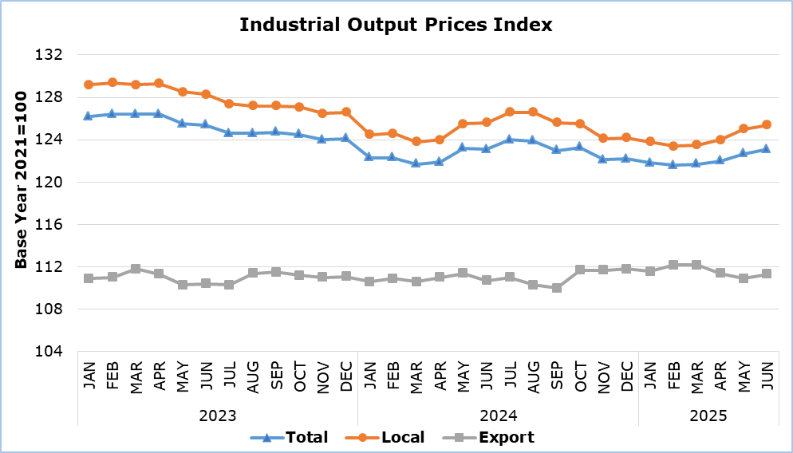

In June 2025 compared to May 2025, the index showed a rise in the sectors of water supply and materials recovery by 2,3%, mining and quarrying by 0,4% and manufacturing by 0,3%. A decrease was recorded in the electricity supply sector (-0,1%).

Compared to the corresponding month of the previous year, an increase was recorded in the mining and quarrying (7,7%) and manufacturing (1,4%) sectors, while a decrease was shown in the sectors of water supply and materials recovery (-7,4%) and electricity supply (-4,4%).

By division of economic activity in manufacturing, in June 2025 compared to the corresponding month of the previous year, increases were recorded in the manufacture of electronic and optical products and electrical equipment (6,6%), the manufacture of furniture, other manufacturing and repair and installation of machinery and equipment (4,0%), the manufacture of paper and paper products and printing (3,6%), the manufacture of textiles, wearing apparel and leather products (2,9%), the manufacture of refined petroleum products, chemicals and chemical products and pharmaceutical products and preparations (2,5%) and the manufacture of machinery and equipment, motor vehicles and other transport equipment (2,0%), while no decrease was recorded.

**Table 1**

|  |  |  |  |  |  |  |
| --- | --- | --- | --- | --- | --- | --- |
| **Economic Activity** | **Index (2021=100)** | |  | **Percentage Change (%)** | | |
| **May**  **2025** | **Jun**  **2025** |  | **Jun 2025/**  **May 2025** | **Jun**  **2025/2024** | **Jan-Jun 2025/2024** |
| Mining and Quarrying | 134,1 | 134,6 |  | 0,4 | 7,7 | 5,9 |
| Manufacturing | 119,4 | 119,8 |  | 0,3 | 1,4 | 0,8 |
| Electricity Supply | 143,9 | 143,8 |  | -0,1 | -4,4 | -4,1 |
| Water Supply and Materials Recovery | 100,2 | 102,5 |  | 2,3 | -7,4 | -3,4 |
| **General Index**  Local  Export | **122,7**  125,0  110,9 | **123,1**  125,4  111,3 |  | **0,3**  0,3  0,4 | **0,0**  -0,2  0,5 | **-0,2**  -0,4  0,7 |

Note: Data for May and June 2025 in the sectors of Electricity Supply and Water Supply and Materials Recovery are preliminary.

**Table 2**

|  |  |  |  |  |
| --- | --- | --- | --- | --- |
| **Code NACE Rev. 2** | **Economic Activity** | **Percentage Change (%)** | | |
| **Jun 2025/**  **May 2025** | **Jun**  **2025/2024** | **Jan-Jun 2025/2024** |
| **C** | **ΜANUFACTURING** | **0,3** | **1,4** | **0,8** |
| 10+11+12 | Manufacture of Food Products, Beverages and Tobacco Products | 0,7 | 0,3 | -0,7 |
| 13+14+15 | Manufacture of Textiles, Wearing Apparel and Leather Products | 0,0 | 2,9 | 3,1 |
| 16 | Manufacture of Wood and Products of Wood and Cork, except Furniture | 0,2 | 1,0 | 0,7 |
| 17+18 | Manufacture of Paper and Paper Products and Printing | 0,0 | 3,6 | 3,4 |
| 19+20+21 | Manufacture of Refined Petroleum Products, Chemicals and Chemical Products and Pharmaceutical Products and Preparations | 0,0 | 2,5 | 2,4 |
| 22 | Manufacture of Rubber and Plastic Products | -0,1 | 0,3 | 0,2 |
| 23 | Manufacture of Other Non-Metallic Mineral Products | 0,2 | 1,6 | 1,1 |
| 24+25 | Manufacture of Basic Metals and Fabricated Metal Products | 0,0 | 1,0 | 0,9 |
| 26+27 | Manufacture of Electronic and Optical Products and Electrical Equipment | 0,0 | 6,6 | 6,3 |
| 28+29+30 | Manufacture of Machinery and Equipment, Motor Vehicles and Other Transport Equipment | 0,2 | 2,0 | 2,0 |
| 31+32+33 | Manufacture of Furniture, Other Manufacturing and Repair and Installation of Machinery and Equipment | 0,2 | 4,0 | 4,1 |

**METHODOLOGICAL INFORMATION**

**Definitions**

The Industrial Output Prices Index is a monthly index and is the combination of the Industrial Output Prices Index for the domestic market and the Industrial Output Prices Index for the non domestic market.

The prices collected for products sold in the domestic market are basic selling prices excluding VAT, discounts, commissions and excise duties. Moreover, the prices collected for products sold in the non domestic market are quoted FOB (free on board).

The prices collected refer mainly to transactions between the enterprises that produce and sell the products chosen for the compilation of the Industrial Output Prices Index and the enterprises that buy these products, regardless of whether those products are to be used as raw materials or as merchandise.

**Scope**  
The monthly Industrial Output Prices Index reflects the evolution of prices in the sectors of mining and quarrying, manufacturing, electricity supply, water supply and materials recovery, that is, sections B, C, D and E of the statistical classification of economic activities NACE Rev. 2 of the European Union. The index does not include sewerage, waste collection, treatment and disposal and remediation activities, which are codes 37, 38.1, 38.2 and 39 of section E. The index can be an early indicator of inflationary pressures in the economy. The aggregated index is broken down to local market and export market indices.

**Data Collection**

The collection of data for the sectors of mining and quarrying, manufacturing and materials recovery is conducted by the Statistical Service by telephone enquiries and e-mail. Data is collected after the first Thursday of each month from a sample of enterprises. For electricity supply and water collection, treatment and supply, data is collected from administrative sources.

**Compilation Method**

The Industrial Output Prices Index is using 2021 as base year, meaning that it shows the monthly changes in prices in relation with the monthly average prices of the year 2021. In the base year, the average of the price indices for the twelve months is 100,0. For example, a monthly price index of 112,3 means that the prices for the specific month have increased by 12,3% in relation to the average monthly prices of 2021.

The aggregated Industrial Output Prices Index is a weighted average of the price indices of the various sub-sectors of Industry, as determined in the statistical classification of economic activities NACE Rev. 2. The weights used are derived from the total sales of the enterprises in the base year (2021) and reflect the turnover of each sub-sector in relation to the total turnover of the Industrial sector.

The compilation of the Industrial Output Prices Index follows the provisions of Regulation (EU) 2019/2152 on European business statistics. The Index is transmitted every month to the Statistical Office of the European Union (Eurostat).

***For more information:***

CYSTAT Portal, subtheme [Industry](https://www.cystat.gov.cy/en/SubthemeStatistics?s=39)

[CYSTAT-DB](https://cystatdb.cystat.gov.cy/pxweb/en/8.CYSTAT-DB/8.CYSTAT-DB__Industry__) (Online Database)

[Predefined Tables](https://www.cystat.gov.cy/en/KeyFiguresList?s=39) (Excel)

[Methodological Information](https://www.cystat.gov.cy/en/MethodologicalDetails?m=2304)

**Data for base year 2021=100 are available only in the CYSTAT-DB Online Database.**

*Contact*  
Evangelia Menelaou: Tel.: 22602165, E-mail: emenelaou@cystat.mof.gov.cy