31 July, 2026

PRESS RELEASE

INDEX OF INDUSTRIAL OUTPUT PRICES: JUNE 2026

Annual Change 2,3%

The Index of Industrial Output Prices for June 2026 reached 125,8 units (base 2021=100), recording an increase of 0,3% compared to May 2026. Compared to the corresponding month of the previous year, the index recorded an increase of 2,3%. For the period January-June 2026, the index showed an increase of 0,8% compared to the corresponding period of 2025.

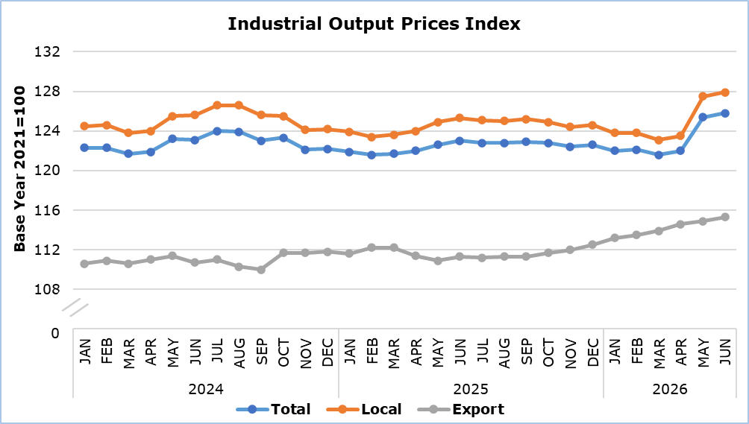

In June 2026 compared to May 2026, the index showed an increase in mining and quarrying by 0,3%, in manufacturing by 0,3% and in electricity supply also by 0,3%, while it showed a decrease in the sector of water supply and materials recovery by 0,2%.

Compared to the corresponding month of the previous year, an increase was recorded in all sectors, as follows: water supply and materials recovery 5,8%, electricity supply 3,6%, manufacturing 1,8% and mining and quarrying 1,6%.

By division of economic activity in manufacturing, in June 2026 compared to the corresponding month of the previous year, increases were recorded in the manufacture of electronic and optical products and electrical equipment (10,8%), the manufacture of furniture, other manufacturing and repair and installation of machinery and equipment (5,6%), the manufacture of basic metals and fabricated metal products (5,2%), the manufacture of wood and products of wood and cork, except furniture (4,1%) and the manufacture of machinery and equipment, motor vehicles and other transport equipment (2,6%), while a decrease was recorded in the manufacture of food products, beverages and tobacco products (-0,2%). No change was recorded in the manufacture of textiles, wearing apparel and leather products.

Table 1
Economic Activity | Index (2021=100) |  |  | Percentage Change (%)
Economic Activity | May  2026 | June  2026 |  | June 2026/ May 2026 | June  2026/2025 | Jan-Jun 2026/2025
Mining and Quarrying | 136,4 | 136,8 |  | 0,3 | 1,6 | 3,1
Manufacturing | 121,6 | 122,0 |  | 0,3 | 1,8 | 1,3
Electricity Supply | 147,4 | 147,9 |  | 0,3 | 3,6 | -1,3
Water Supply and Materials Recovery | 109,7 | 109,5 |  | -0,2 | 5,8 | 2,5
General Index  Local  Export | 125,4  127,5  114,9 | 125,8  127,9  115,3 |  | 0,3  0,3  0,3 | 2,3  2,1  3,6 | 0,8  0,6  2,4
Note: Data for May and June 2026 in the sectors of Electricity Supply and Water Supply and Materials Recovery are preliminary.

Table 2
Code NACE Rev. 2 | Economic Activity | Percentage Change (%)
Code NACE Rev. 2 | Economic Activity | June 2026/ May 2026 | June  2026/2025 | Jan-Jun 2026/2025
C | ΜANUFACTURING | 0,3 | 1,8 | 1,3
10+11+12 | Manufacture of Food Products, Beverages and Tobacco Products | 0,5 | -0,2 | 0,2
13+14+15 | Manufacture of Textiles, Wearing Apparel and Leather Products | 0,0 | 0,0 | 0,1
16 | Manufacture of Wood and Products of Wood and Cork, except Furniture | 0,1 | 4,1 | 2,2
17+18 | Manufacture of Paper and Paper Products and Printing | -0,1 | 0,3 | 0,1
19+20+21 | Manufacture of Refined Petroleum Products, Chemicals and Chemical Products and Pharmaceutical Products and Preparations | 0,3 | 1,1 | 0,7
22 | Manufacture of Rubber and Plastic Products | -0,7 | 1,0 | 0,5
23 | Manufacture of Other Non-Metallic Mineral Products | 0,2 | 1,6 | 1,2
24+25 | Manufacture of Basic Metals and Fabricated Metal Products | 0,1 | 5,2 | 1,8
26+27 | Manufacture of Electronic and Optical Products and Electrical Equipment | 2,7 | 10,8 | 6,1
28+29+30 | Manufacture of Machinery and Equipment, Motor Vehicles and Other Transport Equipment | 0,9 | 2,6 | 1,7
31+32+33 | Manufacture of Furniture, Other Manufacturing and Repair and Installation of Machinery and Equipment | 0,1 | 5,6 | 5,7

METHODOLOGICAL INFORMATION

Definitions
The Industrial Output Prices Index is a monthly index and is the combination of the Industrial Output Prices Index for the domestic market and the Industrial Output Prices Index for the non domestic market.

The prices collected for products sold in the domestic market are basic selling prices excluding VAT, discounts, commissions and excise duties. Moreover, the prices collected for products sold in the non domestic market are quoted FOB (free on board).

The prices collected refer mainly to transactions between the enterprises that produce and sell the products chosen for the compilation of the Industrial Output Prices Index and the enterprises that buy these products, regardless of whether those products are to be used as raw materials or as merchandise.

Scope
The monthly Industrial Output Prices Index reflects the evolution of prices in the sectors of mining and quarrying, manufacturing, electricity supply, water supply and materials recovery, that is, sections B, C, D and E of the statistical classification of economic activities NACE Rev. 2 of the European Union. The index does not include sewerage, waste collection, treatment and disposal and remediation activities, which are codes 37, 38.1, 38.2 and 39 of section E. The index can be an early indicator of inflationary pressures in the economy. The aggregated index is broken down to local market and export market indices.

Data Collection
The collection of data for the sectors of mining and quarrying, manufacturing and materials recovery is conducted by the Statistical Service by telephone enquiries and e-mail. Data is collected after the first Thursday of each month from a sample of enterprises. For electricity supply and water collection, treatment and supply, data is collected from administrative sources.

Compilation Method
The Industrial Output Prices Index is using 2021 as base year, meaning that it shows the monthly changes in prices in relation with the monthly average prices of the year 2021. In the base year, the average of the price indices for the twelve months is 100,0. For example, a monthly price index of 112,3 means that the prices for the specific month have increased by 12,3% in relation to the average monthly prices of 2021.

The aggregated Industrial Output Prices Index is a weighted average of the price indices of the various sub-sectors of Industry, as determined in the statistical classification of economic activities NACE Rev. 2. The weights used are derived from the total sales of the enterprises in the base year (2021) and reflect the turnover of each sub-sector in relation to the total turnover of the Industrial sector.

The compilation of the Industrial Output Prices Index follows the provisions of Regulation (EU) 2019/2152 on European business statistics. The Index is transmitted every month to the Statistical Office of the European Union (Eurostat).

For more information:
CYSTAT Portal, subtheme Industry
CYSTAT-DB (Online Database)
Predefined Tables (Excel)
Methodological Information

Data for base year 2021=100 are available only in the CYSTAT-DB Online Database.

Contact
Evangelia Menelaou: Tel.: 22602165, E-mail: emenelaou@cystat.mof.gov.cy

