30 December, 2022

PRESS RELEASE

INDEX OF INDUSTRIAL OUTPUT PRICES: NOVEMBER 2022

Annual Change +17,2%

The Index of Industrial Output Prices for November 2022 reached 136,2 units (base 2015=100), recording a decrease of 3,3% compared to October 2022. Compared to the corresponding month of the previous year, the index recorded an increase of 17,2%. For the period January-November 2022, the index showed an increase of 22,6% compared to the corresponding period of 2021.

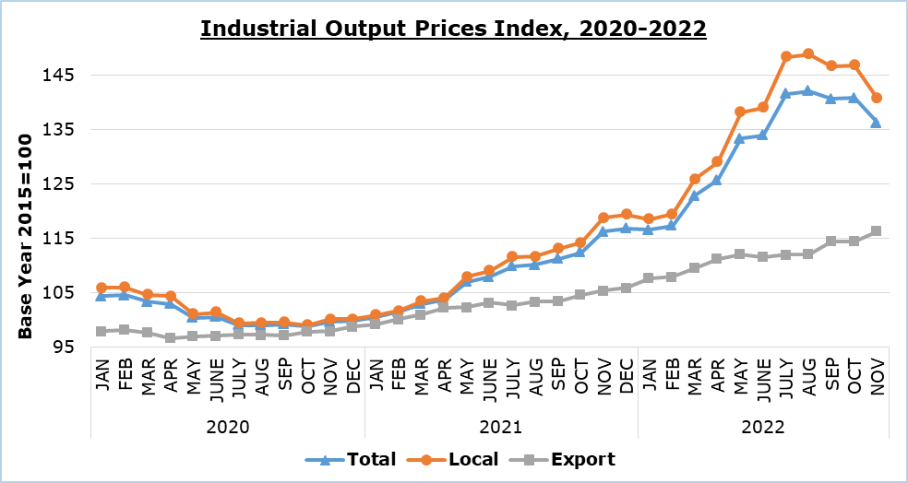

In November 2022 compared to October 2022, the index remained stable in the sector of water supply and materials recovery, while it showed a rise in the sectors of mining and quarrying by 1,0% and manufacturing by 0,7%. In the sector of electricity supply the index recorded a decrease of 12,6%.

Compared to the corresponding month of the previous year, an increase was recorded in all sectors, as follows: electricity supply 32,4%, mining and quarrying 14,8%, manufacturing 12,9% and water supply and materials recovery 6,7%.

By division of economic activity in manufacturing, in November 2022 compared to the corresponding month of the previous year, increases were recorded in all economic activities. The most significant were observed in the manufacture of other non-metallic mineral products (21,3%), the manufacture of food products and beverages (14,3%), the manufacture of rubber and plastic products (14,2%), the manufacture of basic metals and fabricated metal products (13,3%), the manufacture of wood and products of wood and cork, except furniture (13,2%), the manufacture of paper and paper products and printing (12,3%) and the manufacture of electronic and optical products and electrical equipment (9,7%).

Table 1
Economic Activity | Index (2015=100) |  |  | Percentage Change (%)
Economic Activity | Oct  2022 | Nov  2022 |  | Nov 2022/  Oct 2022 | Nov 2022/  Nov 2021 | Jan-Nov 2022/  Jan-Nov 2021
Mining and Quarrying | 115,9 | 117,1 |  | 1,0 | 14,8 | 10,0
Manufacturing | 121,8 | 122,6 |  | 0,7 | 12,9 | 12,3
Electricity Supply | 215,7 | 188,6 |  | -12,6 | 32,4 | 60,4
Water Supply and Materials Recovery | 145,1 | 145,1 |  | 0,0 | 6,7 | 21,0
General Index  Local  Export | 140,8  146,8  114,4 | 136,2  140,7  116,3 |  | -3,3  -4,2  1,7 | 17,2  18,5  10,5 | 22,6  25,5  9,0
Note: Data for October 2022 in the sector of Water Supply and Materials Recovery and November 2022 in the sectors of Electricity Supply and Water Supply and Materials Recovery are preliminary.

Table 2
Code NACE Rev. 2 | Economic Activity | Percentage Change (%)
Code NACE Rev. 2 | Economic Activity | Nov 2022/  Oct 2022 | Nov 2022/  Nov 2021 | Jan-Nov 2022/  Jan-Nov 2021
C | ΜANUFACTURING | 0,7 | 12,9 | 12,3
10+11+12 | Manufacture of Food Products, Beverages and Tobacco Products | 1,0 | 14,3 | 10,6
13+14+15 | Manufacture of Textiles, Wearing Apparel and Leather Products | 0,0 | 5,5 | 6,0
16 | Manufacture of Wood and Products of Wood and Cork, except Furniture | 0,0 | 13,2 | 24,2
17+18 | Manufacture of Paper and Paper Products and Printing | 0,7 | 12,3 | 10,5
19+20+21 | Manufacture of Refined Petroleum Products, Chemicals and Chemical Products and Pharmaceutical Products and Preparations | 0,2 | 4,4 | 2,7
22 | Manufacture of Rubber and Plastic Products | 0,1 | 14,2 | 16,9
23 | Manufacture of Other Non-Metallic Mineral Products | 1,4 | 21,3 | 17,9
24+25 | Manufacture of Basic Metals and Fabricated Metal Products | -0,3 | 13,3 | 24,0
26+27 | Manufacture of Electronic and Optical Products and Electrical Equipment | 0,7 | 9,7 | 7,6
28+29+30 | Manufacture of Machinery and Equipment, Motor Vehicles and Other Transport Equipment | -0,6 | 8,4 | 11,7
31+32+33 | Manufacture of Furniture, Other Manufacturing and Repair and Installation of Machinery and Equipment | 0,4 | 9,2 | 8,9

METHODOLOGICAL INFORMATION

Definitions
The Industrial Output Prices Index is a monthly index and is the combination of the Industrial Output Prices Index for the domestic market and the Industrial Output Prices Index for the non domestic market.

The prices collected for products sold in the domestic market are basic selling prices excluding VAT, discounts, commissions and excise duties. Moreover, the prices collected for products sold in the non domestic market are quoted FOB (free on board).

The prices collected refer mainly to transactions between the enterprises that produce and sell the products chosen for the compilation of the Industrial Output Prices Index and the enterprises that buy these products, regardless of whether those products are to be used as raw materials or as merchandise.

Scope
The monthly Industrial Output Prices Index reflects the evolution of prices in the sectors of mining and quarrying, manufacturing, electricity supply, water supply and materials recovery, that is, sections B, C, D and E of the statistical classification of economic activities NACE Rev. 2 of the European Union. The index does not include sewerage, waste collection, treatment and disposal and remediation activities, which are codes 37, 38.1, 38.2 and 39 of section E. The index can be an early indicator of inflationary pressures in the economy. The aggregated index is broken down to local market and export market indices.

Data collection
The collection of data for the sectors of mining and quarrying, manufacturing and materials recovery is conducted by the Statistical Service by telephone enquiries and e-mail. Data is collected after the first Thursday of each month from a sample of enterprises. The Electricity Authority of Cyprus provides consumption data in quantity and value terms, while data is also received from water distribution and desalination units.

Compilation method
The Industrial Output Prices Index is using 2015 as base year, meaning that it shows the monthly changes in prices in relation with the monthly average prices of the year 2015. In the base year, the average of the price indices for the twelve months is 100,0. For example, a monthly price index of 112,3 means that the prices for the specific month have increased by 12,3% in relation to the average monthly prices of 2015.

The aggregated Industrial Output Prices Index is a weighted average of the price indices of the various sub-sectors of Industry. The weights used reflect the sales value of products belonging to each sub-sector in the base year (2015) in relation to the total sales value of the sector.

The compilation of the Industrial Output Prices Index follows the provisions of Regulation (EU) 2019/2152 on European business statistics. The Index is transmitted every month to the Statistical Office of the European Union (Eurostat).

For more information:
CYSTAT Portal, subtheme Industry
CYSTAT-DB (Online Database)
Predefined Tables (Excel)

Contact
Evangelia Menelaou: Tel.: 22602165, E-mail: emenelaou@cystat.mof.gov.cy

