7 July, 2025

**PRESS RELEASE**

###### RESULTS OF THE SURVEY ON INDUSTRIAL PRODUCTION 2023

**Increase in Value Added in the Industrial Sector by 11,3%**

According to the results of the Survey on Industrial Production 2023, employment in the broad industrial sector increased in 2023 by 1,2% to 42,6 thousand compared to 42,1 thousand persons in 2022. In manufacturing employment reached 37,4 thousand, in mining and quarrying 0,6 thousand, in electricity supply 2,4 thousand and in water supply, sewerage and waste management 2,3 thousand persons.

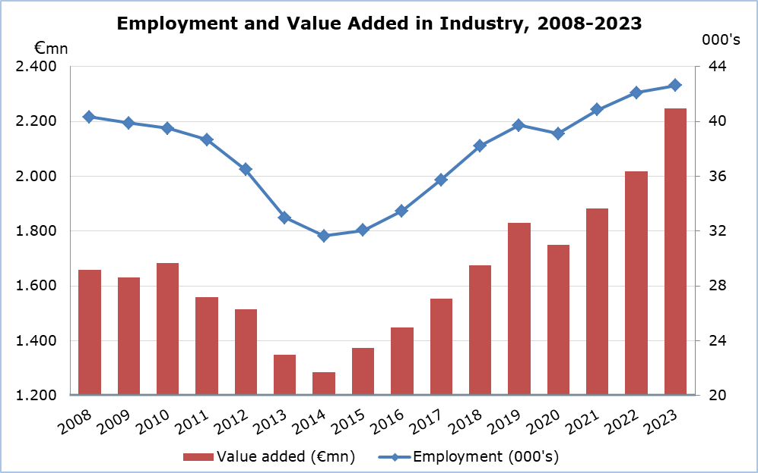

In the whole of the industrial sector, production value at current prices recorded an increase of 5,5% to €6.942,3 million in 2023 compared to €6.581,7 million in 2022. In manufacturing, production value increased by 7,5% to €4.848,9 million, in electricity supply by 0,3% to €1.441,7 million, in water supply, sewerage and waste management by 1,0% to €482,1 million and in mining and quarrying by 7,9% to €169,6 million.

Value added at current prices increased by 11,3% in the total of industry and reached €2.246,2 million in 2023 compared to €2.018,9 million in 2022. In manufacturing, value added increased by 11,6% to €1.643,0 million, in electricity supply by 17,5% to €356,0 million, in water supply, sewerage and waste management by 0,2% to €199,4 million and in mining and quarrying by 7,3% to €47,7 million.

|  |  |  |  |  |  |  |  |  |  |  |  |
| --- | --- | --- | --- | --- | --- | --- | --- | --- | --- | --- | --- |
| **Table** |  | | |  | | | |  | | | |
| **Economic Activity** | **Employment (000’s)** | | | **Production Value (€mn)** | | | **Value Added (€mn)** | | | |
|  | **2022** | **2023** | **%**\* | **2022** | **2023** | **%**\* | **2022** | | **2023** | **%**\* |
| Mining and Quarrying | 0,6 | 0,6 | -3,3 | 157,2 | 169,6 | 7,9 | 44,5 | | 47,7 | 7,3 |
| Manufacturing | 37,1 | 37,4 | 1,0 | 4.509,7 | 4.848,9 | 7,5 | 1.472,5 | | 1.643,0 | 11,6 |
| Electricity Supply | 2,2 | 2,4 | 6,1 | 1.437,2 | 1.441,7 | 0,3 | 303,0 | | 356,0 | 17,5 |
| Water Supply, Sewerage, Waste Management and Remediation Activities | 2,2 | 2,3 | 2,3 | 477,5 | 482,1 | 1,0 | 199,0 | | 199,4 | 0,2 |
| **Total Industry** | **42,1** | **42,6** | **1,2** | **6.581,7** | **6.942,3** | **5,5** | **2.018,9** | | **2.246,2** | **11,3** |

**\* Annual percentage change of 2023 compared to 2022.**

**METHODOLOGICAL INFORMATION**

**Definitions**

**Employment** – The average number of employees and self-employed persons during the year, in full time equivalent terms.

**Production value** - The value of goods produced, services rendered to others, net receipts from the sale of goods sold in the same condition as purchased, other income and changes in the value of work-in-progress at the end of the year.

**Value added** **at current prices** - Derived by deducting from the production value the aggregate costs of all materials used, other production expenses, administrative expenses and rents paid for buildings and machinery.

**Coverage and collection of data**

The Industrial Production Survey covers a sample of around 1.460 enterprises with main activity falling under sections B, C, D and E of the classification system of economic activities NACE Rev. 2 of the European Union.

The collection of data by the Statistical Service is done by personal interviews, by phone interviews, by email and using administrative sources.

***For more information:***

CYSTAT Portal, subtheme [Industry](https://www.cystat.gov.cy/en/SubthemeStatistics?s=39)

[Predefined Tables](https://www.cystat.gov.cy/en/KeyFiguresList?s=39) (Excel)

[Methodological Information](https://www.cystat.gov.cy/en/MethodologicalDetails?m=2066)

*Contact*

Charalambos Alkiviadous: Tel: 22602189, E-mail: [calkiviadous@cystat.mof.gov.cy](mailto:calkiviadous@cystat.mof.gov.cy)

Evangelia Menelaou: Tel.: 22602165, E-mail: emenelaou@cystat.mof.gov.cy