7 July, 2026

PRESS RELEASE

RESULTS OF THE SURVEY ON INDUSTRIAL PRODUCTION: 2024

Increase in Value Added in the Industrial Sector by 3,3%

According to the results of the Survey on Industrial Production 2024, employment in the broad industrial sector increased in 2024 by 0,5% to 42,8 thousand compared to 42,6 thousand persons in 2023. In manufacturing employment reached 38,0 thousand, in mining and quarrying 0,6 thousand, in electricity supply 2,4 thousand and in water supply, sewerage and waste management 1,9 thousand persons.

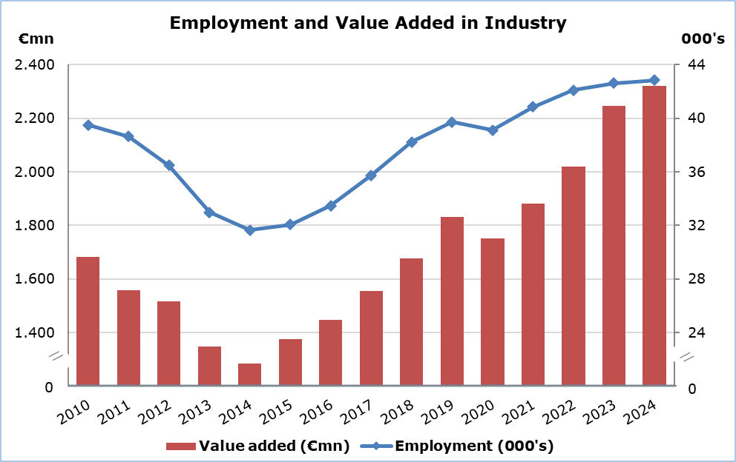

In the whole of the industrial sector, production value at current prices recorded an increase of 0,1% to €6.951,4 million in 2024 compared to €6.942,3 million in 2023. In manufacturing, production value increased by 3,6% to €5.021,6 million, while it decreased in electricity supply by 3,8% to €1.387,0 million, in water supply, sewerage and waste management by 15,5% to €407,6 million and in mining and quarrying by 20,2% to €135,3 million.

Value added at current prices increased by 3,3% in the total of industry and reached €2.321,3 million in 2024 compared to €2.246,2 million in 2023. In manufacturing, value added increased by 6,8% to €1.754,7 million and in electricity supply by 1,9% to €362,7 million, while it decreased in water supply, sewerage and waste management by 19,5% to €160,6 million and in mining and quarrying by 9,3% to €43,3 million.

Table
Economic Activity | Employment (000’s) |  |  | Production Value (€mn) |  |  | Value Added (€mn)
Economic Activity | 2023 | 2024 | %* | 2023 | 2024 | %* | 2023 |  | 2024 | %*
Mining and Quarrying | 0,6 | 0,6 | 1,7 | 169,6 | 135,3 | -20,2 | 47,7 |  | 43,3 | -9,3
Manufacturing | 37,4 | 38,0 | 1,5 | 4.848,9 | 5.021,6 | 3,6 | 1.643,0 |  | 1.754,7 | 6,8
Electricity Supply | 2,4 | 2,4 | 1,9 | 1.441,7 | 1.387,0 | -3,8 | 356,0 |  | 362,7 | 1,9
Water Supply, Sewerage, Waste Management and Remediation Activities | 2,3 | 1,9 | -17,8 | 482,1 | 407,6 | -15,5 | 199,4 |  | 160,6 | -19,5
Total Industry | 42,6 | 42,8 | 0,5 | 6.942,3 | 6.951,4 | 0,1 | 2.246,2 |  | 2.321,3 | 3,3
* Annual percentage change of 2024 compared to 2023.

Note: Data cover the Water Boards and the Sewerage Boards (classified under codes 36 and 37 respectively) for the period up to 30 June 2024. As from 1 July 2024, these Boards were integrated in the newly founded Local Government Organisations, as part of the administrative reform, and now fall under the General Government sector.

METHODOLOGICAL INFORMATION

Definitions

Employment – The average number of employees and self-employed persons during the year, in full time equivalent terms.

Production value - The value of goods produced, services rendered to others, net receipts from the sale of goods sold in the same condition as purchased, other income and changes in the value of work-in-progress at the end of the year.

Value added at current prices - Derived by deducting from the production value the aggregate costs of all materials used, other production expenses, administrative expenses and rents paid for buildings and machinery.

Coverage and collection of data

The Industrial Production Survey covers a sample of around 1.460 enterprises with main activity falling under sections B, C, D and E of the classification system of economic activities NACE Rev. 2 of the European Union.

The collection of data by the Statistical Service is done by personal interviews, by phone interviews, by email and using administrative sources.

For more information:
CYSTAT Portal, subtheme Industry
Predefined Tables (Excel)
Methodological Information

Contact
Charalambos Alkiviadous: Tel: 22602189, E-mail: calkiviadous@cystat.mof.gov.cy
Evangelia Menelaou: Tel.: 22602165, E-mail: emenelaou@cystat.mof.gov.cy

