5 June, 2025

**PRESS RELEASE**

INDUSTRIAL TURNOVER INDEX: **MARCH 2025**

**Annual Change +5,0%**

In March 2025, the Industrial Turnover Index reached 137,7 units (base 2021=100), recording an increase of 5,0% compared to March 2024. For the period January – March 2025, the index recorded an increase of 5,8% compared to the corresponding period of the previous year.

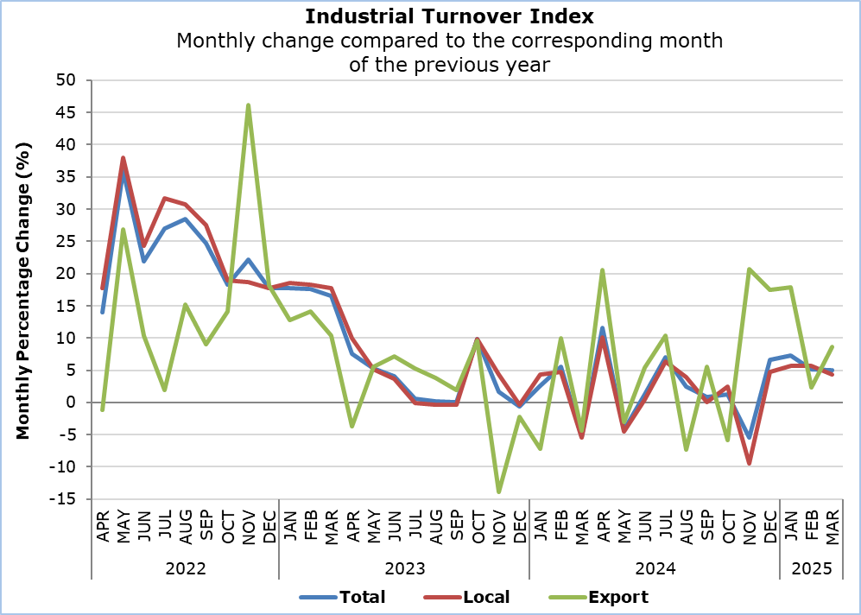

In manufacturing, the Industrial Turnover Index for March 2025 reached 138,3 units, recording an increase of 7,2% compared to March 2024. An increase was also recorded in the mining and quarrying sector (+12,5%). Decreases were noted in the sectors of water supply and materials recovery (-4,5%) and electricity supply (-3,3%).

|  |  |  |  |  |  |
| --- | --- | --- | --- | --- | --- |
| **Table** |  |  |  |  |  |
| **Code**  **(NACE**  **Rev. 2)** | **Economic Activity** | **Index**  **(2021=100)** |  | **Percentage Change (%)** | |
| **Mar**  **2025** |  | **Mar**  **2025/2024** | **Jan-Mar**  **2025/2024** |
|  |  |  |  |  |  |
| **Β** | **MINING AND QUARRYING** | **164,3** |  | **12,5** | **14,1** |
|  |  |  |  |  |  |
| **C** | **ΜANUFACTURING** | **138,3** |  | **7,2** | **7,5** |
|  |  |  |  |  |  |
| 10+11+12 | Manufacture of Food Products, Beverages and Tobacco Products | 127,9 |  | 2,7 | 3,7 |
| 13+14+15 | Manufacture of Textiles, Wearing Apparel and Leather Products | 118,0 |  | -3,5 | -7,2 |
| 16 | Manufacture of Wood and Products of Wood and Cork, except furniture | 150,0 |  | 9,7 | 9,0 |
| 17+18 | Manufacture of Paper and Paper Products and Printing | 108,2 |  | 2,5 | -1,4 |
| 19+20+21 | Manufacture of Refined Petroleum Products, Chemicals and Chemical Products and Pharmaceutical Products and Preparations | 144,6 |  | 8,2 | 8,2 |
| 22 | Manufacture of Rubber and Plastic Products | 127,5 |  | 9,0 | 6,3 |
| 23 | Manufacture of Other Non-Metallic Mineral Products | 159,7 |  | 14,5 | 15,4 |
| 24+25 | Manufacture of Basic Metals and Fabricated Metal Products | 151,3 |  | 11,4 | 9,1 |
| 26+27 | Manufacture of Electronic and Optical Products and Electrical Equipment | 141,5 |  | 28,2 | 36,1 |
| 28+29+30 | Manufacture of Machinery and Equipment, Motor Vehicles and Other Transport Equipment | 145,9 |  | 6,6 | -7,3 |
| 31+32+33 | Manufacture of Furniture, Other Manufacturing and Repair and Installation of Machinery and Equipment | 142,6 |  | 6,1 | 12,5 |
|  |  |  |  |  |  |
| **D** | **ELECTRICITY SUPPLY** | **136,1** |  | **-3,3** | **-1,4** |
|  |  |  |  |  |  |
| **Ε** | **WATER SUPPLY AND MATERIALS RECOVERY** | **123,8** |  | **-4,5** | **-0,5** |
|  |  |  |  |  |  |
| 36 | Water Collection, Treatment and Supply | 149,6 |  | 4,4 | 5,9 |
| 38.3 | Materials Recovery | 94,5 |  | -17,2 | -10,3 |
|  |  |  |  |  |  |
| **B+C+D+E** | **GENERAL INDEX** | **137,7** |  | **5,0** | **5,8** |
|  | Local | 137,1 |  | 4,3 | 5,2 |
|  | Export | 140,6 |  | 8,6 | 9,1 |

**METHODOLOGICAL INFORMATION**

**Scope**

The Industrial Turnover Index reflects the monthly changes of turnover in the branches of mining and quarrying, manufacturing, electricity supply, water supply and materials recovery, that is, sections B, C, D and E of the statistical classification of economic activities NACE Rev. 2 of the European Union. The index does not include sewerage, waste collection, treatment and disposal and remediation activities, which are codes 37, 38.1, 38.2 and 39 of section E. The aggregated index is broken down to local market and export market index. The index is also compiled by main industrial groupings: intermediate goods, energy, capital goods, durable consumer goods and non-durable consumer goods.

**Data Collection**

The collection of data is conducted by the Statistical Service by telephone enquiries or e-mail. The data collection starts five to ten days after the end of the reference period and is normally completed within two months. The mining and quarrying sector covers all major quarrying products but not the support activities for the extraction of natural gas. For manufacturing, electricity supply and water supply and materials recovery all enterprises with turnover 2.000.000 euros and over, or with 20 or more employees are included in the survey and a sample is selected from enterprises employing less than 20 persons. For electricity supply and water collection, treatment and supply, data is also collected from administrative sources.

**Compilation Method and Dissemination Practices**

The Industrial Turnover Index is using 2021 as base year, meaning that it shows the monthly changes in turnover in relation with the monthly turnover average of the year 2021. In the base year, the average of the turnover indices for the twelve months is 100,0. For example, a monthly turnover index of 112,4 means that the turnover for the specific month has increased by 12,4% in relation to the average monthly turnover of 2021.

The aggregated Industrial Turnover Index is a weighted average of the turnover indices of the various sub-sectors of Industry, as determined in the statistical classification of economic activities NACE Rev. 2. The weights used are derived from the total sales of the enterprises in the base year (2021) and reflect the turnover of each sub-sector in relation to the total turnover of the Industrial sector.

The compilation of the Industrial Turnover Index follows the provisions of Regulation (EU) 2019/2152 on European business statistics. The Index is transmitted every month to the Statistical Office of the European Union (Eurostat).

***For more information:***

CYSTAT Portal, subtheme [Industry](https://www.cystat.gov.cy/en/SubthemeStatistics?s=39)

[CYSTAT-DB](https://cystatdb.cystat.gov.cy/pxweb/en/8.CYSTAT-DB/8.CYSTAT-DB__Industry__) (Online Database)

[Predefined Tables](https://www.cystat.gov.cy/en/KeyFiguresList?s=39) (Excel)

[Methodological Information](https://www.cystat.gov.cy/en/MethodologicalDetails?m=2306)

**Data for base year 2021=100 are available only in the CYSTAT-DB Online Database.**

*Contact*

Elisavet Zinonos: Tel.: +357 22602187, Email: [ezinonos@cystat.mof.gov.cy](mailto:ezinonos@cystat.mof.gov.cy)

Charalambos Alkiviadous: Tel.: +357 22602189, Email: [calkiviadous@cystat.mof.gov.cy](mailto:calkiviadous@cystat.mof.gov.cy)