14 June, 2024

**PRESS RELEASE**

###### JOB VACANCIES: 1st QUARTER 2024

**Job Vacancy Rate 3,0%**

The number of job vacancies in the 1st quarter of 2024 reached 13.229, recording an increase of 901 vacancies (7,3%) compared to the same quarter of the previous year where the number was 12.328. Compared to the 4th quarter of 2023 the number of job vacancies increased by 1.191 (9,9%). (Table 1)

The job vacancy rate in the 1st quarter of 2024 was 3,0%, while the job vacancy rate in the previous quarter as well as the 1st quarter of 2023 was 2,8%. The largest job vacancy rates in the 1stquarter of 2024 were observed in the Sectors of Accommodation and Food Service Activities (7,8%), Professional, Scientific and Technical Activities (3,2%) and Information and Communication (3,1%). (Table 2)

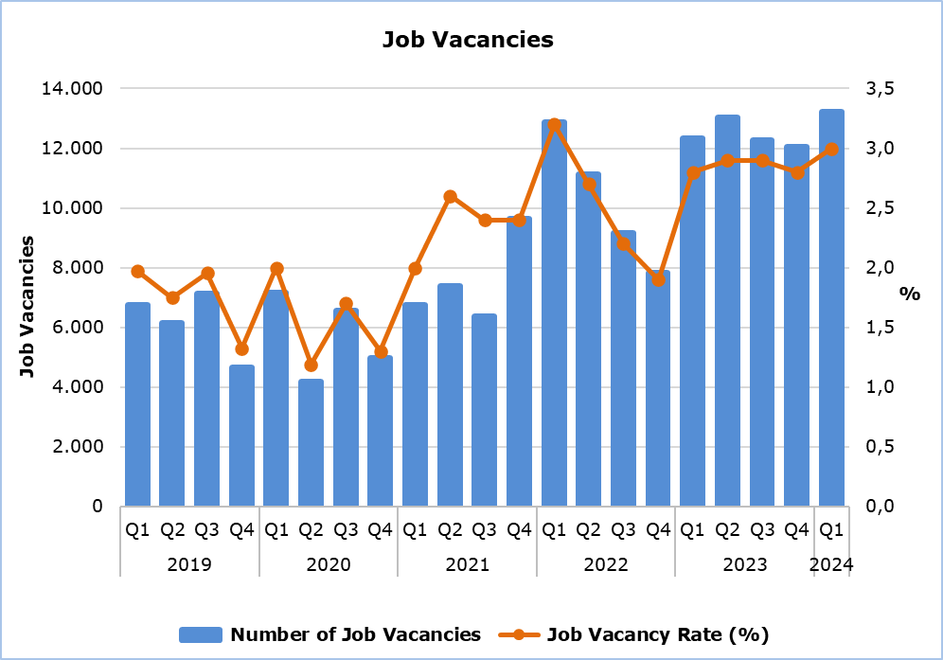

|  |  |  |  |  |  |  |  |
| --- | --- | --- | --- | --- | --- | --- | --- |
| **Table 1** | | | | | | | |
| **Nace Rev.2** | **Economic Activity** | **Number of Job Vacancies** | | |  | **% Change** | |
| **Q1**  **2023** | **Q4**  **2023** | **Q1**  **2024** |  | **Q1 2024/ Q4 2023** | **Q1 2024/2023** |
| B | Mining and Quarrying | 3 | 3 | 5 |  | 66,7 | 66,7 |
| C | Manufacturing | 924 | 624 | 690 |  | 10,6 | -25,3 |
| D | Electricity, Gas, Steam and Air Conditioning Supply | 1 | 4 | 9 |  | 125,0 | 800,0 |
| E | Water Supply, Sewerage, Waste Management and Remediation Activities | 42 | 90 | 79 |  | -12,2 | 88,1 |
| F | Construction | 858 | 980 | 1.022 |  | 4,3 | 19,1 |
| G | Wholesale and Retail Trade, Repair of Motor Vehicles and Motorcycles | 2.126 | 2.659 | 2.322 |  | -12,7 | 9,2 |
| H | Transportation and Storage | 717 | 511 | 587 |  | 14,9 | -18,1 |
| I | Accommodation and Food Service Activities | 3.422 | 1.469 | 3.869 |  | 163,4 | 13,1 |
| J | Information and Communication | 478 | 483 | 603 |  | 24,8 | 26,2 |
| K | Financial and Insurance Activities | 548 | 413 | 372 |  | -9,9 | -32,1 |
| L | Real Estate Activities | 71 | 43 | 13 |  | -69,8 | -81,7 |
| M | Professional, Scientific and Technical Activities | 714 | 1.122 | 1.267 |  | 12,9 | 77,5 |
| N | Administrative and Support Service Activities | 553 | 970 | 547 |  | -43,6 | -1,1 |
| O | Public Administration and Defense, Compulsory Social Security | 347 | 695 | 453 |  | -34,8 | 30,5 |
| P | Education | 411 | 894 | 415 |  | -53,6 | 1,0 |
| Q | Human Health and Social Work Activities | 463 | 531 | 675 |  | 27,1 | 45,8 |
| R | Arts, Entertainment and Recreation | 99 | 57 | 149 |  | 161,4 | 50,5 |
| S | Other Service Activities | 551 | 490 | 152 |  | -69,0 | -72,4 |
|  | **Total** | **12.328** | **12.038** | **13.229** |  | **9,9** | **7,3** |

|  |  |  |  |  |
| --- | --- | --- | --- | --- |
| **Table 2** | | | | |
| **Nace Rev.2** | **Economic Activity** | **Job Vacancy Rate**  **(%)** | | |
| **Q1 2023** | **Q4 2023** | **Q1 2024** |
| B | Mining and Quarrying | 0,7 | 0,5 | 0,9 |
| C | Manufacturing | 2,5 | 1,7 | 1,9 |
| D | Electricity, Gas, Steam and Air Conditioning Supply | 0,1 | 0,2 | 0,6 |
| E | Water Supply, Sewerage, Waste Management and Remediation Activities | 1,2 | 2,5 | 2,5 |
| F | Construction | 2,1 | 2,5 | 2,5 |
| G | Wholesale and Retail Trade, Repair of Motor Vehicles and Motorcycles | 2,8 | 3,5 | 3,0 |
| H | Transportation and Storage | 3,8 | 2,8 | 3,0 |
| I | Accommodation and Food Service Activities | 7,1 | 3,0 | 7,8 |
| J | Information and Communication | 2,8 | 2,9 | 3,1 |
| K | Financial and Insurance Activities | 2,4 | 1,9 | 1,7 |
| L | Real Estate Activities | 1,9 | 1,2 | 0,3 |
| M | Professional, Scientific and Technical Activities | 1,8 | 3,0 | 3,2 |
| N | Administrative and Support Service Activities | 3,0 | 5,2 | 2,9 |
| O | Public Administration and Defense, Compulsory Social Security | 1,1 | 2,2 | 1,4 |
| P | Education | 1,2 | 2,4 | 1,2 |
| Q | Human Health and Social Work Activities | 2,0 | 2,3 | 2,7 |
| R | Arts, Entertainment and Recreation | 1,3 | 0,7 | 1,8 |
| S | Other Service Activities | 4,4 | 3,9 | 1,3 |
|  | **Total** | **2,8** | **2,8** | **3,0** |

**METHODOLOGICAL INFORMATION**

**Definitions**

A **job vacancy** is a paid post that is newly created, unoccupied or about to become vacant, and for which the employer is taking active steps to find a suitable candidate from outside the enterprise concerned and intends to fill it either immediately or within a specific period of time.

The **job vacancy rate** is the number of job vacancies expressed as a percentage of the total number of occupied posts and job vacancies.

**Coverage**

The survey covers enterprises with 1 or more employees classified in all sectors of economic activities according to the Statistical Classification of Economic Activities NACE Rev. 2 of the European Union system, except Sectors A (Agriculture, Forestry and Fishing), T (Activities of Households as Employers; Undifferentiated Goods- and Services-Producing Activities of Households for own use) and U (Activities of Extraterritorial Organizations and Bodies).

**Collection of Data**

The data collection is carried out by telephone interviews every quarter.

***For more information:***

CYSTAT Portal, subtheme [Labour Market](https://www.cystat.gov.cy/en/SubthemeStatistics?s=43)

[CYSTAT-DB](https://cystatdb.cystat.gov.cy/pxweb/en/8.CYSTAT-DB/8.CYSTAT-DB__Labour%20Market__) (Online Database)

[Predefined Tables](https://www.cystat.gov.cy/en/KeyFiguresList?s=43) (Excel)

[Methodological Information](https://www.cystat.gov.cy/en/MethodologicalDetails?m=2260)

**The data included in the Predefined Tables in Excel format are available up to 4th Quarter 2021. Data from the 1st Quarter 2022 onwards are available only in the CYSTAT-DB Online Database.**

*Contact*

Maria Kkoushi: Tel: +357-22602235, Email: [mkkoushi@cystat.mof.gov.cy](mailto:mkkoushi@cystat.mof.gov.cy)