16 June, 2025

**PRESS RELEASE**

###### JOB VACANCIES: 1st QUARTER 2025

**Job Vacancy Rate 2,9%**

The number of job vacancies in the 1st quarter of 2025 reached 13.524, recording an increase of 295 vacancies (2,2%) compared to the same quarter of the previous year where the number was 13.229. Compared to the 4th quarter of 2024 the number of job vacancies increased by 527 (4,1%). (Table 1)

The job vacancy rate in the 1st quarter of 2025 was 2,9%, while the job vacancy rate in the previous quarter and the 1st quarter of 2024 was 2,8% and 3,0% respectively. The largest job vacancy rates in the 1st quarter of 2025 were observed in the Sectors of Arts, Entertainment and Recreation (6,9%), Accommodation and Food Service Activities (5,2%) and Transportation and Storage (4,5%). (Table 2)

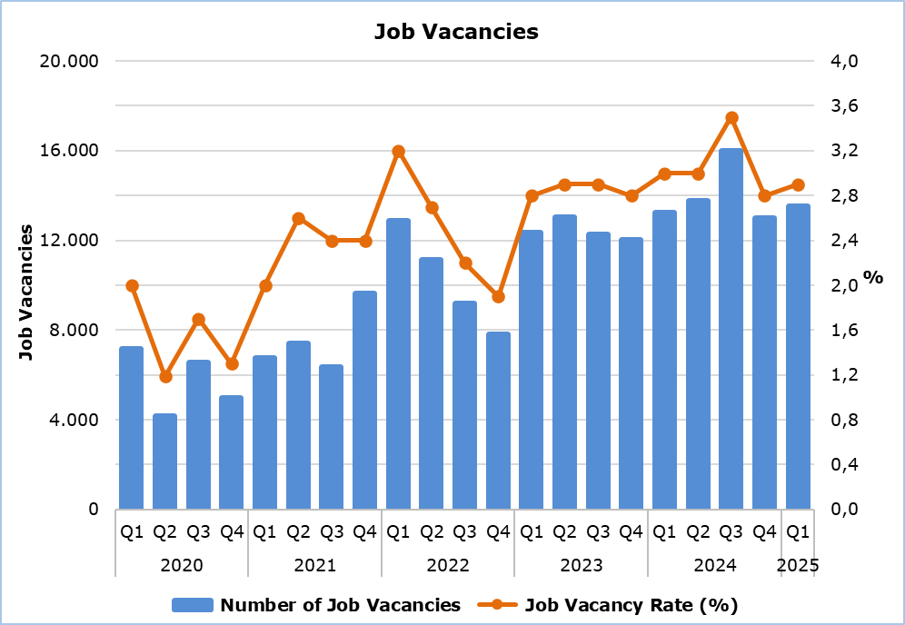

|  |  |  |  |  |  |  |  |
| --- | --- | --- | --- | --- | --- | --- | --- |
| **Table 1** | | | | | | | |
| **Nace Rev.2** | **Economic Activity** | **Number of Job Vacancies** | | |  | **% Change** | |
| **Q1**  **2024** | **Q4**  **2024** | **Q1**  **2025** |  | **Q1 2025/ Q4 2024** | **Q1 2025/2024** |
| B | Mining and Quarrying | 5 | 3 | 22 |  | 633,3 | 340,0 |
| C | Manufacturing | 690 | 1.026 | 1.157 |  | 12,8 | 67,7 |
| D | Electricity, Gas, Steam and Air Conditioning Supply | 9 | 2 | 0 |  | -100,0 | -100,0 |
| E | Water Supply, Sewerage, Waste Management and Remediation Activities | 79 | 89 | 110 |  | 23,6 | 39,2 |
| F | Construction | 1.022 | 920 | 803 |  | -12,7 | -21,4 |
| G | Wholesale and Retail Trade, Repair of Motor Vehicles and Motorcycles | 2.322 | 2.479 | 2.422 |  | -2,3 | 4,3 |
| H | Transportation and Storage | 587 | 360 | 941 |  | 161,4 | 60,3 |
| I | Accommodation and Food Service Activities | 3.869 | 2.431 | 2.664 |  | 9,6 | -31,1 |
| J | Information and Communication | 603 | 750 | 765 |  | 2,0 | 26,9 |
| K | Financial and Insurance Activities | 372 | 635 | 440 |  | -30,7 | 18,3 |
| L | Real Estate Activities | 13 | 110 | 145 |  | 31,8 | 1.015,4 |
| M | Professional, Scientific and Technical Activities | 1.267 | 1.315 | 1.325 |  | 0,8 | 4,6 |
| N | Administrative and Support Service Activities | 547 | 517 | 656 |  | 26,9 | 19,9 |
| O | Public Administration and Defense, Compulsory Social Security | 453 | 618 | 495 |  | -19,9 | 9,3 |
| P | Education | 415 | 196 | 346 |  | 76,5 | -16,6 |
| Q | Human Health and Social Work Activities | 675 | 880 | 353 |  | -59,9 | -47,7 |
| R | Arts, Entertainment and Recreation | 149 | 458 | 677 |  | 47,8 | 354,4 |
| S | Other Service Activities | 152 | 208 | 203 |  | -2,4 | 33,6 |
|  | **Total** | **13.229** | **12.997** | **13.524** |  | **4,1** | **2,2** |

|  |  |  |  |  |
| --- | --- | --- | --- | --- |
| **Table 2** | | | | |
| **Nace Rev.2** | **Economic Activity** | **Job Vacancy Rate**  **(%)** | | |
| **Q1 2024** | **Q4 2024** | **Q1 2025** |
| B | Mining and Quarrying | 0,9 | 0,6 | 3,8 |
| C | Manufacturing | 1,9 | 2,7 | 3,0 |
| D | Electricity, Gas, Steam and Air Conditioning Supply | 0,6 | 0,1 | 0,0 |
| E | Water Supply, Sewerage, Waste Management and Remediation Activities | 2,5 | 2,5 | 3,1 |
| F | Construction | 2,5 | 2,3 | 1,9 |
| G | Wholesale and Retail Trade, Repair of Motor Vehicles and Motorcycles | 3,0 | 3,1 | 3,0 |
| H | Transportation and Storage | 3,0 | 1,9 | 4,5 |
| I | Accommodation and Food Service Activities | 7,8 | 4,6 | 5,2 |
| J | Information and Communication | 3,1 | 3,7 | 3,5 |
| K | Financial and Insurance Activities | 1,7 | 2,8 | 1,8 |
| L | Real Estate Activities | 0,3 | 2,7 | 3,6 |
| M | Professional, Scientific and Technical Activities | 3,2 | 3,3 | 3,2 |
| N | Administrative and Support Service Activities | 2,9 | 2,7 | 3,1 |
| O | Public Administration and Defense, Compulsory Social Security | 1,4 | 1,8 | 1,5 |
| P | Education | 1,2 | 0,5 | 0,9 |
| Q | Human Health and Social Work Activities | 2,7 | 3,5 | 1,4 |
| R | Arts, Entertainment and Recreation | 1,8 | 4,7 | 6,9 |
| S | Other Service Activities | 1,3 | 1,7 | 1,6 |
|  | **Total** | **3,0** | **2,8** | **2,9** |

**METHODOLOGICAL INFORMATION**

**Definitions**

A **job vacancy** is a paid post that is newly created, unoccupied or about to become vacant, and for which the employer is taking active steps to find a suitable candidate from outside the enterprise concerned and intends to fill it either immediately or within a specific period of time.

The **job vacancy rate** is the number of job vacancies expressed as a percentage of the total number of occupied posts and job vacancies.

**Coverage**

The survey covers enterprises with 1 or more employees classified in all sectors of economic activities according to the Statistical Classification of Economic Activities NACE Rev. 2 of the European Union system, except Sectors A (Agriculture, Forestry and Fishing), T (Activities of Households as Employers; Undifferentiated Goods- and Services-Producing Activities of Households for own use) and U (Activities of Extraterritorial Organizations and Bodies).

**Collection of Data**

The data collection is carried out by telephone interviews every quarter.

***For more information:***

CYSTAT Portal, subtheme [Labour Market](https://www.cystat.gov.cy/en/SubthemeStatistics?s=43)

[CYSTAT-DB](https://cystatdb.cystat.gov.cy/pxweb/en/8.CYSTAT-DB/8.CYSTAT-DB__Labour%20Market__) (Online Database)

[Methodological Information](https://www.cystat.gov.cy/en/MethodologicalDetails?m=2260)

*Contact*

Maria Kkoushi: Tel: +357-22602235, Email: [mkkoushi@cystat.mof.gov.cy](mailto:mkkoushi@cystat.mof.gov.cy)