15 June, 2026

PRESS RELEASE

JOB VACANCIES: 1st QUARTER 2026

Job Vacancy Rate 2,8%

The number of job vacancies in the 1st quarter of 2026 reached 13.905 and the job vacancy rate was 2,8%. (Figure)

The largest job vacancy rates in the 1st quarter of 2026 were observed in the Sectors of Arts, Sports and Recreation (5,1%), Construction (4,7%) and Accommodation and Food Service Activities (4,0%). (Table)

It is noted that, as from the first quarter of 2026, data are classified according to the new Statistical Classification of Economic Activities, NACE Rev. 2.1 and are therefore not directly comparable with data for previous periods based on NACE Rev. 2. For comparability purposes, the Statistical Service will continue to publish data according to both classifications for the 2026 reference year, on its online database CYSTAT-DB. Backcasted time series based on NACE Rev. 2.1 for the period from 2018 onwards will be published once the relevant work has been completed.

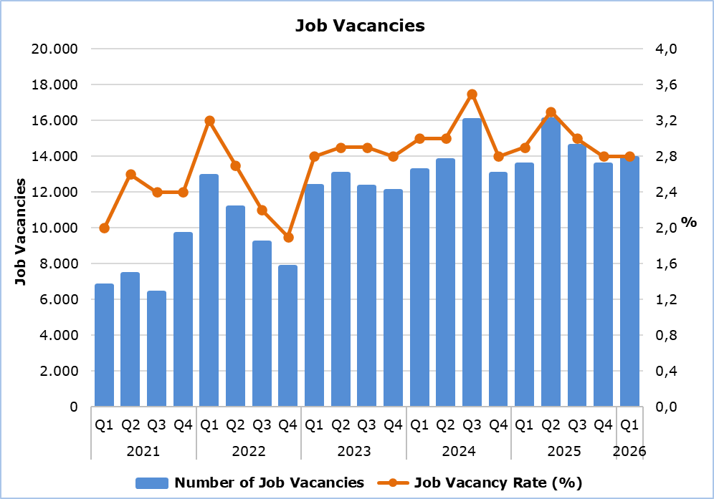

Table
Nace Rev. 2.1 | Οικονομική Δραστηριότητα | Number of Job Vacancies |  |  |  | Job Vacancy Rate (%)
Nace Rev. 2.1 | Οικονομική Δραστηριότητα |  | Q1  2026 |  |  | Q1  2026
B | Mining and Quarrying |  | 3 |  |  | 0,5
C | Manufacturing |  | 905 |  |  | 2,3
D | Electricity, Gas, Steam and Air Conditioning Supply |  | 34 |  |  | 1,8
E | Water Supply, Sewerage, Waste Management and Remediation Activities |  | 48 |  |  | 1,1
F | Construction |  | 1.997 |  |  | 4,7
G | Wholesale and Retail Trade |  | 2.649 |  |  | 3,5
H | Transportation and Storage |  | 567 |  |  | 2,5
I | Accommodation and Food Service Activities |  | 2.189 |  |  | 4,0
J | Publishing, Broadcasting, and Content Production and Distribution Activities |  | 120 |  |  | 1,8
K | Telecommunication, Computer Programming, Consulting, Computing Infrastructure and Other Information Service Activities |  | 530 |  |  | 2,4
L | Financial and Insurance Activities |  | 225 |  |  | 0,9
M | Real Estate Activities |  | 113 |  |  | 1,6
N | Professional, Scientific and Technical Activities |  | 1.086 |  |  | 2,4
O | Administrative and Support Service Activities |  | 668 |  |  | 3,0
P | Public Administration and Defence, Compulsory Social Security |  | 922 |  |  | 2,7
Q | Education |  | 589 |  |  | 1,5
R | Human Health and Social Work Activities |  | 416 |  |  | 1,6
S | Arts, Sports and Recreation |  | 547 |  |  | 5,1
T | Other Service Activities |  | 297 |  |  | 1,6
 | Total |  | 13.905 |  |  | 2,8

METHODOLOGICAL INFORMATION

Definitions

A job vacancy is a paid post that is newly created, unoccupied or about to become vacant, and for which the employer is taking active steps to find a suitable candidate from outside the enterprise concerned and intends to fill it either immediately or within a specific period of time.

The job vacancy rate is the number of job vacancies expressed as a percentage of the total number of occupied posts and job vacancies.

Coverage

The survey covers enterprises with 1 or more employees classified in all sectors of economic activities according to the Statistical Classification of Economic Activities NACE Rev. 2 of the European Union system, except Sectors A (Agriculture, Forestry and Fishing), T (Activities of Households as Employers; Undifferentiated Goods- and Services-Producing Activities of Households for own use) and U (Activities of Extraterritorial Organizations and Bodies).

Collection of Data

The data collection is carried out by telephone interviews every quarter.

Change in the Classification of Economic Activities and Data Comparability

From the first quarter of 2026 onwards, data are presented according to the new Statistical Classification of Economic Activities, NACE Rev. 2.1, which replaces the previous NACE Rev. 2 classification. The NACE Rev. 2.1 revision introduces changes to the structure and classification of certain economic activities compared with NACE Rev. 2, meaning that data from the first quarter of 2026 onwards are not directly comparable with data from previous periods.

For comparability purposes and to facilitate users during the transition period, the Statistical Service will continue to publish data according to both classifications for the 2026 reference year, on its online database, CYSTAT-DB. Backcasted time series based on NACE Rev. 2.1 for the period from 2018 onwards will be published once the relevant work has been completed.

Further information on NACE Rev. 2.1 and the changes introduced compared with NACE Rev. 2 is available on the Classifications Systems webpage.

For more information:
CYSTAT Portal, subtheme Labour Market
CYSTAT-DB (Online Database)
Methodological Information

Contact
Maria Kkoushi: Tel.: +357-24205857, Email: mkkoushi@cystat.mof.gov.cy

