13 September, 2022

**PRESS RELEASE**

###### JOB VACANCIES: 2nd QUARTER 2022

**Job Vacancy Rate 2,7%**

The number of job vacancies in the 2nd quarter of 2022 reached 11.113. The number of job vacancies increased by 3.716 (50,2%) compared to the same quarter of the previous year where the number was 7.397. Compared to the 1st quarter of 2022 the number of job vacancies decreased by 1.761 (-13,7%). (Table 1)

The job vacancy rate in the 2nd quarter of 2022 was 2,7%, while the job vacancy rate in the previous quarter and the 2nd quarter of 2021 was 3,2% and 2,6% respectively. The largest job vacancy rates in the 2nd quarter of 2022 were observed in the Sectors of Accommodation and Food Service Activities (7,2%), Transportation and Storage (4,0%), Administrative and Support Service Activities (3,8%) and Water Supply, Sewerage, Waste Management and Remediation Activities (3,2%). (Table 2)

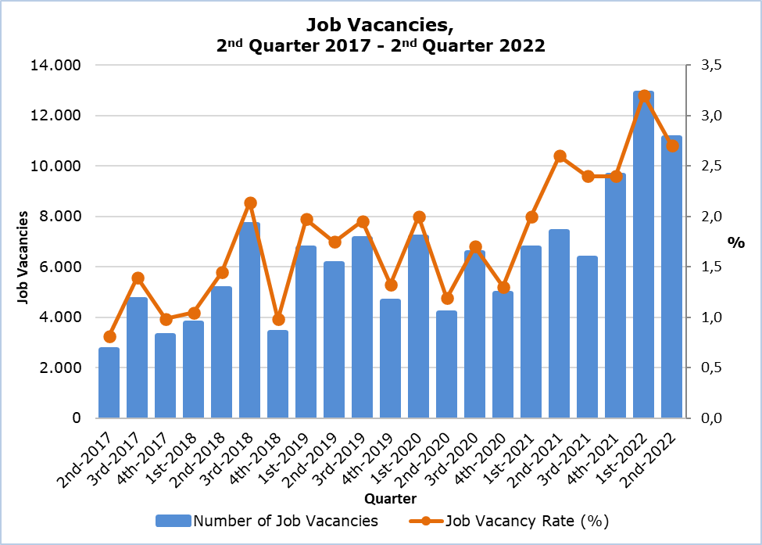

|  |  |  |  |  |  |  |  |
| --- | --- | --- | --- | --- | --- | --- | --- |
| **Table 1** | | | | | | | |
| **Nace Rev.2** | **Economic Activity** | **Number of Job Vacancies** | | |  | **% Change** | |
| **Q2**  **2021** | **Q1 2022** | **Q2 2022** |  | **Q2 2022/ Q1 2022** | **Q2 2022/2021** |
| B | Mining and Quarrying | 2 | 2 | 1 |  | -50,0 | -50,0 |
| C | Manufacturing | 799 | 613 | 881 |  | 43,7 | 10,3 |
| D | Electricity, Gas, Steam and Air Conditioning Supply | 82 | 10 | 0 |  | -100,0 | -100,0 |
| E | Water Supply, Sewerage, Waste Management and Remediation Activities | 28 | 75 | 103 |  | 37,3 | 267,9 |
| F | Construction | 687 | 374 | 408 |  | 9,1 | -40,6 |
| G | Wholesale and Retail Trade, Repair of Motor Vehicles and Motorcycles | 823 | 2.033 | 1.650 |  | -18,8 | 100,5 |
| H | Transportation and Storage | 941 | 526 | 716 |  | 36,1 | -23,9 |
| I | Accommodation and Food Service Activities | 1.598 | 4.452 | 3.625 |  | -18,6 | 126,8 |
| J | Information and Communication | 184 | 386 | 331 |  | -14,2 | 79,9 |
| K | Financial and Insurance Activities | 273 | 553 | 462 |  | -16,5 | 69,2 |
| L | Real Estate Activities | 3 | 57 | 78 |  | 36,8 | 2.500,0 |
| M | Professional, Scientific and Technical Activities | 380 | 1.155 | 669 |  | -42,1 | 76,1 |
| N | Administrative and Support Service Activities | 133 | 665 | 583 |  | -12,3 | 338,3 |
| O | Public Administration and Defense, Compulsory Social Security | 107 | 452 | 166 |  | -63,3 | 55,1 |
| P | Education | 515 | 442 | 526 |  | 19,0 | 2,1 |
| Q | Human Health and Social Work Activities | 681 | 794 | 581 |  | -26,8 | -14,7 |
| R | Arts, Entertainment and Recreation | 14 | 112 | 124 |  | 10,7 | 785,7 |
| S | Other Service Activities | 147 | 173 | 209 |  | 20,8 | 42,2 |
|  | **Total** | **7.397** | **12.874** | **11.113** |  | **-13,7** | **50,2** |

|  |  |  |  |  |
| --- | --- | --- | --- | --- |
| **Table 2** | | | | |
| **Nace Rev.2** | **Economic Activity** | **Job Vacancy Rate**  **(%)** | | |
| **2nd Quarter 2021** | **1st Quarter 2022** | **2nd Quarter 2022** |
| B | Mining and Quarrying | 1,1 | 0,3 | 0,2 |
| C | Manufacturing | 3,5 | 1,8 | 2,5 |
| D | Electricity, Gas, Steam and Air Conditioning Supply | 5,5 | 0,7 | 0,0 |
| E | Water Supply, Sewerage, Waste Management and Remediation Activities | 2,3 | 2,4 | 3,2 |
| F | Construction | 2,2 | 1,0 | 1,1 |
| G | Wholesale and Retail Trade, Repair of Motor Vehicles and Motorcycles | 1,8 | 2,8 | 2,3 |
| H | Transportation and Storage | 2,8 | 3,0 | 4,0 |
| I | Accommodation and Food Service Activities | 7,1 | 10,2 | 7,2 |
| J | Information and Communication | 2,5 | 2,8 | 2,5 |
| K | Financial and Insurance Activities | 1,7 | 2,6 | 2,2 |
| L | Real Estate Activities | 0,4 | 1,8 | 2,4 |
| M | Professional, Scientific and Technical Activities | 2,0 | 3,3 | 1,9 |
| N | Administrative and Support Service Activities | 1,9 | 4,3 | 3,8 |
| O | Public Administration and Defense, Compulsory Social Security | 0,5 | 1,5 | 0,5 |
| P | Education | 1,9 | 1,3 | 1,6 |
| Q | Human Health and Social Work Activities | 4,9 | 3,4 | 2,5 |
| R | Arts, Entertainment and Recreation | 0,6 | 1,7 | 1,8 |
| S | Other Service Activities | 1,4 | 1,6 | 1,8 |
|  | **Total** | **2,6** | **3,2** | **2,7** |

**METHODOLOGICAL INFORMATION**

**Definitions**

A **job vacancy** is a paid post that is newly created, unoccupied or about to become vacant, and for which the employer is taking active steps to find a suitable candidate from outside the enterprise concerned and intends to fill it either immediately or within a specific period of time.

The **job vacancy rate** is the number of job vacancies expressed as a percentage of the total number of occupied posts and job vacancies.

**Coverage**

The survey covers enterprises with 1 or more employees classified in all sectors of economic activities according to the Statistical Classification of Economic Activities NACE Rev. 2 of the European Union system, except Sectors A (Agriculture, Forestry and Fishing), T (Activities of Households as Employers; Undifferentiated Goods- and Services-Producing Activities of Households for own use) and U (Activities of Extraterritorial Organizations and Bodies).

**Collection of data**

The data collection is carried out by telephone interviews every quarter.

***For more information:***

CYSTAT Portal, subtheme [Labour Market](https://www.cystat.gov.cy/en/SubthemeStatistics?s=43)

[CYSTAT-DB](https://cystatdb.cystat.gov.cy/pxweb/en/8.CYSTAT-DB/8.CYSTAT-DB__Labour%20Market__) (Online Database)

[Predefined Tables](https://www.cystat.gov.cy/en/KeyFiguresList?s=43) (Excel)

[Methodological Information](https://www.cystat.gov.cy/en/MethodologicalDetails?m=2260)

**The data included in the Predefined Tables in Excel format are available up to 4th Quarter 2021. Data from the 1st Quarter 2022 onwards are available only in the CYSTAT-DB Online Database.**

*Contact*

Maria Kkoushi: Tel: +357-22602235, Email: [mkkoushi@cystat.mof.gov.cy](mailto:mkkoushi@cystat.mof.gov.cy)