13 September, 2024

**PRESS RELEASE**

###### JOB VACANCIES: 2nd QUARTER 2024

**Job Vacancy Rate 3,0%**

The number of job vacancies in the 2nd quarter of 2024 reached 13.778, recording an increase of 751 vacancies (5,8%) compared to the same quarter of the previous year where the number was 13.027. Compared to the 1st quarter of 2024 the number of job vacancies increased by 549 (4,1%). (Table 1)

The job vacancy rate in the 2nd quarter of 2024 was 3,0%, while the job vacancy rate in the previous quarter and the 2nd quarter of 2023 was 3,0% and 2,9% respectively. The largest job vacancy rates in the 2nd quarter of 2024 were observed in the Sectors of Accommodation and Food Service Activities (6,9%), Transportation and Storage (3,7%) and Information and Communication (3,4%). (Table 2)

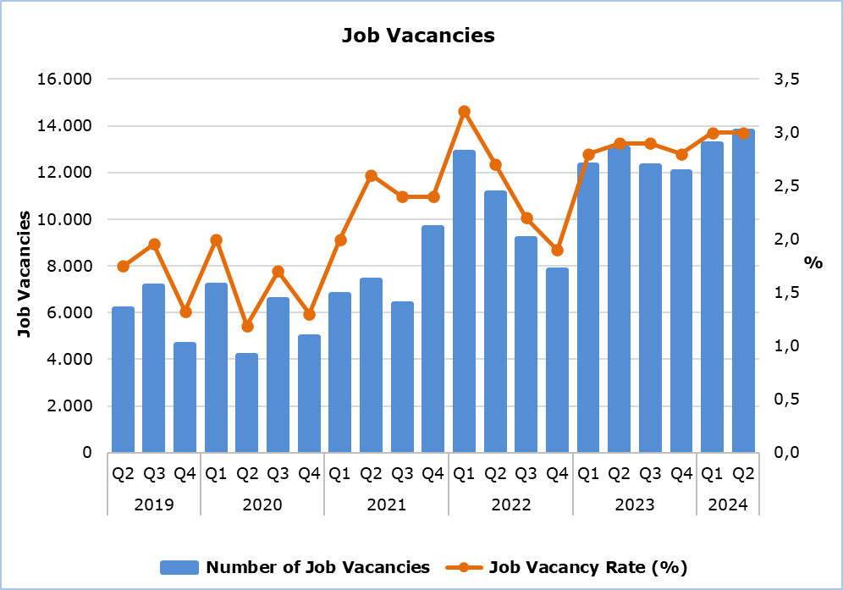

|  |  |  |  |  |  |  |  |
| --- | --- | --- | --- | --- | --- | --- | --- |
| **Table 1** | | | | | | | |
| **Nace Rev.2** | **Economic Activity** | **Number of Job Vacancies** | | |  | **% Change** | |
| **Q2**  **2023** | **Q1**  **2024** | **Q2**  **2024** |  | **Q2 2024/ Q1 2024** | **Q2 2024/2023** |
| B | Mining and Quarrying | 15 | 5 | 8 |  | 60,0 | -46,7 |
| C | Manufacturing | 524 | 690 | 949 |  | 37,5 | 81,1 |
| D | Electricity, Gas, Steam and Air Conditioning Supply | 70 | 9 | 19 |  | 111,1 | -72,9 |
| E | Water Supply, Sewerage, Waste Management and Remediation Activities | 73 | 79 | 61 |  | -22,8 | -16,4 |
| F | Construction | 628 | 1.022 | 793 |  | -22,4 | 26,3 |
| G | Wholesale and Retail Trade, Repair of Motor Vehicles and Motorcycles | 2.069 | 2.322 | 2.331 |  | 0,4 | 12,7 |
| H | Transportation and Storage | 857 | 587 | 743 |  | 26,6 | -13,3 |
| I | Accommodation and Food Service Activities | 4.080 | 3.869 | 3.971 |  | 2,6 | -2,7 |
| J | Information and Communication | 582 | 603 | 659 |  | 9,3 | 13,2 |
| K | Financial and Insurance Activities | 533 | 372 | 477 |  | 28,2 | -10,5 |
| L | Real Estate Activities | 109 | 13 | 12 |  | -7,7 | -89,0 |
| M | Professional, Scientific and Technical Activities | 759 | 1.267 | 1.078 |  | -14,9 | 42,0 |
| N | Administrative and Support Service Activities | 586 | 547 | 643 |  | 17,6 | 9,7 |
| O | Public Administration and Defense, Compulsory Social Security | 295 | 453 | 191 |  | -57,8 | -35,3 |
| P | Education | 892 | 415 | 518 |  | 24,8 | -41,9 |
| Q | Human Health and Social Work Activities | 524 | 675 | 772 |  | 14,4 | 47,3 |
| R | Arts, Entertainment and Recreation | 245 | 149 | 283 |  | 89,9 | 15,5 |
| S | Other Service Activities | 186 | 152 | 270 |  | 77,6 | 45,2 |
|  | **Total** | **13.027** | **13.229** | **13.778** |  | **4,1** | **5,8** |

|  |  |  |  |  |
| --- | --- | --- | --- | --- |
| **Table 2** | | | | |
| **Nace Rev.2** | **Economic Activity** | **Job Vacancy Rate**  **(%)** | | |
| **Q2 2023** | **Q1 2024** | **Q2 2024** |
| B | Mining and Quarrying | 2,7 | 0,9 | 1,5 |
| C | Manufacturing | 1,4 | 1,9 | 2,5 |
| D | Electricity, Gas, Steam and Air Conditioning Supply | 4,1 | 0,6 | 1,1 |
| E | Water Supply, Sewerage, Waste Management and Remediation Activities | 2,0 | 2,5 | 1,9 |
| F | Construction | 1,6 | 2,5 | 2,0 |
| G | Wholesale and Retail Trade, Repair of Motor Vehicles and Motorcycles | 2,7 | 3,0 | 2,9 |
| H | Transportation and Storage | 4,5 | 3,0 | 3,7 |
| I | Accommodation and Food Service Activities | 7,3 | 7,8 | 6,9 |
| J | Information and Communication | 3,3 | 3,1 | 3,4 |
| K | Financial and Insurance Activities | 2,4 | 1,7 | 2,1 |
| L | Real Estate Activities | 2,8 | 0,3 | 0,3 |
| M | Professional, Scientific and Technical Activities | 1,9 | 3,2 | 2,7 |
| N | Administrative and Support Service Activities | 3,1 | 2,9 | 3,3 |
| O | Public Administration and Defense, Compulsory Social Security | 0,9 | 1,4 | 0,6 |
| P | Education | 2,6 | 1,2 | 1,5 |
| Q | Human Health and Social Work Activities | 2,2 | 2,7 | 3,1 |
| R | Arts, Entertainment and Recreation | 3,2 | 1,8 | 3,1 |
| S | Other Service Activities | 1,5 | 1,3 | 2,2 |
|  | **Total** | **2,9** | **3,0** | **3,0** |

**METHODOLOGICAL INFORMATION**

**Definitions**

A **job vacancy** is a paid post that is newly created, unoccupied or about to become vacant, and for which the employer is taking active steps to find a suitable candidate from outside the enterprise concerned and intends to fill it either immediately or within a specific period of time.

The **job vacancy rate** is the number of job vacancies expressed as a percentage of the total number of occupied posts and job vacancies.

**Coverage**

The survey covers enterprises with 1 or more employees classified in all sectors of economic activities according to the Statistical Classification of Economic Activities NACE Rev. 2 of the European Union system, except Sectors A (Agriculture, Forestry and Fishing), T (Activities of Households as Employers; Undifferentiated Goods- and Services-Producing Activities of Households for own use) and U (Activities of Extraterritorial Organizations and Bodies).

**Collection of Data**

The data collection is carried out by telephone interviews every quarter.

***For more information:***

CYSTAT Portal, subtheme [Labour Market](https://www.cystat.gov.cy/en/SubthemeStatistics?s=43)

[CYSTAT-DB](https://cystatdb.cystat.gov.cy/pxweb/en/8.CYSTAT-DB/8.CYSTAT-DB__Labour%20Market__) (Online Database)

[Predefined Tables](https://www.cystat.gov.cy/en/KeyFiguresList?s=43) (Excel)

[Methodological Information](https://www.cystat.gov.cy/en/MethodologicalDetails?m=2260)

**The data included in the Predefined Tables in Excel format are available up to 4th Quarter 2021. Data from the 1st Quarter 2022 onwards are available only in the CYSTAT-DB Online Database.**

*Contact*

Maria Kkoushi: Tel: +357-22602235, Email: [mkkoushi@cystat.mof.gov.cy](mailto:mkkoushi@cystat.mof.gov.cy)