15 September, 2025

**PRESS RELEASE**

###### JOB VACANCIES: 2nd QUARTER 2025

**Job Vacancy Rate 3,3%**

The number of job vacancies in the 2nd quarter of 2025 reached 16.053, recording an increase of 2.275 vacancies (16,5%) compared to the same quarter of the previous year where the number was 13.778. Compared to the 1st quarter of 2025 the number of job vacancies increased by 2.529 (18,7%). (Table 1)

The job vacancy rate in the 2nd quarter of 2025 was 3,3%, while the job vacancy rate in the previous quarter and the 2nd quarter of 2024 was 2,9% and 3,0% respectively. The largest job vacancy rates in the 2nd quarter of 2025 were observed in the Sectors of Accommodation and Food Service Activities (6,6%), Arts, Entertainment and Recreation (4,7%) and Administrative and Support Service Activities (4,0%). (Table 2)

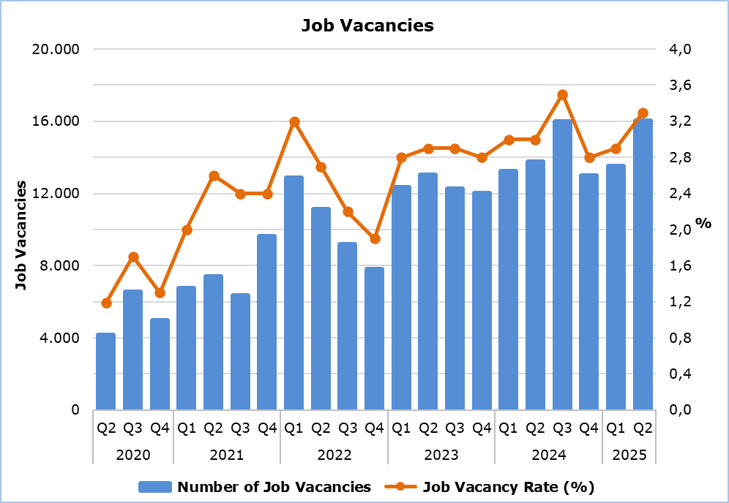

|  |  |  |  |  |  |  |  |
| --- | --- | --- | --- | --- | --- | --- | --- |
| **Table 1** | | | | | | | |
| **Nace Rev.2** | **Economic Activity** | **Number of Job Vacancies** | | |  | **% Change** | |
| **Q2**  **2024** | **Q1**  **2025** | **Q2**  **2025** |  | **Q2 2025/ Q1 2025** | **Q2 2025/2024** |
| B | Mining and Quarrying | 8 | 22 | 21 |  | -4,5 | 162,5 |
| C | Manufacturing | 949 | 1.157 | 1.141 |  | -1,4 | 20,2 |
| D | Electricity, Gas, Steam and Air Conditioning Supply | 19 | 0 | 17 |  | n.a. | -10,5 |
| E | Water Supply, Sewerage, Waste Management and Remediation Activities | 61 | 110 | 58 |  | -47,3 | -4,9 |
| F | Construction | 793 | 803 | 897 |  | 11,7 | 13,1 |
| G | Wholesale and Retail Trade, Repair of Motor Vehicles and Motorcycles | 2.331 | 2.422 | 2.644 |  | 9,2 | 13,4 |
| H | Transportation and Storage | 743 | 941 | 872 |  | -7,3 | 17,4 |
| I | Accommodation and Food Service Activities | 3.971 | 2.664 | 4.062 |  | 52,5 | 2,3 |
| J | Information and Communication | 659 | 765 | 815 |  | 6,5 | 23,7 |
| K | Financial and Insurance Activities | 477 | 440 | 440 |  | 0,0 | -7,8 |
| L | Real Estate Activities | 12 | 145 | 61 |  | -57,9 | 408,3 |
| M | Professional, Scientific and Technical Activities | 1.078 | 1.325 | 1.140 |  | -14,0 | 5,8 |
| N | Administrative and Support Service Activities | 643 | 656 | 885 |  | 34,9 | 37,6 |
| O | Public Administration and Defense, Compulsory Social Security | 191 | 495 | 1.126 |  | 127,5 | 489,5 |
| P | Education | 518 | 346 | 475 |  | 37,3 | -8,3 |
| Q | Human Health and Social Work Activities | 772 | 353 | 648 |  | 83,6 | -16,1 |
| R | Arts, Entertainment and Recreation | 283 | 677 | 455 |  | -32,8 | 60,8 |
| S | Other Service Activities | 270 | 203 | 296 |  | 45,8 | 9,6 |
|  | **Total** | **13.778** | **13.524** | **16.053** |  | **18,7** | **16,5** |

n.a.: Not applicable

|  |  |  |  |  |
| --- | --- | --- | --- | --- |
| **Table 2** | | | | |
| **Nace Rev.2** | **Economic Activity** | **Job Vacancy Rate**  **(%)** | | |
| **Q2 2024** | **Q1 2025** | **Q2 2025** |
| B | Mining and Quarrying | 1,5 | 3,8 | 3,5 |
| C | Manufacturing | 2,5 | 3,0 | 3,0 |
| D | Electricity, Gas, Steam and Air Conditioning Supply | 1,1 | 0,0 | 1,2 |
| E | Water Supply, Sewerage, Waste Management and Remediation Activities | 1,9 | 3,1 | 1,5 |
| F | Construction | 2,0 | 1,9 | 2,1 |
| G | Wholesale and Retail Trade, Repair of Motor Vehicles and Motorcycles | 2,9 | 3,0 | 3,3 |
| H | Transportation and Storage | 3,7 | 4,5 | 3,9 |
| I | Accommodation and Food Service Activities | 6,9 | 5,2 | 6,6 |
| J | Information and Communication | 3,4 | 3,5 | 2,9 |
| K | Financial and Insurance Activities | 2,1 | 1,8 | 1,9 |
| L | Real Estate Activities | 0,3 | 3,6 | 1,7 |
| M | Professional, Scientific and Technical Activities | 2,7 | 3,2 | 2,6 |
| N | Administrative and Support Service Activities | 3,3 | 3,1 | 4,0 |
| O | Public Administration and Defense, Compulsory Social Security | 0,6 | 1,5 | 3,3 |
| P | Education | 1,5 | 0,9 | 1,3 |
| Q | Human Health and Social Work Activities | 3,1 | 1,4 | 2,6 |
| R | Arts, Entertainment and Recreation | 3,1 | 6,9 | 4,7 |
| S | Other Service Activities | 2,2 | 1,6 | 2,3 |
|  | **Total** | **3,0** | **2,9** | **3,3** |

**METHODOLOGICAL INFORMATION**

**Definitions**

A **job vacancy** is a paid post that is newly created, unoccupied or about to become vacant, and for which the employer is taking active steps to find a suitable candidate from outside the enterprise concerned and intends to fill it either immediately or within a specific period of time.

The **job vacancy rate** is the number of job vacancies expressed as a percentage of the total number of occupied posts and job vacancies.

**Coverage**

The survey covers enterprises with 1 or more employees classified in all sectors of economic activities according to the Statistical Classification of Economic Activities NACE Rev. 2 of the European Union system, except Sectors A (Agriculture, Forestry and Fishing), T (Activities of Households as Employers; Undifferentiated Goods- and Services-Producing Activities of Households for own use) and U (Activities of Extraterritorial Organizations and Bodies).

**Collection of Data**

The data collection is carried out by telephone interviews every quarter.

***For more information:***

CYSTAT Portal, subtheme [Labour Market](https://www.cystat.gov.cy/en/SubthemeStatistics?s=43)

[CYSTAT-DB](https://cystatdb.cystat.gov.cy/pxweb/en/8.CYSTAT-DB/8.CYSTAT-DB__Labour%20Market__) (Online Database)

[Methodological Information](https://www.cystat.gov.cy/en/MethodologicalDetails?m=2260)

*Contact*

Maria Kkoushi: Tel: +357-22602235, Email: [mkkoushi@cystat.mof.gov.cy](mailto:mkkoushi@cystat.mof.gov.cy)