16 December, 2024

PRESS RELEASE

JOB VACANCIES: 3rd QUARTER 2024

Job Vacancy Rate 3,5%

The number of job vacancies in the 3rd quarter of 2024 reached 16.010, recording an increase of 3.736 vacancies (30,4%) compared to the same quarter of the previous year where the number was 12.274. Compared to the 2nd quarter of 2024 the number of job vacancies increased by 2.232 (16,2%). (Table 1)

The job vacancy rate in the 3rd quarter of 2024 was 3,5%, while the job vacancy rate in the previous quarter and the 3rd quarter of 2023 was 3,0% and 2,9% respectively. The largest job vacancy rates in the 3rd quarter of 2024 were observed in the Sectors of Electricity, Gas, Steam and Air Conditioning Supply (8,3%), Accommodation and Food Service Activities (6,4%) and Arts, Entertainment and Recreation (6,2%). (Table 2)

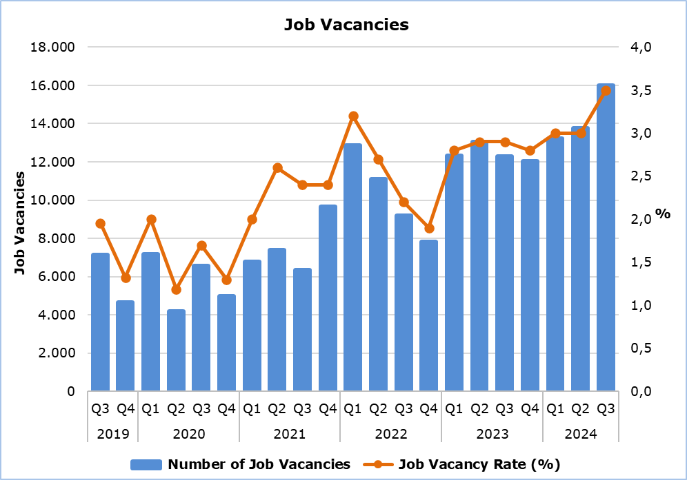

Table 1
Nace Rev.2 | Economic Activity | Number of Job Vacancies |  |  |  | % Change
Nace Rev.2 | Economic Activity | Q3  2023 | Q2  2024 | Q3  2024 |  | Q3 2024/ Q2 2024 | Q3 2024/2023
B | Mining and Quarrying | 4 | 8 | 7 |  | -12,5 | 75,0
C | Manufacturing | 869 | 949 | 1.470 |  | 54,9 | 69,2
D | Electricity, Gas, Steam and Air Conditioning Supply | 6 | 19 | 151 |  | 694,7 | 2.416,7
E | Water Supply, Sewerage, Waste Management and Remediation Activities | 79 | 61 | 71 |  | 16,4 | -10,1
F | Construction | 749 | 793 | 1.315 |  | 65,8 | 75,6
G | Wholesale and Retail Trade, Repair of Motor Vehicles and Motorcycles | 2.304 | 2.331 | 2.849 |  | 22,2 | 23,7
H | Transportation and Storage | 527 | 743 | 767 |  | 3,2 | 45,5
I | Accommodation and Food Service Activities | 2.058 | 3.971 | 3.793 |  | -4,5 | 84,3
J | Information and Communication | 629 | 659 | 724 |  | 9,9 | 15,1
K | Financial and Insurance Activities | 466 | 477 | 509 |  | 6,7 | 9,2
L | Real Estate Activities | 90 | 12 | 84 |  | 600,0 | -6,7
M | Professional, Scientific and Technical Activities | 1.001 | 1.078 | 1.160 |  | 7,6 | 15,9
N | Administrative and Support Service Activities | 808 | 643 | 690 |  | 7,3 | -14,6
O | Public Administration and Defense, Compulsory Social Security | 753 | 191 | 172 |  | -9,9 | -77,2
P | Education | 950 | 518 | 637 |  | 23,0 | -32,9
Q | Human Health and Social Work Activities | 680 | 772 | 753 |  | -2,5 | 10,7
R | Arts, Entertainment and Recreation | 102 | 283 | 639 |  | 125,8 | 526,5
S | Other Service Activities | 199 | 270 | 219 |  | -18,9 | 10,1
 | Total | 12.274 | 13.778 | 16.010 |  | 16,2 | 30,4

Table 2
Nace Rev.2 | Economic Activity | Job Vacancy Rate  (%)
Nace Rev.2 | Economic Activity | Q3 2023 | Q2 2024 | Q3 2024
B | Mining and Quarrying | 0,6 | 1,5 | 1,3
C | Manufacturing | 2,4 | 2,5 | 3,8
D | Electricity, Gas, Steam and Air Conditioning Supply | 0,4 | 1,1 | 8,3
E | Water Supply, Sewerage, Waste Management and Remediation Activities | 2,1 | 1,9 | 2,0
F | Construction | 1,9 | 2,0 | 3,2
G | Wholesale and Retail Trade, Repair of Motor Vehicles and Motorcycles | 3,1 | 2,9 | 3,6
H | Transportation and Storage | 2,9 | 3,7 | 3,8
I | Accommodation and Food Service Activities | 3,9 | 6,9 | 6,4
J | Information and Communication | 4,0 | 3,4 | 3,6
K | Financial and Insurance Activities | 2,2 | 2,1 | 2,2
L | Real Estate Activities | 2,5 | 0,3 | 2,1
M | Professional, Scientific and Technical Activities | 2,8 | 2,7 | 2,9
N | Administrative and Support Service Activities | 4,5 | 3,3 | 3,5
O | Public Administration and Defense, Compulsory Social Security | 2,4 | 0,6 | 0,5
P | Education | 2,9 | 1,5 | 2,0
Q | Human Health and Social Work Activities | 2,9 | 3,1 | 3,0
R | Arts, Entertainment and Recreation | 1,3 | 3,1 | 6,2
S | Other Service Activities | 1,6 | 2,2 | 1,8
 | Total | 2,9 | 3,0 | 3,5

METHODOLOGICAL INFORMATION

Definitions

A job vacancy is a paid post that is newly created, unoccupied or about to become vacant, and for which the employer is taking active steps to find a suitable candidate from outside the enterprise concerned and intends to fill it either immediately or within a specific period of time.

The job vacancy rate is the number of job vacancies expressed as a percentage of the total number of occupied posts and job vacancies.

Coverage

The survey covers enterprises with 1 or more employees classified in all sectors of economic activities according to the Statistical Classification of Economic Activities NACE Rev. 2 of the European Union system, except Sectors A (Agriculture, Forestry and Fishing), T (Activities of Households as Employers; Undifferentiated Goods- and Services-Producing Activities of Households for own use) and U (Activities of Extraterritorial Organizations and Bodies).

Collection of Data

The data collection is carried out by telephone interviews every quarter.

For more information:
CYSTAT Portal, subtheme Labour Market
CYSTAT-DB (Online Database)
Predefined Tables (Excel)
Methodological Information

The data included in the Predefined Tables in Excel format are available up to 4th Quarter 2021. Data from the 1st Quarter 2022 onwards are available only in the CYSTAT-DB Online Database.

Contact
Maria Kkoushi: Tel: +357-22602235, Email: mkkoushi@cystat.mof.gov.cy

