15 December, 2025

PRESS RELEASE

JOB VACANCIES: 3rd QUARTER 2025

Job Vacancy Rate 3,0%

The number of job vacancies in the 3rd quarter of 2025 reached 14.573, recording a decrease of 1.437 vacancies (-9,0%) compared to the same quarter of the previous year where the number was 16.010. Compared to the 2nd quarter of 2025 the number of job vacancies decreased by 1.480 (-9,2%). (Table 1)

The job vacancy rate in the 3rd quarter of 2025 was 3,0%, while the job vacancy rate in the previous quarter and the 3rd quarter of 2024 was 3,3% and 3,5% respectively. The largest job vacancy rates in the 3rd quarter of 2025 were observed in the Sectors of Mining and Quarrying (5,9%), Accommodation and Food Service Activities (4,1%) and Wholesale and Retail Trade, Repair of Motor Vehicles and Motorcycles (4,1%). (Table 2)

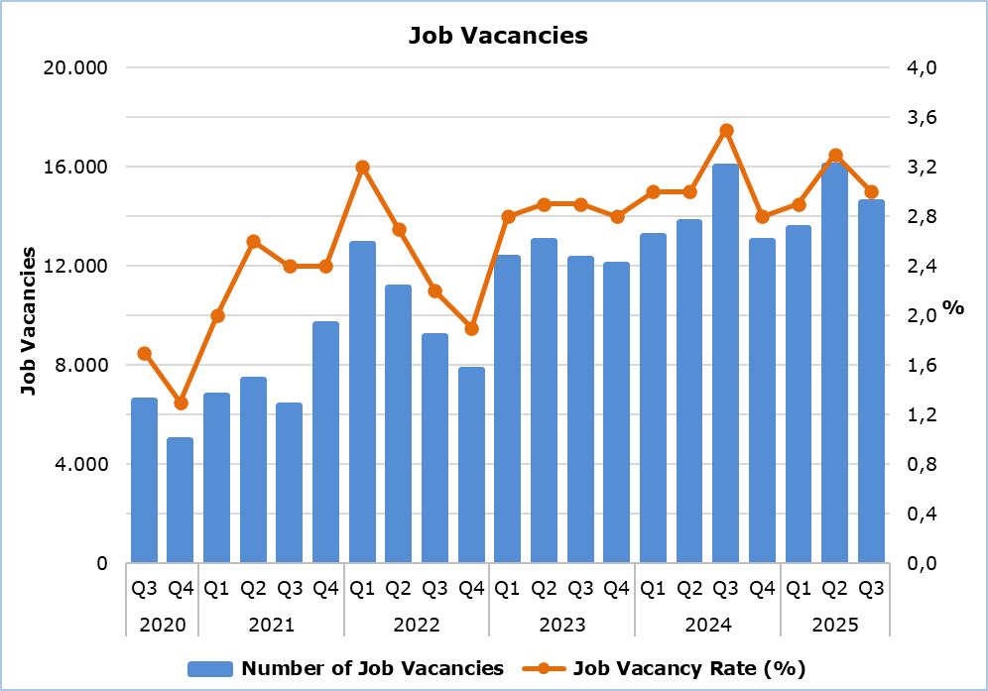

Table 1
Nace Rev.2 | Economic Activity | Number of Job Vacancies |  |  |  | % Change
Nace Rev.2 | Economic Activity | Q3  2024 | Q2  2025 | Q3  2025 |  | Q3 2025/ Q2 2025 | Q3 2025/2024
B | Mining and Quarrying | 7 | 21 | 37 |  | 76,2 | 428,6
C | Manufacturing | 1.470 | 1.141 | 1.146 |  | 0,4 | -22,0
D | Electricity, Gas, Steam and Air Conditioning Supply | 151 | 17 | 59 |  | 247,1 | -60,9
E | Water Supply, Sewerage, Waste Management and Remediation Activities | 71 | 58 | 155 |  | 167,2 | 118,3
F | Construction | 1.315 | 897 | 1.383 |  | 54,2 | 5,2
G | Wholesale and Retail Trade, Repair of Motor Vehicles and Motorcycles | 2.849 | 2.644 | 3.358 |  | 27,0 | 17,9
H | Transportation and Storage | 767 | 872 | 643 |  | -26,3 | -16,2
I | Accommodation and Food Service Activities | 3.793 | 4.062 | 2.519 |  | -38,0 | -33,6
J | Information and Communication | 724 | 815 | 816 |  | 0,1 | 12,7
K | Financial and Insurance Activities | 509 | 440 | 365 |  | -17,0 | -28,3
L | Real Estate Activities | 84 | 61 | 77 |  | 26,2 | -8,3
M | Professional, Scientific and Technical Activities | 1.160 | 1.140 | 1.080 |  | -5,3 | -6,9
N | Administrative and Support Service Activities | 690 | 885 | 779 |  | -12,0 | 12,9
O | Public Administration and Defense, Compulsory Social Security | 172 | 1.126 | 368 |  | -67,3 | 114,0
P | Education | 637 | 475 | 527 |  | 10,9 | -17,3
Q | Human Health and Social Work Activities | 753 | 648 | 513 |  | -20,8 | -31,9
R | Arts, Entertainment and Recreation | 639 | 455 | 405 |  | -11,0 | -36,6
S | Other Service Activities | 219 | 296 | 343 |  | 15,9 | 56,6
 | Total | 16.010 | 16.053 | 14.573 |  | -9,2 | -9,0

Table 2
Nace Rev.2 | Economic Activity | Job Vacancy Rate  (%)
Nace Rev.2 | Economic Activity | Q3 2024 | Q2 2025 | Q3 2025
B | Mining and Quarrying | 1,3 | 3,5 | 5,9
C | Manufacturing | 3,8 | 3,0 | 2,9
D | Electricity, Gas, Steam and Air Conditioning Supply | 8,3 | 1,2 | 3,2
E | Water Supply, Sewerage, Waste Management and Remediation Activities | 2,0 | 1,5 | 3,6
F | Construction | 3,2 | 2,1 | 3,2
G | Wholesale and Retail Trade, Repair of Motor Vehicles and Motorcycles | 3,6 | 3,3 | 4,1
H | Transportation and Storage | 3,8 | 3,9 | 2,8
I | Accommodation and Food Service Activities | 6,4 | 6,6 | 4,1
J | Information and Communication | 3,6 | 2,9 | 3,0
K | Financial and Insurance Activities | 2,2 | 1,9 | 1,5
L | Real Estate Activities | 2,1 | 1,7 | 1,7
M | Professional, Scientific and Technical Activities | 2,9 | 2,6 | 2,5
N | Administrative and Support Service Activities | 3,5 | 4,0 | 3,5
O | Public Administration and Defense, Compulsory Social Security | 0,5 | 3,3 | 1,1
P | Education | 2,0 | 1,3 | 1,6
Q | Human Health and Social Work Activities | 3,0 | 2,6 | 2,0
R | Arts, Entertainment and Recreation | 6,2 | 4,7 | 3,7
S | Other Service Activities | 1,8 | 2,3 | 2,7
 | Total | 3,5 | 3,3 | 3,0

METHODOLOGICAL INFORMATION

Definitions

A job vacancy is a paid post that is newly created, unoccupied or about to become vacant, and for which the employer is taking active steps to find a suitable candidate from outside the enterprise concerned and intends to fill it either immediately or within a specific period of time.

The job vacancy rate is the number of job vacancies expressed as a percentage of the total number of occupied posts and job vacancies.

Coverage

The survey covers enterprises with 1 or more employees classified in all sectors of economic activities according to the Statistical Classification of Economic Activities NACE Rev. 2 of the European Union system, except Sectors A (Agriculture, Forestry and Fishing), T (Activities of Households as Employers; Undifferentiated Goods- and Services-Producing Activities of Households for own use) and U (Activities of Extraterritorial Organizations and Bodies).

Collection of Data

The data collection is carried out by telephone interviews every quarter.

For more information:
CYSTAT Portal, subtheme Labour Market
CYSTAT-DB (Online Database)
Methodological Information

Contact
Maria Kkoushi: Tel.: +357-22602235, Email: mkkoushi@cystat.mof.gov.cy

